Mongo Activities for UiPath

**Installation Guide**

1. Create a UiPath workflow and add a Sequence  
2. Download the .nupkg file from the UiPath MarketPlace Listing  
3. Open Manage Packages  
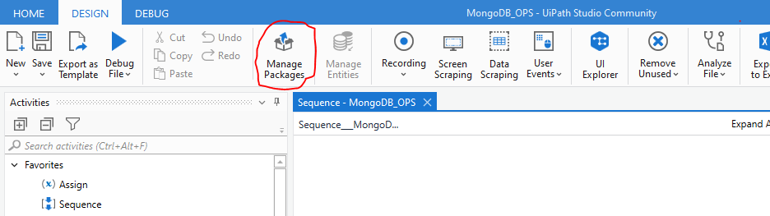

4. Go to Settings> click (+) under ‘user defined package sources’ and click ‘…’ icon to go to the folder where .nupkg file is present.  
  
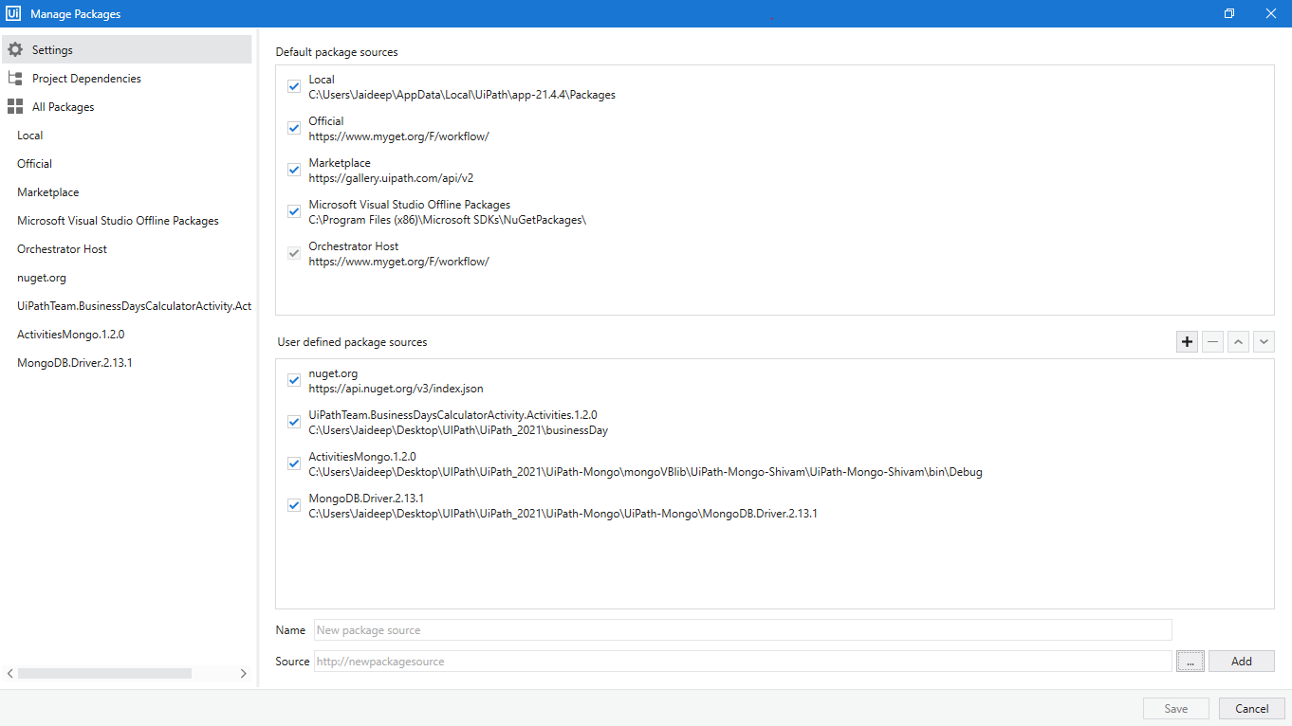

5. After Adding the source file path, give .nupkg file under ‘*Name’*

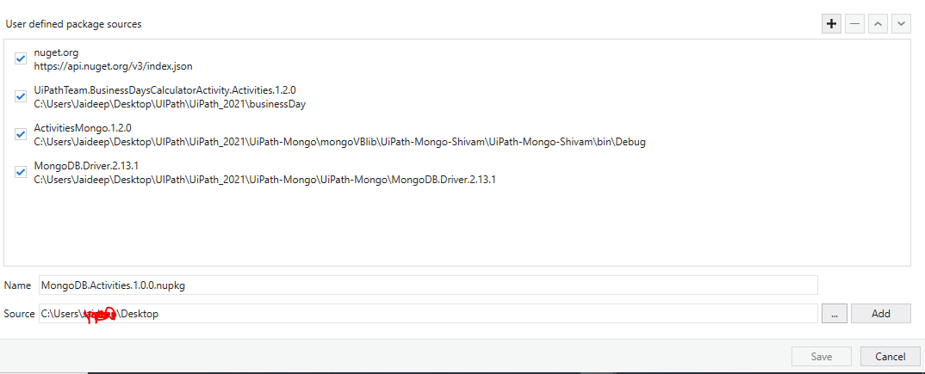

6. Click Add

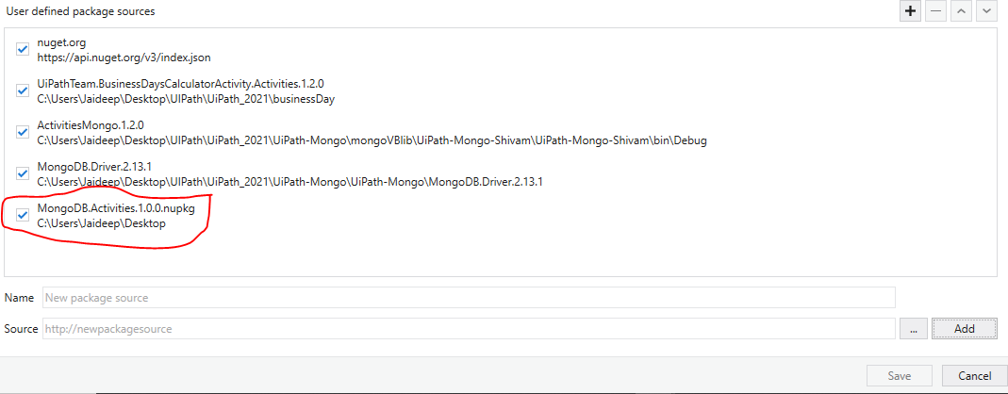

7. Added package can be seen in the feed ribbon.  
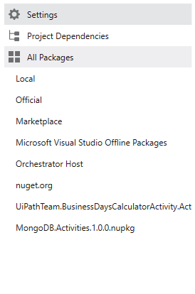

8. Click on it to open, Click install and click Save.

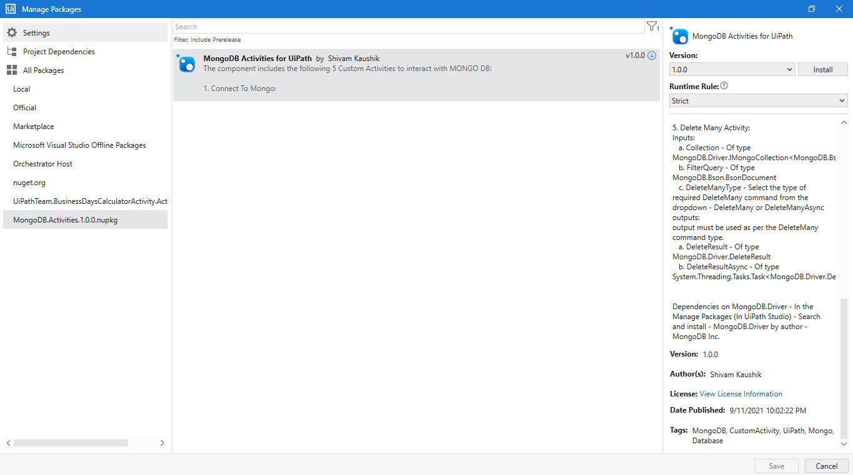

9. View the license, Click ‘I Accept’ to accept to the license and proceed with the installation

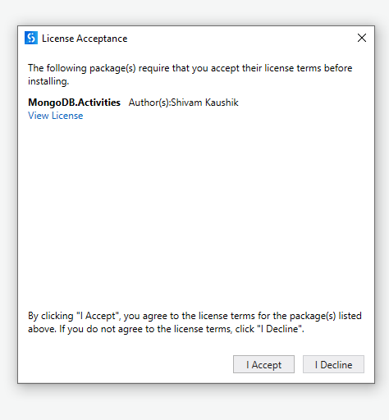

10. In the Manage Packages, go to ‘All Packages’ and search ‘MongoDB.Driver’ by MongoDB Inc. Click Install and Save the package.

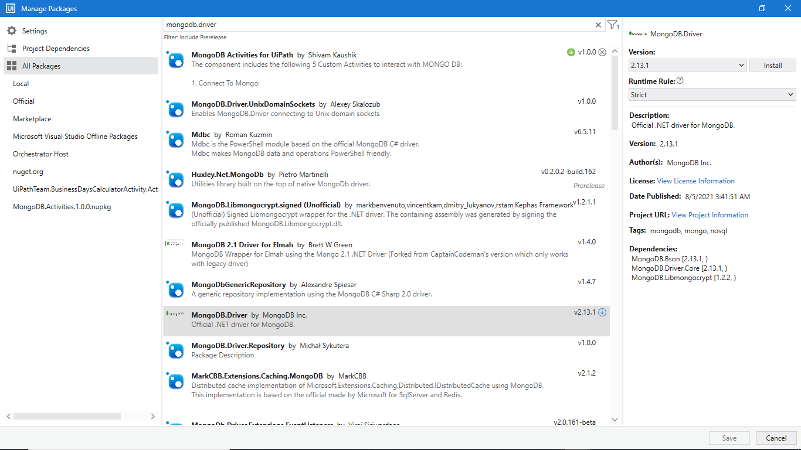

11. Go to Imports ribbon, search and add namespaces - ‘MongoActivities’, ’MongoDb.Driver’, ‘MongoDB.Bson’.

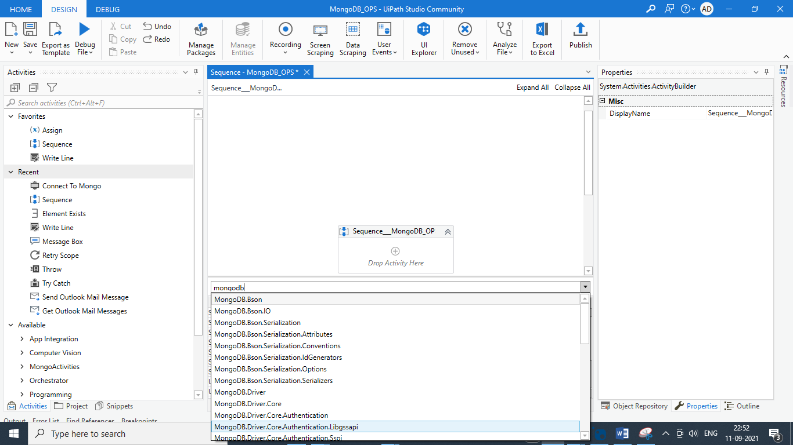

12. After adding the above namespace, they should be visible in the imports ribbon.  
  
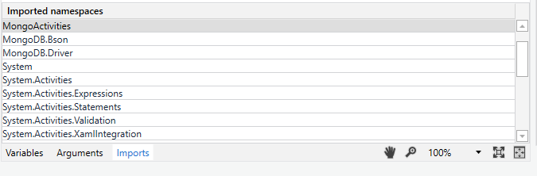

13. All the activities will now be available under ‘MongoActivities’ and ready to use.  
