Project HalfBill

Doc 1: Project Overview

OneBill Intern Program — June 2025

Project HalfBill — headless by design, full revenue lifecycle by capability. Four AI agents. One protocol. Zero product UI.

The Full Architecture
Read this diagram first. The glossary below explains every term in it.
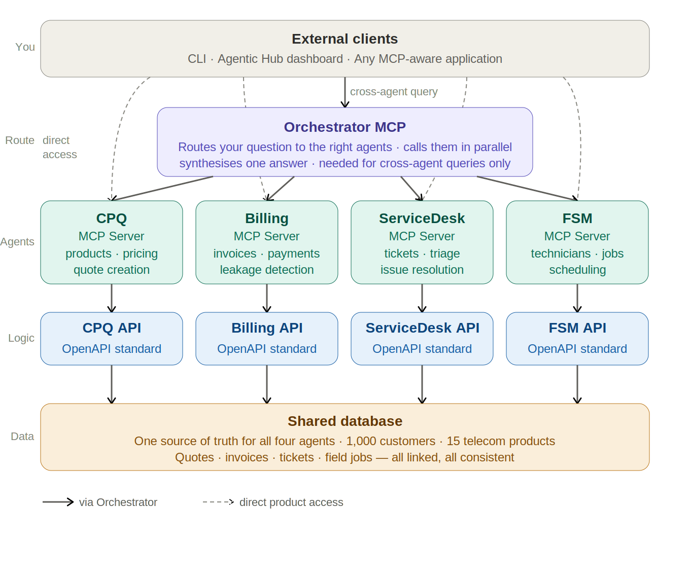
Project HalfBill Architecture

Glossary
Terms appear in the order you encounter them reading the architecture top to bottom.
MCP (Model Context Protocol) An open standard protocol that defines how AI agents discover and call tools. Every server in Project HalfBill speaks MCP. Think of it as a universal interface — any MCP-aware client can connect to any MCP server and immediately discover what it can do.
SSE (Server-Sent Events) The network transport MCP servers use to face the outside world. The server listens on an HTTP port. Clients connect and maintain a persistent HTTP connection. Messages flow as events over that connection. This is how all external clients talk to any MCP server in this project.
MCP Server A process that exposes tools via the MCP protocol over SSE. It starts independently, listens on its own port, and waits for MCP clients to connect. In Project HalfBill there are five: the Orchestrator (port 8002), CPQ (8003), Billing (8004), ServiceDesk (8005), and FSM (8006). Each runs as an independent persistent process — no server spawns or owns another.
MCP Client Any process that connects to an MCP server to discover and call its tools. orchestrator_cli.py is an MCP client. The Agentic Hub is an MCP client. The Orchestrator is an MCP client when it connects to the four product MCP servers.
Independent Persistent Process Each MCP server starts on its own, runs on its own port, and lives independently. No parent process spawns it. No other server owns it.
Horizontal Scaling Running multiple instances of the same server behind a load balancer. Because each MCP server is independent with no shared state — all state lives in Postgres — any can be scaled horizontally without architectural changes.
LLM (Large Language Model) The AI model that does the reasoning. Mistral 7B via Ollama (port 11434), or Claude via Anthropic API. The LLM never directly touches the database or calls APIs. It only produces text and tool call instructions.
Plain LLM Call An LLM call with no tools attached. Input is text, output is always text, no loop. Used by the Orchestrator’s Router and Aggregator.
Agent LLM Call An LLM call with a tool list attached. The LLM can respond with text OR a tool_call. If tool_call, the MCP client session executes it, feeds the result back, and calls the LLM again. Loops until text with no tool_calls. Used by all four product MCP servers.
Tool A Python function registered on an MCP server. The LLM reads the tool name and description to decide when to use it. In this project tools are thin HTTP wrappers calling the Product FastAPI server (port 8001).
Tool Calling — Who Does What
LLM → decides WHICH tool to call and WITH WHAT arguments
produces a tool_call instruction — nothing more
MCP Client Session → Python code inside the MCP server
receives tool_call, calls session.call_tool(name, args)
this is the executor — not the LLM
Tool Function → the Python function that actually runs
HTTP call → Product FastAPI (8001) → Postgres → result
Agent Loop / Reasoning Loop
1. Receive query
2. Call LLM with query + tool list
3. LLM returns tool_call → execute → result back to LLM
4. Repeat until LLM returns text with no tool_call
Orchestrator The coordination layer for cross-agent queries. Runs as an MCP server (orchestrator_server.py, SSE, port 8002). Receives a prompt, routes to relevant agents, calls them in parallel, synthesises one answer. Only needed when multiple agents must work together.
Router The part of the Orchestrator that decides which agents handle a query. One plain LLM call, no tools, returns JSON agent list.
Aggregator The part of the Orchestrator that synthesises multiple agent responses into one answer. One plain LLM call, no tools.
Product FastAPI Server HTTP/REST server on port 8001. All business logic lives here. Called by MCP tool functions internally. Not exposed to external clients directly.
A2A (Agent-to-Agent) One agent writes to Postgres. Another reads it. No direct agent calls. All coordination through shared data.
Q2C2C (Quote to Cash to Care) OneBill’s revenue lifecycle framework. CPQ = Quote. Billing = Cash. ServiceDesk + FSM = Care.
pgvector Postgres extension for vector similarity search. Semantic product search (CPQ) and similar ticket lookup (ServiceDesk).
Agentic Hub UI Streamlit dashboard for operators. Polls each MCP server’s /sse endpoint for health status (up/down). Calls each product’s REST metrics endpoint on the Product FastAPI server for business metrics. No direct Postgres access — business logic stays in FastAPI where it belongs.
Headless No product UI. Products accessed through MCP clients only. Headless ≠ invisible — the Agentic Hub provides observability.

What You Are Building
Product | What it does | Agent job
CPQ | Configure, Price, Quote | Multi-item telecom quotes from natural language
Billing | Invoices, payments, anomalies | Revenue leakage detection, invoice status
ServiceDesk | Support tickets | Triage, route, resolve
FSM | Field Service Management | Dispatch technicians, manage field jobs

Distributed Architecture
Every MCP server is an independent, network-accessible process. This enables:
- Independent deployment — update CPQ without touching Billing
- Horizontal scaling — scale each server independently behind a load balancer
- Failure isolation — FSM down does not affect CPQ or Billing
- Modular access — connect to exactly the agents you need
Single product access → connect directly to port 8003/8004/8005/8006
Cross-agent access → connect to Orchestrator on port 8002
Observability → Agentic Hub connects to all ports

MCP Handshake — How Clients Connect
1. Client: GET http://localhost:8002/sse
2. Server: HTTP 200 — SSE stream established
3. Client: POST /messages {"method":"initialize"}
4. Server: capabilities confirmed
5. Client: POST /messages {"method":"tools/list"}
6. Server: tool names, descriptions, schemas
7. Client: POST /messages {"method":"tools/call", "params":{...}}
8. Server: result returned as SSE event
Same handshake on every MCP server — ports 8002 through 8006.

How the LLM Connects — Three Roles
Role 1: Router — inside Orchestrator, plain call, no tools, once
Input: prompt + agent descriptions
Output: {"agents": ["billing","fsm"]}
Role 2: Agent Reasoning — inside each MCP server, with tools, loops
Input: query + MCP tool list
Loop: tool_call → execute → HTTP → FastAPI → Postgres → result → LLM
Output: text answer when no more tool_calls
Role 3: Aggregator — inside Orchestrator, plain call, no tools, once
Input: original prompt + all agent answers
Output: single synthesised answer

Complete Request Flow
Query: “Acme Corp’s service is down, invoice wrong, need a technician.”
1. orchestrator_cli.py → SSE → Orchestrator (port 8002)
calls tool: query(prompt="...")
2. Orchestrator → LLM Router (plain)
returns: {"agents": ["billing","servicedesk","fsm"]}
3. Orchestrator → 3 SSE connections simultaneously
→ Billing MCP (8004) → billing_server.py
→ ServiceDesk MCP (8005) → servicedesk_server.py
→ FSM MCP (8006) → fsm_server.py
4a. BILLING AGENT LOOP
billing_tools.py → HTTP:8001 → Postgres
4b. SERVICEDESK AGENT LOOP (parallel)
servicedesk_tools.py → HTTP:8001 → Postgres
4c. FSM AGENT LOOP (parallel)
fsm_tools.py → HTTP:8001 → Postgres
5. All 3 answers returned to Orchestrator
6. Orchestrator → LLM Aggregator (plain)
returns single synthesised answer
7. Orchestrator → SSE event → orchestrator_cli.py → printed

A2A Flow — Through Shared Postgres
billing_server.py writes → billing_anomalies
│ foreign key
servicedesk_server.py reads ←──┘
servicedesk_server.py writes → servicedesk_tickets
│ foreign key
fsm_server.py reads ←─────────────────┘
fsm_server.py writes → fsm_jobs

Port Reference
Service | Type | Port | Accessible to
JupyterHub | Web | 8000 | Interns via browser
Product FastAPI | HTTP/REST | 8001 | MCP tool functions (internal)
Orchestrator MCP | SSE/MCP | 8002 | CLI, Agentic Hub, external clients
CPQ MCP | SSE/MCP | 8003 | Direct CPQ access, Orchestrator
Billing MCP | SSE/MCP | 8004 | Direct Billing access, Orchestrator
ServiceDesk MCP | SSE/MCP | 8005 | Direct SD access, Orchestrator
FSM MCP | SSE/MCP | 8006 | Direct FSM access, Orchestrator
Ollama (Mistral 7B) | HTTP | 11434 | All MCP servers
PostgreSQL | TCP | 5432 | Product FastAPI only
Agentic Hub UI | HTTP | 8501 | Operators via browser
Exercise ports | SSE/MCP | 9003-9006 | Week 1 Day 4 exercise only

Team Structure
Team | Owns | Builds
Platform | Infrastructure + observability | orchestrator_server.py, Product FastAPI shell, db.py, agent_registry.py, Agentic Hub
CPQ | Quote agent | /cpq/* endpoints, cpq_server.py, cpq_tools.py
Billing | Billing agent | /billing/* endpoints, billing_server.py, billing_tools.py
ServiceDesk | Ticket agent | /servicedesk/* endpoints, servicedesk_server.py, servicedesk_tools.py
FSM | Field ops agent | /fsm/* endpoints, fsm_server.py, fsm_tools.py

Folder Structure
onebill-agents/
│
├── config.py
│
├── platform/
│ ├── orchestrator/
│ │ ├── orchestrator_server.py ← MCP server (SSE, port 8002)
│ │ ├── router.py ← LLM routing
│ │ └── aggregator.py ← LLM aggregation
│ ├── hub/
│ │ └── app.py ← Streamlit UI (port 8501)
│ └── shared/
│ ├── db.py ← Postgres connection
│ └── agent_registry.py ← Agent registry
│
├── agents/
│ ├── cpq/
│ │ ├── cpq_server.py ← MCP server (SSE, port 8003)
│ │ └── cpq_tools.py ← HTTP wrappers → port 8001
│ ├── billing/
│ │ ├── billing_server.py ← MCP server (SSE, port 8004)
│ │ └── billing_tools.py
│ ├── servicedesk/
│ │ ├── servicedesk_server.py ← MCP server (SSE, port 8005)
│ │ └── servicedesk_tools.py
│ └── fsm/
│ ├── fsm_server.py ← MCP server (SSE, port 8006)
│ └── fsm_tools.py
│
├── fastapi_app/
│ ├── main.py ← HTTP server (port 8001)
│ ├── models.py
│ └── routers/
│ ├── cpq.py
│ ├── billing.py
│ ├── servicedesk.py
│ └── fsm.py
│
└── orchestrator_cli.py ← CLI entry point (MCP client)

Week 1 Schedule
Pre-work (before Day 1): Read Doc 2 (MCP Mental Model) and complete Doc 3 (Environment Setup + all smoke tests passing). Arrive on Day 1 with your environment confirmed working.
Day | Activity | Who | Doc
Day 1 | Orientation. Group review of Doc 1 architecture. Q&A on Doc 2 concepts. Confirm all setups work. | All 20 | Doc 1, Doc 2
Day 2 | Hello World — stdio transport. Build hw_server.py + hw_client.py. Run all observation exercises. | Individual | Doc 4 Part 1
Day 3 | Hello World — SSE transport. Rebuild same agent in SSE mode. Run all SSE observation exercises. | Individual | Doc 4 Part 2
Day 4 | Orchestrator exercise. All 5 teams each build their own orchestrator_server.py. Connect to hw_server.py stand-ins on exercise ports. | Group (5 teams) | Doc 5
Day 5 | Teams split. Each team reads their Doc 6 brief. Design tool surface. Present planned tools to group. | Teams | Doc 6

Four-Week Timeline
Period | Platform Team | Product Teams
Week 1 — Day 1 | Group orientation. Architecture review. Confirm all setups working. | All 20 together
Week 1 — Days 2–3 | Hello World (Doc 4) — individual, both stdio and SSE | All 20 — every intern builds their own
Week 1 — Day 4 | Orchestrator exercise (Doc 5) — all 5 teams each build their own | All 20 — group exercise
Week 1 — Day 5 | Teams split. Platform begins infrastructure scoping. | Each team reads Doc 6 brief. Tool surface design.
Week 2 | orchestrator_server.py, Product FastAPI shell, db.py, agent_registry.py | Finalise tool specs, study OpenAPI contracts
Week 3 | Integration support + Agentic Hub UI | Build FastAPI endpoints + MCP tools. Individual agent testing.
Week 4 | Hub completion + integration support | A2A testing. Capstone demo preparation.

Definition of Done
Individual module - [ ] FastAPI endpoints return correct data from Postgres - [ ] MCP server starts independently on assigned port (SSE) - [ ] All 8-10 sample prompts return data-grounded responses - [ ] Agent never invents data not in Postgres
Cross-agent - [ ] All five MCP servers running independently - [ ] Orchestrator routes correctly for single and multi-product queries - [ ] A2A scenarios produce chained results - [ ] Agentic Hub shows live status for all servers
Capstone demo > “A new customer wants fiber, mobile, and streaming TV. > Build the quote, generate the first invoice, > and schedule installation for next Tuesday.”

Tech Stack
Layer | Technology | Port
CLI | orchestrator_cli.py + MCP SDK | —
Orchestrator | orchestrator_server.py (SSE) | 8002
CPQ agent | cpq_server.py (SSE) | 8003
Billing agent | billing_server.py (SSE) | 8004
ServiceDesk agent | servicedesk_server.py (SSE) | 8005
FSM agent | fsm_server.py (SSE) | 8006
Product APIs | FastAPI + Uvicorn | 8001
Observability | Streamlit + Plotly | 8501
LLM — shared | Mistral 7B via Ollama | 11434
LLM — override | Claude via Anthropic API | —
Database | PostgreSQL 15 + pgvector | 5432
Dev environment | JupyterHub + Miniconda | 8000
Language | Python 3.10+ | —

Further Reading
MCP: https://modelcontextprotocol.io · https://github.com/modelcontextprotocol/python-sdk · https://spec.modelcontextprotocol.io/specification/basic/transports/
LLM Tool Calling: https://docs.mistral.ai/capabilities/function_calling/ · https://docs.anthropic.com/en/docs/build-with-claude/tool-use
FastAPI: https://fastapi.tiangolo.com · pgvector: https://github.com/pgvector/pgvector · Streamlit: https://docs.streamlit.io

Before Day 1 Checklist
- ☐ Read Doc 1 — understand the architecture diagram and file naming
- ☐ Understand Tool Calling — who decides, who executes, who runs
- ☐ Read Doc 2 (MCP Mental Model)
- ☐ Complete Doc 3 (Environment Setup)
- ☐ Know which team you are on

Read Doc 2 next.

