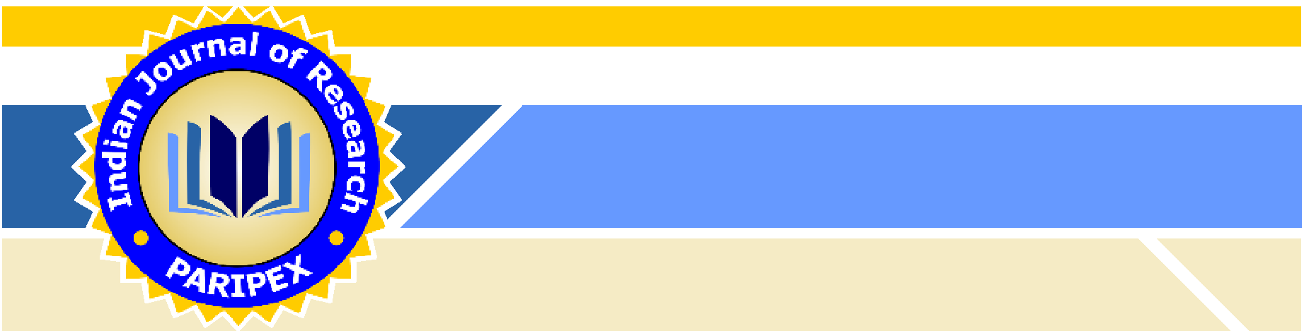**PARIPEX-Indian Journal of Research**

**-An International Journal**

**PRINT ISSN NO 2250 - 1991**

**COPYRIGHT AGREEMENT FORM**

**Any One Author** (behalf of all the co-authors) needs to complete and sign on this form andemail it to **The Editor, JEMR – INDIAN JOURNAL OF RESEARCH, on EDITOR@JEMR.IN**

**I/We, ____________________________________________________________________________________**

**(Author (s) name, the copyright owner/owners of the article**

Title "____________________________________________________________________________________"

Do hereby authorize you to publish the above said article/research paper in, **JEMR – Indian** **Journal of Research**

**I/WE FURTHER CLARIFY THAT:**

1. The Article is my/our original contribution and has not been plagiarized/copied from any source/individual. It does not contravene on the rights of others and does not contain any libelous or unlawful statements and all references have been duly acknowledged at the appropriate places.
2. The article submitted only to **JEMR – Indian Journal of Research, Ahmedabad** and it has not been previously published or submitted elsewhere for publication in a copyrighted publication.
3. I/We hereby authorize you to edit, modify and make changes in the Articles/Research paper to make it suitable for publication in **JEMR – Indian Journal of Research**

**Ahmedabad.**

1. I/We hereby assign all the copyright relating to the said Article/Research Paper to **JEMR –**

**Indian Journal of Research Ahmedabad.**

1. I/We have not assigned any kind of rights to the above said Article/Research Paper to any other person/Institute/Publication.
2. I/We agree to indemnify **JEMR – Indian Journal of Research Ahmedabad** against any claim legal and/or otherwise, action alleging facts which if true, constitute a beach of any of the foregoing warranties

Any One Author's Name:__________

Signature:_______________

Date: __________________________



**www.jemr.in**