

ASSESSMENT-4

Task 1 call the backend url which is like https://hostname/?username=<value take from input>&userid=<value take from input>

Step:-1 Click on Multiple Protocol Gateway

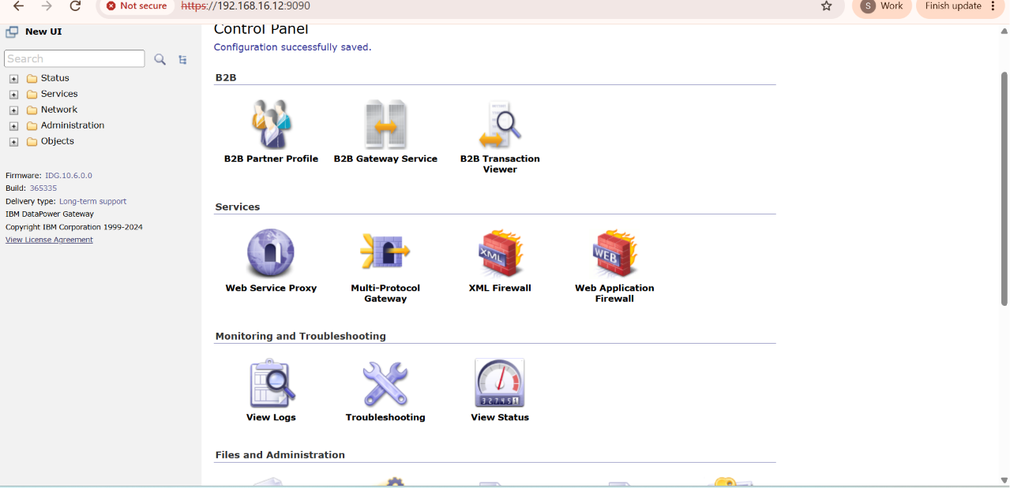

Step 2:-Click on ADD Wizard

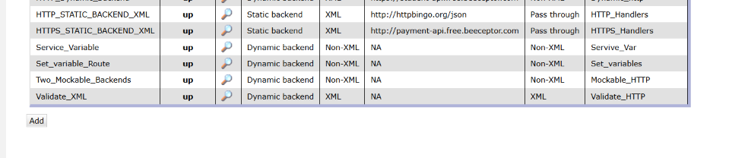

Step 3:- After this GUI Provide the realtaed Configuration

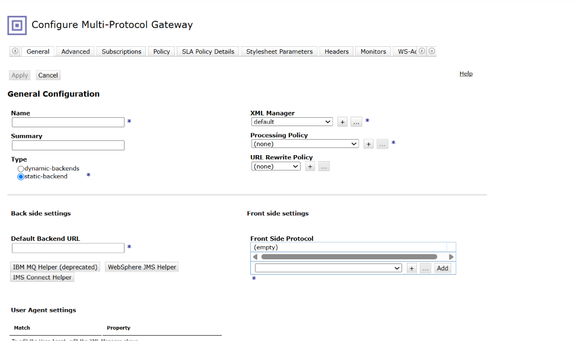

Step 4:-Provide The Name And Summary For this MPGW

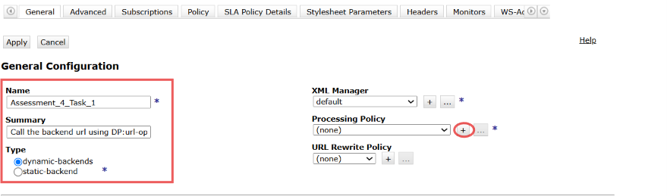

Step 5:-Now Select Type As Dynamic Backend And Click on(+) icon beside Processing policy

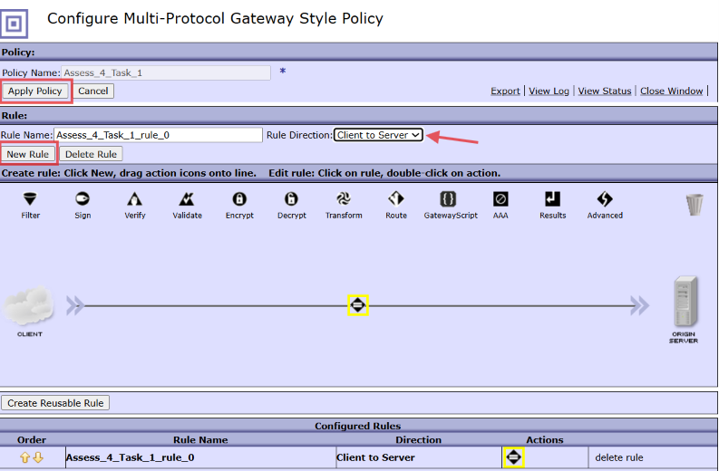

Here Configure MPGW Style policy provide name:-Ass_4_Task1 and Click on Apply policy and New Rule.

Step 6:-After that Double click on Matching icon And configure it For Assessment 2

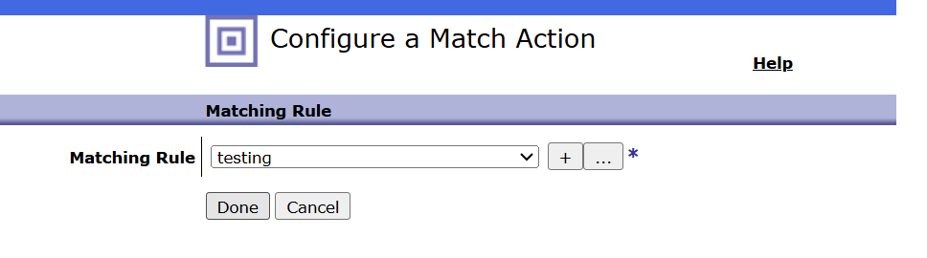

After configure All Select On Done and Apply policy to save the configuration.

Step 7:-Click On Dropdown As Client to Server And Click on Apply Policy

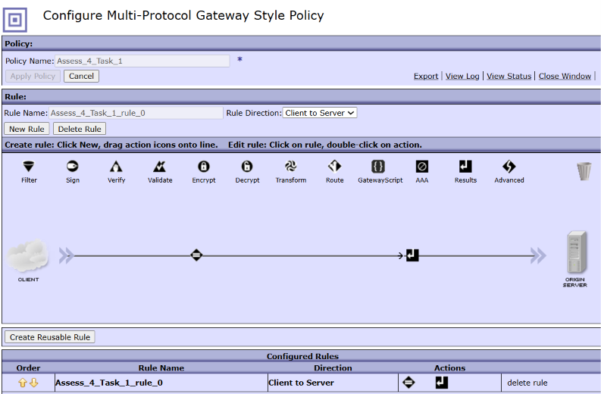

As we Select Dynamic Backend But We Are not calling any Backend So that we have to configure IT as Skip Backside by the help of Advance icon

Step 8:-Drag and Drop Advance icon to the flow And configure it as Set Variable

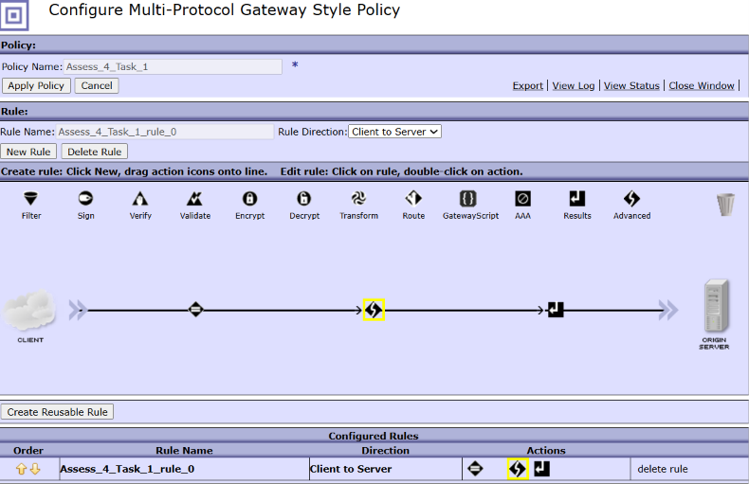

Double click on The Advance icon and Select from it Set Variable Option

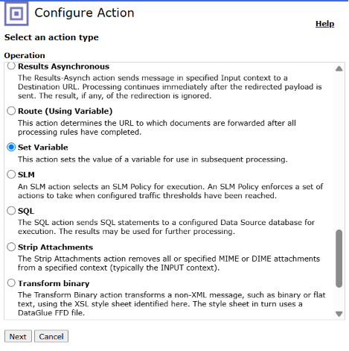
Click on Next

Step 9:-Configure Set Variable Action

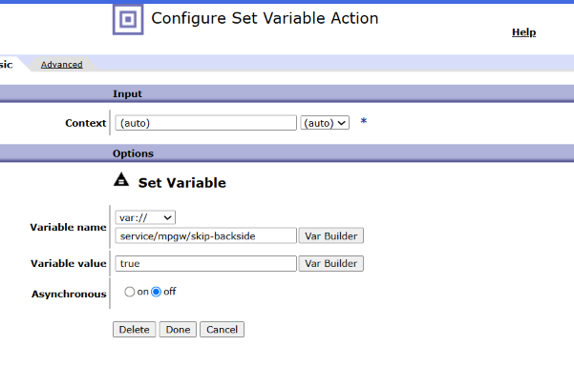

Here we have to configure Variable name:-service/mpgw/skip-backside(Default)
Variable value:-(true or 1)

Click on Done.

Step 10:-Now After that Drag The Gatewayscript Action To the flow

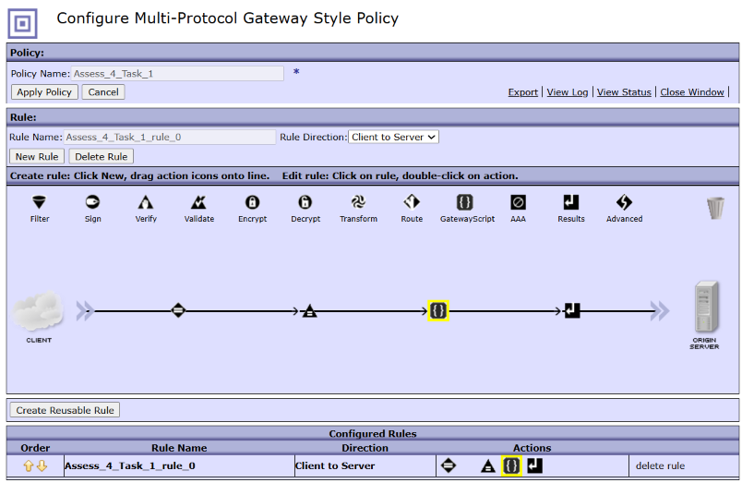

Now before writing XSLT Code Lets Create a Backend Through App connect:-

Step.1:-Create an Application and Msg flow
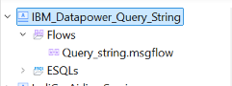

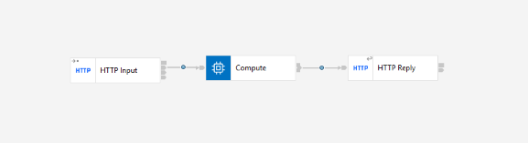

Step 2:-Configure HTTP Input

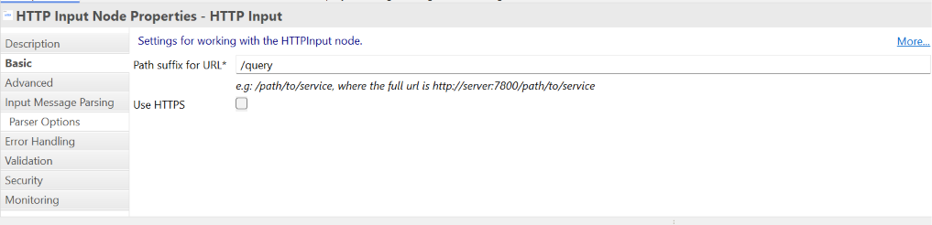
For HTTPS Check The Box.

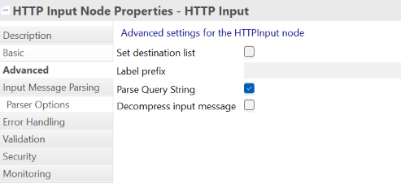

Step 3:-Write compute node code for the Query parameter

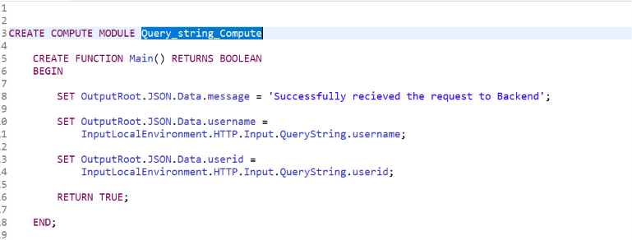

Step 4:-Now From The postman we will check now the Query Parameter And And tHe Url
1.HTTP
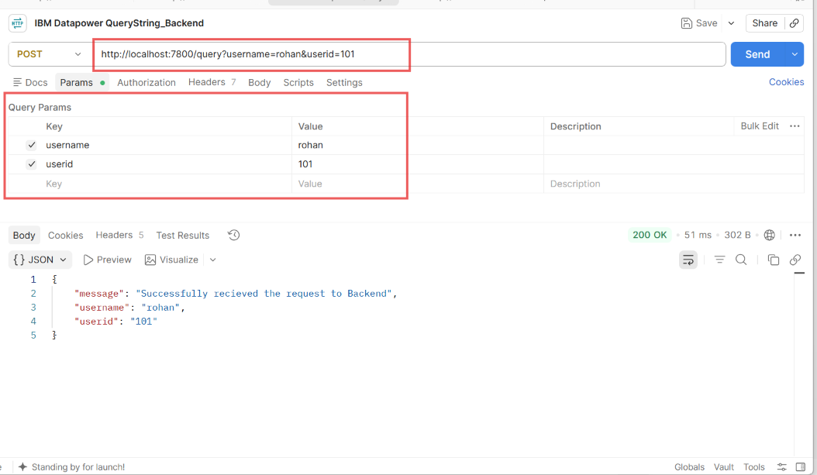

2.HTTPS
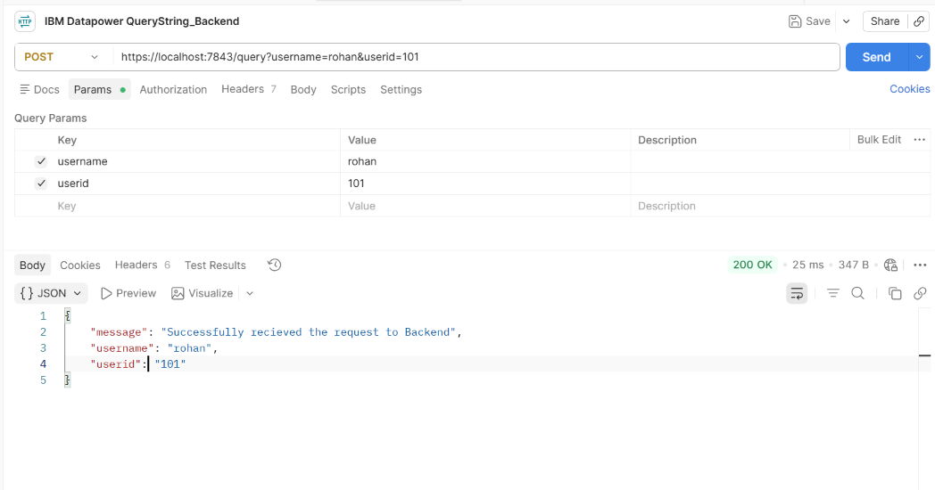

Now Before that we will Write gatewayscript code for this task:-
1.HTTP
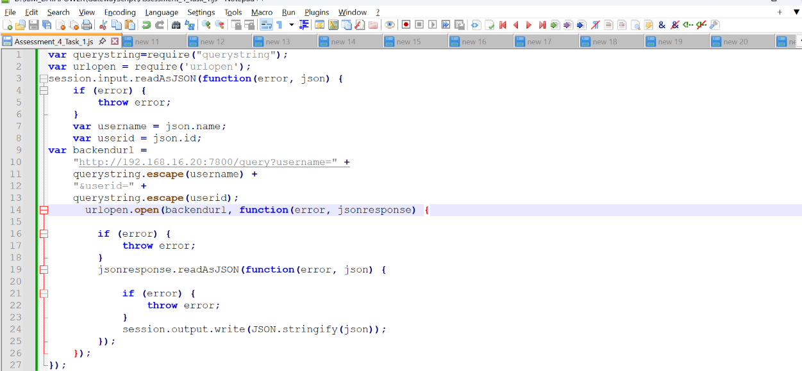

2.HTTPS

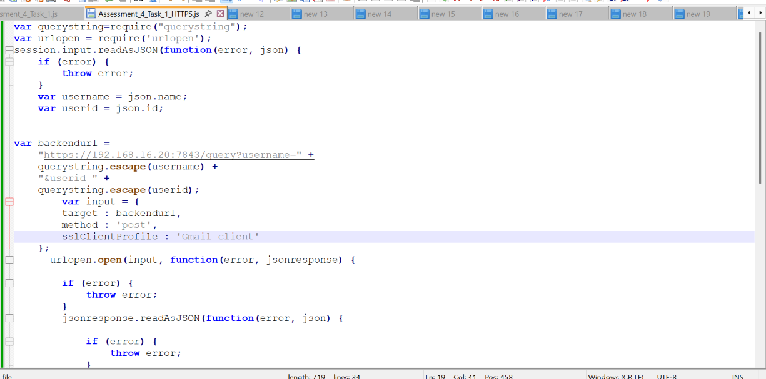
Step 11:-Now configure GatewayScript Action

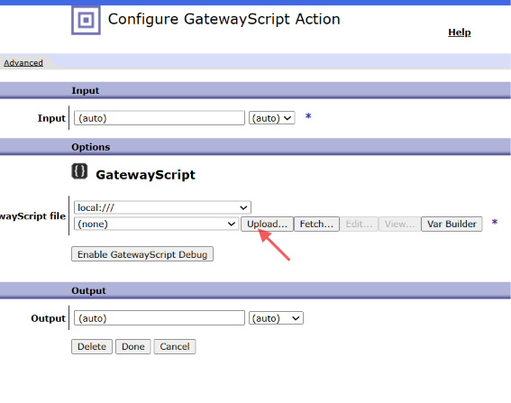

Click on Upload to upload the Above .js File

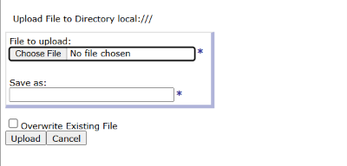
Now Click on Choose file.

From the File explorer Upload the Assessment_4_Task_1.js file
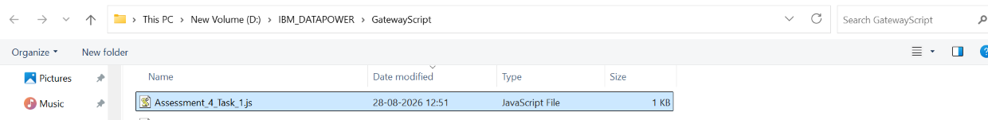

Click on upload button

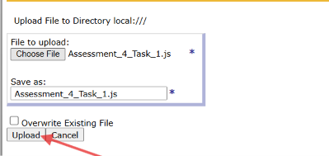

After Uploading the GUI for Transform Action lokk like this:-

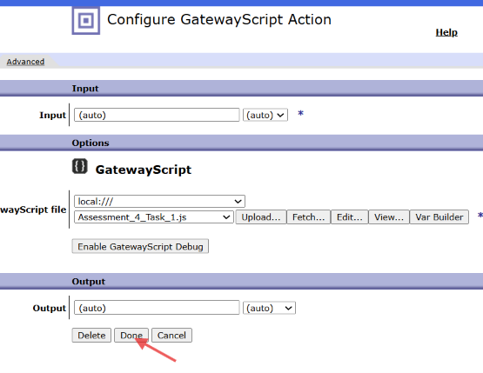

Click On Done.

Step 12:-After That we move in to Main Policy GUI There we have click on Apply policy to save this

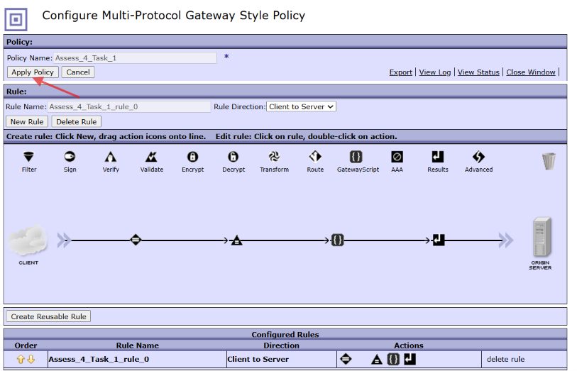

Step 13:-Now Configure The HTTP Handler for this request

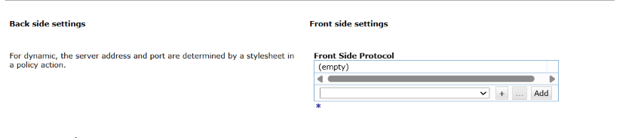

From the dropdown Select HTTP Handler

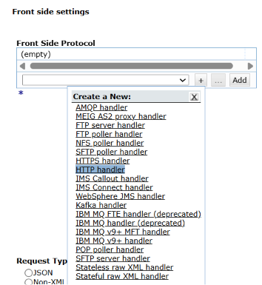

By Select ting HTTP Handler We have to Configure it
Name:-Assessment_4_Handler
PORT=6600

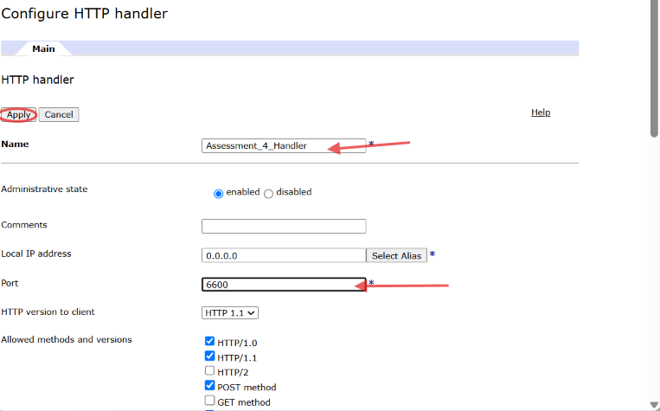

Click on Apply

Step 14:-Now Configure the Request and Response type AS Non-XML

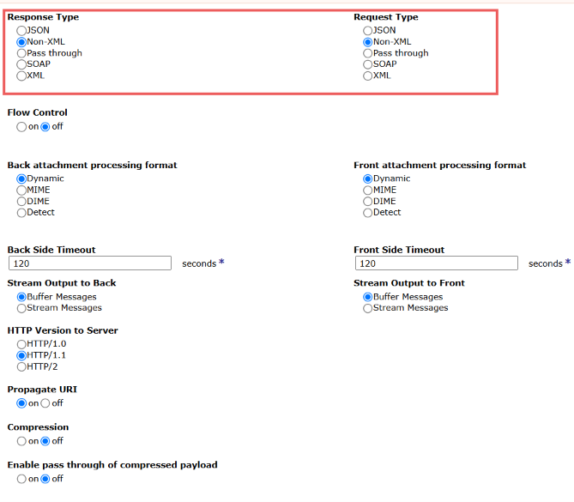

Step 15:Click on Apply and Save to save the whole configuration

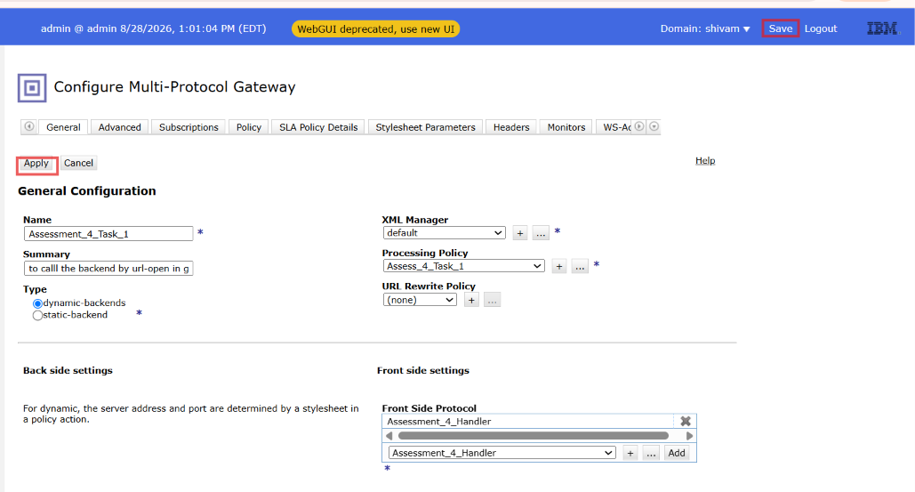

Step 16:- Now From The postman Hit The Api (HTTP Backend)

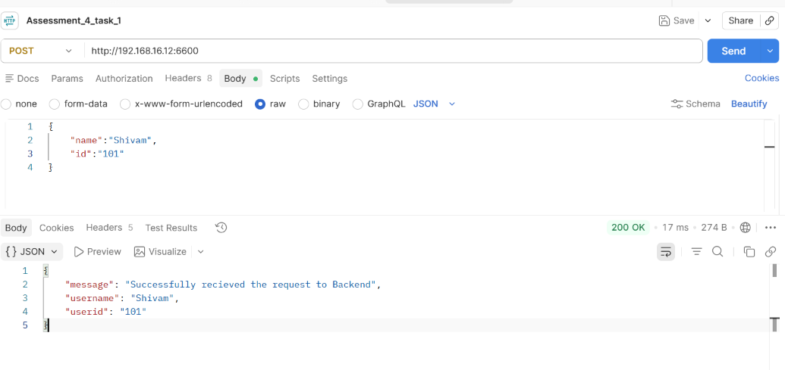
2.HTTPS Backend Output

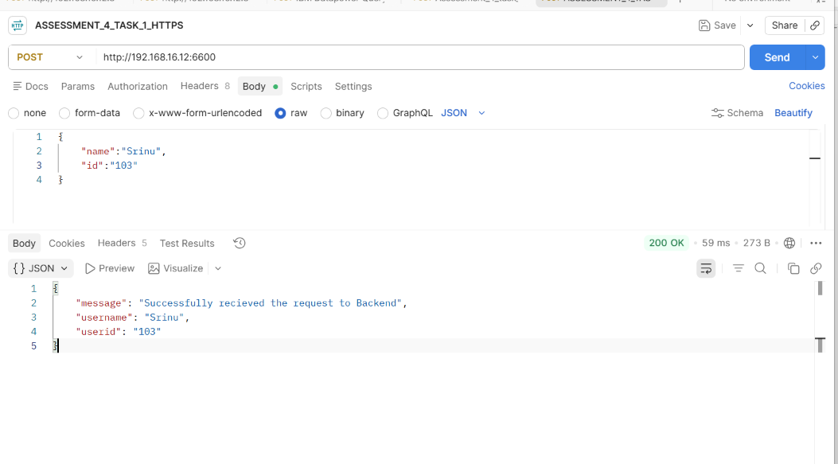

TASK 2:- using gatewayscript

input:name=anusha&id=1234&phno=3242636&phno=26722889
output:
{
"name": "anusha",
"id": "1234",
"phno": [
"3242636",
"26722889"
]
}

Step:-1 Click on Multiple Protocol Gateway

Step 2:-Click on ADD Wizard

Step 3:- After this GUI Provide the realtaed Configuration

Step 4:-Provide The Name And Summary For this MPGW

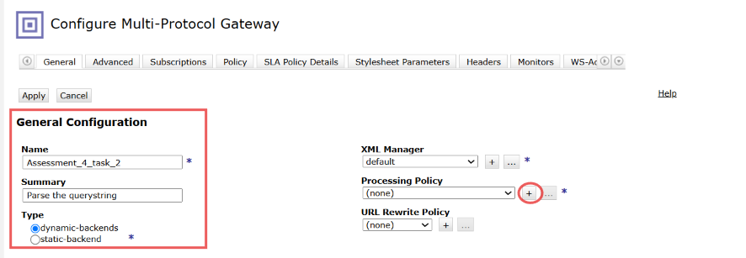

Step 5:-Now Select Type As Dynamic Backend And Click on(+) icon beside Processing policy

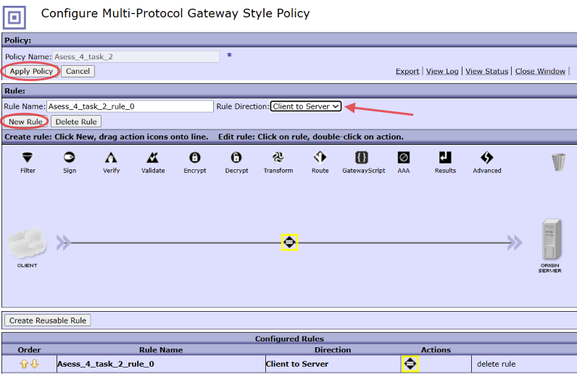

Here Configure MPGW Style policy provide name:-Ass_4_Task_2 and Click on Apply policy and New Rule.
Step 6:-After that Double click on Matching icon And configure it For TESTING

After configure All Select On Done and Apply policy to save the configuration.

Step 7:-Click On Dropdown As Client to Server And Click on Apply Policy

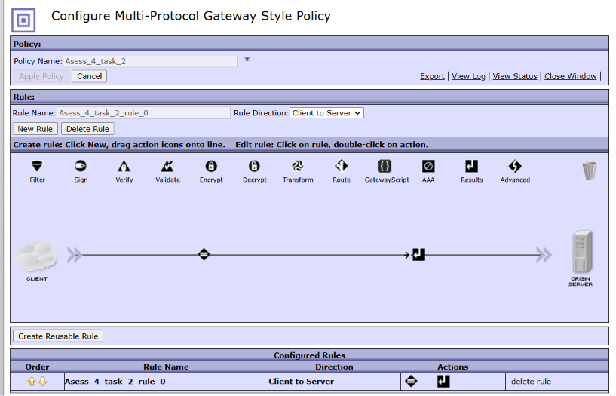

As we Select Dynamic Backend But We Are not calling any Backend So that we have to configure IT as Skip Backside by the help of Advance icon

Step 8:-Drag and Drop Advance icon to the flow And configure it as Set Variable
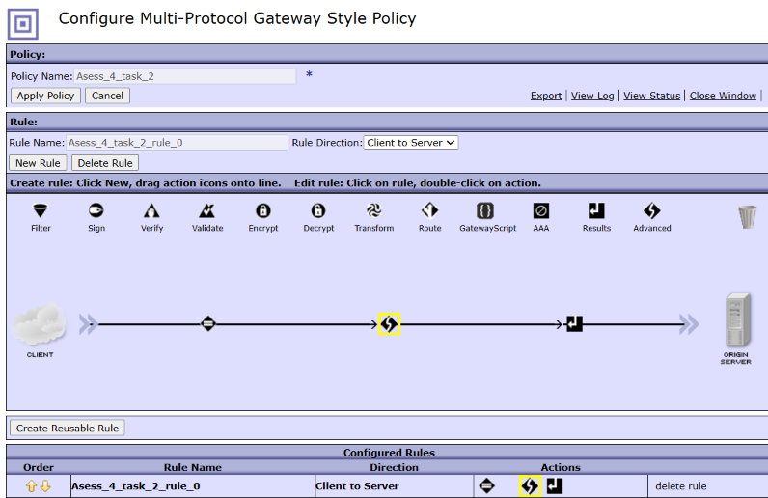

Double click on The Advance icon and Select from it Set Variable Option.

Click on Next

Step 9:-Configure Set Variable Action

Here we have to configure Variable name:-service/mpgw/skip-backside(Default)
Variable value:-(true or 1)

Click on Done.

Step 10:-Now After that Drag The Gatewayscript Action To the flow

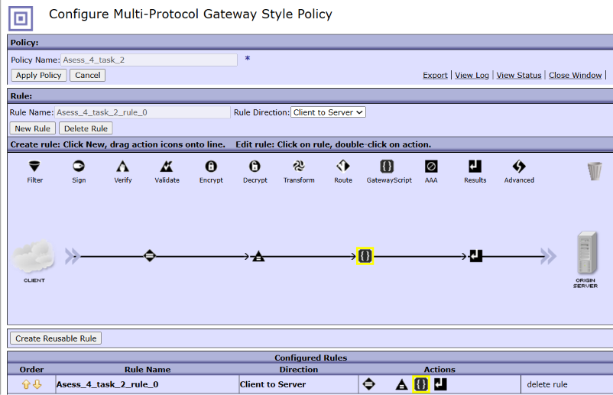

Now Before that we will Write gatewayscript code for this task:-
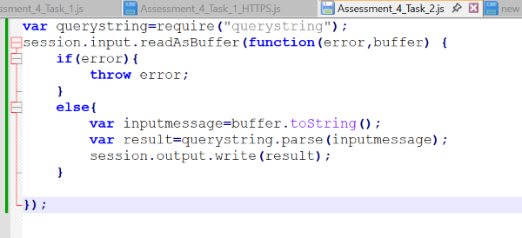

Step 11:-Now configure GatewayScript Action

Click on Upload to upload the Above .js File

Now Click on Choose file.

From the File explorer Upload the Assessment_4_Task_1.js file
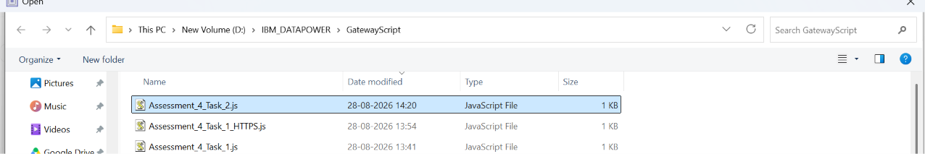

Click on upload button

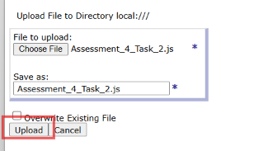

After Uploading the GUI for Transform Action lokk like this:-

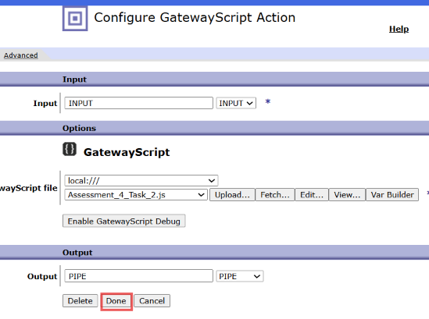

Click On Done.

Step 12:-After That we move in to Main Policy GUI There we have click on Apply policy to save this

Step 13:-Now Configure The HTTP Handler for this request

From the dropdown Select HTTP Handler

By Select ting HTTP Handler We have to Configure it
Name:-Assessment_4_Task_2
PORT=6605

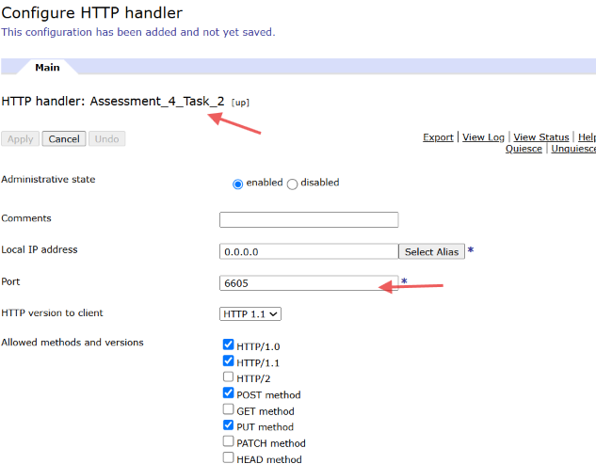

Click on Apply

Step 14:-Now Configure the Request and Response type AS Non-XML

Step 15:Click on Apply and Save to save the whole configuration

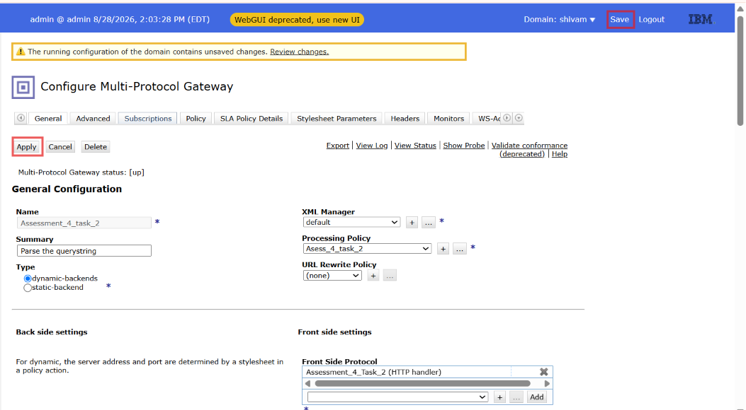

Step 16:- Now From The postman Hit The Api (HTTP Backend)

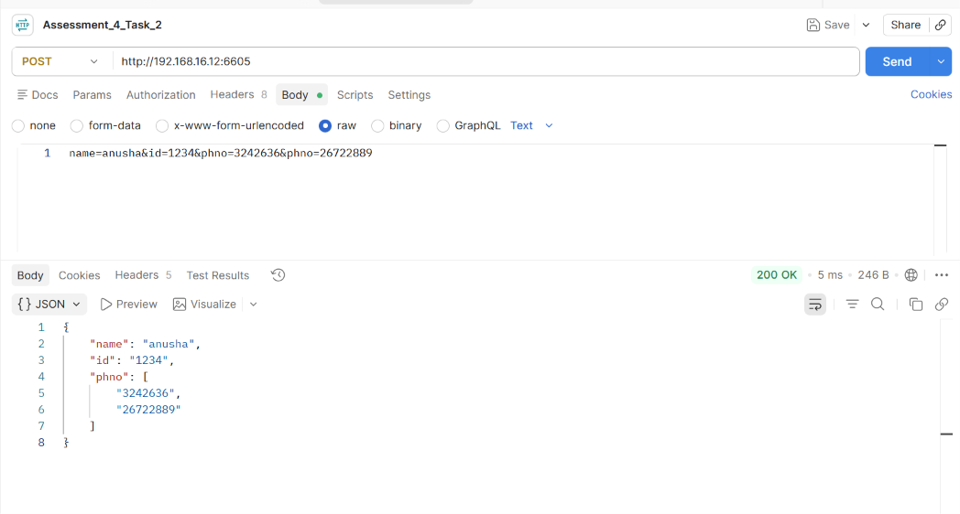

Task 3:- Diff b/w String Buffer , StringBuilder and Buffers explain with code.

Ans:- Lets Us understand One by one
1.StringBuilder:-
- StringBuilder is a class available in Java that represents a mutable and unsynchronized sequence of characters.
- It is mainly used when string manipulation is performed in a single-threaded environment. Since StringBuilder is mutable, we can perform operations such as append, insert, update, and delete on the same StringBuilder object.
- In this the existing object can be modified instead of creating a new object for every modification.
- Therefore, StringBuilder is mainly useful for dynamic and frequent string manipulation, especially when thread safety is not required.

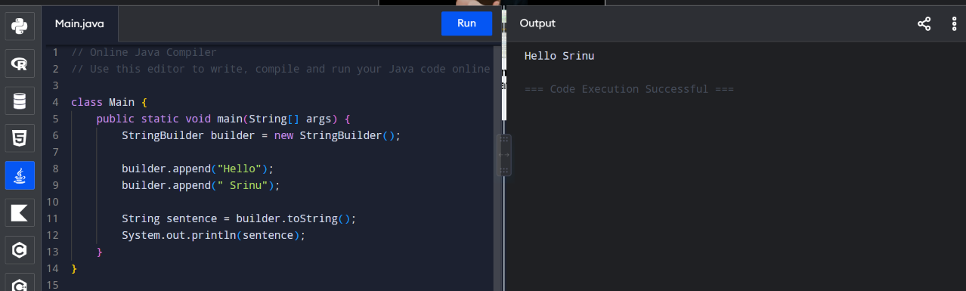

2. StringBuffer
- StringBuffer is similar to StringBuilder. It provides a mutable sequence of characters, which means its contents can be modified without creating a new StringBuffer` object for every modification.
- The main difference between StringBuffer and StringBuilder is that StringBuffer is synchronized, making it thread-safe.
- In this multiple threads can access and modify the same StringBuffer object safely.
- StringBuffer is generally slower than StringBuilder.

Therefore:
- Use StringBuffer when multiple threads may access and modify the same object and thread safety is required.
- Use StringBuilder when working in a single-threaded context or when external synchronization is already provided, because it generally provides better performance.

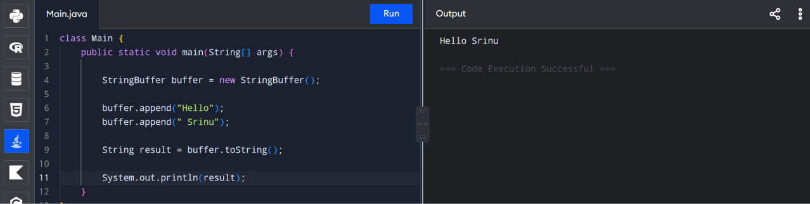

3.Buffers:-
A buffers is a collection of individual Buffer Objects.
It act a s a collection of multiple buffer object as a single contigous memory / contigous mutable buffer.
This module is automatically attached to the Global object.
Used for large payloads. It reads payload as a small individual objects.

Important methods
bufs.copy()
This method is used to copy a specified range of Octets in a buffer object in to another buffer object.
bufs.get()
This method is used to get the element at particular index.
Syntax:-bufs.get(index);
Bufs.indexOf()
This method is mainly used to find the specific element at starting index.it returns the position.
Syntax:-bufs.indexOf(searchelement,Offset);
bufs.push()
This method is used to store the new buffer object into buffers object
bufs.set()
used to set the element at particular index
Syntax:-bufs.set(index,value);
bufs.slice()
This method is used to extract a specific part of the buffers object but not create a new buffer object.
Syntax:bufs.slice(begin,end);
bufs.splice()
This method is used to replace specific part with the new object.
bufs.toBuffer()
Converts all buffer objects into a single buffer object\
Syntax:-bufs.toBuffer();
bufs.toString()
This method is used to convert in String format
Syntax:-bufs.toString(encoding,start,end);
XSLT CODE FOR BUFFERS CLASS
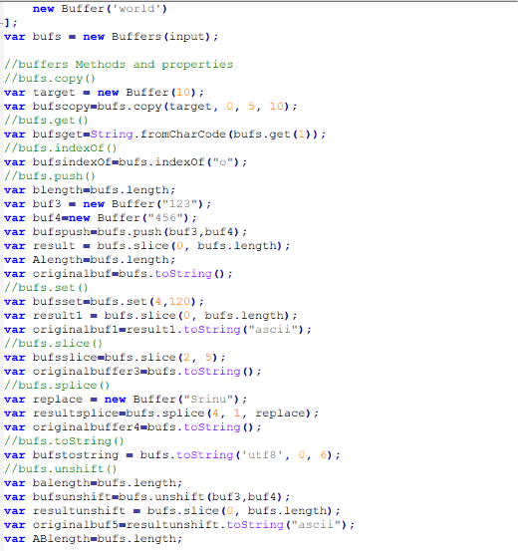

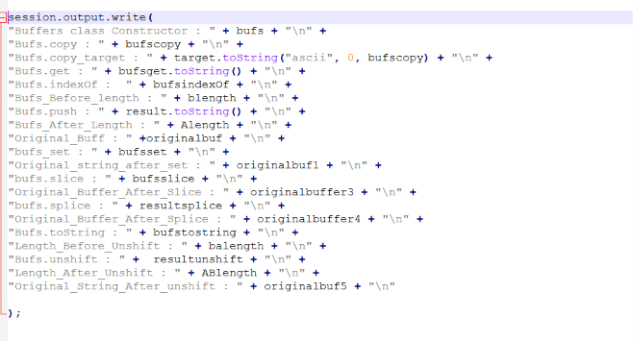

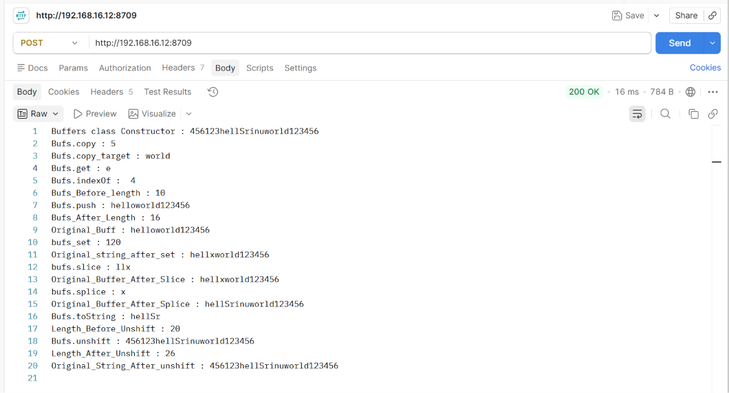

Task 4:- Implement try catch using Gatewayscript.
Step:-1 Click on Multiple Protocol Gateway

Step 2:-Click on ADD Wizard

Step 3:- After this GUI Provide the realtaed Configuration

Step 4:-Provide The Name And Summary For this MPGW

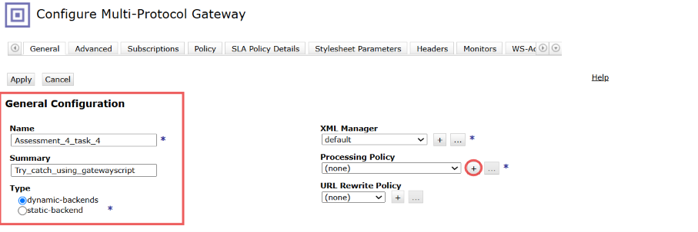

Step 5:-Now Select Type As Dynamic Backend And Click on(+) icon beside Processing policy

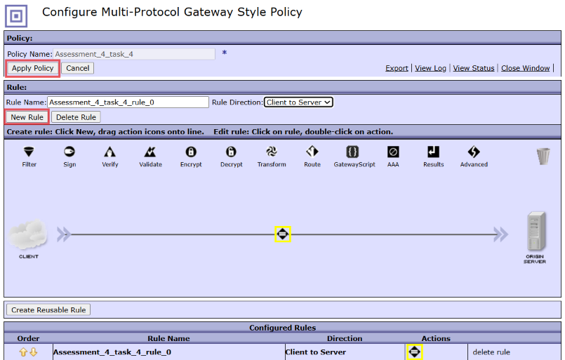

Here Configure MPGW Style policy provide name:-Ass_4_Task_4 and Click on Apply policy and New Rule.
Step 6:-After that Double click on Matching icon And configure it For TESTING

After configure All Select On Done and Apply policy to save the configuration.

Step 7:-Click On Dropdown As Client to Server And Click on Apply Policy

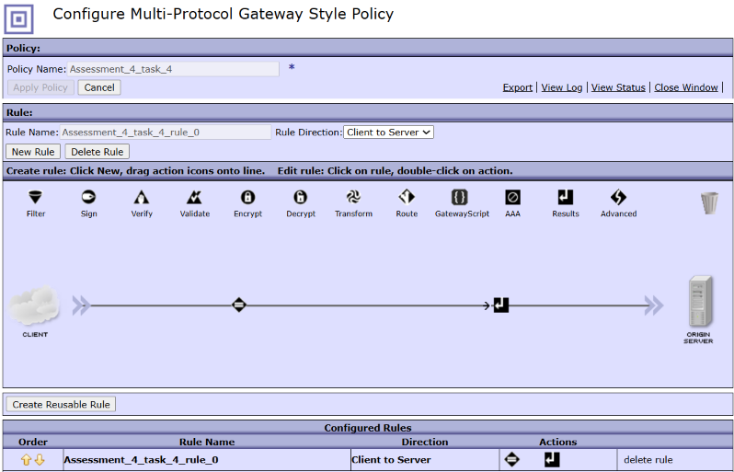

As we Select Dynamic Backend But We Are not calling any Backend So that we have to configure IT as Skip Backside by the help of Advance icon.

Step 8:-Drag and Drop Advance icon to the flow And configure it as Set Variable

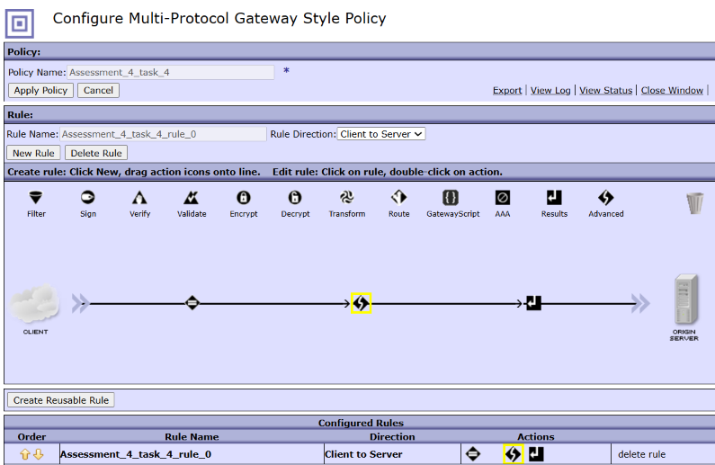

Double click on The Advance icon and Select from it Set Variable Option.

Click on Next

Step 9:-Configure Set Variable Action

Here we have to configure Variable name:-service/mpgw/skip-backside(Default)
Variable value:-(true or 1)

Click on Done.

Step 10:-Now After that Drag The Gatewayscript Action To the flow

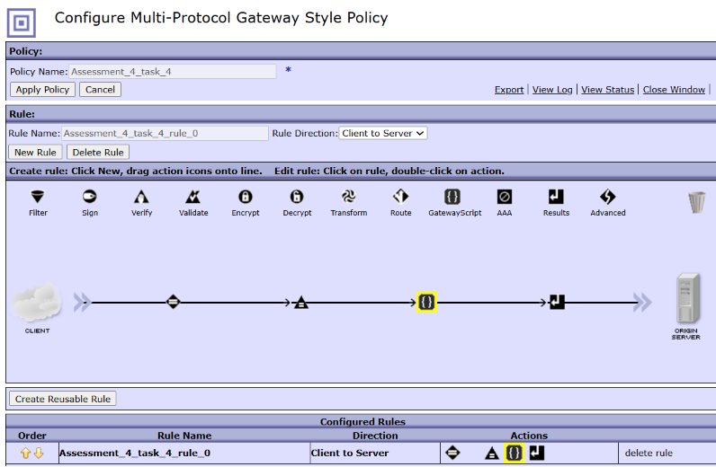

Now Before that we will Write gatewayscript code for this task:-
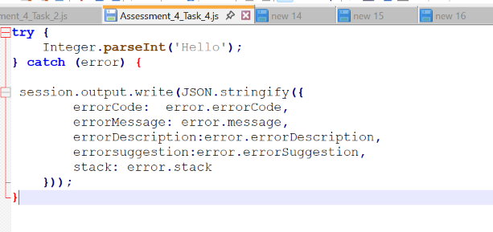
Step 11:-Now configure GatewayScript Action

Click on Upload to upload the Above .js File

Now Click on Choose file.

From the File explorer Upload the Assessment_4_Task_1.js file
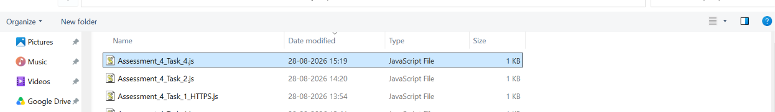

Click on upload button

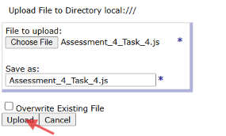

After Uploading the GUI for Transform Action lokk like this:-

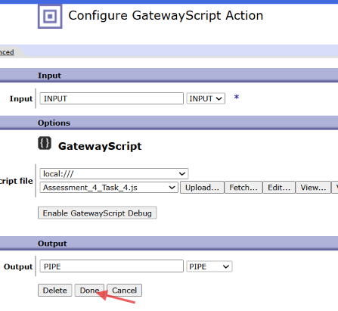

Click On Done.

Step 12:-After That we move in to Main Policy GUI There we have click on Apply policy to save this

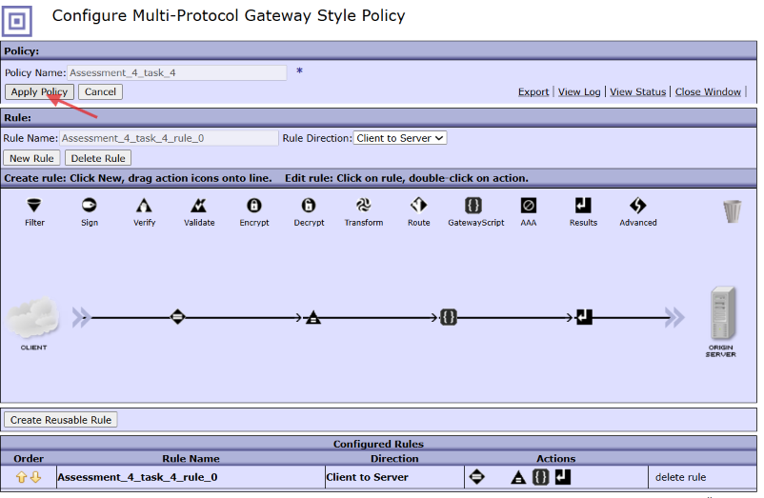

Step 13:-Now Configure The HTTP Handler for this request

From the dropdown Select HTTP Handler

By Select ting HTTP Handler We have to Configure it
Name:-Assessment_4_Task_4
PORT=6607

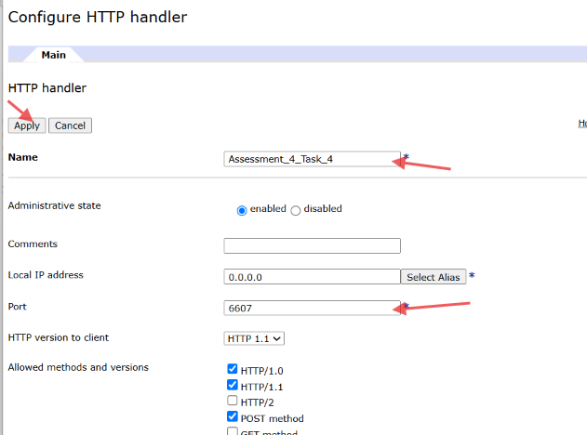

Click on Apply

Step 14:-Now Configure the Request and Response type AS Non-XML

Step 15:Click on Apply and Save to save the whole configuration

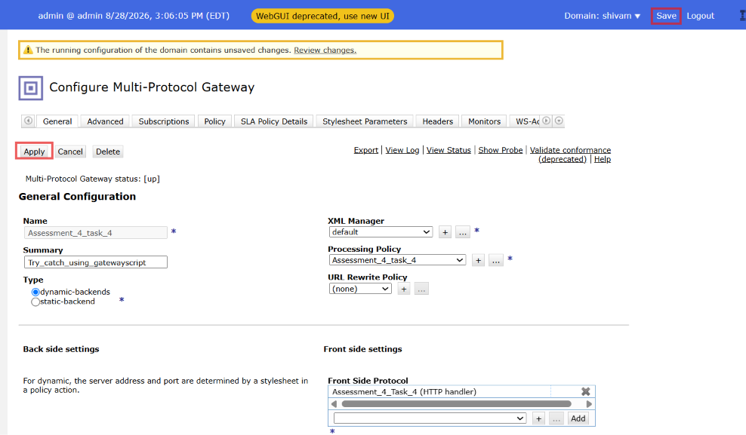

Step 16:- Now From The postman Hit The Api.

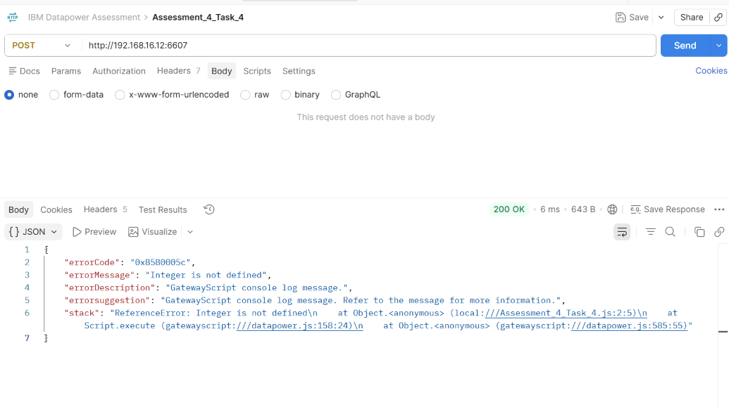

Task 5:- Implement type conversions using gatewayscript.

Ans:- Type conversion means changing a value from one data type to another data type. Used while manipulating the response or request payloads

There are two types of conversion:-
- Implicit type Conversion
- Explicit type Conversion
Number
Conversion of the other data type to Number
Syntax:
Number(val);
Note: when try to convert a string of characters(non numeric) you will get NaN not a number
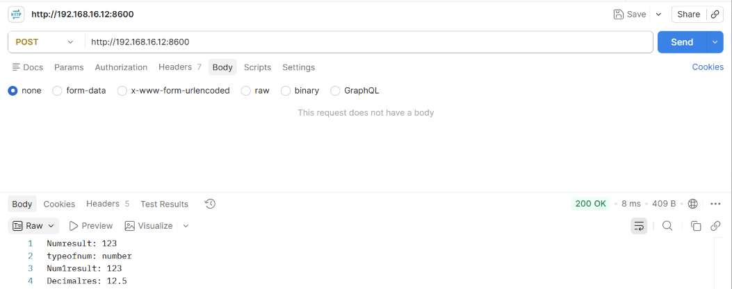
String
• Converts to string data type

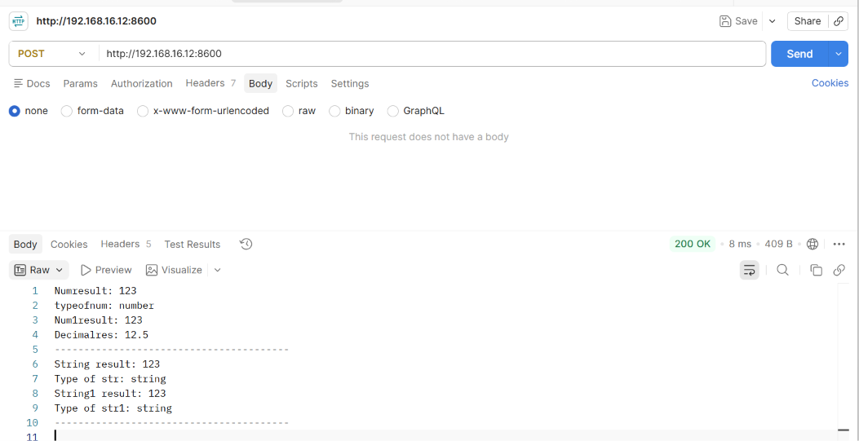

Boolean:- Converts to the boolean

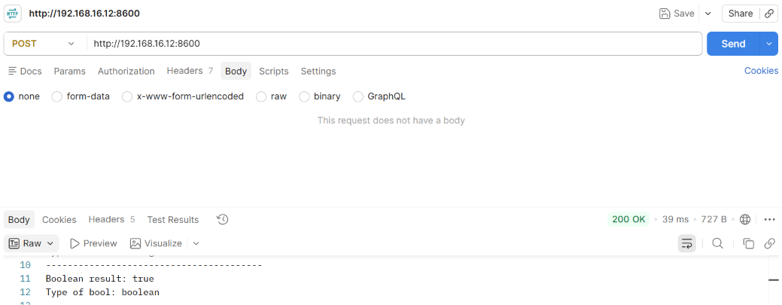

Boolean To String:- To convert the boolean value to String

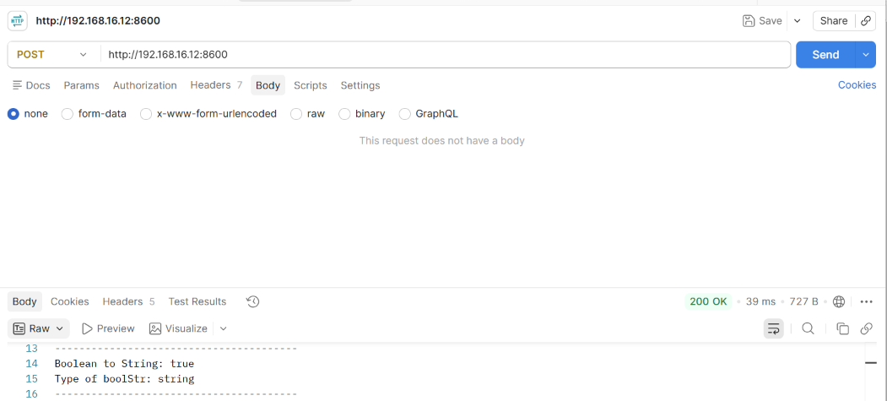

(Buffers to String) :- Conversion of the buffer object back into to the original string and
(Buffer to Buffers):- Converts the multiple buffer objects as single Buffers

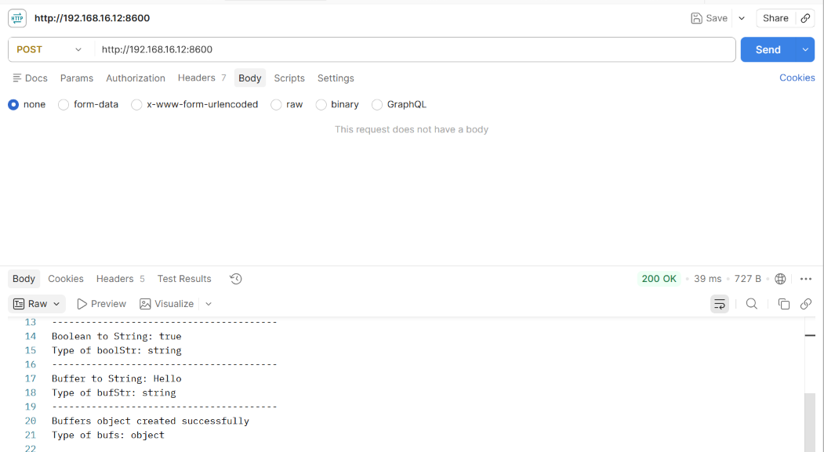

Task 6:- input:
{
"header": {
"channel": "BFSMOB"
},
"cardBoarding": {
"cardLast4Dig": "4191",
"mobileNo": "8591674286",
"recToAdd": {
"addCustNbr": "",
"addAcctNbr": "",
"addCardNbr": "",
"addRelNbr": "",
"sameCustAcct": "",
"sameCustCard": ""
},
"key": [{
"orgKey": "",
"applReqNbr": "M205401190000000075",
"applSeqNbr": "000",
"logoKey": "321",
"source": ""
},{
"orgKey": "",
"applReqNbr": "M205401190000000075",
"applSeqNbr": "000",
"logoKey": "321",
"source": ""
},{
"orgKey": "",
"applReqNbr": "M205401190000000075",
"applSeqNbr": "000",
"logoKey": "321",
"source": ""
}]
}
}

output:
{
"header": {
"channel": "BFSMOB"
},
"cardBoarding": {
"cardLast4Dig": "4191",
"mobileNo": "8591674286",
"recToAdd": {
"addCustNbr": "",
"addAcctNbr": "",
"addCardNbr": "",
"addRelNbr": "",
"sameCustAcct": "",
"sameCustCard": ""
},
"key": [{
"orgKey": "",
"applReqNbr": "M2054***********0075",
"applSeqNbr": "000",
"logoKey": "321",
"source": ""
},
{
"orgKey": "",
"applReqNbr": "M2054***********0075",
"applSeqNbr": "000",
"logoKey": "321",
"source": ""
},
{
"orgKey": "",
"applReqNbr": "M2054***********0075",
"applSeqNbr": "000",
"logoKey": "321",
"source": ""
}
]
}
}
Step:-1 Click on Multiple Protocol Gateway

Step 2:-Click on ADD Wizard

Step 3:- After this GUI Provide the realtaed Configuration

Step 4:-Provide The Name And Summary For this MPGW

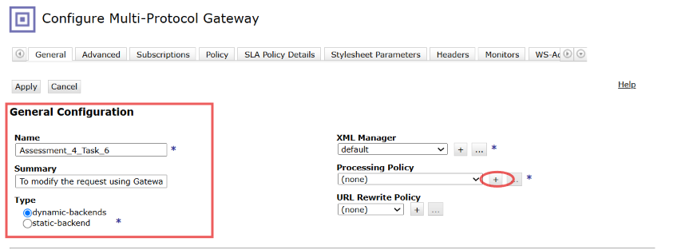

Step 5:-Now Select Type As Dynamic Backend And Click on(+) icon beside Processing policy

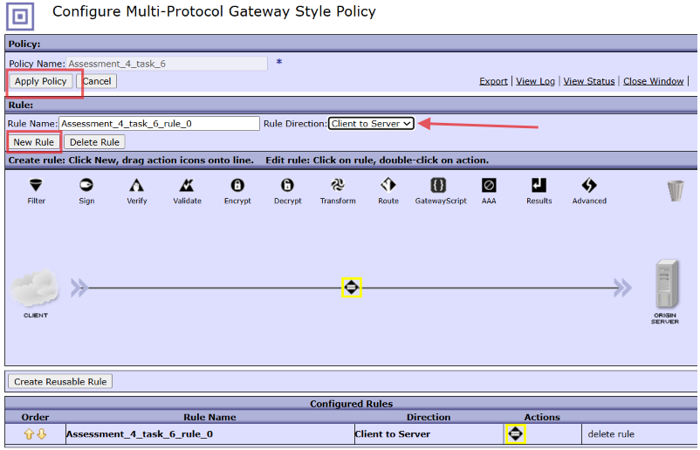

Here Configure MPGW Style policy provide name:-Ass_4_Task_6 and Click on Apply policy and New Rule.
Step 6:-After that Double click on Matching icon And configure it For TESTING

After configure All Select On Done and Apply policy to save the configuration.

Step 7:-Click On Dropdown As Client to Server And Click on Apply Policy

As we Select Dynamic Backend But We Are not calling any Backend So that we have to configure IT as Skip Backside by the help of Advance icon.

Step 8:-Drag and Drop Advance icon to the flow And configure it as Set Variable

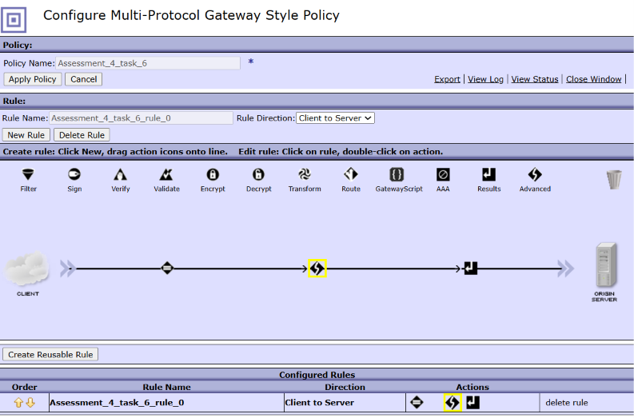

Double click on The Advance icon and Select from it Set Variable Option.

Click on Next

Step 9:-Configure Set Variable Action

Here we have to configure Variable name:-service/mpgw/skip-backside(Default)
Variable value:-(true or 1)

Click on Done.

Step 10:-Now After that Drag The Gatewayscript Action To the flow

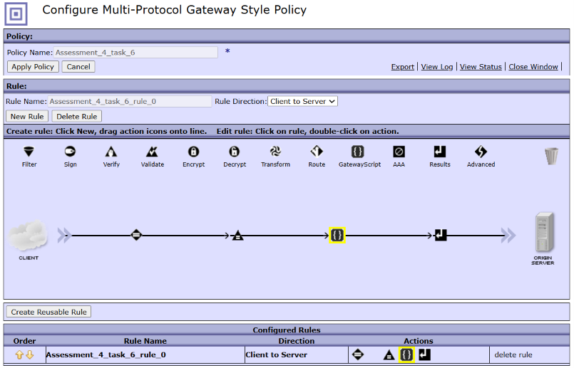

Now Before that we will Write gatewayscript code for this task:-
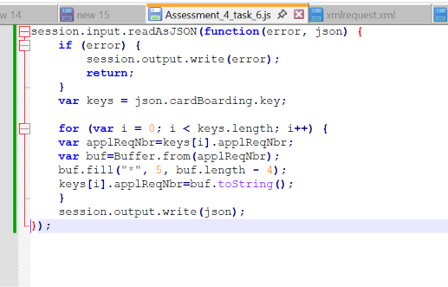
Step 11:-Now configure GatewayScript Action

Click on Upload to upload the Above .js File

Now Click on Choose file.

From the File explorer Upload the Assessment_4_Task_6.js file
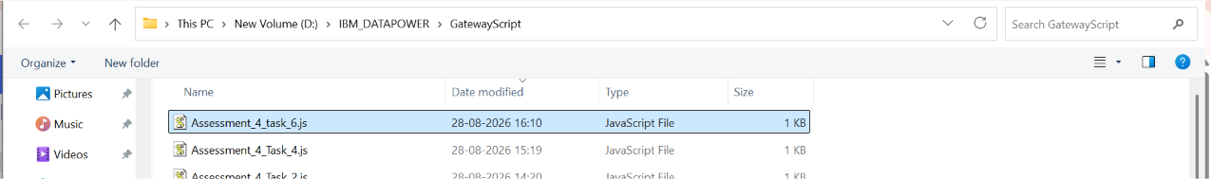

Click on upload button

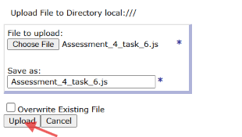

After Uploading the GUI for Transform Action lokk like this:-

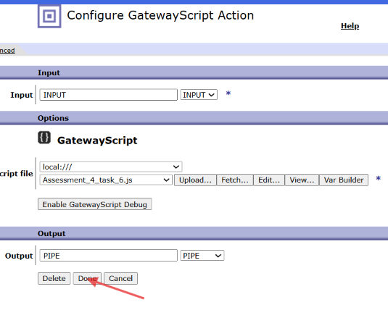

Click On Done.

Step 12:-After That we move in to Main Policy GUI There we have click on Apply policy to save this

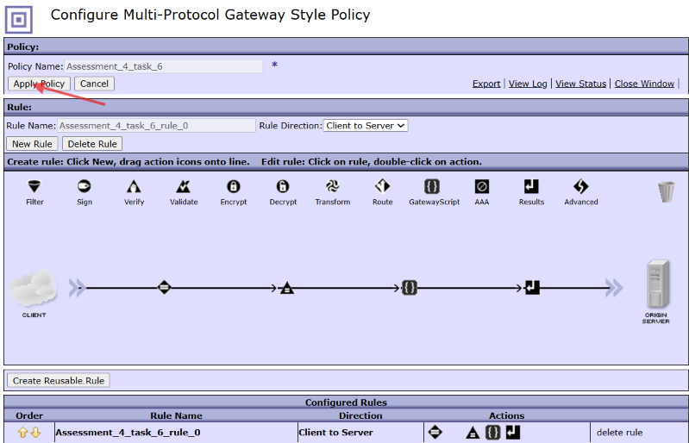

Step 13:-Now Configure The HTTP Handler for this request

From the dropdown Select HTTP Handler

By Select ting HTTP Handler We have to Configure it
Name:-Assessment_4_Task_6
PORT=6610

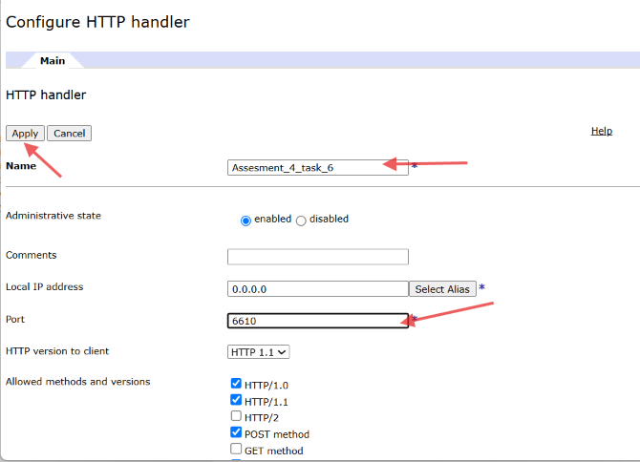

Click on Apply

Step 14:-Now Configure the Request and Response type AS Non-XML

Step 15:Click on Apply and Save to save the whole configuration

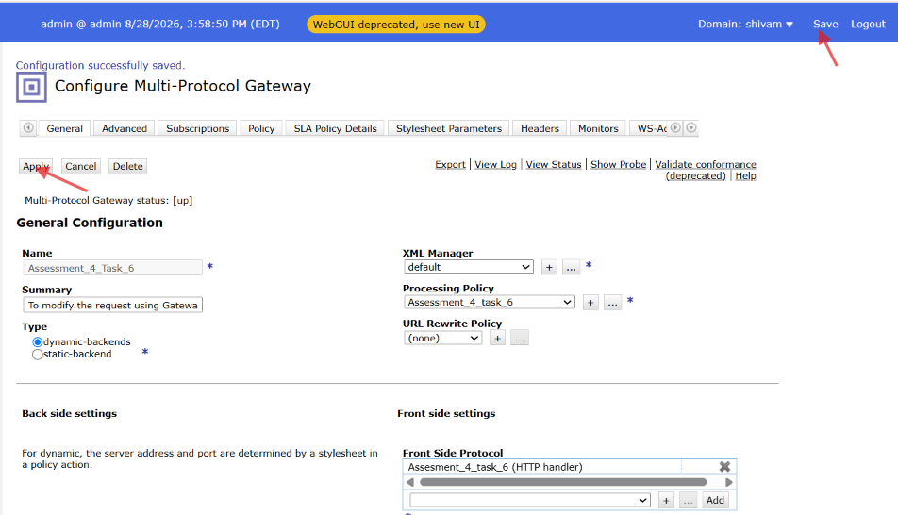

Step 16:- Now From The postman Hit The Api.

REQUEST:-

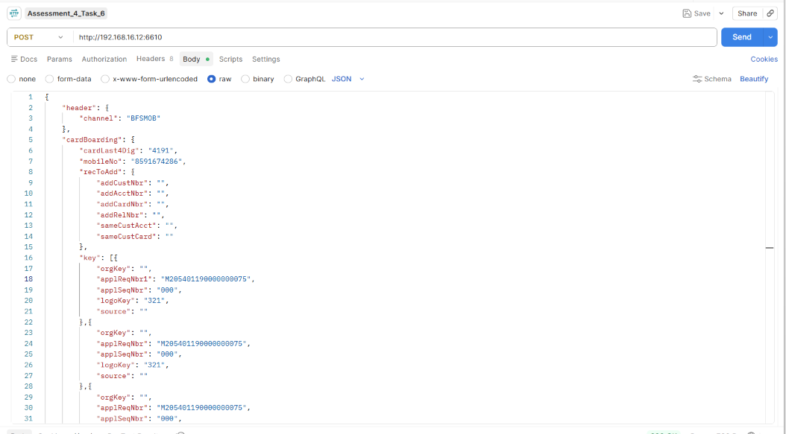

RESPONSE:-

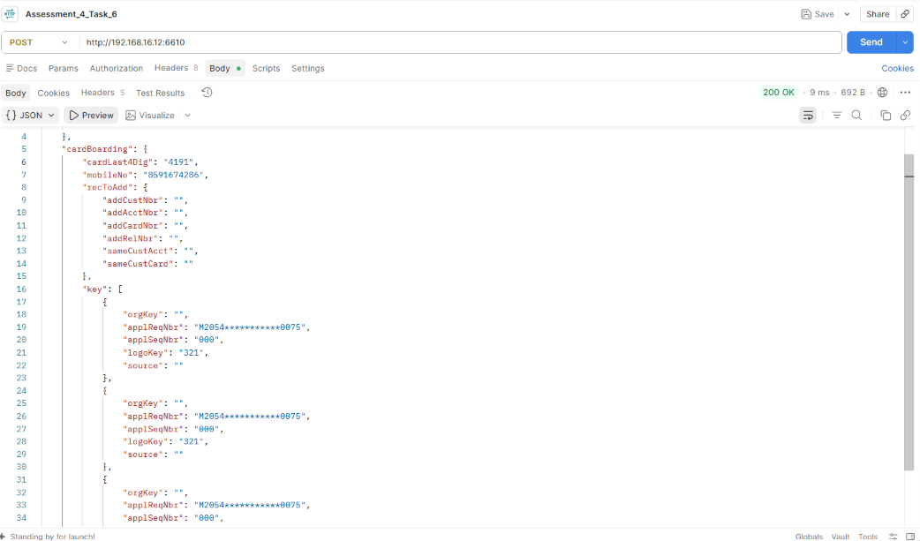

For Wrong input:-
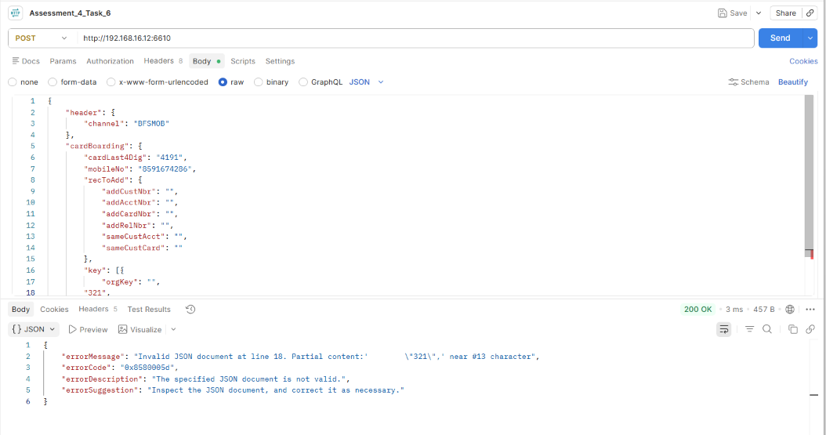

Task 7:- Read XML data using gatewayscript

xmlrequest.xml:
<source>
<route type="xml">
<Validation> Required </Validation>
</route>
<route type="json">
<Validation> Not Required </Validation>
</route>
</source>

input:

<text>test</text>
or
{
"text":"test"
}

Using GatewayScript, process the input. If the content type of the input is XML, use the route with type xml and output the corresponding <Validation> Required </Validation>. If the content type is JSON, use the route with type json and output <Validation> Not Required </Validation>.

Step:-1 Click on Multiple Protocol Gateway

Step 2:-Click on ADD Wizard

Step 3:- After this GUI Provide the realtaed Configuration

Step 4:-Provide The Name And Summary For this MPGW

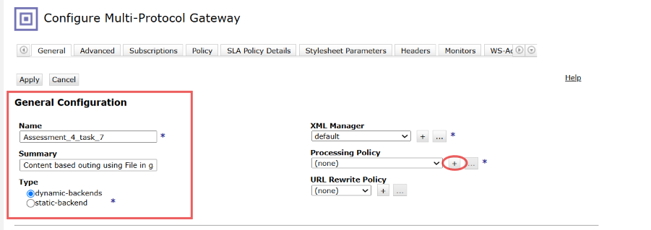

Step 5:-Now Select Type As Dynamic Backend And Click on(+) icon beside Processing policy

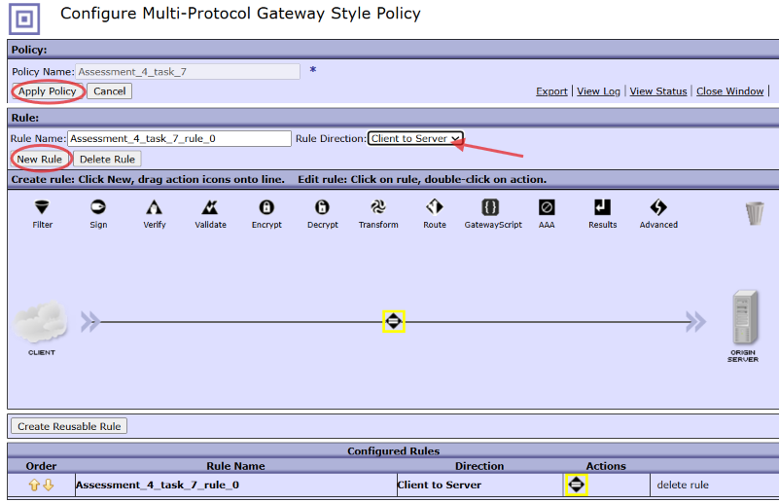

Here Configure MPGW Style policy provide name:-Ass_4_Task_7 and Click on Apply policy and New Rule.
Step 6:-After that Double click on Matching icon And configure it For TESTING

After configure All Select On Done and Apply policy to save the configuration.

Step 7:-Click On Dropdown As Client to Server And Click on Apply Policy

As we Select Dynamic Backend But We Are not calling any Backend So that we have to configure IT as Skip Backside by the help of Advance icon.

Step 8:-Drag and Drop Advance icon to the flow And configure it as Set Variable

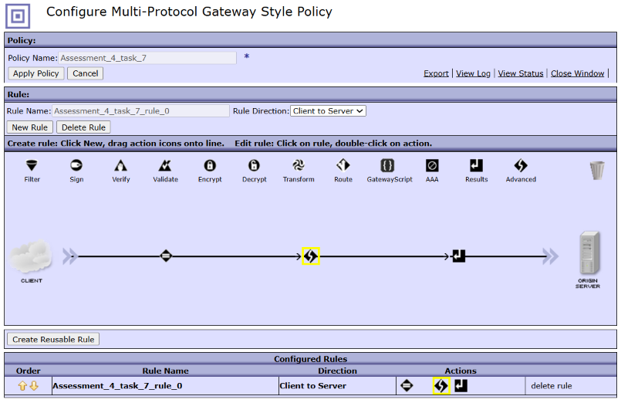

Double click on The Advance icon and Select from it Set Variable Option.

Click on Next

Step 9:-Configure Set Variable Action

Here we have to configure Variable name:-service/mpgw/skip-backside(Default)
Variable value:-(true or 1)

Click on Done.

Step 10:-Now After that Drag The Gatewayscript Action To the flow

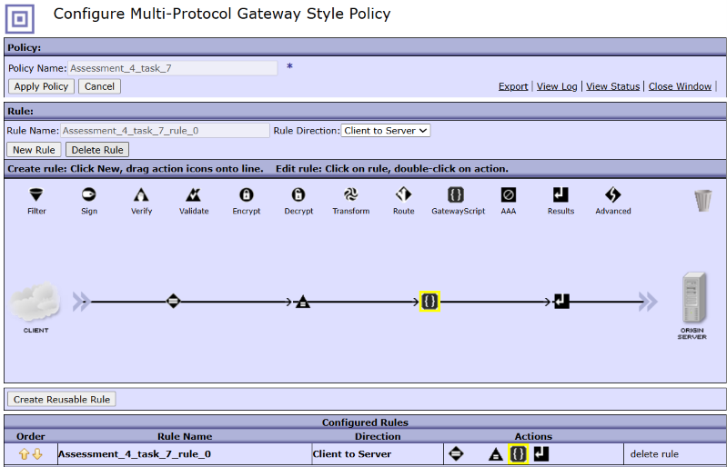

Now Before that we will Write gatewayscript code for this task:-
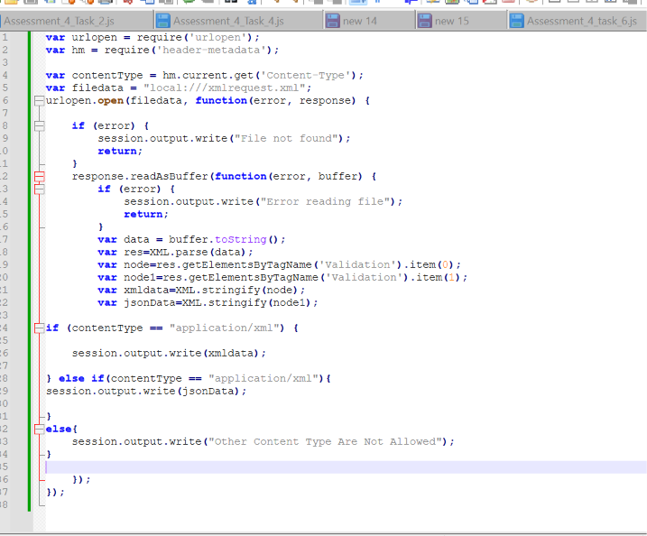

Step 11:-Now configure GatewayScript Action

Click on Upload to upload the Above .js File

Now Click on Choose file.

From the File explorer Upload the Assessment_4_Task_7.js file
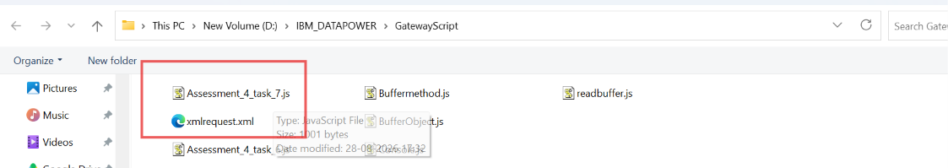

Click on upload button

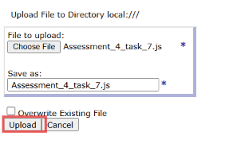

After Uploading the GUI for Transform Action lokk like this:-

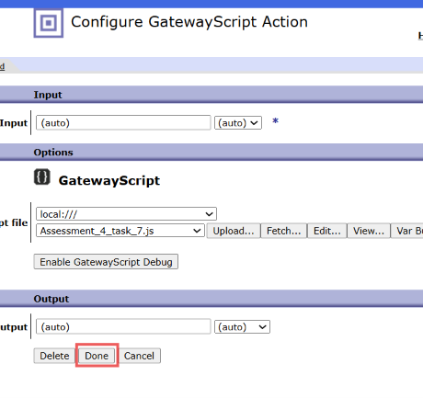

Click On Done.

Step 12:-After That we move in to Main Policy GUI There we have click on Apply policy to save this

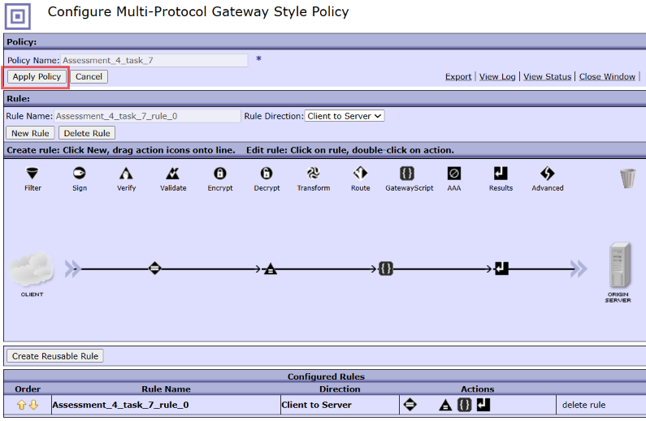

Step 13:-Now Configure The HTTP Handler for this request

From the dropdown Select HTTP Handler

By Select ting HTTP Handler We have to Configure it
Name:-Assessment_4_Task_6
PORT=6610

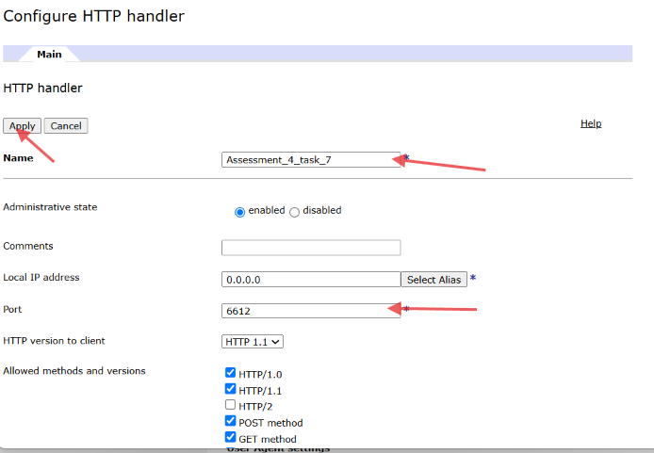

Click on Apply

Step 14:-Now Configure the Request and Response type AS Non-XML

Step 15:Click on Apply and Save to save the whole configuration

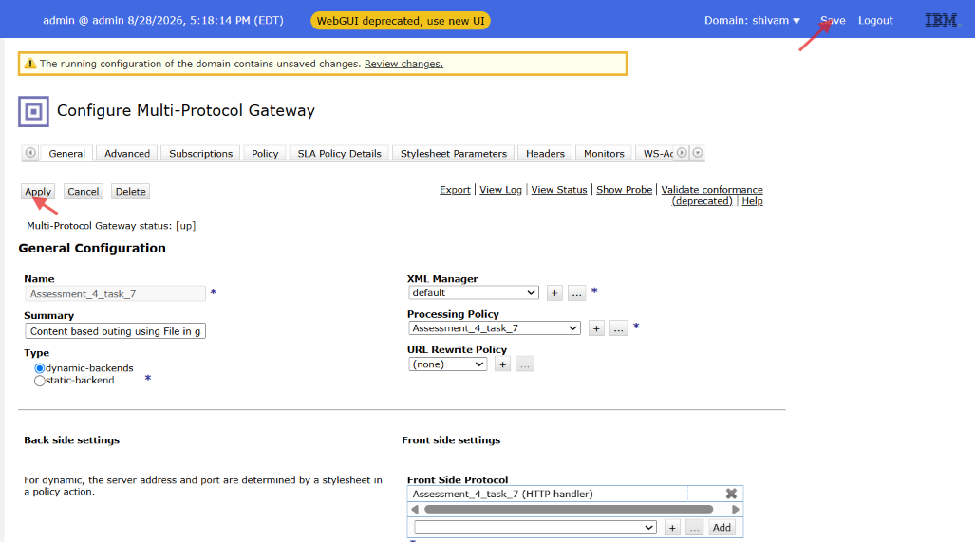

Step 16:- Now From The postman Hit The Api.

1.For XML Data

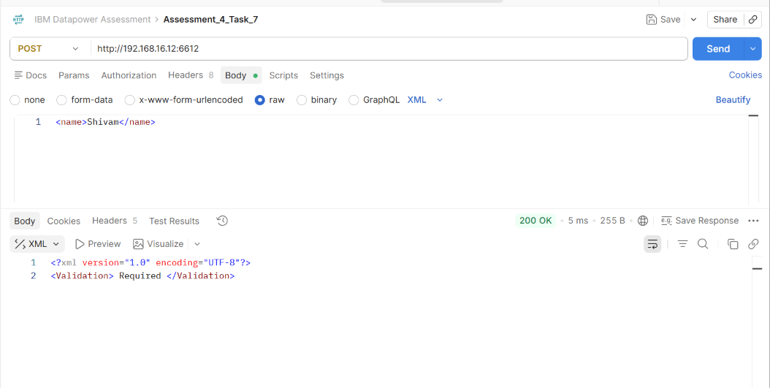

2.For Json Data:-

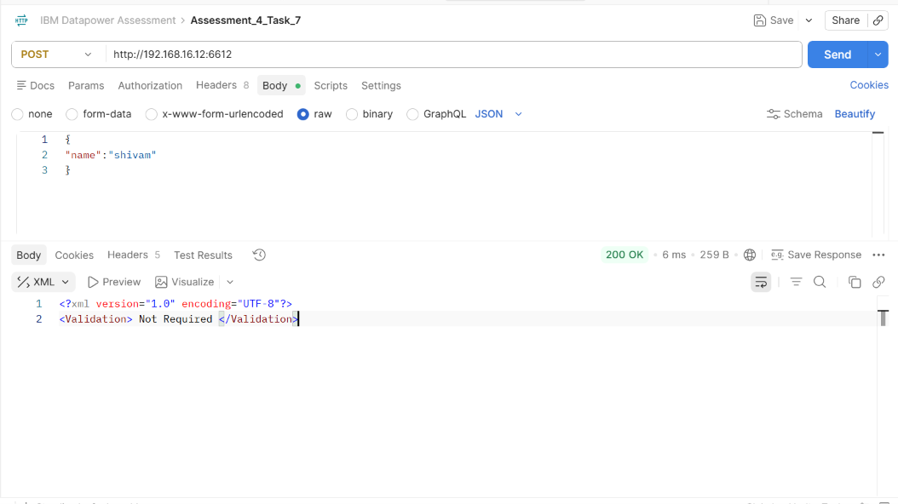

3.for other type

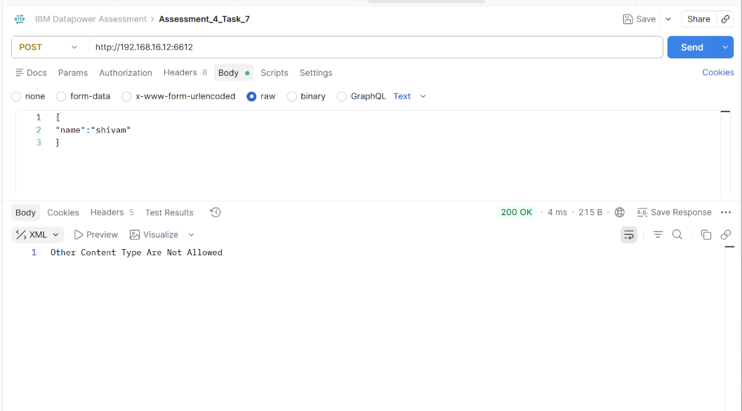

THE END

