Agent Builder – Prompt Generator
Version: v1.0.0
Author: Shivam Yeshwantrao

1. Overview
The Agent Builder – Prompt Generator is a deterministic, dataset-driven system designed to generate compliant, hallucination-free AI calling prompts for financial services use cases.
The system ensures:
- Strict adherence to approved prompt datasets
- Zero free-form prompt creativity
- Controlled multilingual translation
- Strong guardrails against scope drift and policy violations
It is suitable for collections, service reminders, and regulated outbound calling scenarios.

2. High-Level Architecture

2.1 System Components
- Frontend (UI): Streamlit-based structured input form
- Backend: Python-based controlled prompt generation pipeline
- LLM Provider: Azure OpenAI
- Prompt Source: Approved Excel-based dataset (dataset.xlsx)
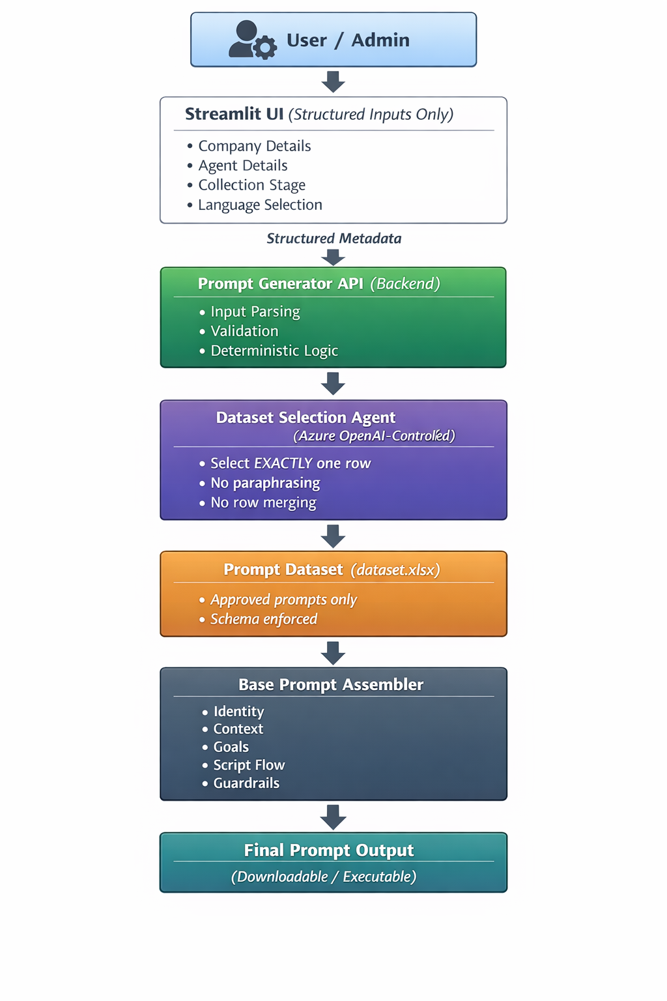

2.2 Design Philosophy
- No raw metadata input from users
- All intelligence and decision-making handled in backend
- Dataset is the single source of truth
- Fail-safe behavior when no dataset match is found

3. User Interface (UI)

3.1 Purpose
The UI is designed to collect only structured inputs, preventing users from injecting uncontrolled metadata or instructions.

3.2 Input Sections

Company Details
- Company Name
- Product Category
- Customer Care Number
- Support Email
- Website (optional)
- Stage of Collection (Pre-Due / Post-Due)

Agent Details
- Agent Name
- Agent Description (persona / tone guidance)

Language Selection
- English
- Hindi
- Marathi

3.3 Output
- Generated base prompt (fully assembled)
- Downloadable prompt text file

4. Backend Architecture

4.1 Core Pipeline Flow
- Metadata Parsing
Converts UI input into a structured key-value dictionary.
- Dataset-Driven Prompt Selection
Uses Azure OpenAI to select exactly one matching row from the approved dataset.
- Base Prompt Assembly
Assembles prompt sections without paraphrasing or modification:
  - Agent Identity
  - Call Context
  - Goals
  - Tone and Style
  - Collection Stage
  - Stepwise Script Flow
  - Closing and Support
  - Exceptions and Handling
- Script Extraction for Translation
Only conversational sections are extracted for translation.
- Structure-Preserving Translation
Translates spoken dialogue while preserving:
  - Headings
  - Step order
  - Placeholders
  - Formatting
- Safe Merge of Translated Sections
Replaces only relevant sections back into the base prompt.
- Placeholder Resolution
Deterministically replaces placeholders using UI metadata.
- Fact Block Injection
Prepends a mandatory factual reference block.

5. Dataset Enforcement Logic

5.1 Selection Rules
- Exactly one dataset row must be selected
- Row selection is based on:
  - Collection stage
  - Language
  - Customer segment
  - Region
  - Loan tenor

5.2 Failure Handling
If no confident match is found:
ERROR: No exact matching prompt profile found in dataset

The system does not generate fallback prompts.

6. Hallucination & Compliance Guardrails
The system enforces strict constraints:
- No merging of dataset rows
- No paraphrasing dataset content
- No additional legal, policy, or pressure language
- No topic deviation during calls

Conversation Guardrails
If the customer:
- Asks about unrelated products → acknowledge and defer
- Attempts off-topic conversation → politely redirect
- Requests unsupported services → note and escalate

7. Translation System

7.1 Translation Scope
Only the following sections are translated:
- Stepwise Script Flow
- Closing and Support
- Exceptions and Handling

7.2 Translation Rules
- Spoken dialogue only
- Placeholders remain untouched
- Structure and formatting preserved
- Temperature set to 0 for determinism

8. FACTS FOR THIS CALL Block

Purpose
Ensures the agent always answers direct factual questions correctly.

Included Facts
- Agent Name
- Company Name
- Product Category
- Customer Care Number
- Support Email

Enforcement
The agent must use these facts verbatim when responding to direct questions.

9. Prompt Evaluation & Refinement (Optional)

9.1 Evaluation Engine
- 35-criteria scoring rubric
- Total score out of 175
- Actionable refinement suggestions

9.2 Refinement Chain
- Applies evaluation feedback
- Improves clarity and structure
- Preserves original intent and compliance

10. Environment Configuration

Required Environment Variables
AZURE_OPENAI_API_KEY=
AZURE_OPENAI_ENDPOINT=https://<your-resource>.cognitiveservices.azure.com
AZURE_OPENAI_API_VERSION=2025-01-01-preview
AZURE_OPENAI_DEPLOYMENT=gpt-4o-mini

Note: API keys must never be committed to version control.

11. Running the Application

11.1 Install Dependencies
pip install -r requirements.txt

11.2 Start the UI
streamlit run app.py

12. Key Design Guarantees
- Deterministic output
- Dataset-grounded prompts
- Zero hallucination by design
- Language-safe translation
- Compliance-first architecture

13. Intended Use Cases
- Loan repayment reminders
- Collections calls
- Financial service notifications
- Regulated outbound calling flows

14. Future Enhancements
- Adding Voice Options.
- Adding Web scraping for extracting information via Company web URL for the agent Database.

