EditGuard Knowledge Editing and Verification Platform
  - Technical Project Report
Governed external memory and measured factual reasoning for conversational AI
EditGuard project team
29 October 2026
This report presents the implemented platform, its independently authored controlled datasets, two frozen comparative evaluations, and the live application checks. The system makes an approved factual correction visible, scoped, traceable and reversible while an upstream trained model generates answers from the applicable memory.
The principal finding is that selected approved context supported perfect observed short answer scores for ReasonKE on both controlled main tests, with a substantial latency cost. Full memory produced errors, the comparison model retained abstentions, and correct final answers did not certify every generated explanation. These boundaries are part of the result.
Completed evidence 1312 original study requests 544 depth study requests 14 India application generations
Project repository github.com/ShivamRaghav7/verity
Release branch codex/reasonke-integration

Abstract
A conversational assistant can use an obsolete service owner even after an organisation updates its records. The resulting error may propagate: the wrong owner implies the wrong on call contact and the wrong contact location. Updating the underlying information is necessary, but an assistant must also select the right supporting facts, keep historical releases distinct, and preserve unrelated answers. EditGuard addresses this bounded maintenance problem through explicit approval, versioned external memory, context selection, neural answer generation and replayable evaluation.
The final application integrates the author published ReasonKE_plus checkpoint with a lightweight Python website, SQLite history, a private inference worker and an evidence dashboard. New corrections update memory without modifying model weights. The project contributes the governed maintenance workflow, retrieval adaptations, independent fictional datasets, matched comparisons, finite execution and recovery, raw output audits and a deployable interface. Foundation model training and the ReasonKE research method remain attributed to their upstream authors.
The original operations evaluation contains 1312 generations: five matched main configurations on 256 questions over 32 held out lineages, plus two 16 question oracle diagnostics. ReasonKE with updated retrieved facts scored 256/256; Qwen with the same updated retrieval scored 241/256 with fifteen abstentions. ReasonKE with full memory scored 231/256, below Qwen full memory at 241/256. A separate depth evaluation contains 544 generations, including 64 three hop questions per main model condition. ReasonKE scored 256/256 main answers and Qwen 248/256, with eight abstentions. Three hop scores were 64/64 and 63/64 respectively. Both models scored 16/16 on each study's separate preselected gold support diagnostic.
The depth main difference was 3.125 percentage points, with a 95 percent paired lineage bootstrap interval from 1.5625 to 5.078125 points. ReasonKE's warm median and 95th percentile latency were 15.94 and 19.28 seconds, compared with Qwen's 1.12 and 1.38 seconds. Fourteen actual India website answers and twelve consistency checks passed, including conflict rejection, historical comparison and atomic rollback. Labels were audited automatically, without independent human semantic review. The perfect observed scores concern small explicit fact worlds and repeated within split templates; they establish neither universal question accuracy nor production reliability.
Contents
Abstract 2
1 Problem and objectives 4
2 Background and method choice 5
3 System architecture and inference 6
4 Knowledge lifecycle and correctness 7
5 Data and explicit ground truth 8
6 Experimental design and scoring 9
7 Model configuration and finite execution 10
8 Experimental results 12
9 Failure analysis and the perfect score 16
10 Application workflow and verification 18
11 Engineering and reproducibility 19
12 Conclusion and future work 20
References 21
Appendix A Reproduction and evidence map 22
Appendix B Metric glossary and worked example 23

The main chapters describe the current text platform. Earlier auxiliary model and visual studies remain archived and are not pooled into these results.

1 Problem and objectives

Application problem
Operational knowledge changes in connected records. A service moves to a new owning team, while each team's contact and each person's office remain separate facts. A user may ask for the owner, the appropriate contact, or the office of that contact using several descriptions of the service. A correction to ownership should change the affected reasoning path while leaving the service's hosting location, another product tier and an older release unchanged.
A web page or structured lookup is often sufficient for a handful of published policies. The stronger use case here is interactive querying across related operational records, with follow up questions, explicit evidence and historical comparisons. EditGuard is a controlled demonstration of that use case, not evidence of commercial demand or a deployed enterprise incident service. We deliberately keep short factual tasks separate from unrestricted dialogue.

Concrete maintenance scenario
In the fictional India handbook, Kaveri Payment Gateway in release 2 initially belongs to Bengaluru Platform Team. That team's contact is Meera Iyer, whose office is in Chennai. An administrator can replace the owner with Pune Reliability Team. Its contact is Arjun Deshmukh, whose office is in Hyderabad. The hosting location remains Bengaluru. Release 1 and the Pro service retain their own owners. Indian place names make the demonstration familiar; the service, people, teams and assignments are invented.
The three hop answer therefore depends on a chain of three relations, rather than on the city in a team's name. Before the ownership update the expected office answer is Chennai; after it the expected answer is Hyderabad. Rollback should restore the original path. This is the intended behaviour; only recorded model responses establish whether a generation achieved it.

Objectives and acceptance criteria
Table 1 Project objectives and observable acceptance
Objective | Acceptance evidence
Govern corrections | Only an explicit operator approval makes a fact authoritative
Respect scope and history | Separate canonical entity property and release keys plus historical revision comparison
Support connected answers | Direct paraphrase two hop and three hop questions scored from raw neural outputs
Make changes reversible | Atomic replacement and rollback with retained versions and event history
Measure tradeoffs fairly | Matched updated contexts output budgets latency and all assigned outcomes
Make results inspectable | Frozen protocols raw ledgers CPU replay scientific exports and a runnable website

Completion is defined by a working product and reproducible evidence, not by a guaranteed accuracy target. Deterministic transaction correctness and generated answer correctness are tested separately. A successful database restore does not count as a neural answer, and an operator supplied source does not independently prove that a statement is true.

2 Background and method choice

What knowledge editing means in this project
Knowledge editing aims to change a model system's response to selected information while preserving behaviour outside the intended scope. Parametric approaches alter model weights. Memory based approaches retain corrections outside the base model and condition behaviour on retrieved edits. EditGuard implements the latter operational route: its learned generator was trained upstream, while local approval changes external memory. The selector and transaction rules are deterministic software. The current deployment has no newly trained standalone scope classifier.

Relevant research
Retrieval augmented generation combines a language model with external retrievable information. Lewis and colleagues studied this approach for knowledge intensive tasks [1]. EditGuard uses retrieval as a practical way to supply current facts, with explicit version and approval control. Our lexical selector and operational schema are adaptations; they are not a reproduction of the original RAG training architecture.
SERAC stores edits in explicit memory and learns their applicability and counterfactual response behaviour [2]. This motivated the initial separation of edit memory, scope and answer generation. The final ReasonKE application does not contain SERAC's trained auxiliary components and is not described as a faithful SERAC implementation.
ROME demonstrates direct changes to factual associations by editing feed forward weights [3]. It provides a useful contrast: EditGuard does not perform this kind of per correction weight edit. Its historical states refer to approved memory revisions rather than alternative neural checkpoints.
ReasonKE research uses explicit reasoning chains to guide the use of new facts in multi hop questions [4]. ReasonKE++ studies process level faithfulness through supervised and reinforcement learning [5]. We integrate an author published ReasonKE_plus checkpoint [6], but its exact correspondence to the paper's reported checkpoint is undocumented. We neither repeat its training nor substitute a published benchmark number for our own measurements.
Table 2 Method families and the implemented choice
Family | What changes | Use in this report
Parametric editing | Selected model weights | Background comparison only
SERAC style editing | Memory plus trained edit routing and response modules | Earlier motivation not the final architecture
Updated retrieval | Approved external information and selected context | Both models receive the same current information
ReasonKE integration | Memory supplied to an upstream trained generator | Final application and measured comparisons

Why this implementation was selected
Reversibility and provenance are central to the product. External versions make an edit inspectable and allow exact historical reconstruction without storing another set of model weights. A compact serving layer keeps the GPU process separate from the website. The completed development comparisons selected retrieved context before final evaluation. The choice is supported by those measurements; it is not a claim that retrieval always beats weight editing or that ReasonKE is the best method on every knowledge editing task.

3 System architecture and inference
The online application and offline experiment pipeline share model and retrieval interfaces but have different responsibilities. Online requests read approved memory and produce conversational responses. Offline runs use a fixed question plan, save every assigned outcome, and produce audited measurements. The dashboard displays saved evidence rather than silently evaluating the current conversation.
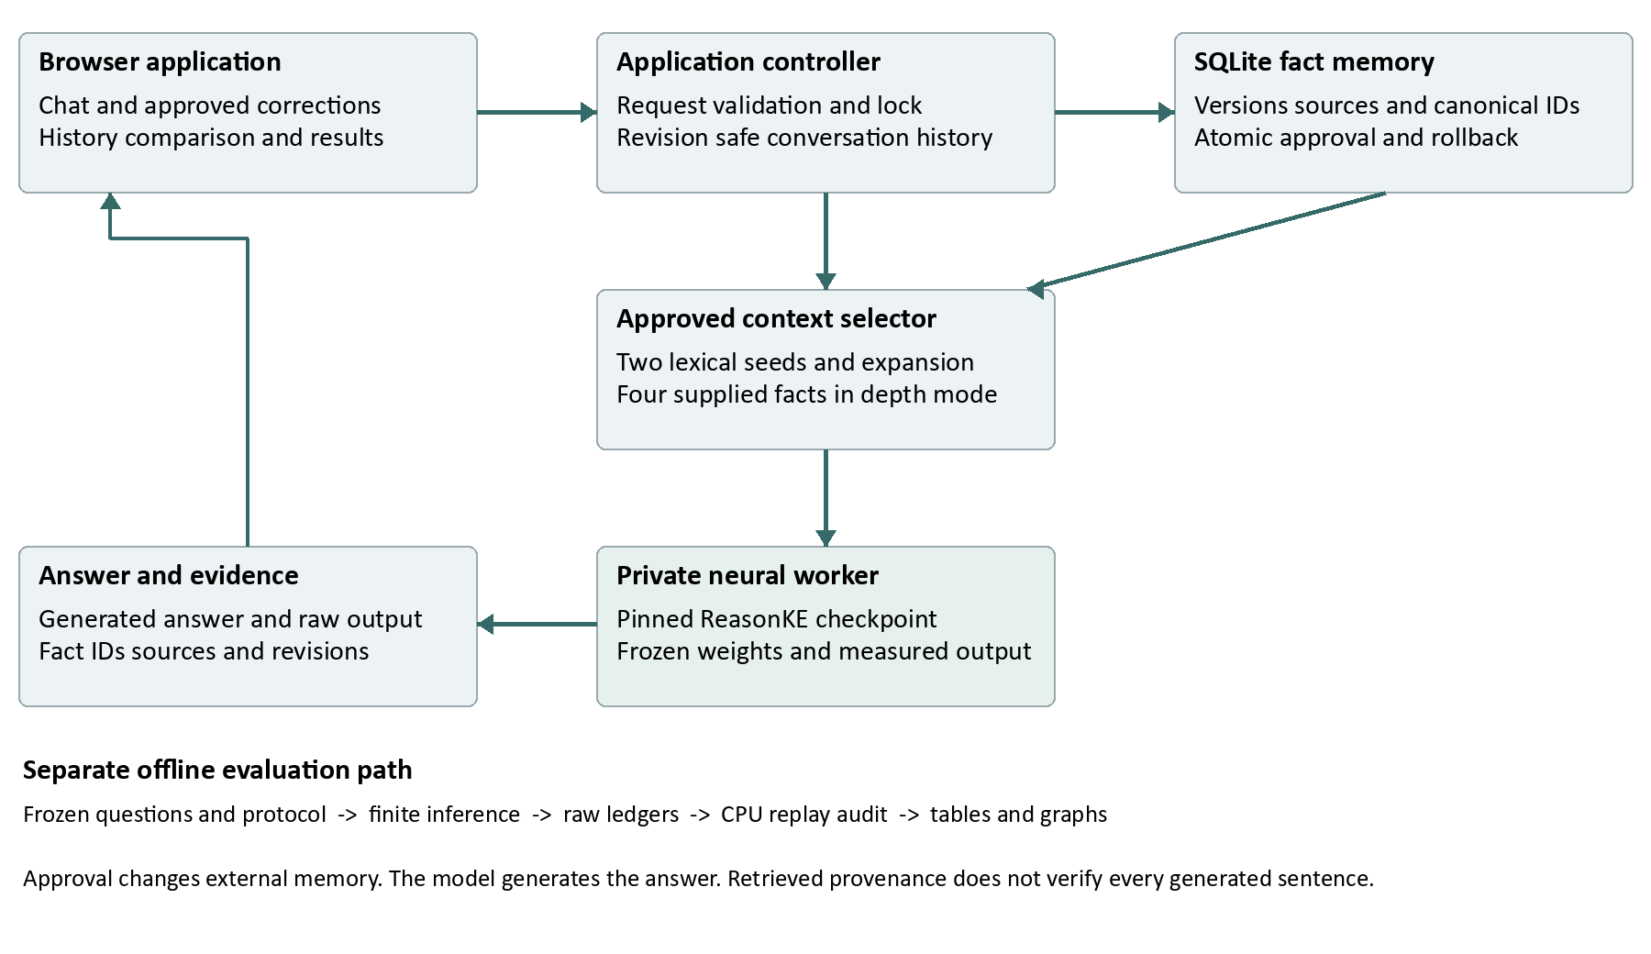
Figure 1 Implemented online data flow and separate evaluation path. This is an architecture schematic, not a performance measurement.

Online request flow
The browser sends a text question to the application controller. The controller validates the request, serializes memory and generation operations, and reads the active approved facts at a specific knowledge revision. It selects supporting facts, adds permitted conversation history and calls the private neural worker. The worker generates text using its pinned checkpoint. The controller stores the complete user and assistant pair, raw output, supplied fact IDs, sources, generation statistics and model and knowledge revisions before returning the response.
Conversation history is revision aware. Complete user and assistant pairs from the current revision can enter a new prompt. Older pairs remain visible but are excluded from new prompts, reducing contamination by answers generated before an edit. Historical comparisons use matched pre question history and exclude correction conditioned pairs from both sides.

Context selection
The original operations study uses a two stage lexical selector. A BM25 style ranker scores fact text against the question, takes two seed facts, adds their answer text to the query, then fills a four fact context after reranking. Tie breaks use stable IDs. Normal retrieval does not read the expected answer or gold supporting fact labels.
The separate depth study and India launcher use bounded iterative expansion. Two question ranked seeds initialize an answer text frontier. The selector adds a highest ranked unseen fact from that frontier and advances to its answer text, with at most three rounds and four total facts. Development selection considered a declared family of seed counts and context caps before final inference. The default CLI still uses the original policy; the India launcher explicitly requests iterative mode. The two policies must not be described as one unchanged experiment.
Both selectors are bounded lexical software rather than trained applicability classifiers. Scope identity and retrieval can reduce mistakes, but the implementation does not supply a calibrated probability that a correction applies to an arbitrary natural language question.

4 Knowledge lifecycle and correctness

Stored facts and identity
Table 3 Core approved fact fields
Field group | Recorded information
Fact content | Question or relation description answer scope and required source
Canonical identity | Entity ID relation ID and scope ID supplied together optional aliases
Version lineage | Fact UUID lineage ID version predecessor and successor links
Lifecycle state | Active superseded or withdrawn status and approval metadata
Audit history | Actor timestamps action and knowledge revision for each event

The canonical key is the combination of entity ID, relation ID and scope ID. Separate release or plan IDs allow multiple applicable histories without collapsing their facts. Where canonical IDs are absent, the legacy key uses normalized question and scope text. SQLite enforces at most one active version per key. Aliases are metadata, not evidence of a learned general entity linker.
Required text fields are bounded and validated. A source describes the operator's supplied provenance; it is not an independent fact checking service. Version timestamps record when a change was approved. The application does not implement a general calendar effective date or overlapping date interval policy engine. Its historical interface is based on knowledge revisions.

Approval replacement and conflicts
A customer message never becomes an authoritative correction automatically. The operator must explicitly approve a fact. A competing approval for an already active key is rejected with HTTP 409. To replace it, the operator names the active predecessor through the supersedes field. One transaction creates the new active version, supersedes the old version, writes audit events and increments the knowledge revision. A failure rolls back the entire change.
The deterministic guarantee concerns the represented key. Two semantically contradictory statements written under unrelated keys may evade this check. The system is therefore a governed local maintenance workflow, not a general natural language contradiction detector. Ambiguous intent and unrepresented scope still require operator judgement or a further question.

Rollback and historical comparison
Atomic rollback applies to an active replacement with a direct predecessor of the same key. In a single BEGIN IMMEDIATE transaction it withdraws the replacement, restores the predecessor and records both events at one revision. It refuses an obsolete replacement that would undo newer state. Repeating an already completed rollback is idempotent in the permitted restored state.
Historical reads replay ordered events up to a requested valid revision without changing current memory. A before and after comparison generates two fresh answers from the same model, with different approved snapshots. The alternative without correction context uses empty edit memory; this is different from the approved pre edit snapshot. Context is reread after changes and history is revision filtered. The ReasonKE selector has no persistent generated answer cache to preserve a stale answer across the update.

5 Data and explicit ground truth

Why controlled fictional data
A fictional catalogue lets us define the original fact, corrected fact, unchanged relations and historical alternatives precisely. A model cannot be assumed to know an invented company from pretraining. Every scored request receives its configured initial or updated facts explicitly. This makes the consequences of a specified edit testable, while limiting ecological validity.
The data are independently authored for this project rather than copied from an upstream benchmark. They are controlled demonstration data, with automatically audited graph paths and labels. There was no independent human semantic review of the final wording. Automatic consistency checks help detect malformed records, but cannot establish that every question is natural or unambiguous.
Table 4 Authored packets and measured populations
Quantity | Original operations | Separate depth
Authored graph lineages | 48 | 48
Facts per world | 9 | 12
Authored questions | 384 | 384
Development lineages and questions | 16 and 128 | 16 and 128
Final lineages and questions | 32 and 256 | 32 and 256
Measured neural development calls | 120 across five conditions | 48 across two models
Final main conditions | 5 | 2
Final assigned generations including oracle | 1312 | 544

Split and wording controls
Lineages are partitioned before question augmentation so related original and edited variants stay together. Development guides model and retrieval choices; the frozen final set supplies the reported held out measurement. The original packet repeats wording templates across the split and tests new assignments more strongly than new language. The depth packet reserves distinct authored development and final wording banks, with disjoint service, team and person identities across the split. It still reuses templates within each split, city values, relation vocabulary and canonical fact syntax. Unseen entities therefore do not imply unrestricted linguistic generalization.
The authored 128 question development partition is larger than the finite neural development workload. The depth profile uses eight requests per model and development uses 24 per model. These are declared subsets, not evidence that all authored development questions were generated under every configuration. The final questions and scoring were fixed before inference.

Depth and locality categories
Table 5 Depth study question groups per main model
Group | Relation path | Assigned
Locality controls | Other property or historical release | 64
One hop | Service to owning team | 64
Two hops | Service to team to contact | 64
Three hops | Service to team to contact to office city | 64

Direct and paraphrased forms each contribute 32 questions to every applicable depth. The two locality categories contribute 32 each. A depth zero label denotes a control, not a task requiring no evidence: it still needs an independent fact. Wrong releases, similar products and other relations remain explicit alternatives in the memory. The display handbook is another separate fictional example and does not rename final test records after evaluation.

6 Experimental design and scoring

Matched configurations
Table 6 Original main conditions
Label | Generator | Provided information
R0 | ReasonKE | Initial facts scored against updated truth staleness diagnostic
R RAG | ReasonKE | Updated approved facts selected by retrieval
R ALL | ReasonKE | The full updated approved memory
G RAG | Qwen instruction model | The same updated selection policy
G ALL | Qwen instruction model | The same full updated approved memory

Updated baselines receive the same approved corrections and supporting records. R0 intentionally represents stale information and is a diagnostic reference, not a claim that a properly updated RAG assistant was left stale. Full memory is the prompt based correction comparison. The final matrix does not include every editing method or a newly trained scope classifier. Any conclusion must stay within these implemented comparisons.
The depth extension compares the two checkpoints using the same selected iterative policy. Each model has 256 main requests and sixteen preselected three hop gold support requests. An oracle diagnostic supplies the required facts directly to isolate answer generation from ordinary retrieval. It remains a distinct population; its successes never replace main failures.

Metrics and denominators
Primary factual accuracy is the number of correct final answers divided by all assigned questions. Wrong answers, abstentions, execution errors and unexecuted requests receive zero primary credit. Coverage is the fraction producing an endorsed answer rather than an abstention or execution failure. Answered only precision conditions on that answered population and is reported separately. An UNKNOWN output is a generated abstention, not an absent request.
Retrieval required fact recall counts supplied gold required fact occurrences divided by all required occurrences. Complete path recall counts questions for which every required supporting fact was supplied. These measures audit routing; they do not imply that the generator answered correctly. Ordinary retrieval does not receive gold IDs. Gold IDs are used by the evaluator after selection and by the separately labelled oracle condition.
Baseline correct retention measures how many originally correct out of scope answers remain correct. Overall locality accuracy measures correctness on every locality question, including those the initial baseline missed. False correction application specifically counts endorsement of an inapplicable edited value. It is narrower than the set of all wrong answers. The depth study has no unchanged baseline condition, so it supplies no new baseline retention estimate.

Answer matching and uncertainty
The scorer compares the extracted endorsed final answer with frozen reviewed canonical aliases attached to a question's subject and relation. A target merely mentioned as an example or rejected possibility is insufficient. Strict response contracts can reject an answer that contains correct information but does not provide the requested short span. Raw outputs remain available for interpretation. No sole LLM judge determines these scores, and no template answer substitutes for a failed neural generation.
Paired comparisons reuse the same questions and resample whole lineages, with 10000 bootstrap resamples and seed 42. Eight question variants from one world are correlated; treating 256 variants as 256 independent natural language tasks would overstate precision. Intervals describe the constructed population and do not remove uncertainty about real deployment traffic. A zero width interval from identical sampled outcomes does not establish universal certainty.

7 Model configuration and finite execution
Table 7 Fixed final inference configuration
Setting | Value
ReasonKE checkpoint | YukinoKaren/ReasonKE_plus
Comparison checkpoint | Qwen/Qwen2.5-7B-Instruct
Parameters per checkpoint | 7615616512 approximately 7.62 billion
Quantization and computation | NF4 double quantization with FP16 computation
Decoding | Greedy one beam no sampling
Input and new token limits | 4096 input tokens and at most 512 new tokens
Normal selected context | At most four approved facts
GPU execution | Tesla T4 one checkpoint loaded at a time
Measured depth software | Python 3.13.16 Torch 2.11.0+cu130 CUDA 13.0 Transformers 4.56.1
Auxiliary runtime packages | Accelerate 1.10.1 bitsandbytes 0.48.1

Both checkpoints were trained upstream. Qwen's official model card describes its instruction tuned transformer architecture [7]. EditGuard loads pinned safe tensor revisions without remote model code, measures inference resources and conditions answers on approved facts. We performed no new checkpoint fine tuning or per correction gradient update for these final studies. Training and validation loss curves would therefore be misleading in this report. Earlier auxiliary model experiments are preserved independently and do not become evidence of training this final model.
Profiling preceded substantial inference. The depth eight request profiles measured mean times of 15.97 seconds for ReasonKE and 1.09 seconds for Qwen. Their uncertain extrapolations excluded downloads and loading. Final runs had finite assigned populations, 1800 second load watchdogs, 240 second request watchdogs and an eight hour per model cap. These are stopping limits, not advertised runtimes. Peak depth loading allocation was 6.59 GiB per model and peak generation allocation approximately 5.39 GiB. Allocation and reservation are not total GPU capacity.
Every request outcome is written atomically. Exact plan resume verifies source, data, settings and protocol identity and skips recorded successes, wrong answers, abstentions and errors. It runs only unfinished assignments. The final protocols were frozen before final generations; no test outcome justified prompt, alias or threshold changes.

8 Experimental results

Original operations comparison
Table 8 All original main outcomes
Configuration | Correct | Accuracy | Wrong | Abstain
ReasonKE initial facts | 136/256 | 53.12% | 120 | 0
ReasonKE retrieved | 256/256 | 100.00% | 0 | 0
ReasonKE full memory | 231/256 | 90.23% | 25 | 0
Qwen retrieved | 241/256 | 94.14% | 0 | 15
Qwen full memory | 241/256 | 94.14% | 13 | 2

All five conditions completed 256 assigned questions. No execution error or unfinished request remained. Both separate oracle conditions scored 16/16. The original final total is five times 256 plus twice sixteen, or 1312 generations. The table retains the stale reference and all unsuccessful updated outcomes rather than presenting only the strongest method.
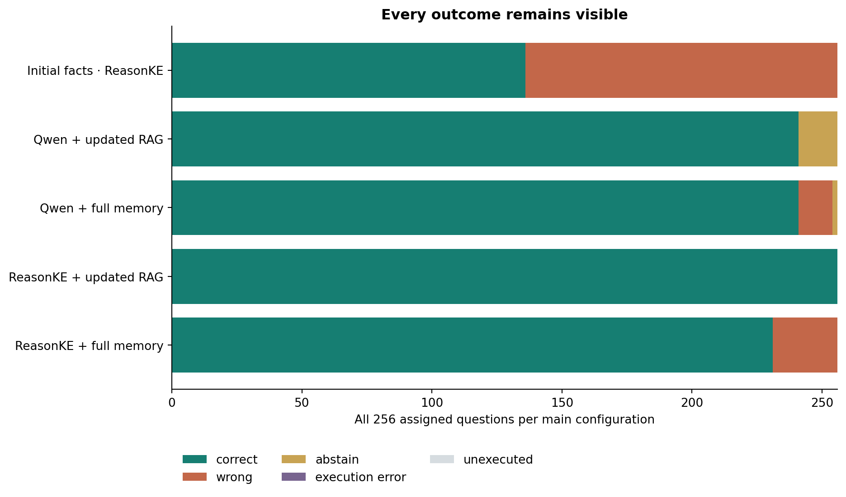
Figure 2 Original study outcome composition with 256 assigned questions per main condition. R0 is a stale diagnostic. All updated conditions receive the approved correction.
ReasonKE's selected updated context produced 256/256 correct answers, compared with 231/256 under full memory. The same model therefore did not maintain a perfect result when given more competing facts. Qwen retrieved and full memory each scored 241/256, but with different outcome types. This shows why the combination of model and supplied context matters more than a single headline accuracy. It does not identify a causal internal attention mechanism.

Locality and preservation
Table 9 Original locality correctness and preservation
Configuration | All locality correct | Baseline correct retained
ReasonKE initial facts | 124/128 | Reference set of 124
ReasonKE retrieved updated facts | 128/128 | 124/124
ReasonKE full updated memory | 119/128 | 117/124

Retaining an originally wrong answer is not factual success. The retrieved condition preserved all 124 baseline correct locality answers and answered all 128 locality questions correctly. The full memory condition retained 117/124 and answered 119/128 correctly. Endorsement of an inapplicable edited value occurred in zero of 128 retrieved locality opportunities, three of 128 ReasonKE full memory opportunities and one of 128 Qwen full memory opportunities.

Paired original differences
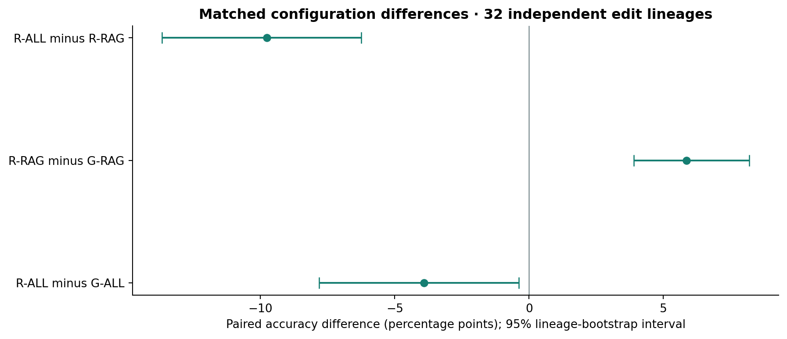
Figure 3 Paired original accuracy differences with 95 percent intervals from resampling 32 whole lineages. Negative values mean the first listed condition scored lower.
ReasonKE retrieved minus Qwen retrieved was +5.859375 percentage points, with a paired interval from +3.90625 to +8.203125. ReasonKE full memory minus Qwen full memory was -3.90625 points, with an interval from -7.8125 to -0.390625. ReasonKE therefore did not beat the comparison model in every configuration. These are matched checkpoint comparisons, not a verified causal ablation of the upstream training procedure.

Separate depth challenge
Table 10 Depth main results by group
Question group | ReasonKE correct | Qwen correct | Qwen abstain
Locality controls | 64/64 | 64/64 | 0
One hop | 64/64 | 64/64 | 0
Two hops | 64/64 | 57/64 | 7
Three hops | 64/64 | 63/64 | 1
All main questions | 256/256 | 248/256 | 8

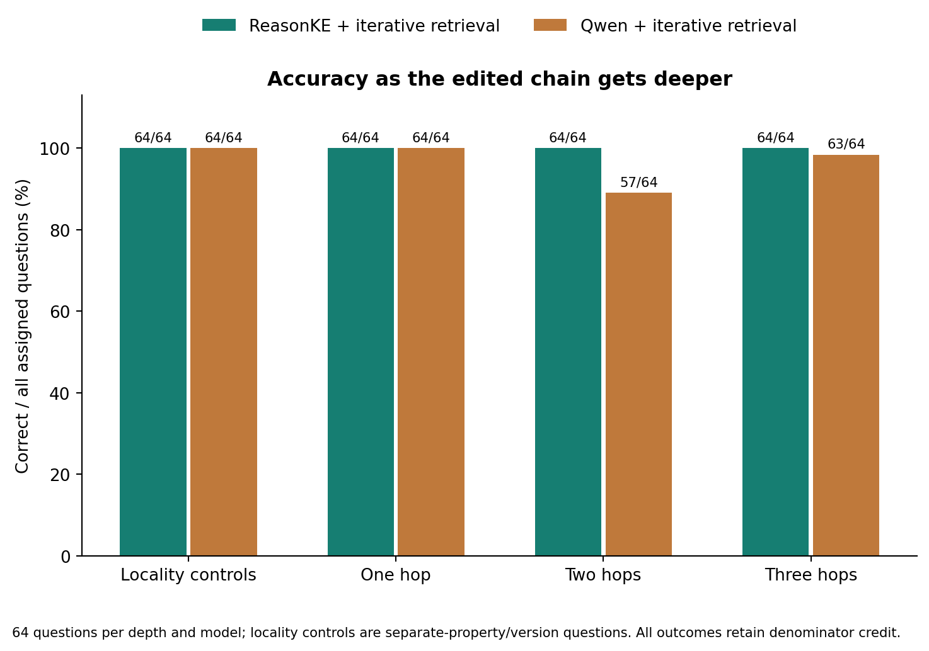
Figure 4 Separate depth accuracy by relation count. Every group contains 64 assigned questions per model. Zero denotes locality controls requiring an independent fact.
Each checkpoint completed 272 requests: 256 main plus sixteen preselected three hop oracle requests. Main and oracle questions must not be pooled into a 272 question headline. ReasonKE main accuracy was 100 percent and Qwen main accuracy 96.875 percent. Each oracle diagnostic scored 16/16. Both final ledgers completed without execution errors or unfinished assignments.
The main ReasonKE minus Qwen difference was +3.125 percentage points, with a 95 percent lineage bootstrap interval of +1.5625 to +5.078125. For three hops the difference was +1.5625 points, with an interval of 0 to +4.6875. The three hop interval includes zero, so this small subset does not establish a stable nonzero advantage. The two studies have different question populations and selectors; a lower or higher cross study percentage cannot isolate the effect of hop count.

Support selection and answer production
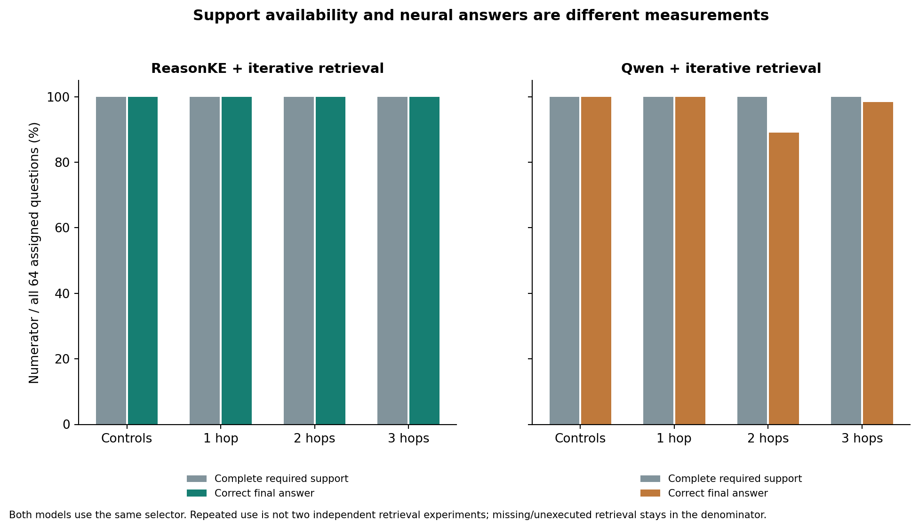
Figure 5 Required support versus final answer success in the depth study. The same selector supplies complete paths for both models; Qwen still abstains on eight main questions.
The depth selector supplied all 448 required fact occurrences across 256 main paths for each model, including 192 required occurrences across all 64 three hop paths. These repeated counts describe one shared retrieval policy, not two independent retrieval experiments. The original selector supplied all 320 required occurrences and all 64 two hop paths in its separate population.
Complete support cannot be counted as a correct neural answer. All eight depth abstentions had their required facts supplied. The observed failures occur after successful support selection under the fixed generation configuration. None of those eight question IDs belongs to the preselected oracle subset; the 16/16 oracle result cannot be described as repairing those failures.

Latency and resource cost
Table 11 Warm selected context latency
Study and model | Generated n | p50 seconds | p95 seconds
Original ReasonKE | 256 | 15.06 | 16.71
Original Qwen | 256 | 0.92 | 1.20
Depth ReasonKE | 256 | 15.94 | 19.28
Depth Qwen | 256 | 1.12 | 1.38

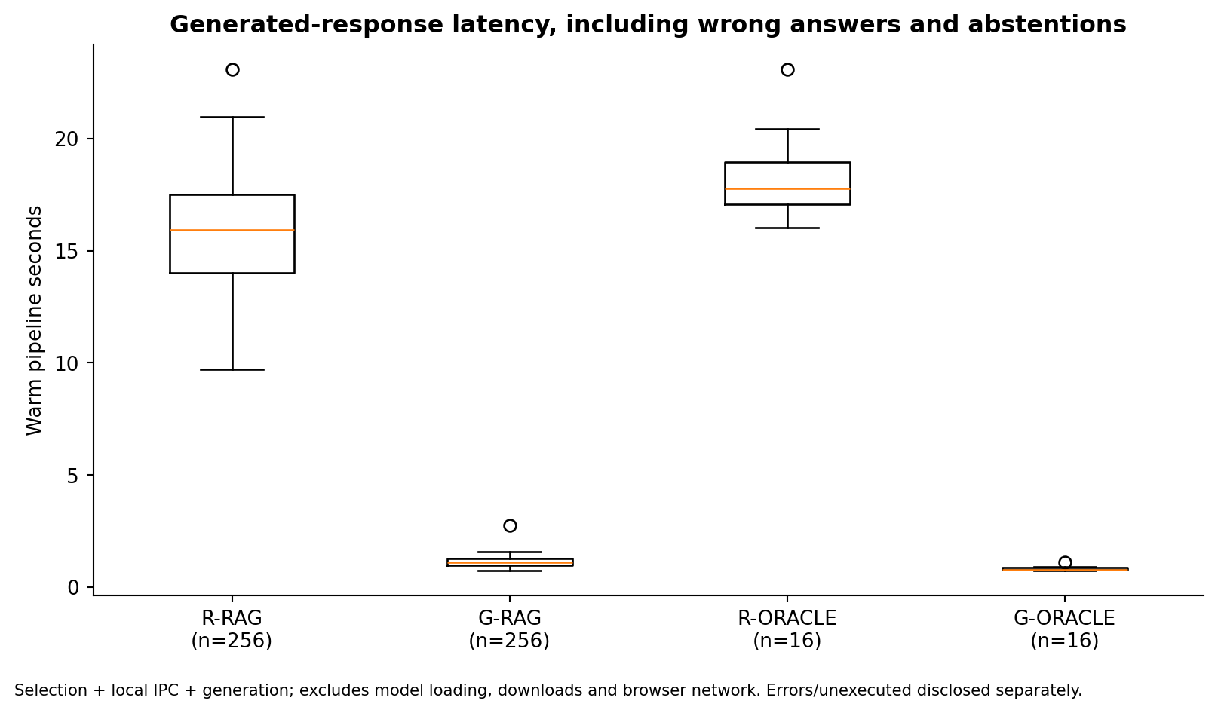
Figure 6 Depth pipeline latency distributions. The main conditions each have 256 generated responses; oracle conditions each have sixteen. Abstentions remain in the measured latency population.
Warm request time includes context selection, local process communication and generation. Loading, downloads, browser network and operator actions are excluded. Qwen's times include its abstained outputs. ReasonKE produced more correct main answers in these samples while taking materially longer. A deployment decision must account for this delay; accuracy alone is an incomplete service metric. The approximately 6.59 GiB loading allocation also exceeded the laptop's roughly 6 GiB GPU capacity for this fixed loader, so a T4 was used. This does not prove that every possible quantized 7B implementation is impossible on that laptop.

9 Failure analysis and the perfect score

Retained failures across configurations
The original study provides important counterevidence to a universal reliability claim. ReasonKE full memory produced 25 strict wrong answers although required support was present. Inspection found that each endorsed an answer belonging to another supplied fact. Qwen retrieved produced fifteen literal UNKNOWN abstentions, all among its 32 two hop paraphrases. These remain zero credit outcomes even though Qwen's answered only precision was perfect.
Qwen full memory retained thirteen strict wrong answers and two abstentions. Not every strict mismatch is a false factual endorsement: two outputs include a compatible owner and contact chain but violate the person only answer contract, and another combines a Pro owner with the requested contact. We retain the fixed scores while explaining that distinction. Changing aliases after test inspection would invalidate the frozen evaluation.
Table 12 All eight depth abstentions
Lineage | Category | Expected | Actual
depth-001 | Two hop | Diya Desai | UNKNOWN
depth-004 | Two hop | Arjun Desai | UNKNOWN
depth-016 | Two hop | Arjun Nair | UNKNOWN
depth-024 | Three hop paraphrase | Indore | UNKNOWN
depth-025 | Two hop | Diya Kapoor | UNKNOWN
depth-028 | Two hop | Arjun Kapoor | UNKNOWN
depth-031 | Two hop | Ishita Kapoor | UNKNOWN
depth-040 | Two hop | Arjun Menon | UNKNOWN

The seven direct two hop abstentions concentrate in one final wording template: identify the service's release 2 owning team and give only its on call contact's name. Qwen abstained on seven of nine instantiations, whereas the other direct two hop templates scored 23/23. All 32 two hop paraphrases were correct. This descriptive concentration does not prove an internal cause. It also explains why the observed three hop group scored higher than the two hop group; a monotonic decline with depth is not supported by this sample.

What the 100 percent result means
The correct claim is observed controlled benchmark accuracy. ReasonKE returned an accepted final short answer for all 256 assigned main questions in each of two separately frozen studies. This is a genuine recorded result, not a target filled from a database or an upstream paper score. It should neither be hidden nor described as a promise about arbitrary questions.
Several properties make ceiling performance plausible. Each world contains just nine or twelve explicit facts. The tested paths are short and the relation families repeat. The selector supplies every required fact in these final populations. Answers are short canonical names or places, and wording templates repeat within each split. Even in the depth study, new entity assignments and separate wording banks remain close to the same constructed task family. The test has limited power to distinguish two strong models on its easiest groups.
There are 32 held out lineages per study, each producing eight correlated questions. The 256 variants are not 256 independent arbitrary conversations. Automatically generated or authored labels were mechanically audited, not independently reviewed by people. Hash checks demonstrate evidence integrity and identity; they do not prove semantic validity, eliminate every form of leakage or make the catalogue representative of a real organisation.
The perfect score therefore establishes that the chosen system completed this specified contract under its fixed inputs. It does not establish reliable language ambiguity detection, open domain retrieval, many simultaneous unrelated edits, multilingual use, adversarial sources or correctness of an unrestricted conversation. A bootstrap can have zero width when every sampled lineage succeeds; that arithmetic does not imply certainty on future traffic. We do not add invented failures or alter the test to make a percentage appear more realistic.

Answers and explanations are different claims
A separate original explanation audit selected 32 traces before inspection, sixteen from ReasonKE retrieved and sixteen from full memory. For the retrieved traces all 32 extracted indexed subanswers were supported. Full memory had 26 supported, three contradicted and three unsupported indexed claims. Each condition also contained 64 prose segments that the bounded audit did not assess. No complete trace was certified as fully verified. A correct final name can coexist with unsupported explanation text, so the interface displays supplied provenance without certifying every generated sentence.

Threats to validity and the next useful study
Internal validity is supported by fixed questions, matched settings, all outcome denominators and replayable raw outputs, but strict formatting rules can disagree with a human assessment of useful information. Construct validity is limited by template based questions and narrow graph relations. External validity is limited by small fictional memories and absence of real user traffic. Checkpoint comparisons do not isolate a causal training effect because exact parent ancestry is not verified. The original and depth populations cannot be pooled into a single improved score.
A future study should first freeze independently human reviewed questions from realistic operational records, with broader wording, genuinely ambiguous requests, missing evidence and larger distractor collections. It should measure safe refusal and error severity as well as exact answers and latency. Such a study would test the limits suggested by these results. It is future validation, not a retroactive modification of the completed benchmark or a condition for reporting its observations.

10 Application workflow and verification

Using the website
Chat accepts ordinary text conversations and factual questions. Knowledge contains the correction library, explicit approval editor, canonical IDs, source metadata, version history and rollback. Research results displays the original text experiment and separate depth challenge, with raw evidence exports and scientific graphs. The current ReasonKE worker is text only; the image capability of an archived backend is not part of this final model evaluation.
In a fresh workspace, approve the nine fictional India facts. Ask who owns Kaveri Payment Gateway in release 2 and ask for the contact's office city. Draft the provided ownership update and explicitly approve the replacement. Ask the direct and three hop questions again; ask the hosting and release 1 questions to inspect locality. Use Compare original and corrected with approved memory revision 9 to generate historical and current answers. Roll back the replacement and ask the same questions anew. A previously stored chat answer stays unchanged; the new response uses restored memory.
Revision 9 identifies the approved starting handbook, revision 10 the ownership replacement and revision 11 its atomic rollback. These numbers refer to this finite demonstration, not to every future user workspace. Normal conversation remains available, but this factual benchmark does not score the quality or truth of every possible conversational reply.

Measured website workload
Table 13 India application acceptance populations
Stage | Assigned neural answers
Initial direct two hop and three hop | 3
Edited paraphrase paths and locality | 6
Historical and current office comparison | 2
Rollback direct two hop and three hop | 3
Total actual model generations | 14

All fourteen generated answers matched their fixed short answer contracts. All twelve recorded provenance and transaction consistency checks passed, including rejected competing approval, unchanged memory after rejection, historical comparison and restoration of the initial nine active facts. Thirteen HTTP generation requests produced fourteen answers because one comparison invoked the model twice. Request p50 and p95 were 17.11 and 33.39 seconds, with 268.45 seconds total workload time. The mixed request quantiles are not per generation latency.
The laptop replay verified raw answer extraction, exact model revision, iterative context policy, expected memory revisions, all scores and the saved rollback contents without new model calls. This is one fictional display lineage, not fourteen independent held out facts. The earlier website supplement also completed twelve workflow and four history answers, with eleven recorded consistency checks. Neither operational workload changes a frozen benchmark denominator.

Deterministic and neural evidence
Transaction and deployment tests can establish that a conflict is rejected or a memory snapshot restores correctly. They cannot establish that the model generated the correct contact. The engineering deployment receipt records 24 software checks with zero model generations and null model accuracy. Conversely, a model's correct answer does not prove atomic database behaviour. The project retains both types of evidence with separate labels.

11 Engineering and reproducibility

Minimal deployment stack
The browser uses HTML, CSS and JavaScript. The website uses Python's standard library HTTP server and SQLite, with a small pinned image dependency for the preserved application surface. The private neural worker adds PyTorch, Transformers, Accelerate, bitsandbytes and safetensors in an isolated environment. The lightweight application container excludes weights, private chat databases and session secrets. It can serve saved evidence without a GPU, but requires a ready model worker for live neural answers. It is not a self contained GPU image.
The local server binds loopback, validates Host and exact Origin and requires a session token for changes. The worker uses a separate bearer credential and rejects direct browser origin requests. Colab permits the exact configured HTTPS proxy origin. This is a single operator research deployment. It does not provide enterprise role based access control, tenant isolation, distributed consistency or a security certification.

Recovery and evidence integrity
Final protocols bind source files, data, settings, scoring and completed development inputs by SHA256. Raw ledgers retain task identity, selected facts, raw model text, extracted answer, outcome, tokens, latency and resources. CPU replay reconstructs the request and scores the saved text. Figure manifests bind scientific exports to those results. A checksum detects mismatched bytes relative to the saved manifest; it is not proof of factual truth or independent authorship.
An earlier temporary development runtime expired before outputs were downloaded. Those unknown outcomes are disclosed and excluded from measured evidence. Saved profiles were restored byte for byte for a replacement development run before the depth protocol was frozen. A later browser disconnection left the final evaluator alive. Preservation checks confirm that all previously saved 174, 197, 235 and 247 ReasonKE records stayed unchanged in the completed 272 record ledger. No completed failure was rerun to improve a score.
Portable text workspace exports retain conversations, facts, versions and events. Restore validates schema, bounded size, references, lineage consistency and agreement of event replay with state, then imports transactionally into an empty workspace. An export is private user data; it is separate from the public fictional benchmark receipts. A temporary Colab session can end without losing published results, but live chat needs the pinned worker loaded again.

Regression and continuous integration
Automated checks cover fact identity and lifecycle transitions, atomic rollback, historical reads, conversation history, request validation, worker contracts, dataset splits, retrieval, scoring, evidence tampering, recovery, figure export and the finite India workflow audit. JavaScript syntax, container construction and HTTP deployment checks run in GitHub Actions. The completed release ae7bb2010a82fd1d744d008eb7c6f870198aece5 passed all six workflow jobs [10]. These software checks provide regression evidence; their count does not increase model accuracy.

12 Conclusion and future work
EditGuard implements a usable maintenance workflow around an attributed learned generator. An operator can approve a scoped factual replacement, inspect its provenance, compare historical and current answers, reject an unresolved competing approval and restore the previous state atomically. The independent datasets, fair updated contexts, finite runners and raw evidence audits make the resulting behaviour measurable and reviewable.
The completed original and depth studies support a bounded finding: selected approved facts enabled ReasonKE to produce every requested short main answer correctly in these controlled packets, while the matched Qwen conditions retained abstentions. The same ReasonKE checkpoint failed under full memory and had substantially higher latency. The three hop subset difference interval includes zero, and explanation text is not fully verified. These findings support the integrated design without claiming that one model or editing method is universally superior.
The project delivers an engineered and evaluated platform around an upstream trained checkpoint. It does not claim new foundation model training, faithful SERAC replication or guaranteed dialogue accuracy. The next validation should use independently reviewed operational questions, larger memories, ambiguous scopes and missing facts.

References
[1] P Lewis and colleagues. Retrieval Augmented Generation for Knowledge Intensive NLP Tasks. NeurIPS 2020. https://arxiv.org/abs/2005.11401
[2] E Mitchell C Lin A Bosselut C D Manning and C Finn. Memory Based Model Editing at Scale. ICML 2022. https://arxiv.org/abs/2206.06520
[3] K Meng D Bau A Andonian and Y Belinkov. Locating and Editing Factual Associations in GPT. NeurIPS 2022. https://arxiv.org/abs/2202.05262
[4] Y Wu L Ding L Shen and D Tao. Robust Knowledge Editing via Explicit Reasoning Chains for Distractor Resilient Multi Hop QA. Official Reason KE repository and citation. https://github.com/YukinoshitaKaren/Reason-KE
[5] Y Wu L Ding L Shen and D Tao. Reason KE++ Aligning the Process Not Just the Outcome for Faithful LLM Knowledge Editing. 2025. https://arxiv.org/abs/2511.12661
[6] YukinoKaren. ReasonKE_plus author published checkpoint. Revision ceaedc2ae7c8fed6257953587d991ce550db6106. https://huggingface.co/YukinoKaren/ReasonKE_plus . Exact checkpoint to paper score association and weight license metadata remain undocumented in the inspected evidence.
[7] Qwen team. Qwen2.5 7B Instruct official model card. Revision a09a35458c702b33eeacc393d103063234e8bc28. https://huggingface.co/Qwen/Qwen2.5-7B-Instruct/blob/a09a35458c702b33eeacc393d103063234e8bc28/README.md
[8] EditGuard project. Completed original operations evidence and frozen protocol. reports/reasonke/operations-final . https://github.com/ShivamRaghav7/verity/tree/ae7bb2010a82fd1d744d008eb7c6f870198aece5/reports/reasonke/operations-final
[9] EditGuard project. Completed separate depth evidence and India application audit. reports/reasonke/depth-final . https://github.com/ShivamRaghav7/verity/tree/ae7bb2010a82fd1d744d008eb7c6f870198aece5/reports/reasonke/depth-final
[10] EditGuard project. Passing release regression workflow. 28 October 2026. https://github.com/ShivamRaghav7/verity/actions/runs/40723337854
Primary research describes the method families; local raw receipts establish the numerical findings reported here. Published upstream scores are not our results. The final deployment differs from the earlier archived auxiliary model and visual studies. Their histories are retained in the repository but excluded from the two current scorecards. Web references were checked on 28 October 2026.

Appendix A Reproduction and evidence map

Released evidence
Table 14 Evidence artifacts and their purpose
Repository location | Purpose
reports/reasonke/operations-final | Original raw outputs metrics protocol explanation audit and failures
reports/reasonke/depth-final | Depth raw outputs metrics protocol failures and preservation audit
depth-final/india-acceptance.json | All fourteen neural application responses and transaction snapshots
depth-final/india-host-audit.json | CPU replay of the application receipt with zero model calls
Each study derived directory | CSV tables PNG and SVG figures and source hash manifests
docs/INDIA_DEMO.md | Operator walkthrough including comparison rollback and private export
docs/CHAT_API.md | Application API reference
notebooks/07_india_chat.ipynb | Pinned India website launcher without benchmark execution
notebooks/06_depth_challenge.ipynb | Staged fixed profile development freeze and final experiment

Recompute scores without another model call
Run these from the repository using an isolated Python environment. Use fresh output paths; preserve the released evidence. The commands below audit saved responses and do not generate new answers.
python -m editguard_depth.metrics \
reports/reasonke/depth-final/final-reasonke.json \
reports/reasonke/depth-final/final-instruction.json \
--protocol reports/reasonke/depth-final/protocol.json \
--output artifacts/depth-replay-results.json

python -m scripts.audit_india_http \
reports/reasonke/depth-final/india-acceptance.json \
--output artifacts/india-replay-audit.json
These are shell continuation examples. In PowerShell, put the command on one line or use its backtick continuation syntax. Do not copy the backslash as a PowerShell continuation.

Pinned identities
ReasonKE model revision
ceaedc2ae7c8fed6257953587d991ce550db6106
Qwen model revision
a09a35458c702b33eeacc393d103063234e8bc28
Depth inference source
7da6d1df5a790c51c7cc95d4378117f5eae052c3
Depth protocol SHA256
df120622131d617b37b7bfdfdfd141cbe23fe07fa5bf9ff914732d99dcfe1941
Original protocol SHA256
23914664df3378be46be463ea60cd8b5b258eb13b6b55c68b38f76d3b15c94c5
The depth protocol was published in commit 08d274e204e0dc8c7fcff94cc3aabcefda0debef before final inference. Exact source and data identities are in each protocol. Complete source restoration, rather than only copying a result JSON, is required to rerun an experiment.

Appendix B Metric glossary and worked example
Table 15 How to read the report numbers
Term | Interpretation
256 main questions | Eight variants per 32 held out graph lineages in one study and configuration
272 requests per depth model | 256 main plus sixteen separate oracle diagnostics
Primary accuracy | Correct divided by all assigned questions including unsuccessful outcomes
Coverage | Fraction producing an endorsed answer rather than abstaining or failing
Retention | Previously correct locality answers that remain correct
Required fact occurrence | A necessary supporting fact counted once for each question needing it
Complete path | Every required supporting fact was supplied for the question
p50 and p95 | Median and 95th percentile of the stated measured latency population
Percentage point difference | Direct subtraction of two percentages not relative percent improvement
Paired lineage interval | Bootstrap uncertainty with complete graph lineages resampled together
Oracle support | Gold supporting facts for a preselected diagnostic not normal retrieval
Revision | Approved memory state distinct from a model weight checkpoint

For the depth main comparison, Qwen produced 248 accepted answers and eight UNKNOWN responses. Primary accuracy is 248 divided by 256, or 96.875 percent. Answered only precision is 248 divided by 248, or 100 percent. Reporting only the latter would hide the abstentions. ReasonKE's 256 divided by 256 gives an observed 100 percent, so the direct difference is 3.125 percentage points.
For original locality, the initial model answered 124 of 128 controls correctly. Preserving those 124 answers gives 124/124 retention, while answering all controls correctly gives 128/128 factual locality accuracy. They answer different questions and require different denominators. Neither number proves that all possible unrelated questions are preserved.

