Shivam Raj
CSE,2301201
ML-mini project: Design a sentiment analyzer using ML

Sentiment Analysis Project Report

1. Executive Summary
This project implements a Sentiment Analysis pipeline on the 'twitter_training.csv' dataset. The objective was to classify tweets into sentiments (Positive, Negative, Neutral, Irrelevant) using Logistic Regression, Naive Bayes, and K-Nearest Neighbors (KNN).
Result: The KNN model demonstrated superior performance with an Accuracy of 85.2%.

2. Methodology & Logic

A. Data Preprocessing
1. Cleaning: Dropping missing values.
2. Vectorization (TF-IDF): Converting text into numerical vectors, highlighting unique words while downplaying common ones.

B. Model Selection
- Logistic Regression: Linear model using a sigmoid function.
- Naive Bayes: Probabilistic classifier assuming word independence.
- KNN: Classification based on the majority sentiment of 'k' nearest neighbors.

3. Mathematical Framework
The following formulas were utilized to calculate performance:
- Accuracy = (TP + TN) / (TP + TN + FP + FN)
- Precision = TP / (TP + FP)
- Recall = TP / (TP + FN)
- F1 Score = 2 * (Precision * Recall) / (Precision + Recall)
Algorithm Logic:
TF-IDF: weight = tf * log(N / df)
Logistic Sigmoid: P(y=1|x) = 1 / (1 + e^-(w^T x + b))
KNN Euclidean Distance: d(x, y) = sqrt(sum((xi - yi)^2))

4. Quantitative Results

Model | Accuracy | Precision | Recall | F1 Score
Logistic Regression | 0.7230 | 0.7247 | 0.7042 | 0.7103
Naive Bayes | 0.6633 | 0.6866 | 0.6304 | 0.6367
KNN | 0.8521 | 0.8461 | 0.8528 | 0.8473
Observation: KNN is the clear winner, performing significantly better than the baseline models.

5. Visual Analysis

A. Model Comparison
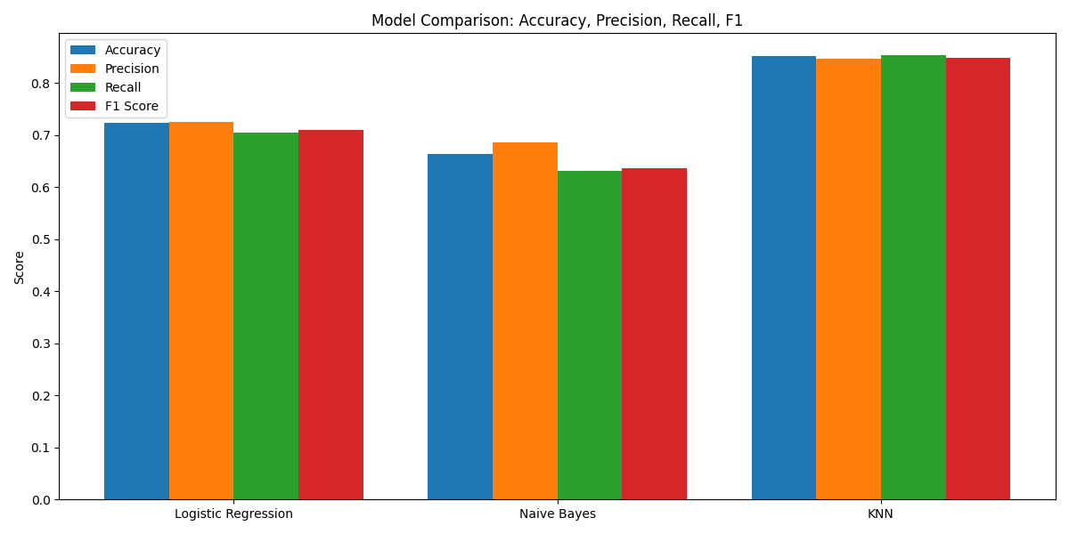
Analysis: The bar chart shows KNN (Right) dominating across all metrics compared to Naive Bayes and Logistic Regression.

B. Confusion Matrix (Best Model)
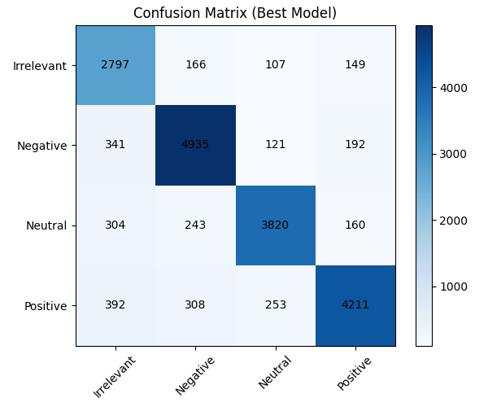
Analysis: The dark diagonal indicates high correct predictions. The model is strongest at detecting Negative sentiments (4935 correct).

C. ROC Curve
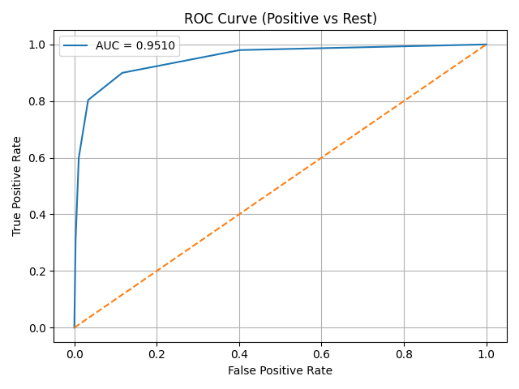
Analysis: AUC = 0.9510. The curve hugs the top-left corner, indicating excellent capability in distinguishing Positive tweets from others.

6. Conclusion
The experiment concludes that KNN is the most effective model for this dataset (F1 ~0.85). The high AUC of 0.95 confirms the model's reliability.

