Kubernetes/ K8s
Github/gitlab = remote repository Git = vcs tool Docker = containerization tool
Kubernetes = orchestration tool [Terraform Jenkins datalog: Remaining]

In Docker generally we can’t do – auto scaling, auto healing, loadbalancing , rollback strategies, or rollout strategies, vertical scaling , persistent data
For that we use K8s.
Note: Containers are created by the container engine.
Orchestration of container is done by K8s.
K8s Objects
- Service: nodeport, clusterip, loadbalancing
- Pods:
- Deployment
- Daemon set
- hpa:
- ingress and ingress controller
- pvc and pv
- config key and maps
- replica set
- replica controller

Kubernetes Architecture:
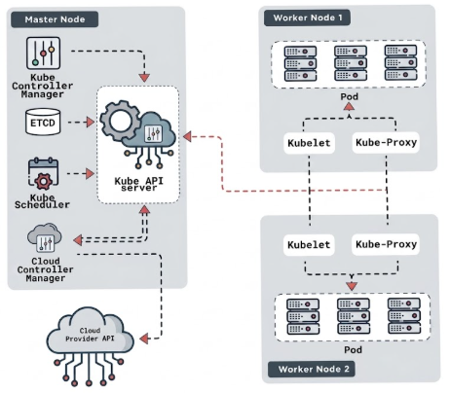
Kubernetes Architecture
Master Node Components
etcd: It acts as a database log system in cluster as all the logs from K8s cluster is maintained in K8s.
Control Manager: It is the component that maintain state of pods in actual vs desired state
Scheduler: Acts as a pod scheduling service component. It schedules pods creation.
API Server: It is communication Hub which basically becomes a center point for communication in cluster.

Worker Node Components:
Pods: It is like wrapper around the containers a light weight entity just like container.
kubelet: It actually creates a pod
kubeproxy: It actually looks in networking and traffic management part in cluster.

Lifecycle of Pids:
Running:
creating:
crashed:
errorloop:
What is Cluster?
Cluster is a networking architecture in which more than one node (instances) are available in which one node is Worker Node and another one Master node (control Plane).
Worker Node: do the work assigned by master node by taking commands from it.
Master Node: Will assign work/commands to the worker node
NOTE: Cluster are created in aws vpc.
kubectl: This command creates Pods.
The thing is there are containers are present in pods.
Self-hosted cluster (Open source)
Worker Node and Master Node
Everything we have to do manually in Self hosted cluster.
Tools: Kubedm, minikube, kind : Asked in Interview how to create these clusters
Cloud Provider based cluster
Worker Node and Master Node: aws nodes are not accessible (no ssh access)
Aws service: eks

Creating Cluster using eks:
Step 1. Configure cluster
In aws search for “eks” click on “Create Cluster” Click on “Custom configuration”
“EKS Auto Mode” is by default enable, disable it to manage manually
Cluster configuration: “Name”
“Cluster IAM role” : click on “Create new role” “Role name”
“Default policies” : AmazonEKSClusterPolicy Click on “Create Role” button
(Here EC2 and eks service are working together and eks service want an access of Ec2 service then we have to create an IAM role,
We have to create to roles first one is for eks service want an access of Ec2 service and another is
eks service want an access of entire cloud.
)
Kubernetes version settings : Kubernetes version (latest v)
Upgrade policy: Standerd support, extended support
[Interview Que: Which kubernetes version are you using ?
Ans: Currently we are using 1.34 (tell one version less) and we are moving to 1.35 v in upcoming year/month.]

Control plane scaling tier: keep it unchecked.
Auto Mode Compute: keep it as it
Cluster access: keep it as it
Deletion protection: it is enable in production, to not to delete cluster
Click on “Next button” to navigate “Specify networking” Page
Step 2. Specify networking:
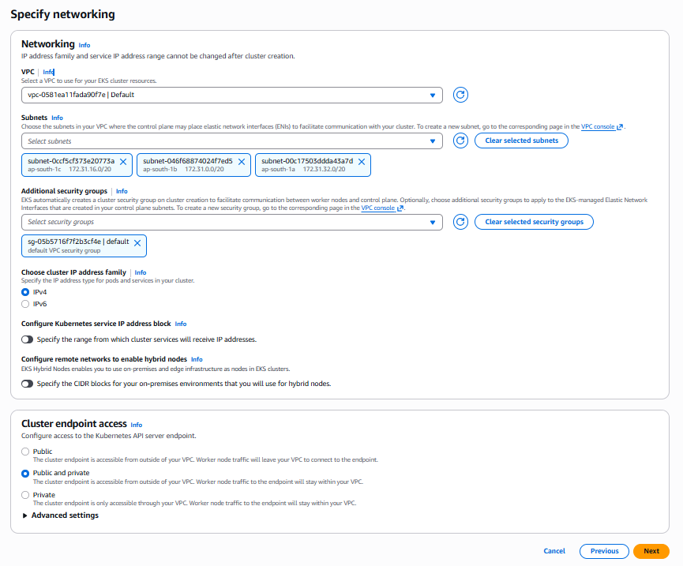

Step 3. Configure observability
It is for monitoring the cluster.
We don’t get entire access of instances so CloudWatch gives us lots of data

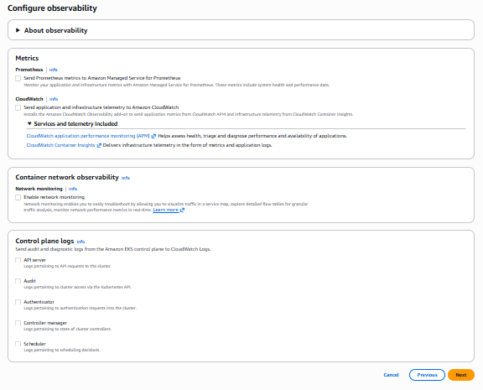
Step 4. Select add-ons
Here are some pre-selected components by AWS, that we have to compulsorily use.
K8s architecture components are already selected here.

Step 5. Configure selected add-ons settings : click next

Step 6. Review and create : click on create
Wait until our cluster status is Active.
Now we are creating Worker Nodes:
1. go inside cluster click on Compute Node Groups : Click Add node group Button
Navigated to “Node group configuration”
Step 1 : Configure node group
Give Name Node IAM role Click on “Create new role” Button
[Here is the 2nd IAM role, we are giving role to Ec2 ]
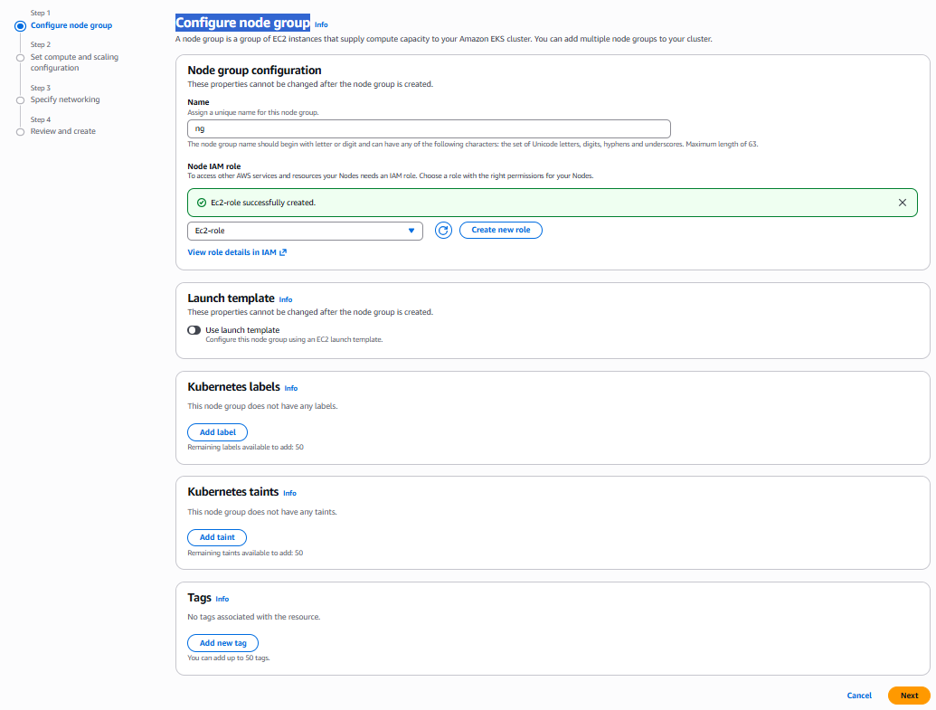
Policies in image are attached to EC2 Role
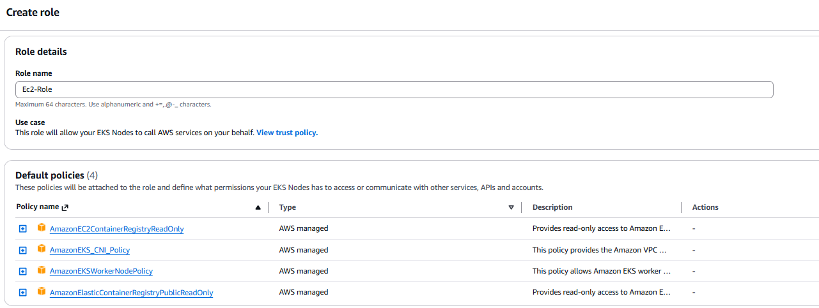
Step 2: Set compute and scaling configuration
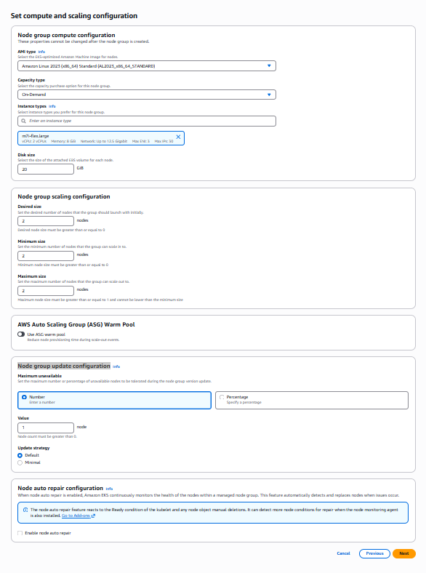
Ensure Instance types is good e.g. m7i-flex.large
Node group update configuration: Here we have to mention how much worker nodes should be down during group version updating, suppose we have 5 nodes and we set number 1, then our one node will be down.
In this section we set up and down of worker node.

Step 3: Specify networking
Just select subnet and click on next
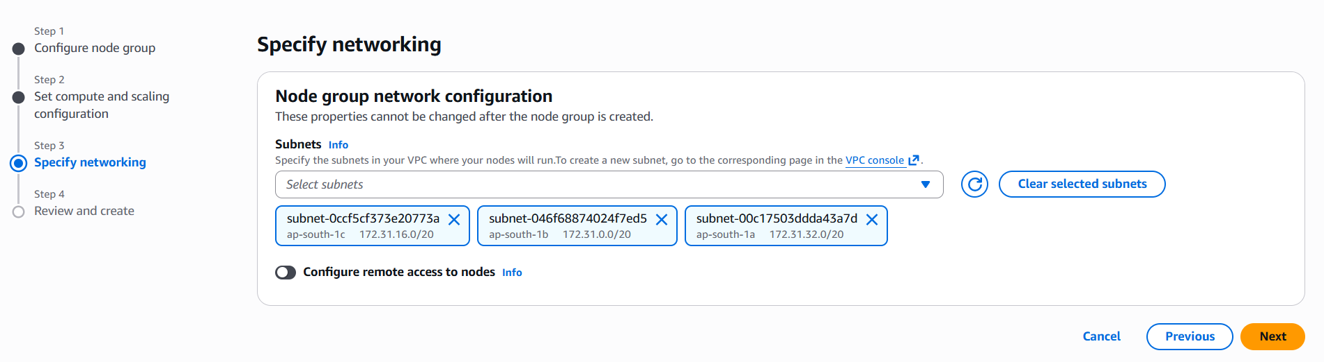
Step 4: Review and create: Click on next after review
Wait until worker node status is Active.
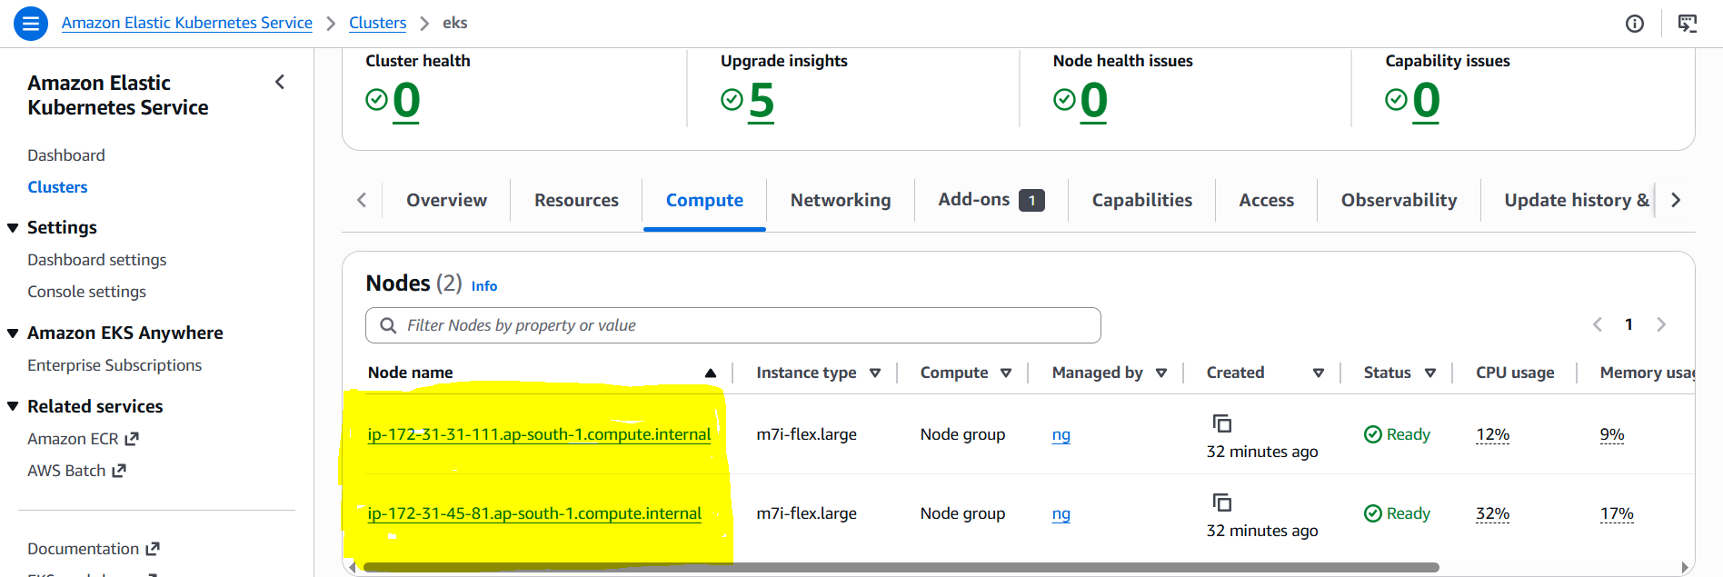
Now the Nodes are active.

Now Connect CLI to Cluster
Also open CLI for access. To open Click on CloudShell to open terminal.
Run Command : aws configure
Now click on Here 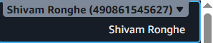 and click on “Security Credentials” and click on create access key button
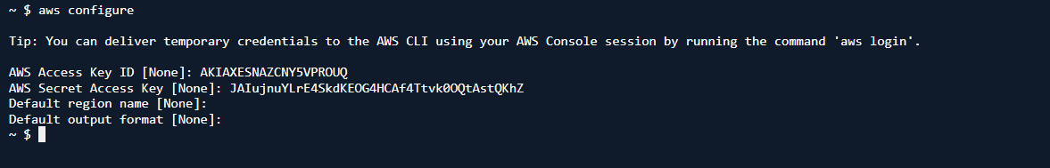
Here we have given credentials by giving access key and secret access key
Now we have logged in to cloud through CLI

Run this command in CloudShell to connect CLI to the Cluster.
Syntax: aws eks update-kubeconfig --region <your-region> --name <your-cluster-name>
Example: aws eks update-kubeconfig --region ap-south-1 --name eks
Now we are telling to CLI that connect me to that cluster

Run this command in CloudShell to ensure the nodes are created or not
Cmd: kubectl get nodes
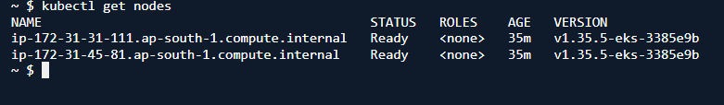
Now these nodes are we can see in EC2 as an Instances in Mumbai ap-south-1 region
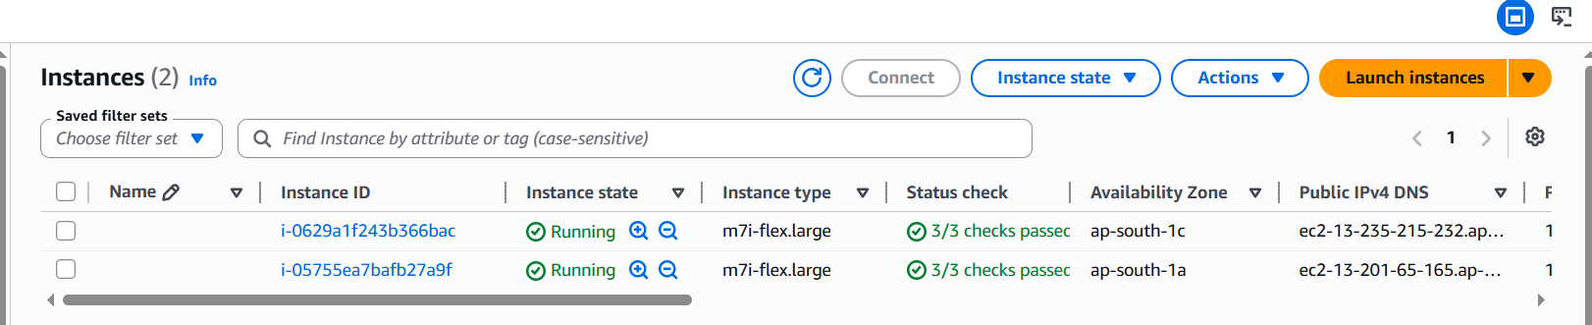
These 2 instances are not accessible, we can’t take its SSH, because its key is never created.

Now Delete this:
Don’t delete it from instances, because due to autoscaling new will automatically generated. So Delete node then delete cluster, then instances will automatically terminated.

Service Object:
Service is a networking object of K8s which is used to expose the pods in cluster to the internet.
Assigning of static ip to pods is also possible using Service Object.
Subtopics of Service:
clusteIP: It provides static IP and single static ip endpoints to the pods. It is not use for expose
NodePort: It is like the Port mapping in Docker. It expose/maps the pods ports with random port of the node. The random port range : 3000 - 32767
LoadBalaner: It plays the role to a single endpoint and loadbalancing to a multiple.
Pods are placed horizontally and it has to do autoscaling horizontally.
Jya service type chi cmd apan run keli tyacha adhi chya services automatically cover hotat tya service sobat, suppose If I run cmd of LoadBalancer then automatically along with LoadBalancer NodePort and ClusterIP will also create.

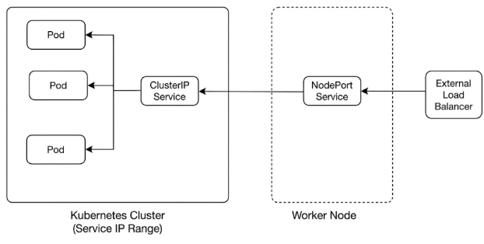
Working:
Run cmd in cloudshell: aws configure
Run : aws eks update-kubeconfig --name eks --region ap-south-1
Run: kubectl get nodes to get clusters.
1. ClusterIP
ClusterIP pod create command
Syntax: kubectl run podname --image nginx
e.g: kubectl run cipod --image nginx
This command will expose pod on 80 port number.

Cmd to see how many pods available:
Kubectl get pods

Cmd to describe pod info:
kubectl describe pod cipod

Expose to clusterIP
Syntax: kubectl expose pod podname --port=<service-port> --target-port=<pod-port> --type=ClusterIP --name=<service-name>
--port=<service-port>: It is port number of image container
--target-port=<pod-port>: Pod port number
e.g: kubectl expose pod cipod --port=80 --target-port=80 --type=ClusterIP

cmd to see created services
kubectl get service
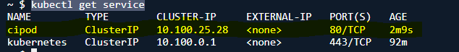
2. NodePort
NodePort Pod Create Commad:
Syntax: kubectl run podname --image imagename
e.g: kubectl run npod --image nginx

Expose to Nodeport: (NodePort is randomly assigned)
kubectl expose pod <pod-name> --port=<service-port> --target-port=<pod-port> --name=<service-name> --type=NodePort
e.g: kubectl expose pod npod --port=80 --target-port=80 --type=NodePort

eka pod la ek type chi ch service assign hot aste je service ClusterIP la assign ahe tr ti NodePort la ssign nahi hou shakat
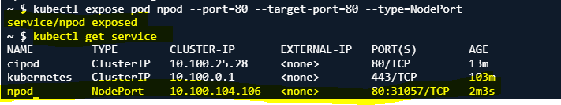

- Now we got the NodePort as 31057 on port number 80.
- We have created an nginx image, we have to expose our nginx image through this Nodeport.
- We have cluster in the form of instances. 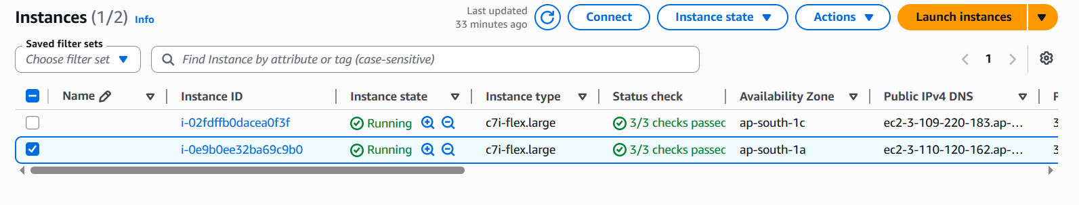
- Now we will get public ip of these 2 instances and expose our image one by one, before expose ensure inbound rules as given in below image.
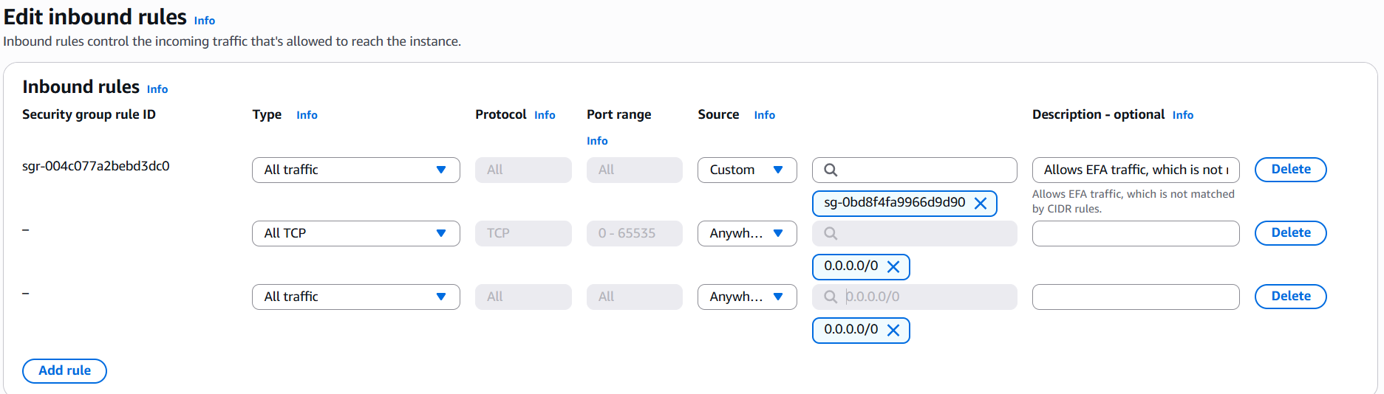
IP of 1st cluster/instance: http://3.109.220.183:31057/
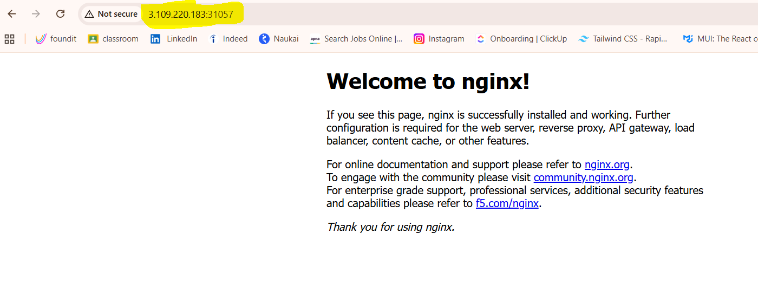
IP of 2nd cluster/instance: http://3.110.120.162:31057/
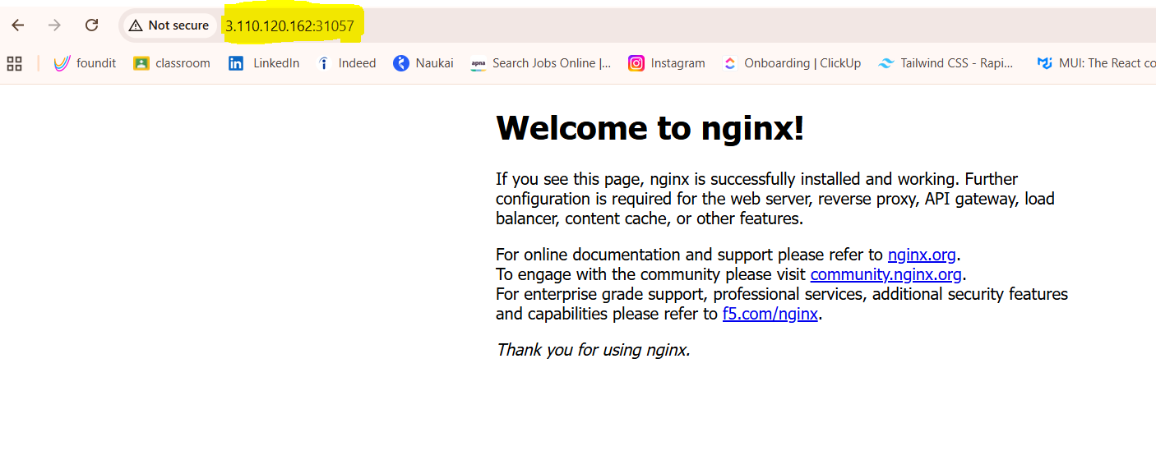
Our image is successfully exposed on both instances

3. LoadBalancer
LoadBalancer Pod create Cmd
Syntax: kubectl run podname --image imagename
e.g: kubectl run lbpod --image nginx
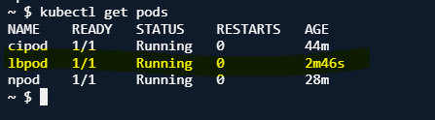

LoadBalancer Pod expose command
Syntax: kubectl expose pod <pod-name> --port=<service-port> --target-port=<pod-port> --name=<service-name> --type=LoadBalancer
e.g: kubectl expose pod lbpod --port=80 --target-port=80 --type=LoadBalancer
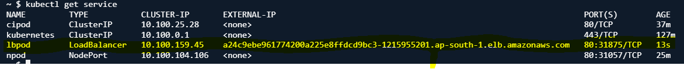

LoadBalancer is created.
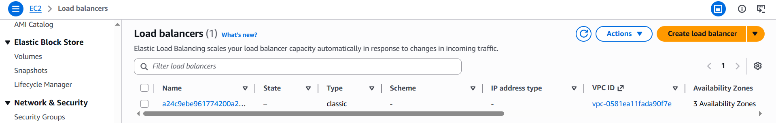

Expose LoadBalancer using External_IP
http://a24c9ebe961774200a225e8ffdcd9bc3-1215955201.ap-south-1.elb.amazonaws.com/
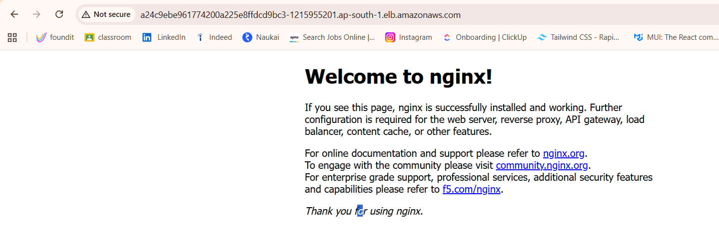
We can also expose LoadBalancer through its NodePort with instance ip
http://3.110.120.162:31875/
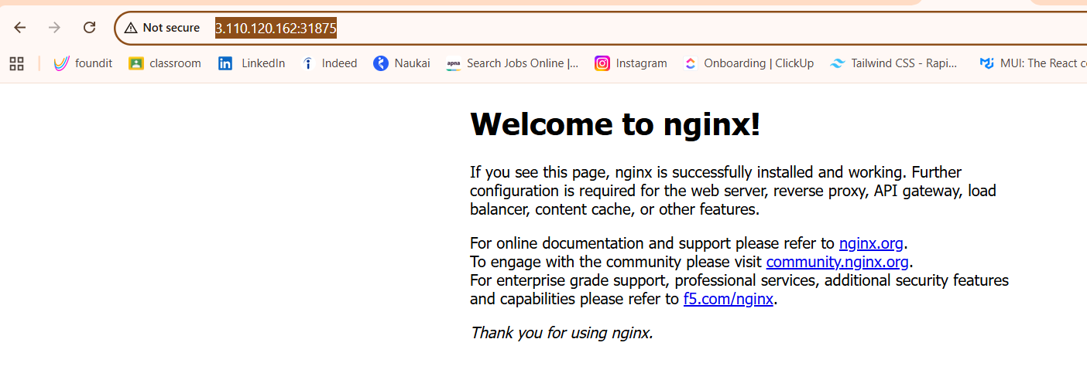
Interpod/ Intrapod:
Inter-pod refers to any mechanism, network traffic, or scheduling rule that occurs across two or more distinct Pod instances. These Pods could be running on the same worker node or distributed across entirely different nodes in the cluster
Intra-pod refers to any operation, resource sharing, or communication that happens strictly inside a single Pod boundary. It involves co-located, multi-container environments where multiple containers live and die together as a singular unit
Side Car Container: A Sidecar Container is a secondary container that runs inside the same Pod alongside your main application container.
Manifest File : yaml
A Manifest File (often just called a "manifest" or "YAML file") is a specification document written in YAML or JSON format that describes exactly what you want your Kubernetes resources to look like.
It acts as a blueprint or an instruction manual that you hand over to Kubernetes, telling it: "Deploy this specific app, with these configurations, using this much memory."
Syntax: Key: Value
e.g apiVersion: v1
A key has a value, that value can be work as a Key as well
e..g: metadata: # 3. Identification data
name: billing-service
labels: tier: backend
Here metadata is an key, and name and labels are value of metadata but that are key as well and that key has an value.

Multi Lining: If we have value of multiple lines , so k8s should know that multiple lines are values of single key for that we use symbols “|” (Use at end) or “—” (Use at Front)
Addr: Rajapeth | OR Addr: Rajapeth
Amravati -- Amravati

Fields/ Components of yaml file
apiVersion: The version of the Kubernetes API you are using to create this object (e.g., v1, apps/v1). Versions are different according to objects.
metadata: Data that helps uniquely identify the object, including its name, uid, and optional labels.
kind: The type of Kubernetes object you want to create (e.g., Pod, Service, Deployment).
spec: The actual configuration and specifications for the object (the container images to use, port numbers, replica counts, etc.).

kubectl api-resources ( | less): This command lists all the supported API resource types available on your Kubernetes cluster
We can see what api version, kind is suitable for particular object.
Writing simple yaml file for pod
pod.yaml
apiVersion: v1
kind: Pod
metadata:
name: nginx-pod
spec:
containers:
- name: my-name
image: nginx:latest
ports:
- containerPort: 80

Run command Vim pod.yaml and paste this file
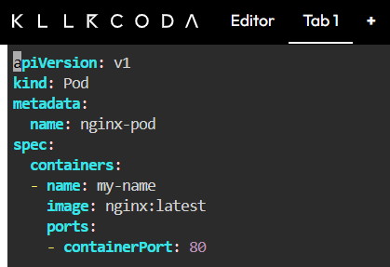

Then Run command
kubectl apply -f pod.yaml: whatever the component write it inside pod.yaml file read that component and generate the pod.
-f = filename
Then
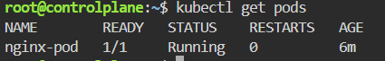

23
24
25
26
27
28
29
39
31
32
33
34
35
36
37
38

