Shivam Sakthivelpandi
CS 330: Computational Graphics and Visualization
Final Project: Design Decisions
For the final project I built a study desk in OpenGL. It combines the desk lamp from my Milestone One sketch with the objects I broke down in my Final Project Review: the monitor, mouse, books, coffee mug, and pencil holder. Figure 1 shows the finished scene from the starting camera position.
Figure 1
The Finished Desk Scene
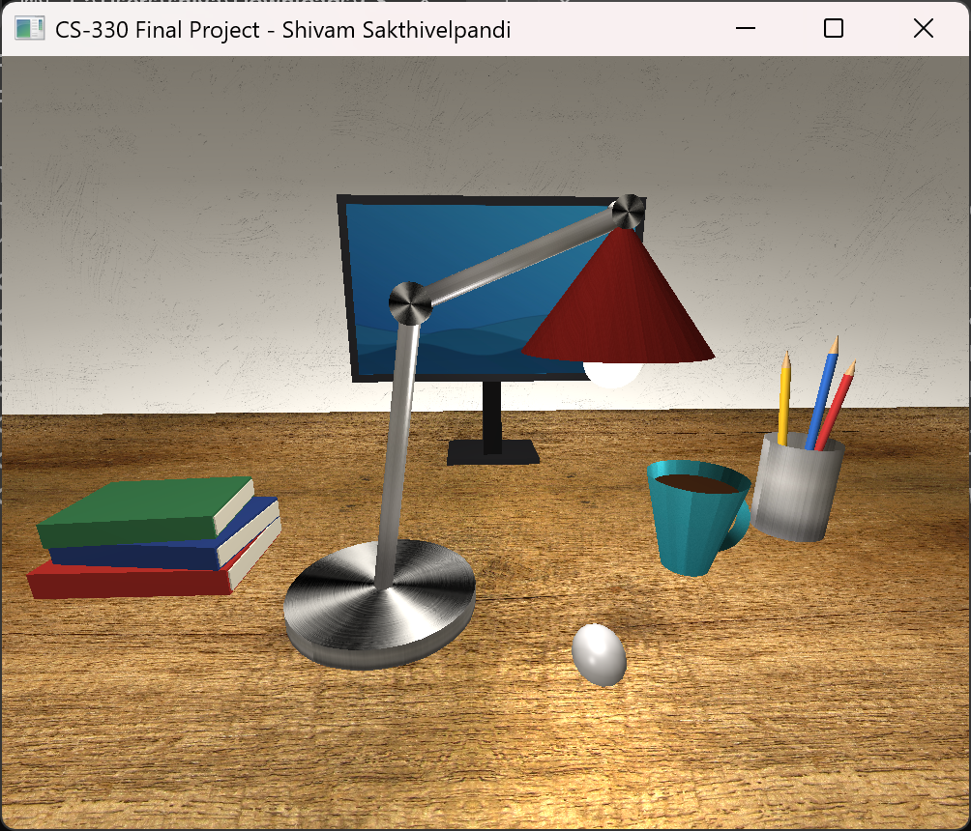
Development Choices
I chose a desk because the objects on it break down into simple shapes without much guessing. The desk is a plane in front of a back wall, and the monitor is a thin box with a plane for the screen, standing on a triangular prism neck and a flat box base. The books are boxes, the mouse is the top half of a sphere so it sits flat on the desk, and the pencil holder is a cylinder with three pencils made from a cylinder and a cone each. The coffee mug is a tapered cylinder that is wider at the top, with half of a torus for the handle. Between them the objects use eight of the basic shapes: plane, box, cylinder, cone, sphere, tapered cylinder, prism, and torus. The monitor sits at the back of the desk, the books are on the left, the lamp is near the middle, the mug and pencil holder are on the right, and the mouse is in front. The lamp was my main complex object. It has a cylinder base, two cylinder arms, round hinge plates at the joints, a cone for the shade, and half of a sphere for the bulb. I built it around three points (the base, the elbow, and the head), so every part is placed from those and the lamp stays connected if one point moves. When I checked triangle counts near the end, the lamp was over 2,000 because each joint was a full sphere. I changed the joints to thin hinge plates, used only the bottom half of a sphere for the bulb, and stopped drawing cylinder ends that can't be seen. That got the lamp under 1,000, and the pencil holder, monitor, mouse, and books are under it too. The mug is the one exception at about 1,230, because most of its triangles come from the course's torus mesh. I kept the half torus handle anyway since it was part of my plan and it looks much more like a real mug handle than the boxy version I tried. For textures I used brushed steel on the lamp and pencil holder, wood on the desk, drywall on the wall, glazed ceramic on the mug, and a desktop wallpaper image on the monitor screen. The screen material has extra ambient light so it looks like it is turned on. The wood photo wasn't made to repeat, so tiling it left hard lines across the desk. Setting that texture to mirrored repeat fixed it. The lighting uses the Phong model with three lights: a warm point light at the lamp bulb, a soft white room light in front of the desk, and a dim light behind the wall so the backs of objects don't go dark when the camera moves around them. The desk material has a strong specular value, so the lamp leaves a shiny spot on the wood. The course shader only uses a light's color through its ambient value and always adds all four light slots, so I set the colors through ambient and turned the unused slot off.
Navigating the Scene
The camera is controlled with the keyboard and mouse. W and S move forward and back, A and D move left and right, and Q and E move up and down. Moving the mouse turns the camera to look up, down, left, or right without moving it, and the scroll wheel changes how fast it moves, with scrolling up making it faster. Movement is multiplied by the time between frames, so it runs at the same speed on any computer. Pressing O switches to an orthographic view and P switches back to perspective. The camera stays in the same place and angle, and only the projection matrix changes. I had two bugs to fix along the way. The scene opened turned to the side because the cursor jumping to the window center counted as a mouse move, so I set up the mouse callbacks after the cursor is captured. The view also jumped on the first mouse move because the starting yaw and pitch didn't match the starting direction, so I set them to match.
Custom Functions
I split the code into small functions so each one has a single job. RenderScene() just calls one function per object: RenderDesk(), RenderMonitor(), RenderBooks(), RenderDeskLamp(), RenderMouse(), RenderCoffeeMug(), and RenderPencilCup(). The most reusable one is DrawCylinderBetween(). It takes two points and a radius and works out the scale, rotation, and position to put a cylinder between them. I use it for the lamp arms and the pencils, and DrawConeBetween() does the same thing for the pencil tips. DrawBook() draws a cover and page block at any size, angle, and color, so the whole stack is three short calls, and DrawPencil() and DrawLampHinge() work the same way. For setup, AddMaterial() and SetLight() replaced long blocks of repeated shader calls with one line each, which made it much easier to adjust the lighting while I was testing.

