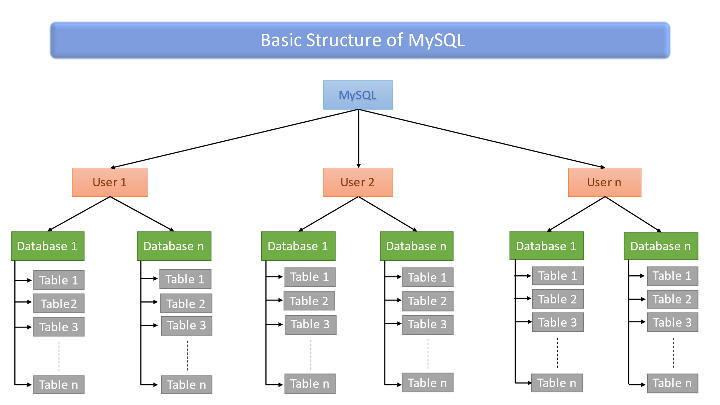

How to run MySQL?
Open the Command Prompt and navigate to the bin folder of your MySQL Server installation directory.
Then connect to the server using the mysql -u root -p command.
Enter the password.
Syntax :- mysql -u root -p

Data types in MySQL Database
Numeric data type
INTEGER or INT | 4 bytes | INTEGER and INT are essentially the same, and you can use them interchangeably. Both data types are used to store whole numbers . Both will work the same way in practice.
TINYINT | 1 byte | It's used for storing very small integer values.
SMALLINT | 2 bytes | It's used for small integer values.
MEDIUMINT | 3 bytes | It's used for medium-sized integer values.
BIGINT | 8 bytes | It's used for large integer values.
NUMERIC |  | DECIMAL and NUMERIC are data types used in databases like MySQL to store numbers with a fixed number of digits both before and after the decimal point. These types are commonly used when you need exact representations of decimal numbers. For example,  if you define a DECIMAL(5,2), it means you want a number with a total of 5 digits, and 2 of them should be after the decimal point.
DECIMAL
FLOAT | 4 bytes | FLOAT and DOUBLE are both data types used in databases, including MySQL, to store numerical values that have a decimal component.
DOUBLE | 8 bytes
String data Types
CHAR | The CHAR data type is used to store fixed-length character strings. For example, if you define a column as CHAR(10), it will always occupy 10 characters of storage, If the actual string is shorter than the specified length(10), MySQL fill the extra space with blank characters. A blank character, often referred to as a space character, is a non-printable character that represents an empty space.  Syntax: CHAR(fixed-size)
VARCHAR | VARCHAR is a data type used to store variable-length character strings. The term "variable-length" means that the storage space required for a VARCHAR column is determined by the length of the actual data stored in that column. For example, if you define a column as VARCHAR(30), this column contains maximum 30 character. If you insert data that contains less than 30 character into this column, The size of column will be equals to the size of data. Syntax: VARCHAR(max-size)
TEXT | the TEXT data type is used for storing large strings or text data. TEXT columns can hold variable-length character strings, and they are ideal for storing large amounts of text, such as paragraphs or entire documents.  Types: TINYTEXT, TEXT, MEDIUMTEXT, LONGTEXT.
ENUM | ENUM data type is used to store single value that are specified in the list during table creation.  ENUM values are stored in the order in which they are listed during table creation. The first value in the list has an index of 1, the second has an index of 2, and so on.
SET | The SET data type is used to store a set of values chosen from a predefined list of possible values. If you try to insert a value not present in the defined set, MySQL will store an empty set ('') or ignore the invalid value, depending on the SQL mode.
- ENUM data type Syntax & Example:
Syntax: column_name ENUM('value1', 'value2', ..., 'valueN’);
Example: CREATE TABLE example_enum (
id INT,
status ENUM('active', 'inactive', 'pending’)
);
// Inserting a row with a valid ENUM value
INSERT INTO example_enum (id, status) VALUES (1, 'active’); Or
INSERT INTO example_enum (id, status) VALUES (1, 1); // You can select enum values by index
INSERT INTO example_enum (id, status) VALUES (1, NULL); // If you don’t apply NOT NULL constraint
This would result in an error
INSERT INTO example_enum (id, status) VALUES (2, 'archived’);
INSERT INTO example_enum (id, status) VALUES (3, 'active,inactive’); // You can’t select multiple values
INSERT INTO example_enum (id, status) VALUES (4, ‘ ’); // Error
INSERT INTO example_enum (id, status) VALUES (4, 0); // Error because ENUM start indexing from 1

- Set data type Syntax & Example:
Syntax: column_name SET('value1', 'value2', ..., 'valueN’);
Example: CREATE TABLE employee_skills (
id INT,
skills SET('Programming', 'Database', 'Networking', 'Design')
);
// Inserting a row with a valid ENUM value
INSERT INTO employee_skills (id, skills) VALUES (1, ‘Programming’); Or
INSERT INTO employee_skills (id, skills) VALUES (1, 1); // You can select enum values by index
INSERT INTO employee_skills (id, skills) VALUES (1, NULL); // If you don’t apply NOT NULL constraint
INSERT INTO employee_skills (id, skills) VALUES (1, ‘Programming,Database’); // You can select multiple values
INSERT INTO employee_skills (id, skills) VALUES (1, ‘ ’); // No error occur
Or INSERT INTO employee_skills (id, skills) VALUES (1, 0); // No error occur because SET start indexing from 0 to n.
SELECT * FROM employee_skills WHERE skills = 'Programming,Database';
This would result in an error
INSERT INTO employee_skills (id, skills) VALUES (2, ‘App Development’);

Difference between Set and Enum.
The SET and ENUM data types work in a similar way because MySQL uses it with a predefined list of values. But one thing makes it different that are ENUM data type can hold only a single member of the predefined list of values, whereas SET data type allows us to store zero or any number of values together.
Items in Enum | Select individual item
Item 1 | 1
Item 2 | 2
Item 3 | 3
Item 4 | 4
Item 5 | 5
Item 6 | 6
If you don’t insert value of Set or Enum type column, by default its value are null.
Select Item by index into the ENUM data type--
Items in Set | Select individual item 2^(n-1)  N-> no. of item | Select group of items | Binary Value
Item 1 | 1 | 3 = 1, 2 | 0011
Item 2 | 2 | 5 = 1, 3 | 0101
Item 3 | 4 | 6 = 2, 3 | 0110
Item 4 | 8 | 7 = 1, 2, 3 | 0111
Item 5 | 16 | 9 = 1, 4 | 1001
Item 6 | 32 | 10 = 2, 4 | 1010
Select Item by index into the SET data type-

Date and Time Types
DATE | The DATE data type is used to store date values in the 'YYYY-MM-DD' format. It represents a date without a time component.  Dates are represented in the 'YYYY-MM-DD' format, where 'YYYY' is the four-digit year, 'MM' is the two-digit month (01 to 12), and 'DD' is the two-digit day of the month (01 to 31).  The DATE type supports a range of dates from '1000-01-01' to '9999-12-31’. The storage size of a DATE is 3 bytes. It's a fixed-size data type.  - You can assign a default value to a DATE column, which is used when a new row is inserted and if no value is explicitly provided for that column. For Example-  CREATE TABLE Employee (  id INT,  Joining_date DATE DEFAULT '2023-01-01'  );  - you can use functions like CURDATE() to retrieve the current date. SELECT CURDATE();  - DATE_ADD() to add or subtract days, months, or years from a DATE value.
TIME | The TIME data type is used to store time values, representing the time of day without a date component. By default, format for representing TIME values is 'HH:MM:SS' (hours, minutes, seconds).You can use the TIME_FORMAT() function to customize the display format. For Example-  CREATE TABLE example_time ( event_time TIME DEFAULT '00:00:00' );  INSERT INTO example_time (event_time) VALUES ('12:30:45');  You can perform various operations on TIME values, such as addition, subtraction, and comparison.
DATETIME | The DATETIME data type is used to store date and time values together.  The format for DATETIME values is 'YYYY-MM-DD HH:MM:SS'.  HH represents the two-digit hour of the day (00 to 23).  MM represents the two-digit minute of the hour (00 to 59).  SS represents the two-digit second of the minute (00 to 59).  The storage size for a DATETIME column is 8 bytes.  Example-  CREATE TABLE example_table (  event_datetime DATETIME DEFAULT '2000-12-05 00:00:00'  );  INSERT INTO example_table ( event_datetime ) VALUES ('2023-12-05 14:00:00');
TIMESTAMP | The TIMESTAMP data type is used to store date and time values representing the point in time when a row is created or modified. especially for tracking the creation and modification times of records in a database.  The TIMESTAMP data type stores date and time values in the format 'YYYY-MM-DD HH:MM:SS'.  When a row is inserted or updated, the TIMESTAMP column can be set to the current timestamp value.  CREATE TABLE example_table (  id INT,  created_at TIMESTAMP DEFAULT CURRENT_TIMESTAMP,  updated_at TIMESTAMP DEFAULT CURRENT_TIMESTAMP ON UPDATE CURRENT_TIMESTAMP  );  The CURRENT_TIMESTAMP function can be used to retrieve the current date and time.
YEAR | The YEAR data type is used to store year values. It specifically represents a four-digit year in the range from 1901 to 2155, and 0000.  You can insert values into a YEAR column using the 'YYYY' format.  You can perform various operations on YEAR values, such as comparisons (=, !=, <, <=, >, >=) and arithmetic operations.  The YEAR data type in MySQL is stored as a one-byte value.

BOOLEAN data type
BOOLEAN or BOOL | The BOOLEAN or BOOL data type is an alias for TINYINT(1). This means that a boolean value is represented using a single byte, and it can store either 0 or 1.  The values have the following interpretations:  - 0: Represents false or off.  - 1: Represents true or on.  The only allowed values for BOOLEAN or BOOL are 0 and 1. Any other integer values will be implicitly converted to 0 or 1 when stored in a BOOLEAN column.  CREATE TABLE example_table (  id INT,  is_active BOOLEAN  );  SELECT * FROM example_table WHERE boolean_column = 1;  Note: both data types are same.

Binary Types:
BINARY | In MySQL, the binary data type is used for storing binary data, which can include any type of data, such as images, audio, video, or other non-textual information.  The BINARY data type is used to store fixed-length binary strings. When you declare a column as BINARY, you need to specify the length of the string. For example-  CREATE TABLE binary_table (  id INT,  binary_data BINARY(50)  );
VARBINARY | The VARBINARY data type, on the other hand, is used for variable-length binary strings. It allows for more flexibility as the length can vary based on the actual data stored. For example, VARBINARY(255) would allow a variable-length binary string with a maximum length of 255 bytes.  CREATE TABLE binary_table (  id INT,  Varbinary_data VARBINARY(50)  );  Binary data is case-sensitive, and comparisons are based on binary values. This means that 'ABC' and 'abc' are considered different.
Blob | In MySQL, the term "BLOB" stands for Binary Large Object. It is a data type used to store binary data, which can represent a variety of information, including images, audio, video, or any other binary format data.  When you define a column with a BLOB data type, you are allocating storage space for binary data. BLOB columns are often used in database tables to store files such as images, PDFs, or other binary data.  In MySQL, a BLOB is a data type that stores binary objects. It is a collection of binary data stored as a single entity in a database system.  BLOBs can store a variable amount of data. The four BLOB types in MySQL are: LONGBLOB, MEDIUMBLOB, BLOB, TINYBLOB.  Exp:  CREATE TABLE example_table (  id INT PRIMARY KEY,  binary_data BLOB  );

MySQL Commands

