SIMPLE TABLE
<HTML>
<HEAD>
</HEAD>
<TITLE> ANIME SHOWS </TITLE>

<BODY TEXT="black" Background ="ANIMEC.JPG">
<TABLE BORDER=10 BORDERCOLOR= PINK BGCOLOR= YELLOW CELLPADDING=3 CELLSPACING=0 HEIGHT=300 WIDTH=650

<TR><TH COLSPAN=8>DETAIL OF STUDENTS </TH> </TR>
<TR><TH COLSPAN=4>HARDWARE STUDENTS </TH> <TH COLSPAN=4>SOFTWARE STUDENTS</TH></TR>
<TR> <TH>S.NO.</TH> <TH>NAME</TH> <TH>SUBJECT</TH> <TH>MARKS</TH>
<TH>S.NO.</TH> <TH>NAME</TH> <TH>SUBJECT</TH> <TH>MARKS</TH></TR>
<TR> <TD>1</TD> <TD>SHIVAM</TD> <TD>ENGLISH</TD> <TD>95</TD> <TD>2</TD> <TD>SONAM</TD> <TD>MATHS</TD> <TD>50</TD>
<TR> <TD>3</TD> <TD>SHUBAM</TD> <TD>SCIENCE</TD> <TD>80</TD> <TD>4</TD> <TD>ANSH</TD> <TD>HINDI</TD> <TD>60</TD></TR>
</TABLE>
</BODY>
</HTML>
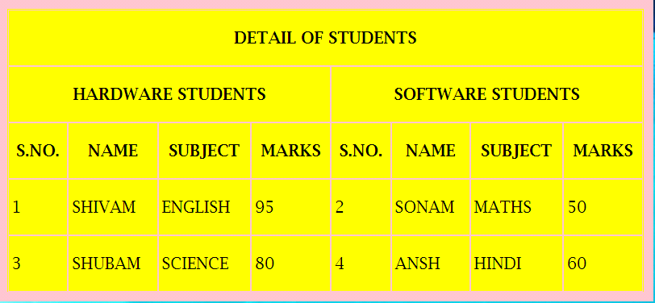

TABLE WITH CAPTION, LINK, WIDTH, TABLE/DATA ALIGNMENT

<TABLE ALIGN=CENTER BORDER=3 BORDERCOLOR= PINK BGCOLOR CELLPADDING=0 CELLSPACING=0 WIDTH=70%> <BR>

<CAPTION>DOWNLOAD ATTACHEMENT </CAPTION>
<TR><TH>FILE NAME</TH> <TH>REC.DOC.</TH></TR>
<TR><TD ALIGN=CENTER> NOTICE</TD> <TD ALIGN=CENTER> <A HREF="C:\Users\hp\3D Objects\Captures\HTML">FILE.HTML</A></TD></TR>

</TABLE>
</BODY>
</HTML>

(b)ROWSPAN
<TABLE ALIGN=CENTER BORDER=3 BORDERCOLOR= PINK BGCOLOR CELLPADDING=0 CELLSPACING=0 WIDTH=70%> <BR>
<CAPTION>DOWNLOAD ATTACHEMENT </CAPTION>
<TR><TH>FILE NAME</TH><TH COLSPAN=2>DOWNLOADS</TH></TR>
<TR ALIGN=CENTER>
<TD ROWSPAN=2>REC.DOC.</TD> <TD> <A HREF= "C:\Users\hp\Downloads">NOTICE</A></TD>
<TD> <A HREF="FILENAME.HTML">ADVERTISEMENT </A></TD></TR>
<TR ALIGN=CENTER><TD COLSPAN=2> <A HREF="C:\Users\hp\Downloads">APPLY ONLINE</A></TD></TR>

