**Name: Shivam Rajaram Shinde**

**Roll No.: 180**

**Div: CV1**

**Computer Vision Assignment No. 1**

**Problem Statement :** Average Filter (3x3, 5x5, 11x11, and 15x15). Analysis of using avg filters with different kernel sizes. Adding Salt and Pepper noise. Removing noise using a median filter with different kernel sizes. Analysis of using Gaussian kernels with different kernel sizes for Blur effect.

**Average Filter (3x3, 5x5, 11x11, and 15x15). Analysis of using avg filters with different kernel sizes.**

On increasing kernel size, the resulting image has less high frequency and less noise. On increasing, the kernel size image gets smoother. Edge details are not preserved.

**Original Image**

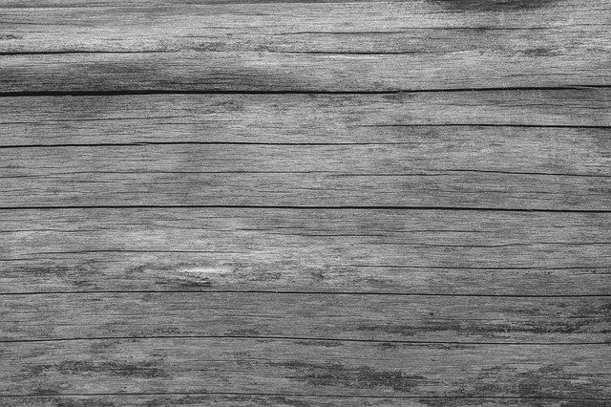

**Average Filter of 3x3**

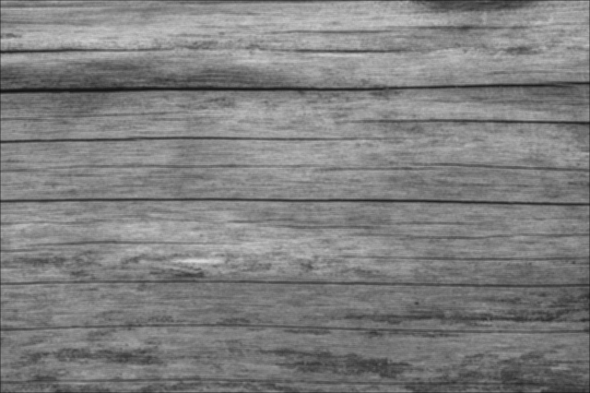

**Average Filter of 5x5**

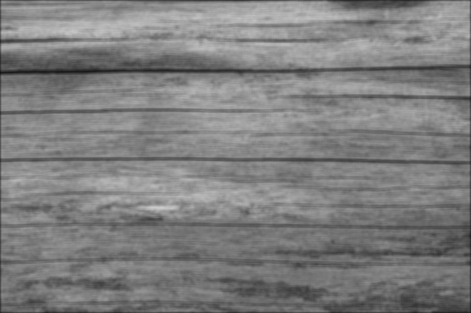

**Average Filter of 11x11**

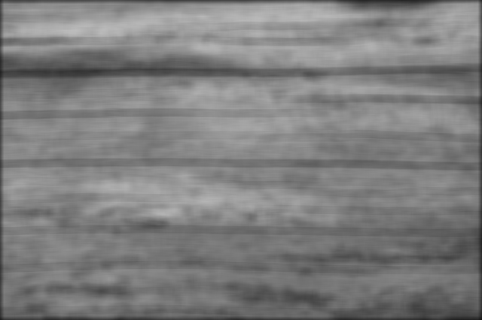

**Average Filter of 15x15**



**Adding Salt and Pepper noise. Removing noise using a median filter with different kernel sizes.**

On increasing kernel size, image quality is degraded. It seems like median filter is not good for images with high noise. On increasing kernel size image gets smoother. But median filter is better than Average filter on preserving edge details.

Salt and Pepper Noise

**Original Image**

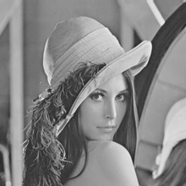

**10% Salt and Pepper Noise 20% Salt and Pepper Noise**

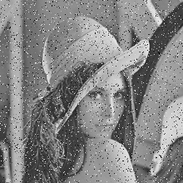 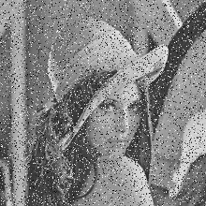

**Results of Median Filtering on 10% Salt and Pepper Noise Image**

**Kernel Size 3x3 Kernel Size 5x5 Kernel Size 11x11**

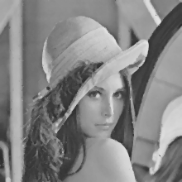 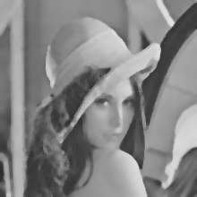 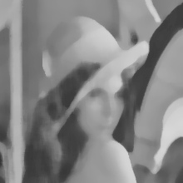

**Results of Median Filtering on 20% Salt and Pepper Noise Image**

**Kernel Size 3x3 Kernel Size 5x5 Kernel Size 11x11**

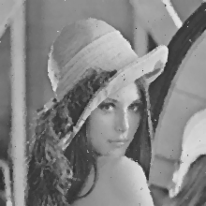 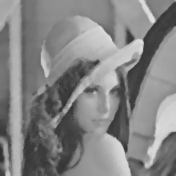 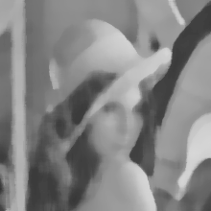

**Analysis of using Gaussian kernels with different kernel sizes for Blur effect.**

Pixel gets more spread out in gaussian on increasing kernel size. Image get much smoother. On increasing kernel size of pixels also increase. Thus creating more blurriness in the image. It also reduces high frequency details significantly on increasing kernel size.

**Results of Gaussian Filter on original image**

**Original Image**

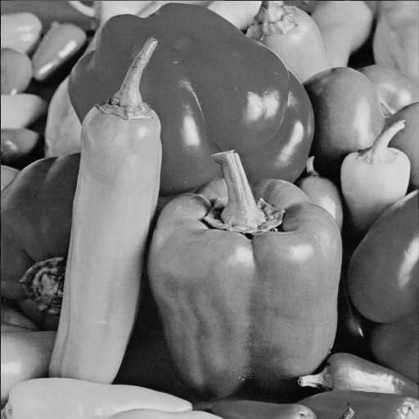

**Gaussian Filter Kernel 3x3, 𝜎 = 1 Gaussian Filter Kernel 5x5, 𝜎 = 3**

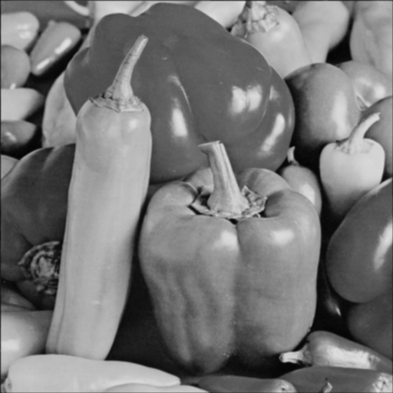 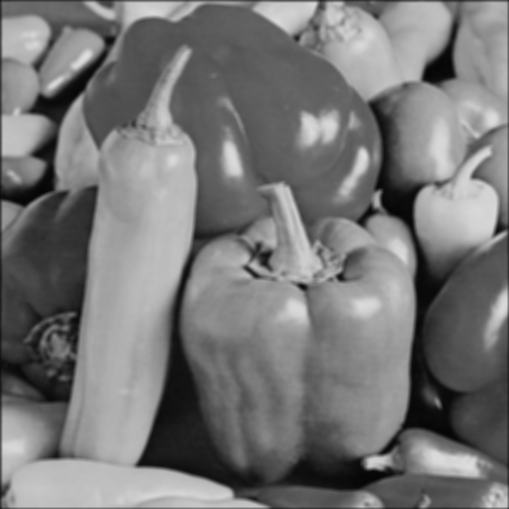

**Gaussian Filter Kernel 11x11, 𝜎 = 4 Gaussian Filter Kernel 15x15, 𝜎 = 7**

