**Name : Shivam Rajaram Shinde**

**Roll No.: 180**

**Div : CV1**

**Computer Vision Assignment-2**

**Problem Statement:**

Image Annotation using mouse.

Add Trackbar as controller

**Output:**

Original Image:

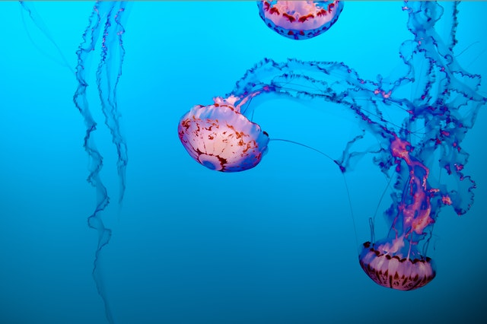

1) Image Annotation using Mouse

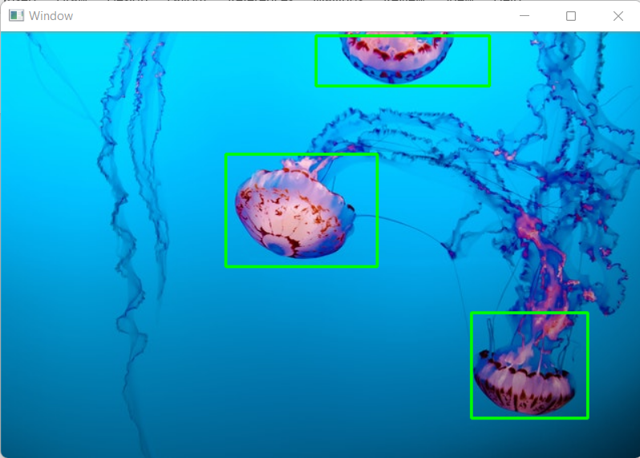

2) Add Trackbar as controller

**Scale-1**

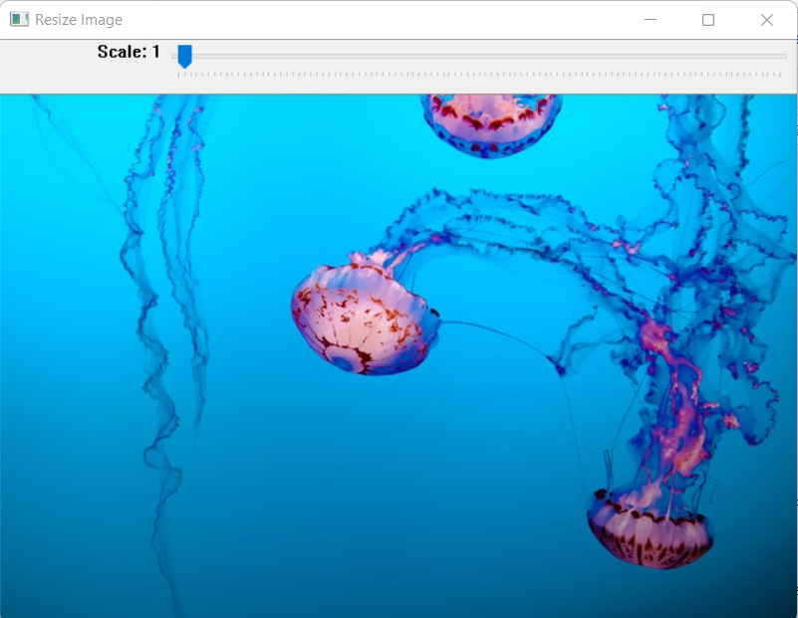

**Scale-36**

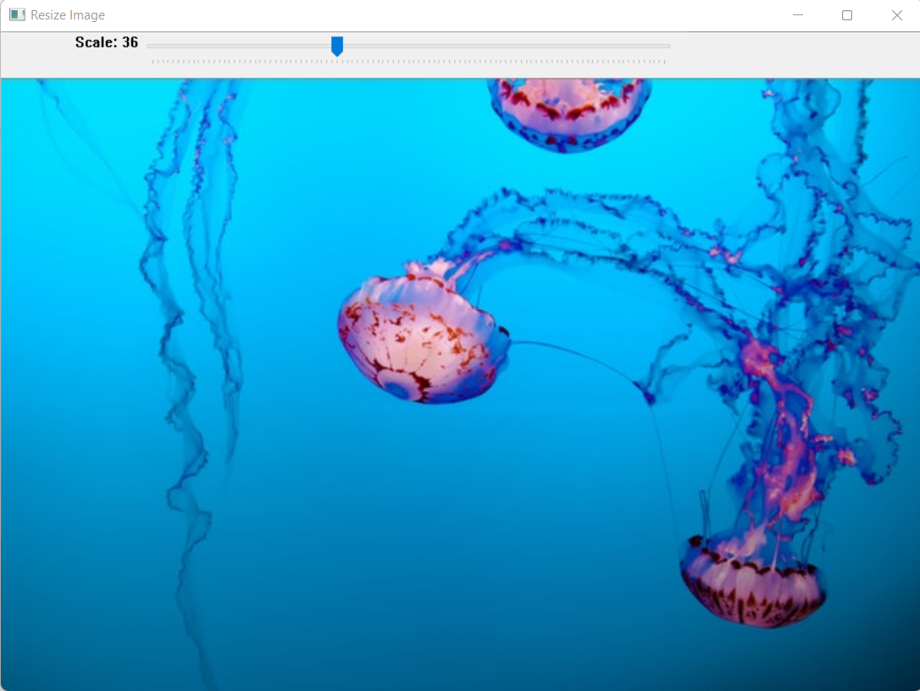

**Scale-100**

