**Think and Answer**

**eYRC#2586**

|  |  |
| --- | --- |
| **Team leader name** | Aditya Kore |
| **College** | Dr. Vishwanath Karad MIT World Peace University |
| **Email** | adityakore16@gmail.com |
| **Date** | 25-11-2019 |

Please answer all the questions given below. You are allowed to use figures or diagrams to support your answer. Since these questions test your understanding of the whole subject, please refrain from directly asking for answers on Piazza.

**Section 1 - Simple Pendulum**

Q1) Find the eigenvalues of Simple Pendulum at equilibrium point (0,0). Is the system stable or unstable at this point? (2)

Ans. At equilibrium point (0,0) the eigenvalues will be sqrt(g/L)i , -sqrt(g/L)i. The values are purely imaginary so system will be marginally stable.

Q2) Can the Pendulum be balanced at an arbitrary point such as (2π/3,0) using the Pole Placement or LQR controller? Why? Why Not? Justify your answer. (3)

Ans. Yes, Pendulum can be balanced at an arbitrary point using Pole Placement or LQR controller because we can calculate jacobian for that angle and find state equation for that point. Gain matrix can then be calculated to get negative real eigenvalues for stable system.

**Section 2 - Mass Spring System**

Q3) Derive the equations of Mass Spring system. (3)

Ans.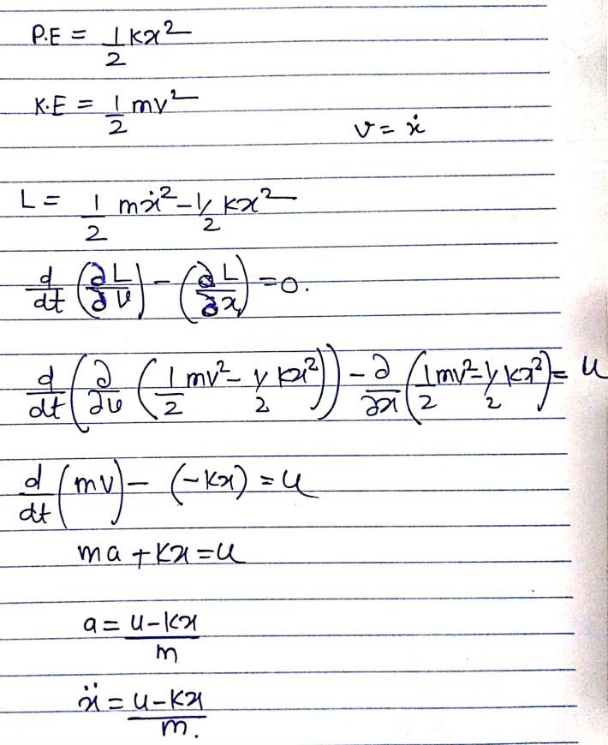

Q4) Is the mass spring system a linear system or non-linear? Justify your answer. (1)

Ans. It is a linear system because degree of state variable ‘x’ is 1.

Q5) Can the mass spring system be driven to arbitrary state (0.8, 0) using pole placement controller? (Assuming 0.8 is the position and 0 is the velocity). (1)

Ans. Yes, the system can be driven to any arbitrary set using pole placement controller.

**Section 3 - Simple Pulley**

Q6) Under what conditions, will the system remain perfectly at rest? Justify your answer. (1)

Ans. The system will remain perfectly at rest when force on both blocks is same. Because net force will balance each other.

Q7) How many equilibrium points does the system have? Are they stable or unstable? Justify your answer. (2)

Ans. The system will have infinite stable equilibrium points if the force on both sides is same. Example when mass of both blocks is same.

**Section 4 - Complex Pulley**

Q8) Derive the equations of motion for the complex pulley system. (5)

Ans.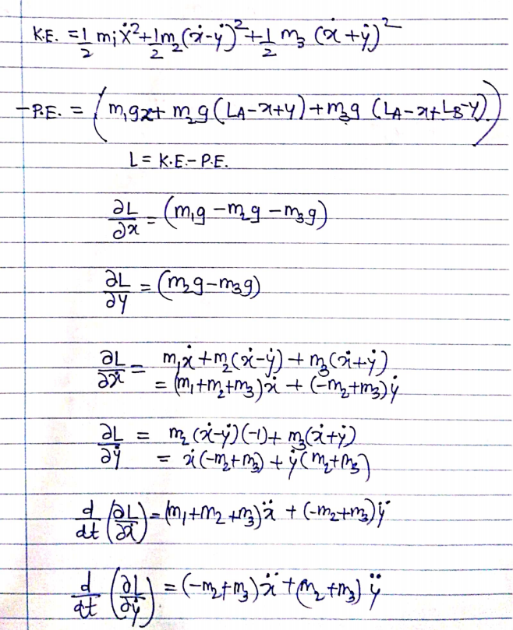

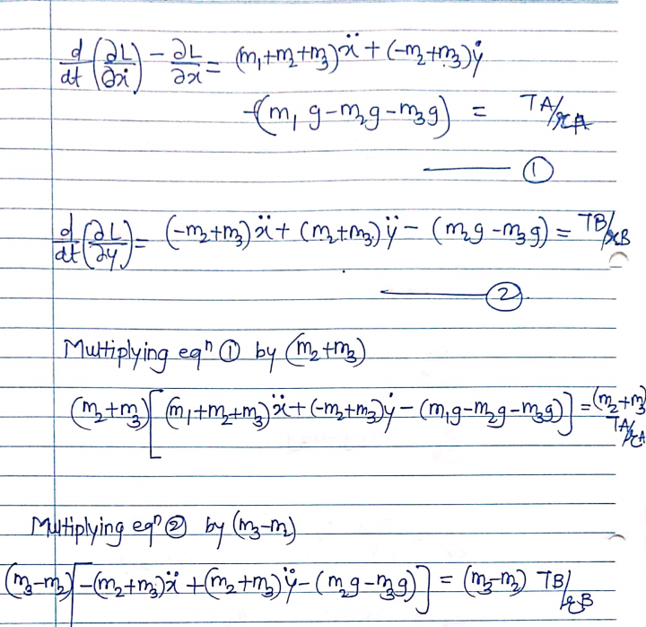

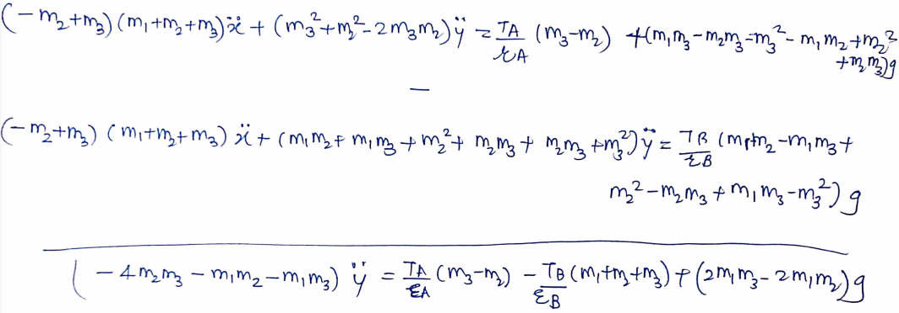

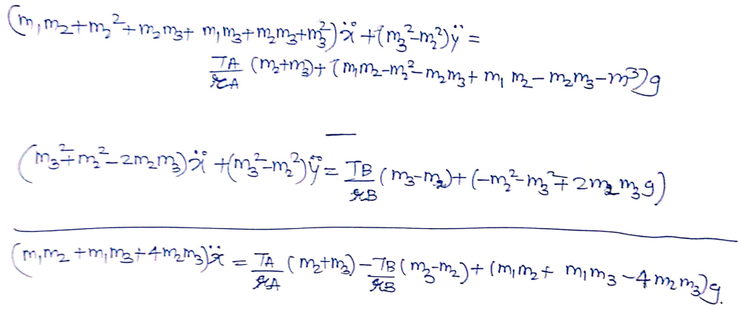

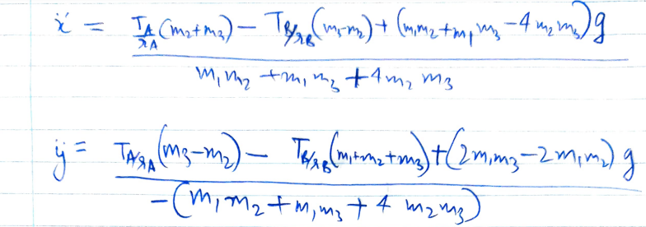

Q9) Derive the A and B matrices for the complex pulley system. Is the system linear or non linear? (4)

Ans.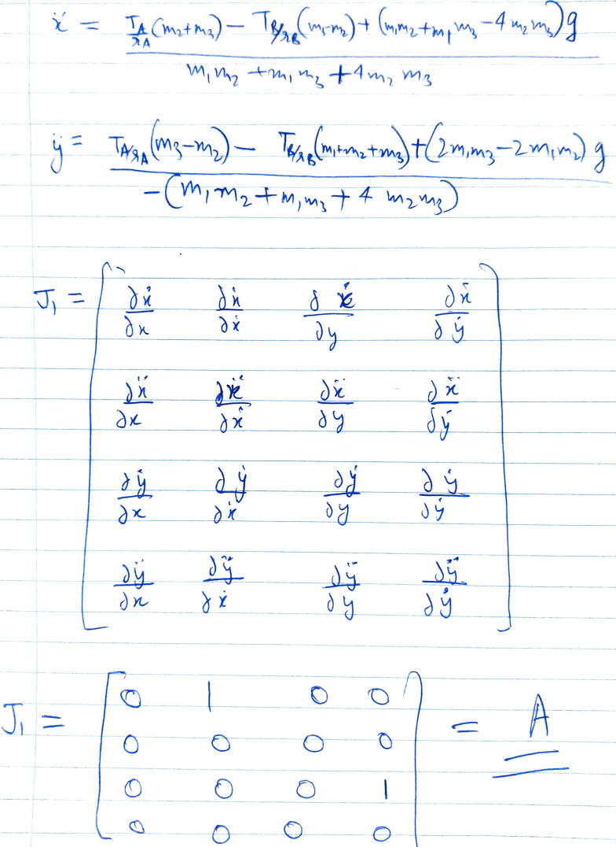

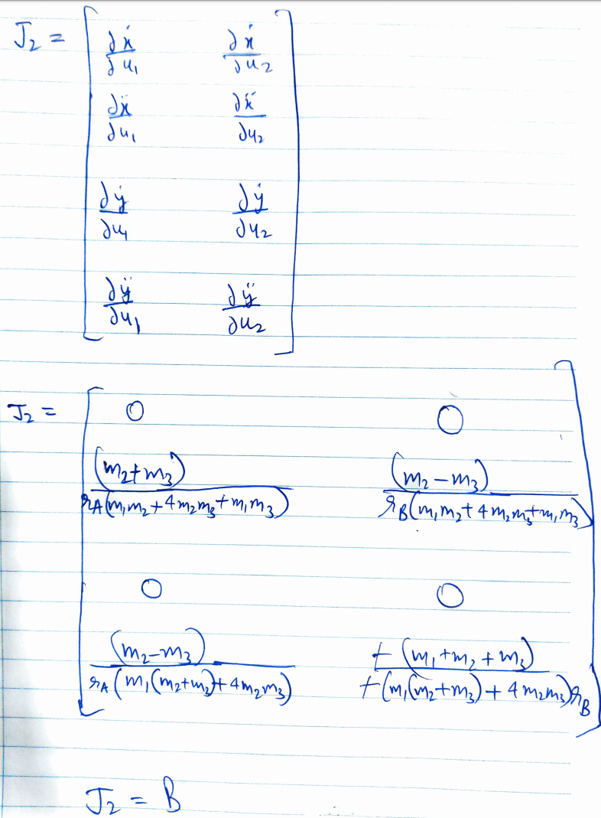

Q10) Under what conditions, will the system remain perfectly at rest? Justify your answer. (3)

Ans. When the net force on both pulleys is zero for example when blocks on both sides have the same mass.

**Section 5 - Inverted Cart Pendulum**

Q11) Derive the equations of motion for the inverted cart pendulum system. Is this system linear or non-linear? Why? (7)

Ans.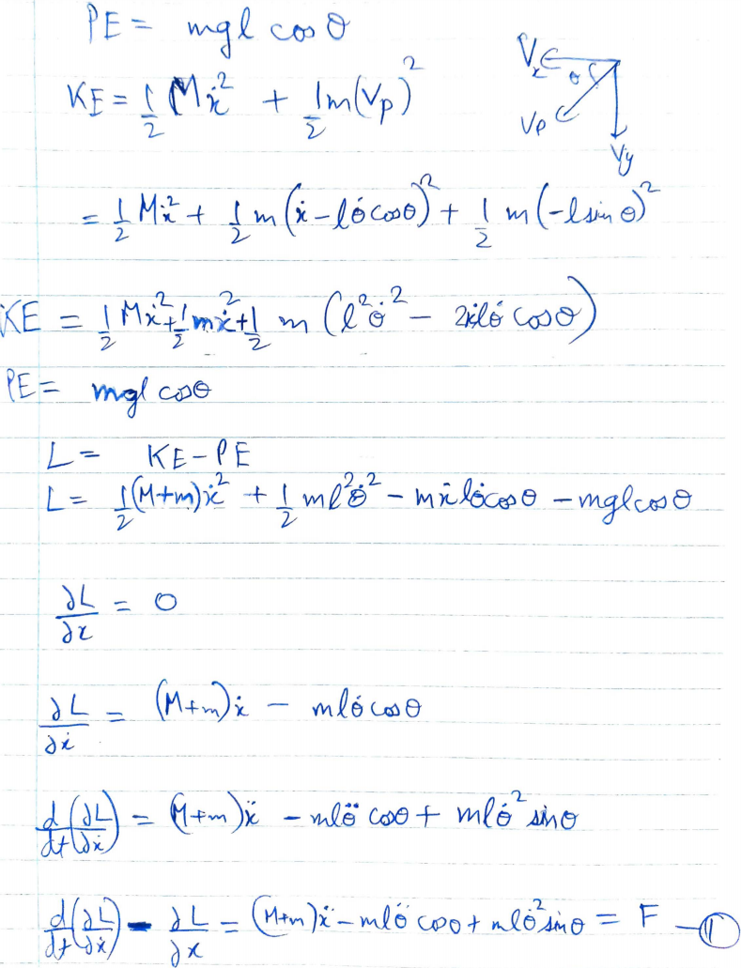

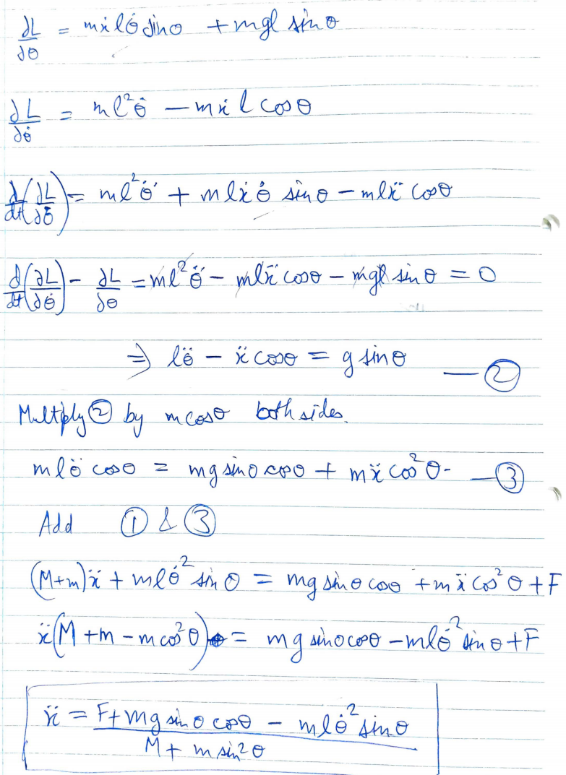

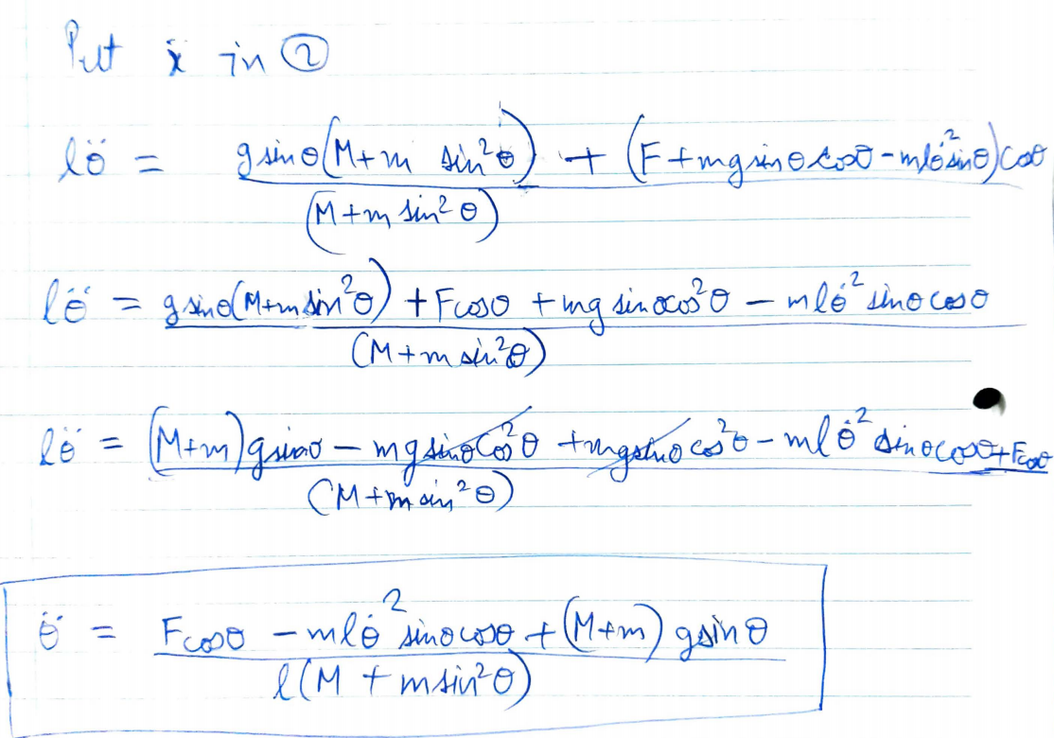

The system is non-linear cause the degree of state equation variable is 2.

Q12) How many equilibrium points does the inverted cart pendulum system have? Categorize them as stable or unstable? (3)

Ans. Inverted Cart Pendulum has 2 equilibrium points at theta=0 and pi. System is in stable equilibrium at theta=0 when pendulum is below the cart and unstable equilibrium theta=pi when pendulum is above the cart.