

APRIL 2023

Cara

## MINI-PROJECT-II REPORT

***Submitted by***

Shivam Prakash Singh (201500653)

Ansh Malhotra (201500109)

Apurva Vashistha (201500138)

Sushant Kumar Singh (201500727)

***in partial fulfilment for the award of the degree of***

# BACHELOR OF ENGINEERING

**IN**

Computer Engineering and Application

## GLA University, Mathura

APRIL 2023

**TABLE OF CONTENTS**

1.Abstract ……..3

2.Introduction ……..4

3.Design flow/ Process ……..5

4.Result & Analysis ….6-11

5.Conclusion & future work …….12

6. References …….13

7.GitHub Link …….14

**ABSTRACT**

This e-commerce website provides an online platform for customers to browse and purchase a variety of products and services. The website offers a user-friendly interface that allows customers to search for products based on category, price range, and other customizable filters. Customers can create accounts, store payment and shipping information, and track their orders through the website. The website also includes features such as product reviews, ratings, and recommendations to help customers make informed purchasing decisions. The e-commerce website is designed to provide a secure and convenient shopping experience for customers, with various payment options and reliable shipping methods..

**Introduction**

An e-commerce website is an online platform where businesses can sell their products or services directly to consumers through the internet. These websites are designed to provide a convenient and easy-to-use interface that allows customers to browse through products, make purchases, and have them delivered directly to their doorstep.

A successful e-commerce website must have several key features, including a user-friendly interface, a secure payment gateway, and an efficient checkout process. The website should also have an attractive design that is consistent with the brand's image and messaging.

To create an e-commerce website, businesses typically use e-commerce platforms or content management systems (CMS) that are specifically designed for online sales. Popular e-commerce platforms include Shopify, WooCommerce, Magento, and BigCommerce.

Once the website is up and running, businesses must also focus on marketing and advertising to drive traffic to the site and convert visitors into customers. This may involve search engine optimization (SEO), social media marketing, email marketing, and other forms of digital advertising.

Overall, an e-commerce website can be a powerful tool for businesses looking to expand their reach and connect with customers in new ways. By providing a convenient and accessible online shopping experience, businesses can tap into the growing trend of online shopping and capitalize on the opportunities presented by the digital economy.

# DESIGN FLOW/PROCESS

1. Research and Analysis: This stage involves gathering information about the business, target audience, competitors, and market trends. Conducting user research to identify user needs, preferences, and behaviors can help in designing a website that meets the user's requirements.
2. Planning: Based on the research findings, the website's design plan is created, which includes the website's layout, functionality, features, and navigation. Planning involves creating a sitemap, wireframes, and prototypes to visualize the website's structure and design.
3. Design: In this stage, the website's visual design is created. This includes selecting the color scheme, typography, graphics, and images that align with the brand identity and target audience.
4. Development: This stage involves coding the website using HTML, CSS, and JavaScript. E-commerce websites typically require additional development work to integrate payment gateways, shopping carts, and inventory management systems.
5. Testing: The website is thoroughly tested to ensure that it is user-friendly, responsive, and functional across different devices and browsers. Testing also involves checking the website's security, performance, and accessibility.
6. Launch: Once the website is tested and approved, it is launched. This involves uploading the website to a hosting server, configuring the domain name, and setting up analytics to track website performance.
7. Maintenance: Maintaining an e-commerce website is an ongoing process that involves monitoring the website's performance, fixing bugs, updating content, and adding new features to improve the user experience.

# RESULTS AND ANALYSIS

Home Page:-

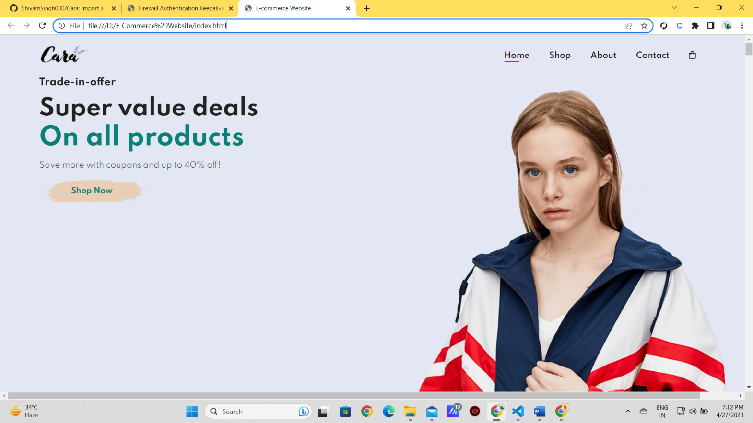

The Home page is the base page of our website it will allow the user to travel through all the pages and allow users to experience all the opportunities.

It consists of a nav bar, and a footer, with background URLs and images linked to several pages of the website. HTML,CSS is the only technology used in it.

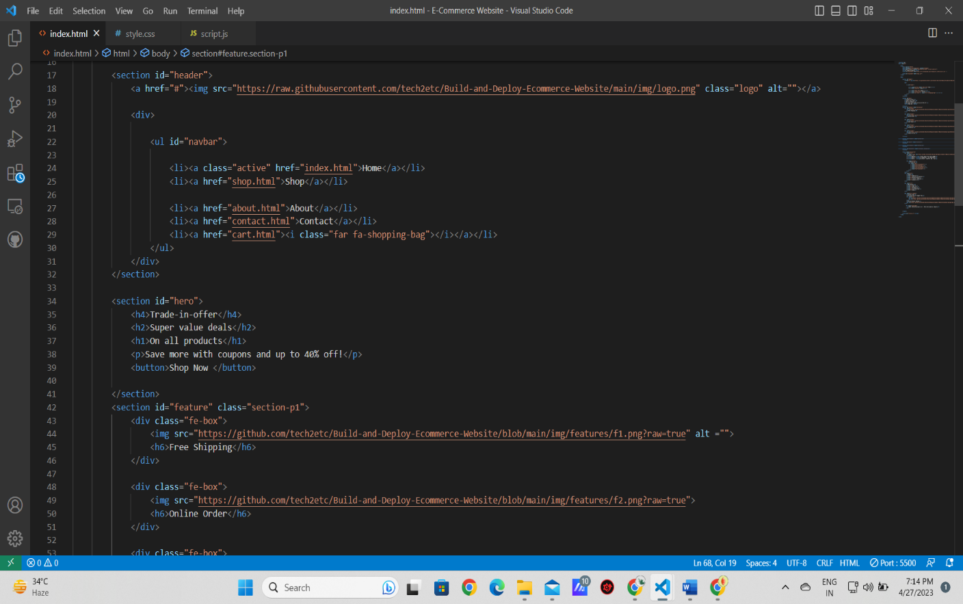

About us Page:-

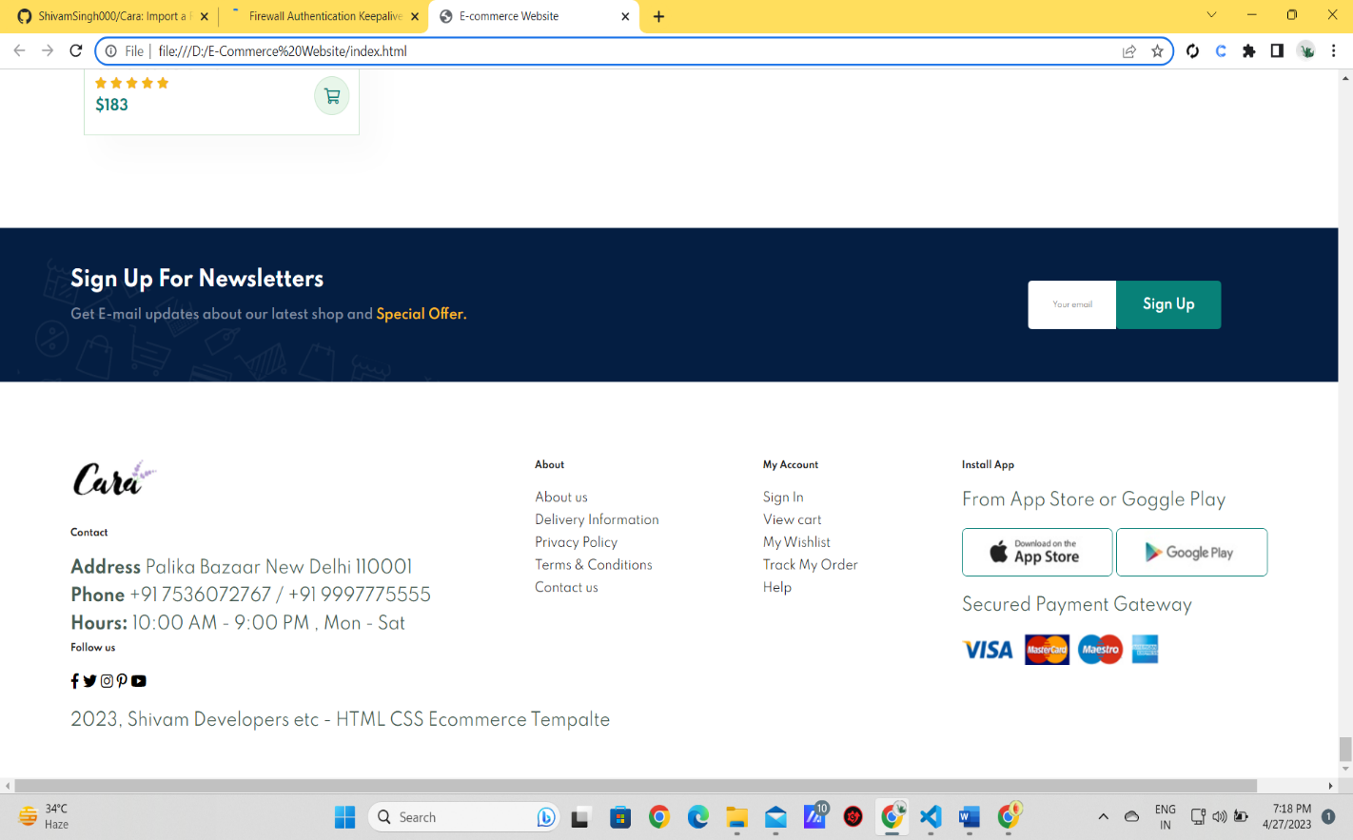

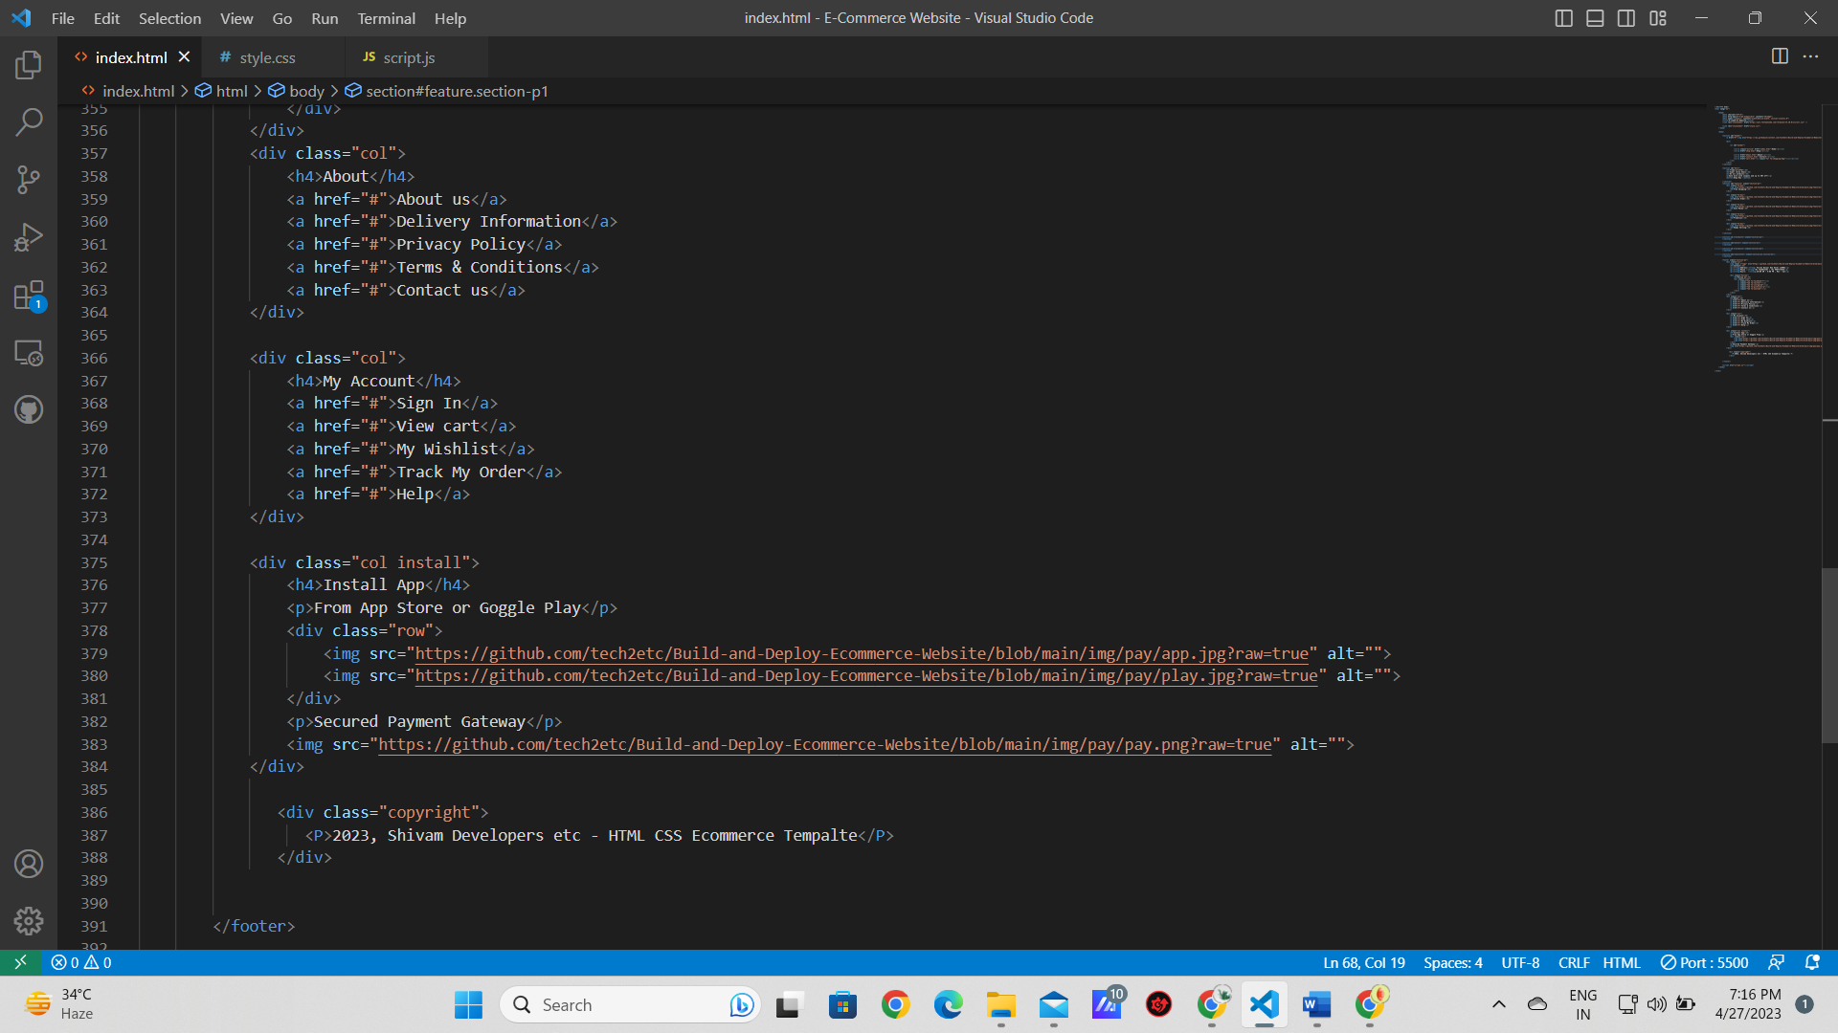

Featured Product Page:-

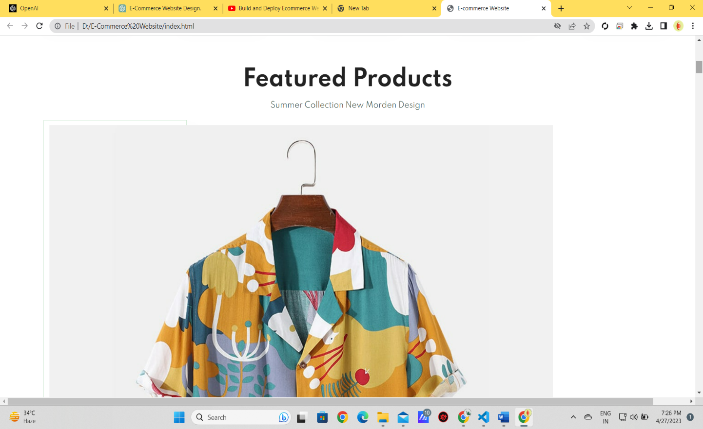

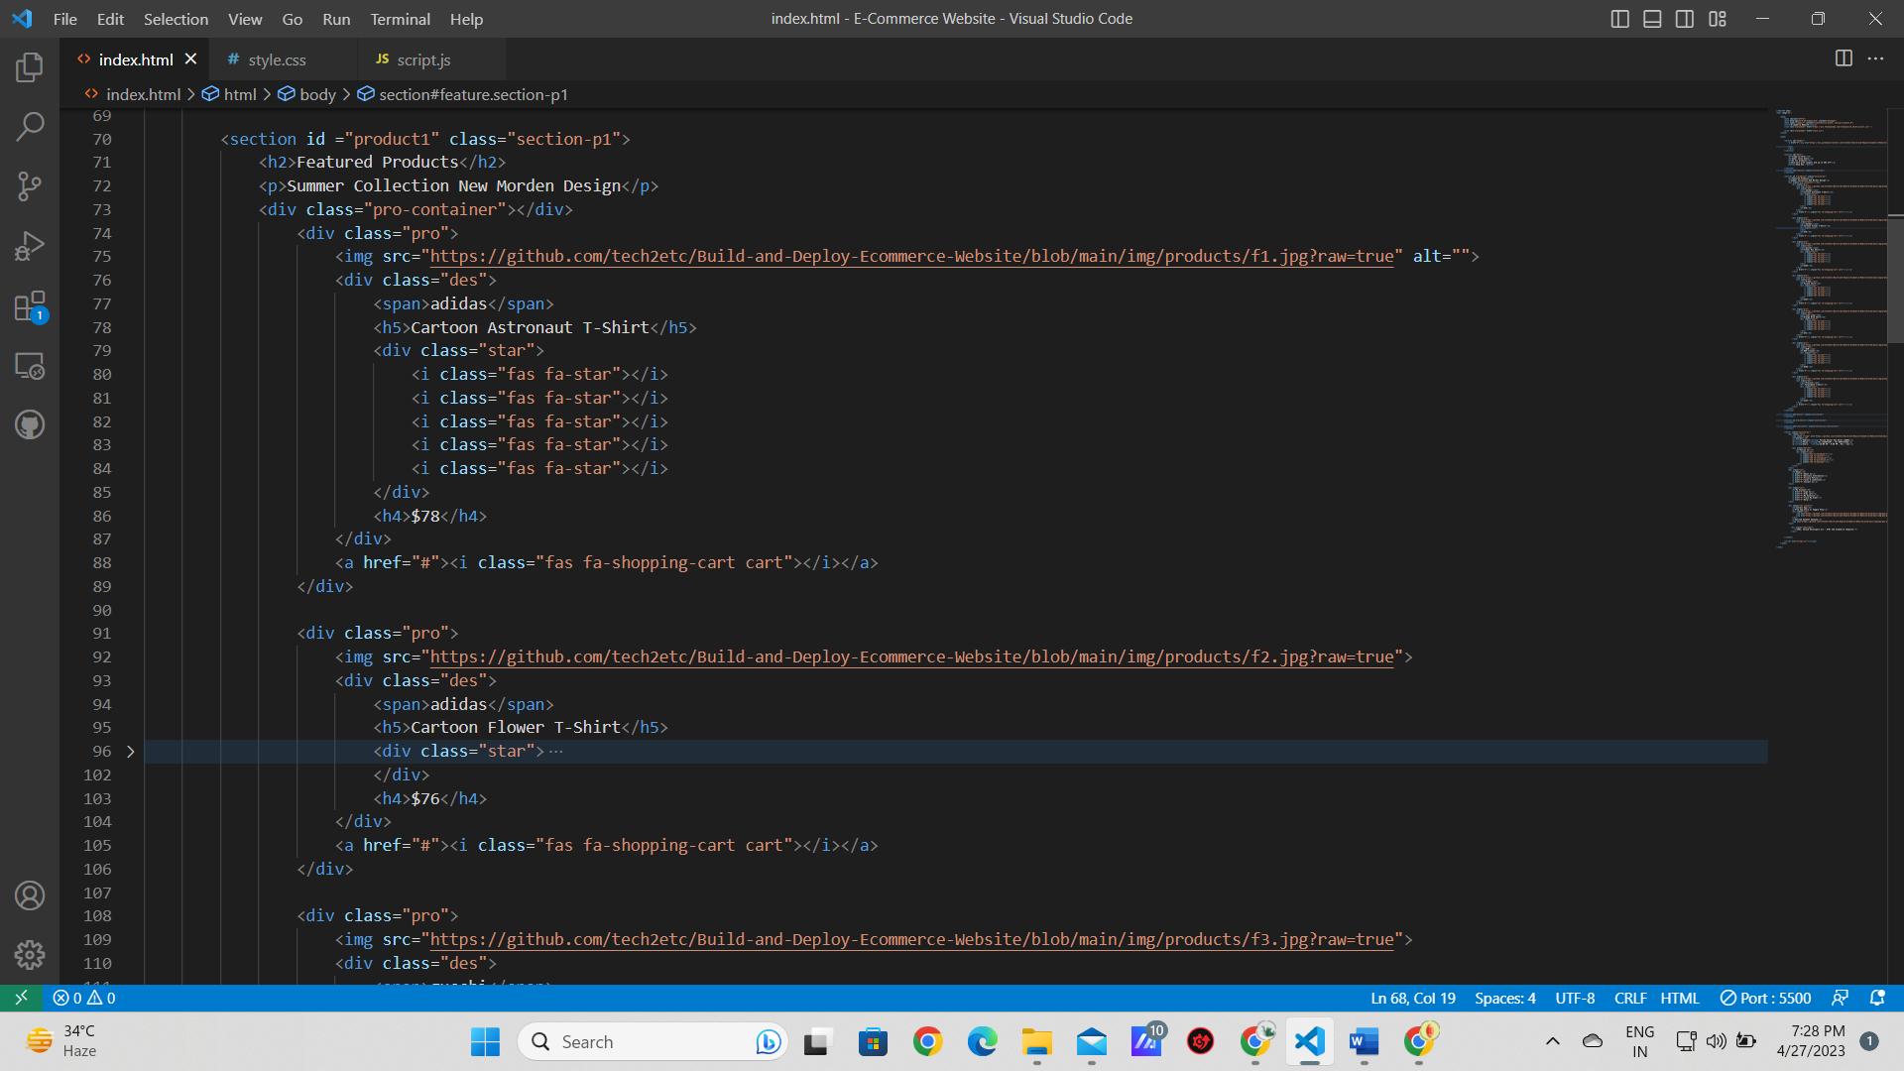

# CONCLUSION AND FUTURE WORK

This project is an open-source website for all age groups. Friendly UI helps in finding the required information. Though all the vital information is free but in future, we are going to modify, the paid courses will help users with one-on-one tutors. A big-time database will be monitored and we will provide goodies and memberships to learners.

# REFERENCES

Websites:

* W3Schools
* YouTube
* JavaTpoint
* GFG

**GITHUB LINK**

[**https://github.com/ShivamSingh000/Cara**](https://github.com/ShivamSingh000/Cara)