Experiment -1.1

**Student Name:** Shivam **UID:** 22BDO10025

**Branch**: AIT-CSE-DevOps **Section/Group:** 22BCD-1/A

**Semester:** 5 **Date of Performance:** 20 july 2024

**Subject Name:** Docker and Kubernates **Subject Code:** 22CSH-343

1. **Aim/Overview of the practical:**

Write JavaScript to validate the following fields of the registration form:

* + First Name (Name should contains alphabets and the length should not be less than 6 characters)
  + Password (Password should not be less than 6 characters length
  + E-mail id (should not contain any invalid and must follow the standard pattern, name@domain.com)
  + Mobile Number (Phone number should contain 10 digits only)
  + Last Name and Address (should not be Empty)

1. **Apparatus:** Windows 11 PC, VS Code, Chrome Browser
2. **Steps for experiment/practical:**
3. **First name: HTML:** 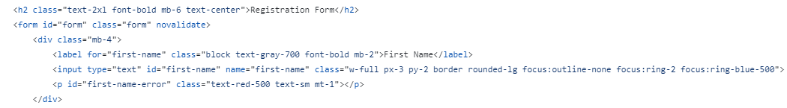
4. **Last name:**

**HTML:**

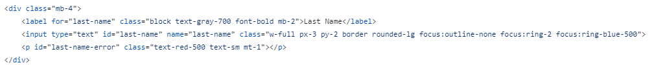

**JavaScript:**

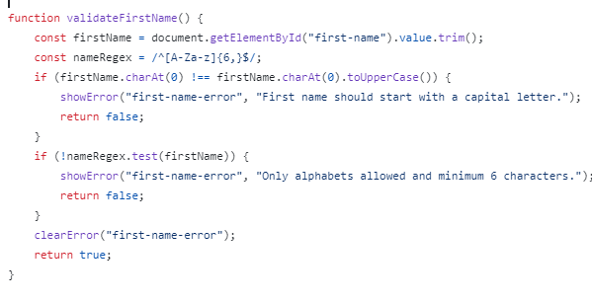

1. **Password: HTML:**

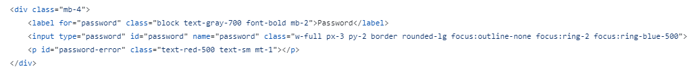

**Javascript:**



**Error Log:**

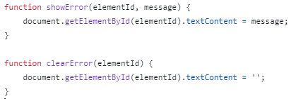

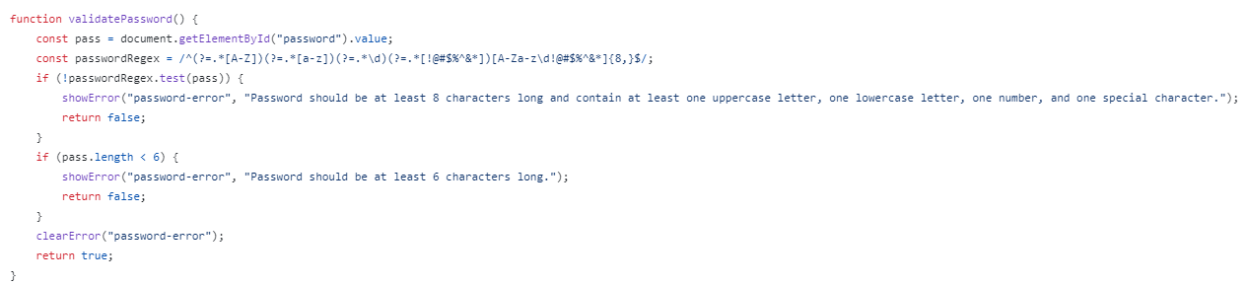

1. **Email:**

**HTML:**

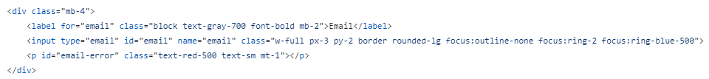

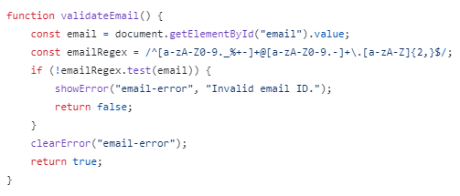



1. **Phone Number: HTML:**

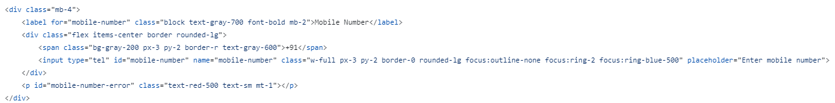

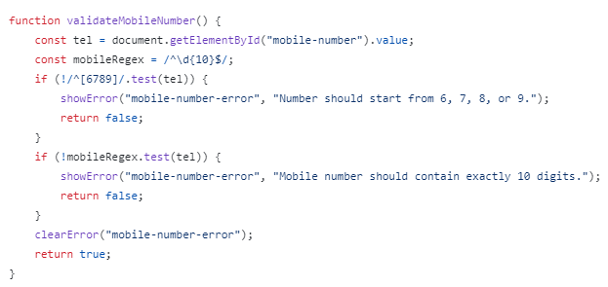



**6:Address:**

**HTML:**

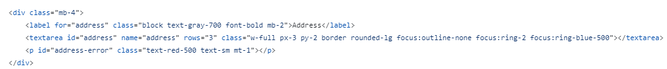

1. **Result/Output/Writing Summary:**

**PTO**

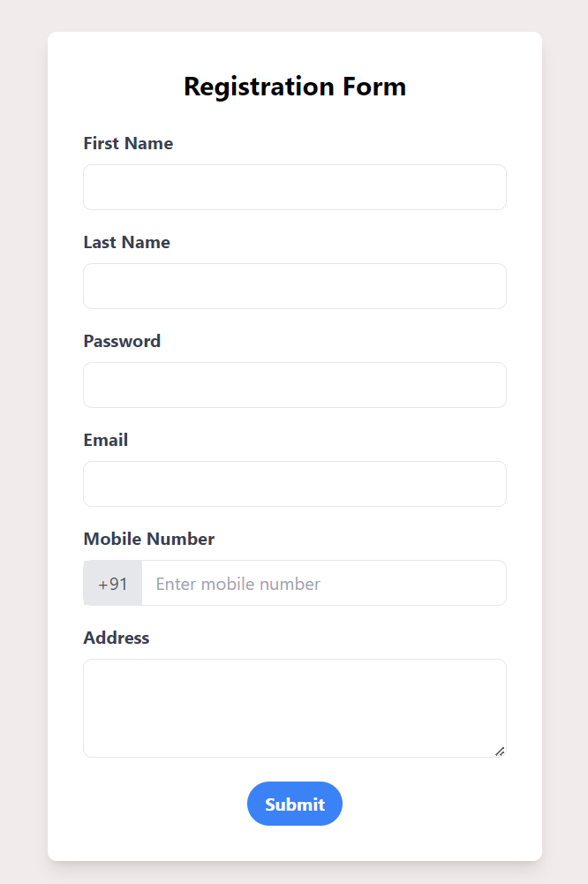

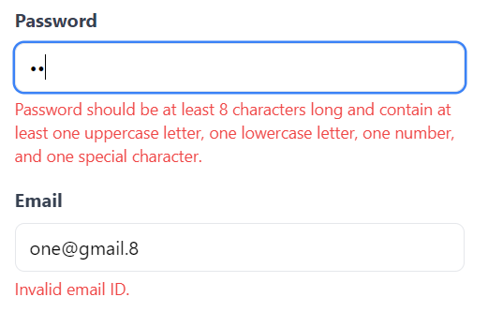

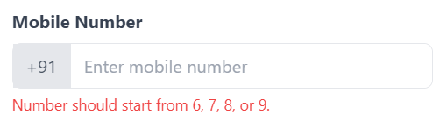

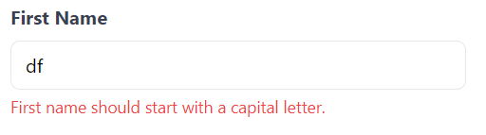

**Learning outcomes (What I have learnt):**

1. I have learnt how to structure a webpage using HTML
2. I have learnt how to grant logic in our webpage using JavaScript
3. I have learnt how to design our webpage using CSS
4. I have learnt how I can show an element based on some condition
5. I have learnt about the DOM model in JS

**Evaluation Grid (To be created as per the SOP and Assessment guidelines by the faculty):**

|  |  |  |  |
| --- | --- | --- | --- |
| Sr. No. | Parameters | Marks Obtained | Maximum Marks |
| 1. |  |  |  |
| 2. |  |  |  |
| 3. |  |  |  |
|  |  |  |  |