To Build a V-Profile Project

Anand Tiwari(AIT-Chandigarh University), Ankur Gupta(AIT-Chandigarh University), Shivam(AIT-Chandigarh University),Vishwachi Pandey(AIT-Chandigarh University)

***Abstract*—This project's multi-tier nature provides a comprehensive environment for developers to work on different aspects of the application, from server-side scripting with PHP/Python/Perl, managing databases with MySQL, to handling web server configurations using Apache and NGINX. Additional components such as Tomcat, RabbitMQ, and Memcached are seamlessly integrated to support diverse functionalities and improve the overall performance of the application.**

***Keyword***—***V-profile, Ngnix, Apache, Memecached, WordPress LAMP STACK***

1. Introduction

THE development workflow for multi-tier web applications, particularly those utilizing the LAMP stack with additional components like NGINX, Tomcat, RabbitMQ, Memcached, and MySQL, all within a WordPress framework. Let's break down the key points and aspects of your project:

Challenges Addressed: We have identified several challenges in the current development ecosystem, including complexity in local setups, non-reproducibility of environments, limited comfort in implementing real changes, inefficient R&D capabilities, and reliance on manual configurations. These are common pain points in web development, especially in complex environments like the one you're dealing with.

Tools and Technologies: We have chosen a set of tools and technologies to achieve your objectives, including Vagrant, VirtualBox, Git Bash, and Visual Studio Code. These tools are widely used in the industry and are well-suited for automating and managing development environments.

Architecture and Components: Our project's multi-tier architecture, which includes LAMP, NGINX, Tomcat, RabbitMQ, Memcached, and MySQL within a WordPress framework, provides a comprehensive platform for developers to address various aspects of web development, from server-side scripting to database management and beyond. This comprehensive setup ensures that developers have the necessary resources to build and test their applications effectively.

Benefits: By establishing an automated, code-driven local environment, your project empowers developers to conduct meaningful R&D activities. It enables the creation of isolated test environments, ensuring that changes are thoroughly tested before deployment to production. Additionally, the adoption of version control with Git enhances collaboration, while tools like Vagrant and VirtualBox provide a scalable infrastructure for local development.

1. OBJECTIVE

The objectives of implementing the automated, repeatable, and standardized local development environment for the multi-tier web application are defined to address the identified challenges and enhance the overall development process. These objectives guide the project towards achieving a more efficient and developer-friendly environment:

1. Simplify Local Setup.
2. Ensure Reproducibility.
3. Enable Comfortable Real Changes.
4. Enhance R&D Capabilities.
5. Minimize Dependency on Manual Configurations
6. LITERATURE REVIEW
7. *Resonance-Enhanced Wideband Grating for Efficient Perfectly Vertical Coupling*

In the research paper, a resonance enhanced center-symmetric structure is proposed and experimentally validated to increase the optical bandwidth of waveguide grating couplers. The experimental results demonstrate a state-of-the-art performance in increasing the 1 dB optical bandwidth of perfectly vertical grating couplers to 121 nm for standard single mode fiber. The proposed structure is designed based on the Resonant-cavity-enhanced structure and exhibits a broadband and flat transmission spectrum. The authors used a genetic algorithm for optimization and achieved a coupling efficiency of −3.78 dB with a 1-dB bandwidth of 130 nm through simulation. The experimentally measured coupling efficiency was −4.6 dB with a 1-dB bandwidth of 121 nm. The proposed grating coupler had good fabrication tolerance and is suitable for large-scale photonic integration. Compared to previous grating couplers, this broadband grating coupler demonstrated a significant improvement and is applicable to various practical applications.

1. *Scaling Memcached at Facebook*

The research paper discusses how Facebook utilizes Memcached as a core component to create and expand a distributed key-value store supporting the largest social network worldwide. The system is designed to manage an immense volume of requests and store trillions of items to provide a seamless experience for over a billion users. The paper emphasizes the system's operation, such as get k and SELECT, and mentions its involvement with the database, web server, and Memcached. The authors describe the evolution of Facebook’s Memcached-based architecture and highlight enhancements to Memcached that improve performance and increase memory efficiency. They discuss the deployment of Memcached pools, traffic per server on selected Memcached pools, and the distribution of item sizes for various pools in bytes. The paper also characterizes the Memcached workload using data from servers running in production and provides an analysis of the load and performance and capacity of Memcached pools. Finally, the paper addresses other large websites that have recognized the utility of key-value stores, such as Amazon, LinkedIn, and Twitter.

Operation and Design Overview

The paper discusses the utilization of Memcached as a fundamental component in Facebook's system to create and expand a distributed key-value store that supports the world's largest social network. The system is designed to handle an immense volume of requests and store trillions of items, aiming to provide a seamless experience for over a billion users. The operations of the system, such as get k and SELECT, are highlighted, along with its association with the database, web server, and Memcached. Additionally, the paper emphasizes the importance of incorporating transactional consistency and automatic management in an application data cache, indicating the focus on maintaining system integrity and reliability. Overall, the study sheds light on the intricate design and operation of Facebook's key-value store and its critical role in supporting the massive scale and seamless experience for its vast user base.

1. *Web Server Performance of Apache and Nginx: A Systematic(2017)*

The paper provides a thorough review of various studies comparing the performance of web servers, with specific focus on Apache and Nginx. The study compares metrics such as response time, CPU utilization, and memory usage under different workloads and webpage sizes. The findings indicate that Nginx outperforms Apache in many metrics, showing better response time, CPU utilization, and memory usage. Nginx's performance is highlighted as more consistent under increased requests, while Apache's memory usage increases quickly with additional requests. Additionally, the study suggests that future research should consider including metrics such as uptime and landing page speed in the testing of web server performance. The conclusion emphasizes that both Apache and Nginx are powerful and capable, and the choice of web server should be based on specific user needs. Overall, the paper provides a comprehensive analysis of web server performance and highlights the superiority of Nginx over Apache in various performance metrics.

1. *Vulnerability Analysis of Vagrant Boxes(2017)*

A research paper from the Blekinge Institute of Technology, Sweden, examines security aspects of virtual machines and the benefits of abstraction compared to regular machines. The research shows that while abstraction provides some security benefits, many vulnerabilities from regular machines remain even on virtual machines. The authors introduce Vagrant as a management tool for virtual machines and identify a shortcoming in automatically scanning these Vagrant boxes for vulnerabilities and insecure configurations. To solve this, they establish a method to automatically detect such vulnerabilities without running the box or executing code. The method includes base box scanning as well as analysis of the Vagrant file using static code analysis. The results give an indication of the number of vulnerabilities in a given box, despite some limitations. The study contributes to the understanding of security aspects of virtual machines and suggests methods to manage vulnerabilities in the large number of virtual machines in use today.

1. *Doing database design with MySQL(2015)*

The paper discusses the use of MySQL as a relational database management system in two database-design learning cases. It highlights the forward-engineering technique to transform a data model into a physical database and the reverse-engineering process to create a data model from an existing database using MySQL Workbench and MySQL Community Server. The paper also compares the capabilities of MySQL to Microsoft Access in terms of reverse engineering a physical database into a relationship diagram. It emphasizes the importance of database design in the development process, focusing on logical data modeling, Entity Relationship Diagrams (ERDs), and transformation techniques. The study provides two comprehensive cases of structuring an ERD followed by forward engineering and reverse engineering using MySQL Workbench. It also delves into the analysis of a problem statement, model development, database implementation, and the important features of the tools involved in the process. Additionally, the paper addresses the challenges in teaching and learning database design, emphasizing the significance of graphical tools, especially when working in a team setting. The paper concludes by underlining the role of MySQL Workbench in providing excellent graphical and technological tools for database designers and the importance of considering it in teaching introductory database courses.

1. *Distributing Messages Using Rabbitmq with Advanced Message Exchanges(2019)*

The research paper explores the utilization of RabbitMQ, an open-source message-broker software, which implements the Advanced Message Queuing Protocol (AMQP) and offers support for protocols such as STOMP and MQTT through a plug-in architecture. The paper emphasizes RabbitMQ's server program being written in Erlang and its support for clustering and failover using the Open Telecom Platform framework. The AMQP protocol and the different types of exchanges utilized by RabbitMQ are also a focal point. It discusses the AMQP model, message acknowledgements, and various exchange types (direct, fanout, and topic exchanges) with detailed explanations. The paper also highlights the features of RabbitMQ such as reliability, routing, clustering, high availability, management web user interface, command-line interface, cross-platform nature, and support for AMQP Version 0-9-1. Notably, the comparative arguments for Kafka and RabbitMQ are also briefly mentioned.

1. METHODOLOGIES

The methodology for implementing the automated, repeatable, and standardized local setup for the multi-tier web application is structured and systematic. It begins with a comprehensive analysis of the current development environment and gathers requirements from stakeholders. The selection of appropriate technologies and tools, including Infrastructure as Code principles, configuration management, and local testing environment setup, follows. Documentation and training ensure a smooth transition for the development team. User feedback plays a crucial role, with iterative development addressing suggestions and issues. Integration with the existing development workflow, security considerations, and monitoring tools contribute to a seamless and secure environment. The methodology concludes with a focus on ongoing maintenance, ensuring the continued efficiency and relevance of the automated setup. This approach aims to deliver a user-friendly and secure local development environment, promoting collaboration, innovation, and efficiency in multi-tier web application development.

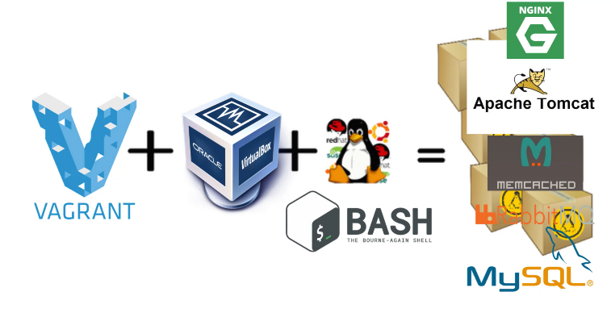

Figure1. Tools used

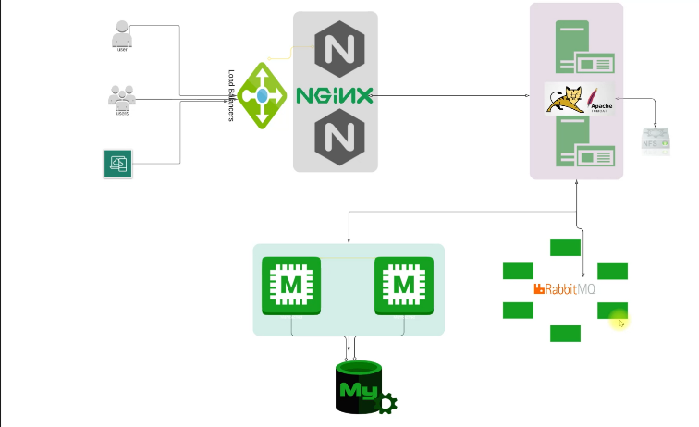

Figure2. Services workflow

VII.EXPERIMENTAL SETUP

The experimental setup for validating the automated, repeatable, and standardized local development environment involves configuring development machines with a minimum of 8GB RAM, multi-core processors, and necessary storage. Key software components include VirtualBox or VMware for virtualization, Vagrant for automation, Git bash for command-line operations, and Visual Studio Code with relevant extensions for development. The setup process includes installing and configuring these tools, cloning the project repository with automated scripts, and installing necessary development tools. Automated setup execution is initiated by running Vagrant commands, closely monitoring for errors. Feature development occurs within Visual Studio Code, utilizing Git for version control. Performance and stability testing involve using tools like Apache JMeter, assessing key metrics, and evaluating system stability under varying workloads. The experimental findings are summarized in a comprehensive report, highlighting insights into the effectiveness and efficiency of the automated local development environment. The report includes recommendations based on the observed performance and stability metrics, providing valuable guidance for further optimization and utilization in multi-tier web application development.

1. Conclusion

The V-Profile project aims to streamline the local setup process for multi-tier web applications, facilitating seamless research and development activities on laptops or desktops. Addressing the challenges of complexity and non-repeatability in local setups, the project provides an automated solution through code, enabling users to make changes comfortably in a simulated environment. Utilizing tools such as Oracle VM VirtualBox for hypervisor, Vagrant for automation, Git Bash for CLI, and VS Code as the IDE, the project's objective is to automate VM setup locally, empowering users to conduct extensive research and development activities on their machines. The architecture of the project services encompasses crucial components such as NGINX, TOMCAT for Java web applications, RABBITMQ, MEMCACHED, and MYSQL, fostering a comprehensive development environment. The automated setup architecture revolves around Vagrant, VirtualBox, and Git Bash, orchestrating an efficient environment for project development and experimentation. In conclusion, the V-Profile project offers a robust framework for setting up and conducting research and development activities locally, enhancing user comfort, repeatability, and efficiency in managing project runtime services

VI. FUTURE SCOPE

The project expands its versatility by incorporating Redis, MongoDB, and Elasticsearch support. Docker integration enhances isolation, portability, and scalability. Advanced configuration tools like Ansible automate setup and maintenance. Users can customize environments, selecting service versions and resource allocations. Integration with CI/CD pipelines automates deployment, ensuring smooth transitions between development, testing, and production. This facilitates rapid iteration with confidence and reliability, streamlining the development lifecycle. With these enhancements, the project offers a robust platform for web application development, empowering developers to tackle diverse challenges efficiently and effectively while maintaining a high level of flexibility and control over their environments.

IX.REFERENCES

[1] Xuetong Zhou , Member, IEEE, Yi Wang, Zunyue Zhang, and Hon Ki Tsang IEEE PHOTONICS TECHNOLOGY LETTERS, VOL. 36, NO. 8, 15 APRIL 2024

[2] Rajesh Nishtala, Hans Fugal, Steven Grimm, Marc Kwiatkowski, Herman Lee, Harry C. Li, Ryan McElroy, Mike Paleczny, Daniel Peek, Paul Saab, David Stafford, Tony Tung, Venkateshwaran Venkataramani

[3] Douglas Kunda1* Sipiwe Chihana2 Muwanei Sinyinda2 1.School of Science Engineering and Technology, Mulungushi University, PO box 80415 kabwe, Zambia 2.School of Science Engineering and Technology, Mulungushi University, PO box 80415 kabwe, Zambia SSN 2222-1719 (Paper) ISSN 2222-2863 (Online) Vol.8, No.2, 2017

[4] Andreas Holmqvist | Fredrik Lycke Blekinge Institute of Technology, Karlskrona, Sweden, 2017.

[5] Jerzy Letkowski Western New England University Journal of Technology Research

[6] International Journal of Research Studies in Computer Science and Engineering (IJRSCSE) Volume 6, Issue 2, 2019, PP 24-28 ISSN 2349-4840 (Print) & ISSN 2349-4859 (Online) DOI: http://dx.doi.org/10.20431/2349-4859.0602004