Experimental comparison

The figure contrasts Method A and Method B on the same experiment. Its ordering is qualitative evidence, with no exact values printed.
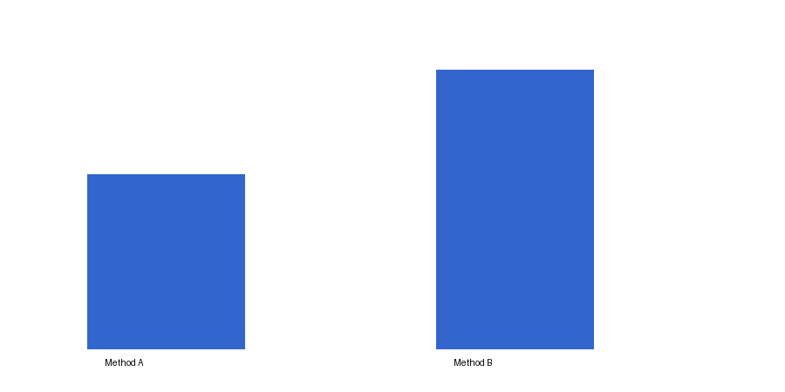
Figure 1. Comparison of methods.
Method | Accuracy (%)
Method A | 80
Method B | 90
Note
Same conditions
The numerator x is an observation and n is the number of observations. Their fraction defines the mean term.$\frac{x}{n}$

