git config –global user.email shivamvala122@gmail.com
git config –global user.name shivam

git init
initialize the empty git repository

ls list

ls – lart
show all the hidden folder

.it will show a .git folder
.git folder gives us the complete data

git status shows the status
it says that you have untracked file and you should track it and use it in git

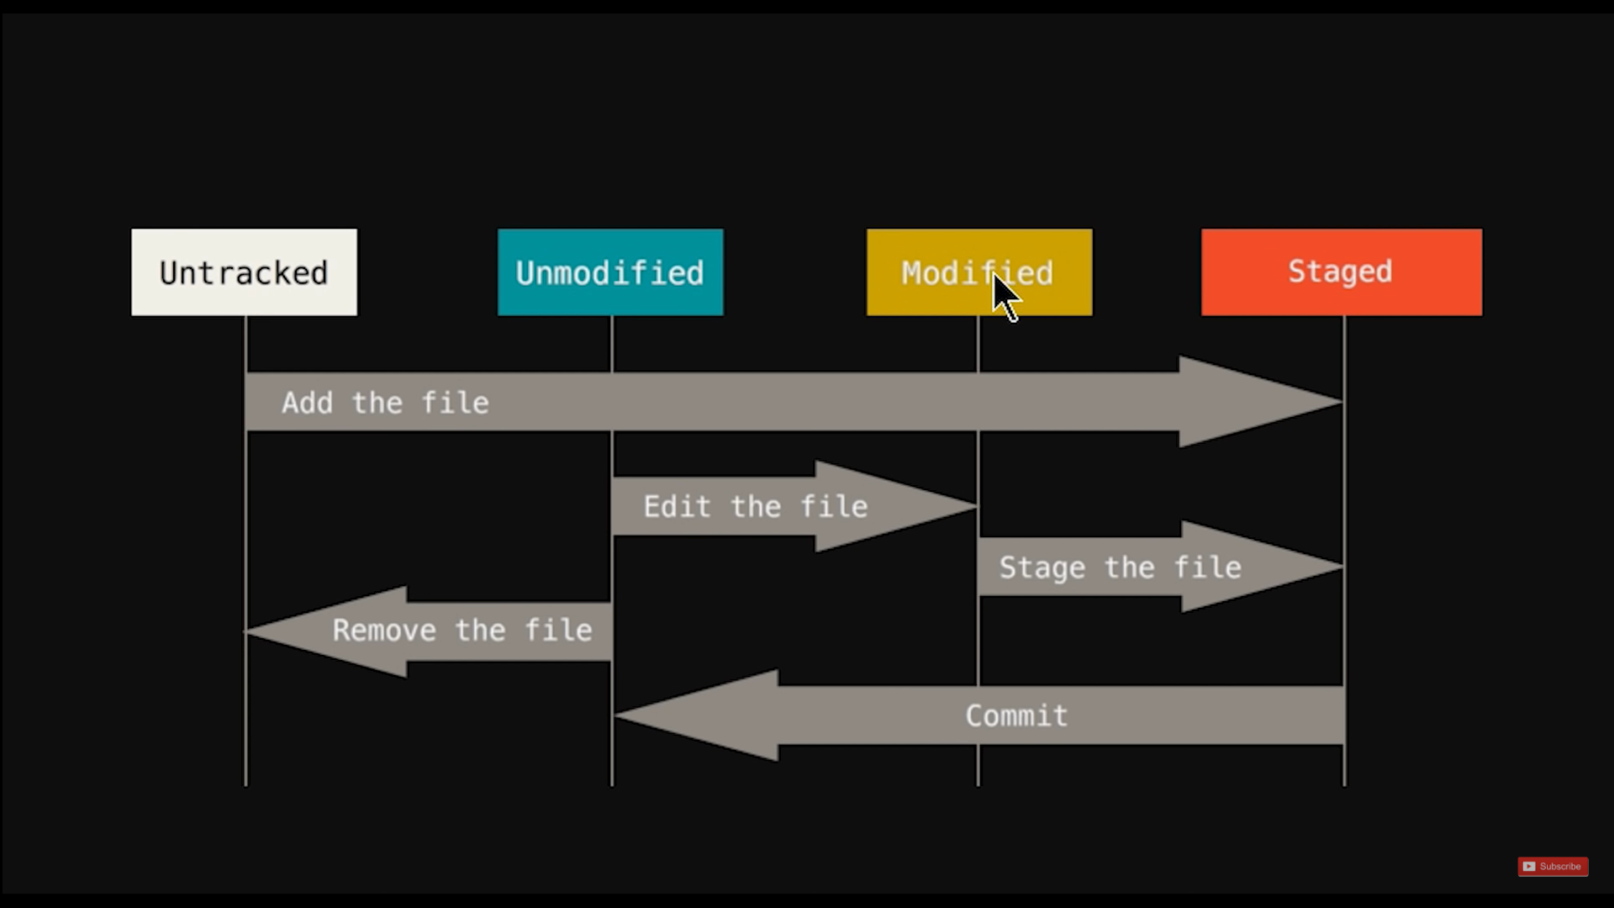

we genrally don’t wan’t to change log files or binary files if we wan’t to track index.hhtml

so we will just put them in stagging area what if we wan’t to track index.html

stagging area is the area from where the file will go to commit

what is commit it is a snapshot

git status gives untracked app

git add index.html : file goes to stagging area

than git commit than press I and type Initial commit than press escape : w and q

touch about.html

touch is a command that creates blank files

Following file stages all the file together

git add -A

git commit -m "added more htmls"

git checkout recovers the all file with last commit

git checkout contact.html

git checkout -f

git log shows what you committed and at what time

git log -p -1

it will show us what commit also we made

git diff
compares files in working directoy and stagging area

git diff --staged

compares files in staging area with last commit

It allows us to skip staging area and directly commit
git commit -a -m "Skippedd staging area and fixed <"

git rm --cached waste.html

git rm –cached removes file from stagging area only

git rm removes file from working directory also

git status -s shows which files are modified recently

git ignore

touch.gitignore

add *.log it woll ignore all the log files

Branches makes different copies

git branch feature1 making branch feature1
git checkout feaure1 switching to branch feature 1

git checkout master
git merge feature1

git checkout -b flaskIntegration makes as weell as switch to another branch

