Practical_1 Analysis
Sorting Algorithm

1. Bubble Sort

Definition
Bubble Sort is a simple comparison-based sorting algorithm that repeatedly compares adjacent elements and swaps them if they are in the wrong order. After each pass, the largest unsorted element moves to its correct position.

Key Points
- Comparison-based sorting algorithm.
- Compares adjacent elements.
- Largest element is placed at the end after each pass.
- Stable sorting algorithm.
- In-place sorting algorithm.
- Easy to implement but inefficient for large datasets.

Complexity
Case | Time Complexity
Best | O(n)
Average | O(n²)
Worst | O(n²)
Space | O(1)

Output :- 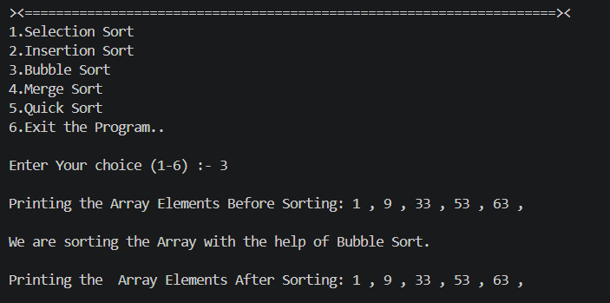

2. Selection Sort

Definition
Selection Sort repeatedly finds the smallest element from the unsorted portion of the array and places it at the beginning.

Key Points
- Comparison-based sorting algorithm.
- Selects the minimum element in each pass.
- Smallest element is placed at the beginning after each pass.
- Not a stable sorting algorithm.
- In-place sorting algorithm.
- Performs fewer swaps than Bubble Sort.

Complexity
Case | Time Complexity
Best | O(n²)
Average | O(n²)
Worst | O(n²)
Space | O(1)

Output :- 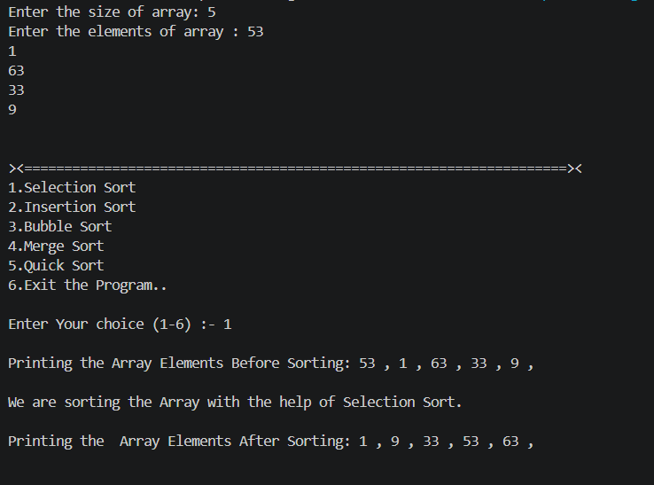

3. Insertion Sort

Definition
Insertion Sort builds the sorted array one element at a time by inserting each element into its correct position in the already sorted portion.

Key Points
- Comparison-based sorting algorithm.
- Builds a sorted portion from left to right.
- Efficient for nearly sorted arrays.
- Stable sorting algorithm.
- In-place sorting algorithm.
- Simple and efficient for small datasets.

Complexity
Case | Time Complexity
Best | O(n)
Average | O(n²)
Worst | O(n²)
Space | O(1)

Output :-

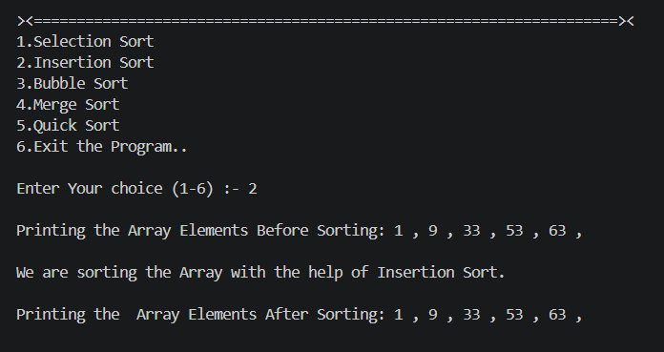

4. Merge Sort

Definition
Merge Sort is a Divide and Conquer algorithm that recursively divides the array into smaller parts, sorts them, and merges them to produce a sorted array.

Key Points
- Divide and Conquer algorithm.
- Divides the array recursively.
- Merges sorted subarrays.
- Stable sorting algorithm.
- Not an in-place sorting algorithm.
- Suitable for large datasets.

Complexity
Case | Time Complexity
Best | O(n log n)
Average | O(n log n)
Worst | O(n log n)
Space | O(n)

Output :- 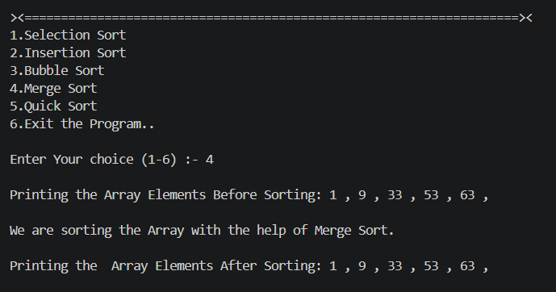

5. Quick Sort

Definition
Quick Sort is a Divide and Conquer algorithm that selects a pivot element and partitions the array into smaller and larger elements around the pivot.

Key Points
- Divide and Conquer algorithm.
- Uses a pivot element for partitioning.
- Very fast in practice.
- In-place sorting algorithm.
- Not a stable sorting algorithm.
- Performance depends on pivot selection.

Complexity
Case | Time Complexity
Best | O(n log n)
Average | O(n log n)
Worst | O(n²)
Space | O(log n)

Output :- 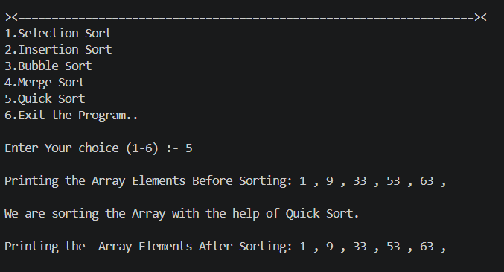

Comparison Table
Feature | Bubble Sort | Selection Sort | Insertion Sort | Merge Sort | Quick Sort
Technique | Comparison | Comparison | Comparison | Divide & Conquer | Divide & Conquer
Best Time | O(n) | O(n²) | O(n) | O(n log n) | O(n log n)
Average Time | O(n²) | O(n²) | O(n²) | O(n log n) | O(n log n)
Worst Time | O(n²) | O(n²) | O(n²) | O(n log n) | O(n²)
Space Complexity | O(1) | O(1) | O(1) | O(n) | O(log n) (Average)
Stable | ✅ Yes | ❌ No | ✅ Yes | ✅ Yes | ❌ No
In-place | ✅ Yes | ✅ Yes | ✅ Yes | ❌ No | ✅ Yes
Adaptive | ✅ Yes | ❌ No | ✅ Yes | ❌ No | ❌ No
Suitable For | Small datasets | Small datasets | Nearly sorted arrays | Large datasets | Large datasets

Algorithm | First Element Fixed (Ascending) | Stable | In-place
Bubble Sort | Largest element | ✅ | ✅
Selection Sort | Smallest element | ❌ | ✅
Insertion Sort | No fixed element (grows sorted prefix) | ✅ | ✅
Merge Sort | No fixed element | ✅ | ❌
Quick Sort | Depends on pivot | ❌ | ✅

