Practical_2 Analysis
Searching Algorithm

Searching Algorithms - Short Notes

1. Linear Search

Definition
Linear Search is the simplest searching algorithm that checks each element of the array sequentially until the target element is found or the entire array has been searched.

Key Points :-
- Sequential searching algorithm.
- Checks elements one by one from the beginning.
- Does not require the array to be sorted.
- Easy to understand and implement.
- Suitable for small or unsorted datasets.
- Inefficient for large datasets.

Complexity :-
Case | Time Complexity
Best | O(1)
Average | O(n)
Worst | O(n)
Space | O(1)

Output :- 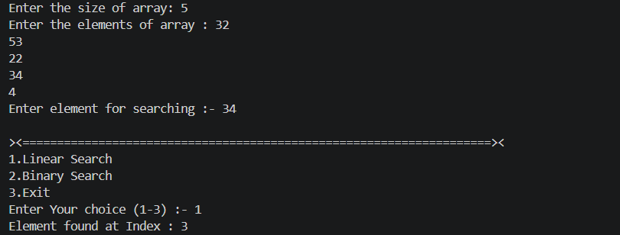

2. Binary Search

Definition :-
Binary Search is an efficient searching algorithm that works by repeatedly dividing the search interval into two halves until the target element is found.

Key Points :-
- Divide and Conquer algorithm.
- Works only on sorted arrays.
- Repeatedly compares the target with the middle element.
- Eliminates half of the search space in every iteration.
- Much faster than Linear Search for large datasets.
- Can be implemented using iteration or recursion.

Complexity :-
Case | Time Complexity
Best | O(1)
Average | O(log n)
Worst | O(log n)
Space (Iterative) | O(1)
Space (Recursive) | O(log n)

Output :- 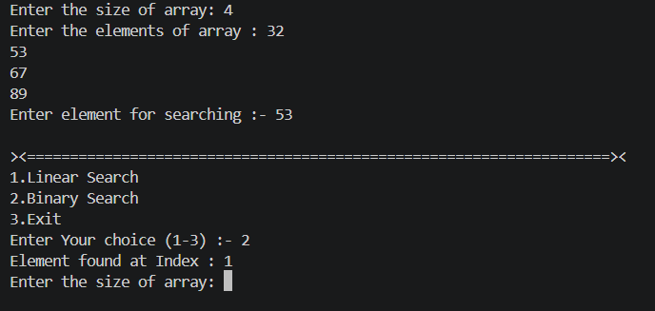

Comparison Table
Feature | Linear Search | Binary Search
Technique | Sequential Search | Divide & Conquer
Data Requirement | Sorted or Unsorted | Sorted Array Required
Best Time | O(1) | O(1)
Average Time | O(n) | O(log n)
Worst Time | O(n) | O(log n)
Space Complexity (Iterative) | O(1) | O(1)
Space Complexity (Recursive) | O(1) | O(log n)
Easy to Implement | ✅ Yes | ✅ Yes
Suitable for Large Datasets | ❌ No | ✅ Yes
Suitable for Unsorted Data | ✅ Yes | ❌ No

Feature | Linear Search | Binary Search
Array Required | Sorted or Unsorted | Sorted Only
Speed | Slow | Fast
Best Use Case | Small or Unsorted Arrays | Large Sorted Arrays
Best Time | O(1) | O(1)
Average Time | O(n) | O(log n)
Worst Time | O(n) | O(log n)
Space | O(1) | O(1) (Iterative)

