SHOPNEST DASHBOARD COMPREHENSIVE REPORT



S M SHIVAMANI

Contents
Executive Summary 3
Methodology 3
1. Top Categories by Total Price 3
2. Delayed Orders Analysis 4
3. Monthly Comparison of Delayed and On-Time Orders 4
4. Payment Method Analysis 5
5. Product Rating Analysis 6
6. State-wise Sales Analysis 7
7. Seasonal Sales Patterns 7
8. Revenue Analysis 8
Appendix: Key KPIs and Metrics 9

Executive Summary
This report summarizes key explanation from the ShopNest Power BI dashboard. It addresses the analytical questions requested: Top categories by sales, delayed orders analysis, monthly comparison of delayed vs on-time orders, payment method analysis, product rating analysis, state-wise sales analysis, seasonal sales patterns, and revenue analysis. Screenshots of the dashboard visuals are attached in the relevant sections for reference.

Methodology
Data from ShopNest transactional records (orders, deliveries, payments, reviews, product metadata and customer state) was prepared and visualized in Power BI. Key calculations and definitions used in analysis:
- Total Revenue: sum of payment value.
- Delayed Order: an order is said to be delayed when order_delivered_customer_date > order_estimated_delivery_date.
- On-time Order: order_delivered_customer_date ≤ order_estimated_delivery_date.
- AOV (Average Order Value): Total Revenue / Total Orders.
Quarterly / Yearly aggregations were used to identify seasonal patterns and trends.

1. Top Categories by Total Price
Objective: Identify and visually represent the top 10 product categories by total sales.
Explanation:
- The top 10 categories by total revenue are shown in the dashboard bar chart titled 'Top 10 Products By Sales'.
- The leading categories include Health Beauty, Watches Gifts, Bed Bath Table, Sports Leisure and Computers Accessories.
- These categories account for a substantial portion of total revenue and should be prioritized for inventory, promotions and supplier negotiations and they contribute 40.6% of total sales.
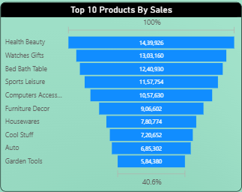Visualization:
The chart highlights the Health & Beauty category as the highest grossing, followed closely by Watches & Gifts, Bed/Bath/Table, and Sports/Leisure. These top categories account for the largest portion of sales, demonstrating strong consumer demand in these segments.

2. Delayed Orders Analysis
Objective: Determine the number of delayed orders in each category. An order is delayed if actual delivery date is later than estimated delivery date.
Explanation:
-Total delay count reported on the dashboard:
- 7,826 delayed orders.
- On-time orders are 88,652 with 2,963 pending.
Visualization:
The delayed orders analysis by product category pinpoints which types of products are most affected by late deliveries. Typically, high-volume categories such as Health_Beauty, Bed_Bath_Table, and Sports_Leisure may see more delays simply due to order volume, while niche categories could have fewer but potentially more severe logistical issues. Reviewing the delayed order counts for each category highlights where operational bottlenecks or supply chain issues might be concentrated. For categories with the highest delay counts, investigating vendor reliability, stock levels, or distribution processes can uncover actionable methods to improve delivery performance and customer satisfaction.

3. Monthly Comparison of Delayed and On-Time Orders
Objective: Compare the number of delayed orders to orders received earlier (on-time) for each month and enable drillthrough for details.
Explanation:
The comparison between delayed and on-time orders is illustrated by analyzing the monthly “On Time Count” alongside “%GT Delay Count”, highlighting trends and discrepancies in order delivery performance throughout the year.
Key Monthly Observations
- On Time Counts peak in July and August (9.9K–10K).
- Delay Percentages are highest in April (20.93%) and March (14.08%), indicating periods with the greatest proportion of late deliveries relative to order volume.
- Months with the lowest delay rates are June (2.61%), October (3.07%), and September (2.77%), reflecting better timeliness during these periods.
- The magnitude of on-time orders declines sharply in September and October, with a moderate rebound in November and December.

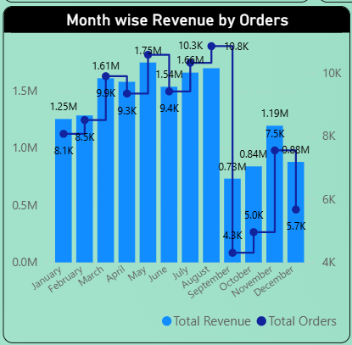Visualization:
High on-time rates and low delays mid-year reflect successful logistic planning, while peaks in delay percentage identify months needing strategic attention.
By enabling drill through capabilities, users can investigate specific delayed orders, underlying causes, and affected customers for any chosen month. This supports targeted process improvements and responsive customer service practices

4. Payment Method Analysis
Objective: Analyze most frequently used payment methods using a visually appealing representation.
Explanation:
- Credit Card is overwhelmingly the preferred payment method, accounting for 78.34% of all transactions (76,795 payments) and generating most of the revenue (12,542,084.19). This dominance indicates high customer trust and convenience with credit card transactions.
- Boleto (a popular Brazilian payment slip) is the second most used, representing 17.92% of payments (19,784 transactions) and 2,869,361.27 in revenue. This option is vital for customers who do not use credit cards.
- Voucher and Debit Card are much less frequently used, together making up less than 5% of transactions and limiting their impact on total revenue.
- Negligible or undefined payment types have almost no presence in the customer base.
- 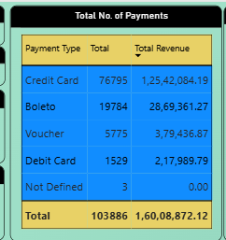
These visuals highlight not only which payment methods are most popular but also which drive the business’s financial performance. Companies can use this insight to optimize checkout processes and marketing for the most used payment methods, while also exploring ways to encourage alternative payment adoption to broaden their customer base.

5. Product Rating Analysis
Objective: Determine top 10 highest-rated products and bottom 10 lowest-rated products.
Explanation:
The Product Rating Analysis identifies both the top 10 highest-rated and bottom 10 lowest-rated product categories, highlighting customer satisfaction patterns across the catalog.
- Highly Rated Products:
Product categories such as CDs/DVDs/Music, Children’s Clothing, General Interest Books, Sport Fashion, and Imported Books consistently achieved high ratings, with scores generally above 4.3 out of 5. This indicates strong customer satisfaction and positive experiences with these products, likely due to perceived quality, value, or alignment with customer expectations.
- Low Rated Products:
On the other hand, categories like Security and Services, Office Furniture, Male and Female Clothing, and certain home-related items (such as Mattresses, Audio, and Construction Tools—Safety) received much lower average ratings, with some scores dropping below 3.8. 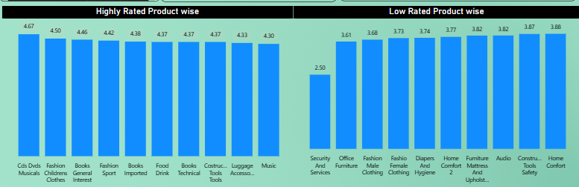
This analysis empowers the business to:
- Reinforce strengths by promoting and maintaining the quality of highly-rated categories.
- Address weaknesses by investigating root causes of dissatisfaction in low-rated categories these could involve quality issues, inaccurate descriptions, delivery challenges, or other service gaps.
- Acting on these insights can lead to targeted improvements in product offerings, marketing strategies, and customer support, ultimately driving higher overall satisfaction and repeat business.

6. State-wise Sales Analysis
Objective: Identify and visually represent states with high and low sales for regional performance understanding.
Explanation:
Top 10 States by Revenue
- A small number of important states account for a large portion of sales revenue. With over 6 million, São Paulo (SP) is well ahead, followed by Rio de Janeiro (RJ) with 2.1 million and Minas Gerais (MG) with 1.9 million. Revenues from the other top-performing states, such as RS, PR, SC, BA, DF, GO, and ES, range from roughly 0.9 million to 0.3 million. These markets are essential for company expansion and client involvement as, according to this concentration, they have the biggest consumer base and the highest demand.
Bottom 10 states by revenue
- States like Amazonas (AM), Rondônia (RO), Tocantins (TO), Sergipe (SE), Alagoas (AL), Rio Grande do Norte (RN), and Piauí (PI) are gradually increasing towards 0.1 million, while the lowest-performing states, like Roraima (RR), Amapá (AP), and Acre (AC), each contribute less than 0.02 million. These findings draw attention to the significant unrealised market potential and the regional disparity in the distribution of sales.
- 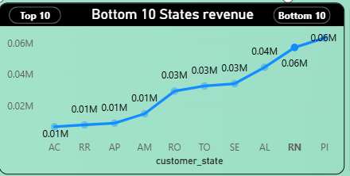
Overall, this analysis highlights major business opportunities:
- Focus retention and up-sell strategies in the high-revenue states to maintain market dominance.
Develop targeted marketing, outreach, or logistical initiatives in low-revenue states to drive growth and tap into new customer bases.

7. Seasonal Sales Patterns
Objective: Investigate and visualize any seasonal (quarterly) patterns or trends in sales data over the year.
Explanation:
The dashboard’s visualization of total revenue by quarter and year uncovers shifts in seasonal sales trends:
- 2016: Recorded revenue was negligible, indicating a launch or ramp-up year.
- 2017: From Q1 (0.9M) to Q4 (2.9M), there was a consistent increase that peaked in the last quarter. This suggests excellent year-end success, which is frequently linked to seasonal sales or well-timed promotions.
- 2018: The pattern shifted, with Q1 and Q2 showing exceptional performance (both 3.3M), followed by a decline in Q3 (2.0M) and almost no sales in Q4. This adjustment implies that the year's peak sales activity took place earlier, whether because of modifications to marketing tactics, outside circumstances, or customer behavior.

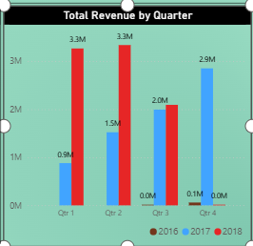
Important observations:
Early-year (Q1/Q2, 2018) sales peaks replaced late-year (Q4, 2017) sales peaks.
Better forecasting, inventory management, and focused advertising campaigns to optimize sales during times of strong demand are made possible by an understanding of these cyclical variations.
The findings encourage maximizing operational resources in accordance with established sales cycles in order to boost productivity and profitability.

8. Revenue Analysis
Objective: Determine total revenue generated by ShopNest and how it changes over time (yearly). Represent trends and patterns.
Explanation:
Total revenue shown in the dashboard: approximately 16.01M across the dataset period.
- 2016: The business generated a modest revenue of 0.1M, indicating either its launch phase or a year with limited operations.
- 2017: Revenue soared to 7.2M, which might be attributed to more successful initiatives, improved client acquisition, or substantial corporate expansion.
- 2018: Revenue reached 8.7 million, a significant rise that supported ongoing corporate development and expansion.
- AOV is approximately 160.99 and overall review average is about 4.07, which indicates healthy basket values and generally positive customer feedback.
Recommendation: continue strategies that drove 2017-2018 growth while addressing fulfillment and rating issues to sustain growth.
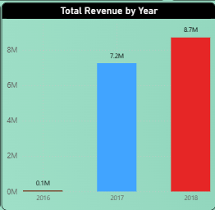
Trends & Patterns:
The annual rising trend shows steady progress in increasing revenues and growing operations.
The biggest spike was from 2016 to 2017, indicating a scaling phase after debut.
The success of Shop Nest’s continuous operations, marketing, and perhaps product expansion is demonstrated by its continued growth into 2018

Appendix: Key KPIs and Metrics
- Total Orders: 99,441 orders indicate a substantial sales volume processed by ShopNest.
- Total Revenue: Approximately 16 million reflects strong financial performance and effective revenue generation.
- Average Order Value (AOV): 160.99 signifies healthy customer spending per transaction.
- Overall Customer Review: 4.07/5 suggests generally positive customer satisfaction across products and services.
- Month-over-Month (MoM) Growth: 4.17% growth surpasses the 4% target, showing steady business momentum.
- KPI Target Achievement: 8.70 million achieved against an initial goal of 1.5 million (479.98% over target), signaling exceptional operational performance.
- Payment Methods:
Credit Card dominates with 78.34% of transactions and generates the highest revenue.
Boleto payment method follows at 17.92%, serving as an important alternative.
Voucher and Debit Card form a small minority of transactions.
- Delivery Performance:
On-time deliveries peak mid-year with delays most prominent in March, April, and November.
Small box and envelope shipments contribute disproportionately to delivery delays.
- Product Performance:
Top sales categories include Health & Beauty, Watches & Gifts, and Household items.
Highest customer ratings for entertainment and clothing products; lowest ratings in Security, Office Furniture, and selected home categories.
- Regional Sales:
Sales are highly focused in states like São Paulo and Rio de Janeiro with much lower revenues in northern and smaller states, highlighting expansion potential.
- Seasonal Sales Patterns:
Shift from Q4 sales peak in 2017 to Q1/Q2 peaks in 2018 impacts inventory and marketing strategy planning.

