**Programming Language: Python**

1. **Linear search:**

* **Theory:**
* **How It Works:**
* Start from the first element.
* Compare each element with the target.
* Stop when you find it or reach the end.
* **Code:**

*#LInear Search Algorithm*

**def** linear_search(*arr*, *target*):

**if**(target **in** arr):

**return** arr.index(target)

**else**:

**return** **-**1

arr**=**[1, 2, 3, 4, 5]

target**=**3

result**=**linear_search(arr, target)

**if** result**!=-**1:

**print**(**f**"Target {target} found at index: {result}")

**else**:

**print**(**f**"Target {target} not found in the array")

* output:

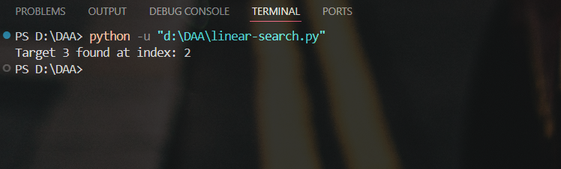

* Time Complexity:

1. Worst time complexity:O(n)

* If the target is not present or is the last element, we must check every element once.n = length of the array.

1. Best case time complexity: O(1)

* If the target is at the **first index**, we find it immediately.
* Space Complexity: O(1)

Justification:

* No **extra data structures** or **recursive calls** are used.

1. **Binary Search:**

* Theory:
* Binary search is a fast and intelligent search technique used to find an item in a sorted list.
* It works by repeatedly dividing the search range in half and eliminating the part that doesn’t contain the target.
* Rather than going through every item one by one, binary search tries to zero in on the answer quickly cutting the search space in half with every step.
* Code:

**def** binary_search(*arr*, *target*):

**if** **len**(arr) **==** 0:

**return** 0

    mid **=** **len**(arr)**//** 2

**if** mid**==**1:

**return** arr[mid]

**if** arr[mid]**==**target:

**return** mid

**elif** arr[mid]**>**target:

**return** binary_search(arr[:mid], target)

**elif** arr[mid]**<**target:

**return** binary_search(arr[mid**+**1:], target)

**else**:

**return** **-**1

arr**=**[1,2,3,4,5,6,7]

target **=** 3

**print**(binary_search(arr, target))

* output:

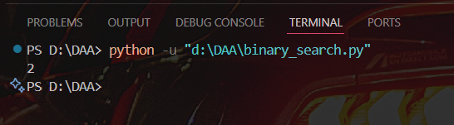

* Time Complexity: O(log n)

Justification:

* Each recursive call cuts the array in half.
* Suppose the array has n elements:
* First call → size n
* Next → size n/2
* Then → n/4, n/8, ... until size becomes 1.
* So the number of steps is roughly log₂(n).
* Worst case time complexity: O(log n)
* At each recursive step, the array is divided into half → just like cutting a book in half to find a page faster.
* Even in the worst case (when the element is at the very end or not in the list), the function performs at most log₂(n) steps before concluding.
* So, for n = 8 → max steps ≈ 3 (since 2³ = 8)
* Space Complexity: O(log n)

Justification:

* You're using slicing like arr[:mid] and arr[mid+1:] in every recursive call.
* This creates a new array copy each time, which takes space.
* Also, recursion uses call stack memory.
* Both slicing and recursion depth go up to log n → hence, space = O(log n).