**AIM: To plot unit impulse signal using Python.**

In signal processing, a unit impulse signal, also known as a Dirac delta function or impulse function, is a mathematical function that has the value of 1 at time zero and zero elsewhere. Generating a unit impulse signal in Python can be done using the NumPy library.

**Steps:**

* First, we import the necessary libraries: numpy for numerical computations and matplotlib.pyplot for plotting.
* Next, we define a function called unit_impulse that takes two arguments: length (the length of the signal) and position (the position of the impulse within the signal).
* Inside the unit_impulse function, we create an array of zeros with the specified length using np.zeros(length).
* We set the value at the specified position to 1, representing the impulse.
* We define the parameters **start**, **stop**, and **step** to specify the x-axis range and step size.
* We use np.arange to generate the x-axis values. The np.arange function creates an array of numbers from start to stop (inclusive) with a step size of step.
* We calculate the length of the impulse signal using len(x), which represents the number of x-axis values.
* We modify the unit_impulse function call to calculate the position of the impulse based on the x-axis range. Since we want the impulse at n=0, we set the position to abs(start)//step, which calculates the index of 0 in the x-axis array.
* abs(start): The abs() function returns the absolute value of the start variable. This is done to ensure that the result is always positive, regardless of whether start is positive or negative.
* abs(start)//step: The // operator performs integer division, which discards the decimal part of the division result and returns the integer quotient. In this case, abs(start)//step calculates the number of steps from the start value to reach the position of 0 in the x-axis array.
* The unit_impulse function returns the generated signal.
* By using abs(start)//step as the position argument in the unit_impulse function call, we ensure that the impulse is correctly positioned at n=0 within the generated unit impulse signal.
* For example, if start = -10 and step = 1, the expression abs(start)//step evaluates to (10)//(1), which equals 10. This means that the impulse will be placed at index 10 in the signal, aligning it with n=0.
* Using abs(start)//step allows the code to handle both positive and negative start values correctly, ensuring that the unit impulse is positioned accurately regardless of the specified x-axis range and step size.
* We then define the desired length and position for the unit impulse signal.
* We generate the unit impulse signal by calling the unit_impulse function with the specified parameters.
* Finally, we plot the unit impulse signal using plt.stem to create a stem plot, and then display the plot using plt.show().
* When you run this code, it will generate a stem plot showing the unit impulse signal with a spike at the specified position (in this case, position 10).
* plt.grid(True) in the code helps to improve the visual representation of the plot by adding gridlines, making it easier to analyze.
* Note: To run this code, you'll need to have the NumPy and Matplotlib libraries installed. You can install them using pip install numpy matplotlib.

**Program:**

import numpy as np

import matplotlib.pyplot as plt

def unit_impulse(length, position):

signal = np.zeros(length)

signal[position] = 1

return signal

# Parameters

start = -10 # Start value of the x-axis range

stop = 10 # Stop value of the x-axis range

step = 1 # Step size

# Generate x-axis values

x = np.arange(start, stop+step, step)

# Generate unit impulse signal

impulse_signal = unit_impulse(len(x), abs(start)//step)

# Plot the signal

plt.stem(x, impulse_signal)

plt.xlabel('Time')

plt.ylabel('Amplitude')

plt.title('Unit Impulse Signal')

plt.grid(True)

plt.show()

**Output:**

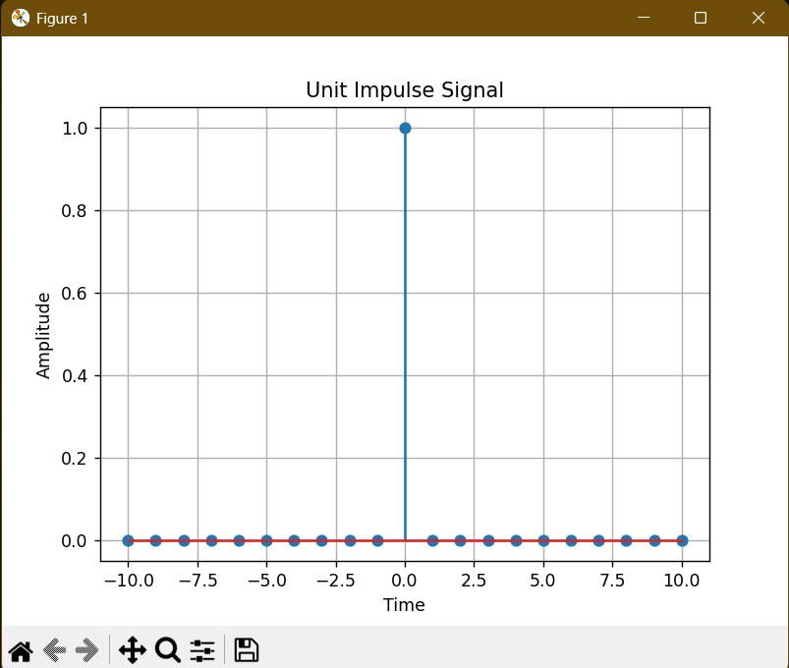

**AIM**

Simulate impulse train

**Code:**

import numpy as np

import matplotlib.pyplot as plt

def simulate_impulse_train(signal_length, period):

impulse_train = np.zeros(signal_length)

for n in range(signal_length):

if n % period == 0:

impulse_train[n] = 1

return impulse_train

# Define the parameters for the impulse train

signal_length = 100 # Length of the impulse train

period = 10 # Period of the impulse train

# Simulate the impulse train

impulse_train = simulate_impulse_train(signal_length, period)

# Plot and display the impulse train

plt.stem(impulse_train)

plt.title('Impulse Train')

plt.xlabel('Sample')

plt.ylabel('Amplitude')

plt.show()

# Save the impulse train array (optional)

# np.savetxt('impulse_train.txt', impulse_train, delimiter=',')

**Output:**

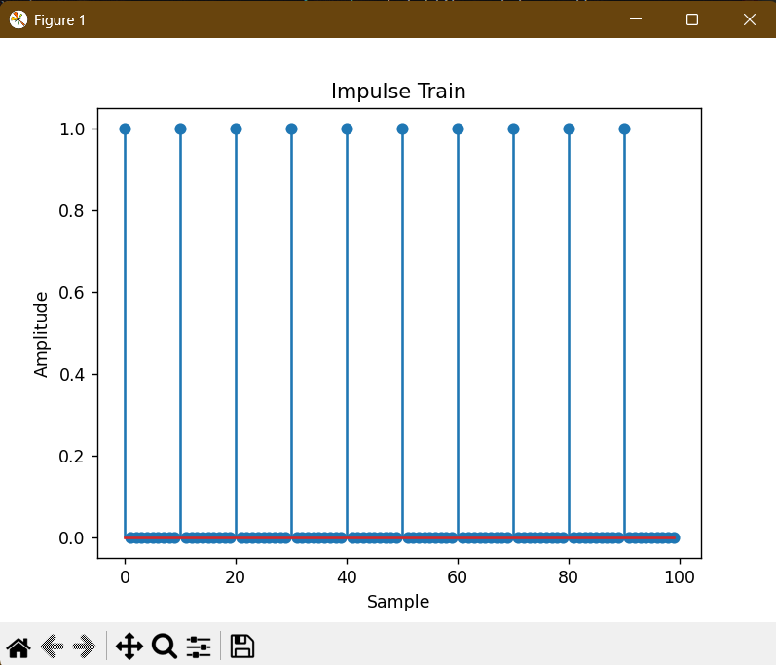

**AIM:** Write a python program to Simulate continuous and discrete unit step signal,

**Code:**

import numpy as np

import matplotlib.pyplot as plt

def simulate_continuous_unit_step(time):

unit_step = np.zeros_like(time)

unit_step[time >= 0] = 1

return unit_step

def simulate_discrete_unit_step(num_samples):

unit_step = np.zeros(num_samples)

unit_step[num_samples // 2:] = 1

return unit_step

# Define the time range for the continuous unit step signal

time = np.linspace(-5, 5, 1000) # Time range from -5 to 5

# Simulate the continuous unit step signal

continuous_unit_step = simulate_continuous_unit_step(time)

# Define the number of samples for the discrete unit step signal

num_samples = 20 # Number of samples

# Simulate the discrete unit step signal

discrete_unit_step = simulate_discrete_unit_step(num_samples)

# Plot and display the continuous and discrete unit step signals

plt.figure(figsize=(10, 6))

plt.subplot(2, 1, 1)

plt.plot(time, continuous_unit_step)

plt.title('Continuous Unit Step Signal')

plt.xlabel('Time')

plt.ylabel('Amplitude')

plt.subplot(2, 1, 2)

plt.stem(discrete_unit_step)

plt.title('Discrete Unit Step Signal')

plt.xlabel('Sample')

plt.ylabel('Amplitude')

plt.tight_layout()

plt.show()

# Save the unit step signal arrays (optional)

# np.savetxt('continuous_unit_step.txt', continuous_unit_step, delimiter=',')

# np.savetxt('discrete_unit_step.txt', discrete_unit_step, delimiter=',')

**Output:**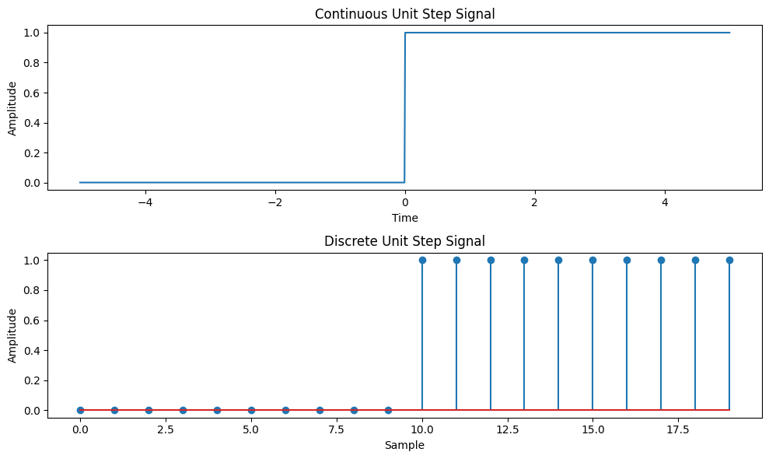

**AIM:** Write a python program to Simulate continuous and discrete ramp signal,

**Code:**

import numpy as np

import matplotlib.pyplot as plt

def simulate_continuous_ramp(time, slope):

ramp = np.zeros_like(time)

ramp[time >= 0] = slope * time[time >= 0]

return ramp

def simulate_discrete_ramp(num_samples, slope):

ramp = np.zeros(num_samples)

ramp[num_samples // 2:] = slope * np.arange(num_samples // 2, num_samples)

return ramp

# Define the time range for the continuous ramp signal

time = np.linspace(-5, 5, 1000) # Time range from -5 to 5

# Define the number of samples and slope for the discrete ramp signal

num_samples = 20 # Number of samples

slope = 2 # Slope of the ramp

# Simulate the continuous ramp signal

continuous_ramp = simulate_continuous_ramp(time, slope)

# Simulate the discrete ramp signal

discrete_ramp = simulate_discrete_ramp(num_samples, slope)

# Plot and display the continuous and discrete ramp signals

plt.figure(figsize=(10, 6))

plt.subplot(2, 1, 1)

plt.plot(time, continuous_ramp)

plt.title('Continuous Ramp Signal')

plt.xlabel('Time')

plt.ylabel('Amplitude')

plt.subplot(2, 1, 2)

plt.stem(discrete_ramp)

plt.title('Discrete Ramp Signal')

plt.xlabel('Sample')

plt.ylabel('Amplitude')

plt.tight_layout()

plt.show()

# Save the ramp signal arrays (optional)

# np.savetxt('continuous_ramp.txt', continuous_ramp, delimiter=',')

# np.savetxt('discrete_ramp.txt', discrete_ramp, delimiter=',')

Output:

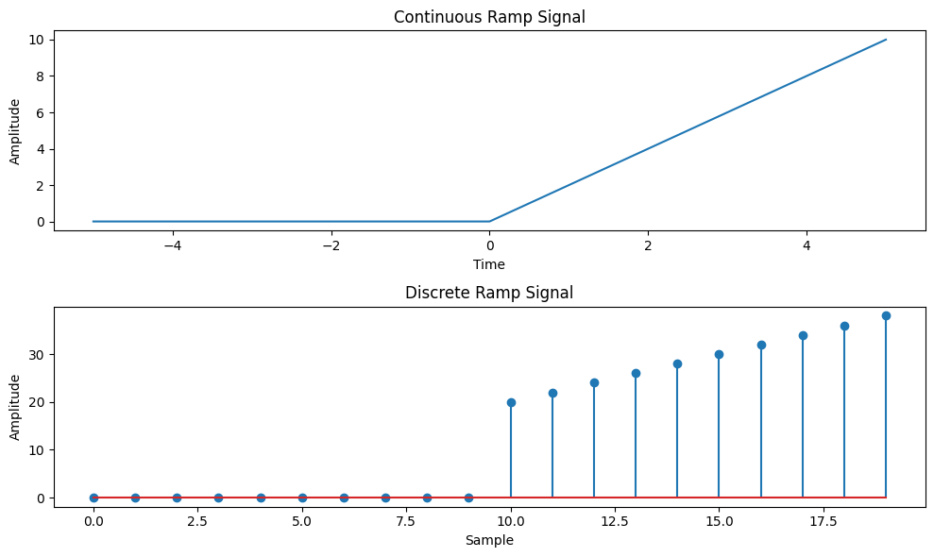

**AIM:** Write a python program to Simulate continuous and discrete exponential signal,

**Code:**

import numpy as np

import matplotlib.pyplot as plt

def simulate_continuous_exponential(time, amplitude, coefficient):

exponential_signal = amplitude * np.exp(coefficient * time)

return exponential_signal

def simulate_discrete_exponential(num_samples, amplitude, coefficient):

exponential_signal = amplitude * np.exp(coefficient * np.arange(num_samples))

return exponential_signal

# Define the time range for the continuous exponential signal

time = np.linspace(0, 5, 1000) # Time range from 0 to 5

# Define the number of samples, initial amplitude, and coefficient for the discrete exponential signal

num_samples = 20 # Number of samples

amplitude = 2 # Initial amplitude

coefficient = -0.5 # Exponential coefficient

# Simulate the continuous exponential signal

continuous_exponential = simulate_continuous_exponential(time, amplitude, coefficient)

# Simulate the discrete exponential signal

discrete_exponential = simulate_discrete_exponential(num_samples, amplitude, coefficient)

# Plot and display the continuous and discrete exponential signals

plt.figure(figsize=(10, 6))

plt.subplot(2, 1, 1)

plt.plot(time, continuous_exponential)

plt.title('Continuous Exponential Signal')

plt.xlabel('Time')

plt.ylabel('Amplitude')

plt.subplot(2, 1, 2)

plt.stem(discrete_exponential)

plt.title('Discrete Exponential Signal')

plt.xlabel('Sample')

plt.ylabel('Amplitude')

plt.tight_layout()

plt.show()

# Save the exponential signal arrays (optional)

# np.savetxt('continuous_exponential.txt', continuous_exponential, delimiter=',')

# np.savetxt('discrete_exponential.txt', discrete_exponential, delimiter=',')

**Explanation:**

**Output:**

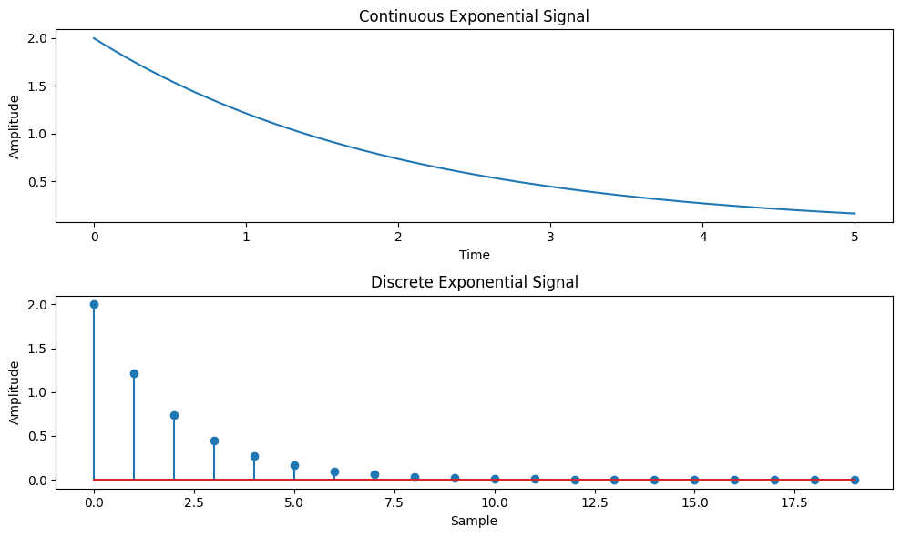

**AIM**: Write a python program to Simulate continuous and discrete parabolic signal

**Code:**

import numpy as np

import matplotlib.pyplot as plt

def simulate_continuous_parabolic(time, coefficients):

parabolic_signal = np.polyval(coefficients, time)

return parabolic_signal

def simulate_discrete_parabolic(num_samples, coefficients):

parabolic_signal = np.polyval(coefficients, np.arange(num_samples))

return parabolic_signal

# Define the time range for the continuous parabolic signal

time = np.linspace(-5, 5, 1000) # Time range from -5 to 5

# Define the number of samples and coefficients for the discrete parabolic signal

num_samples = 20 # Number of samples

coefficients = [1, 2, 1] # Coefficients of the parabolic signal

# Simulate the continuous parabolic signal

continuous_parabolic = simulate_continuous_parabolic(time, coefficients)

# Simulate the discrete parabolic signal

discrete_parabolic = simulate_discrete_parabolic(num_samples, coefficients)

# Plot and display the continuous and discrete parabolic signals

plt.figure(figsize=(10, 6))

plt.subplot(2, 1, 1)

plt.plot(time, continuous_parabolic)

plt.title('Continuous Parabolic Signal')

plt.xlabel('Time')

plt.ylabel('Amplitude')

plt.subplot(2, 1, 2)

plt.stem(discrete_parabolic)

plt.title('Discrete Parabolic Signal')

plt.xlabel('Sample')

plt.ylabel('Amplitude')

plt.tight_layout()

plt.show()

# Save the parabolic signal arrays (optional)

# np.savetxt('continuous_parabolic.txt', continuous_parabolic, delimiter=',')

# np.savetxt('discrete_parabolic.txt', discrete_parabolic, delimiter=',')

**Output:**

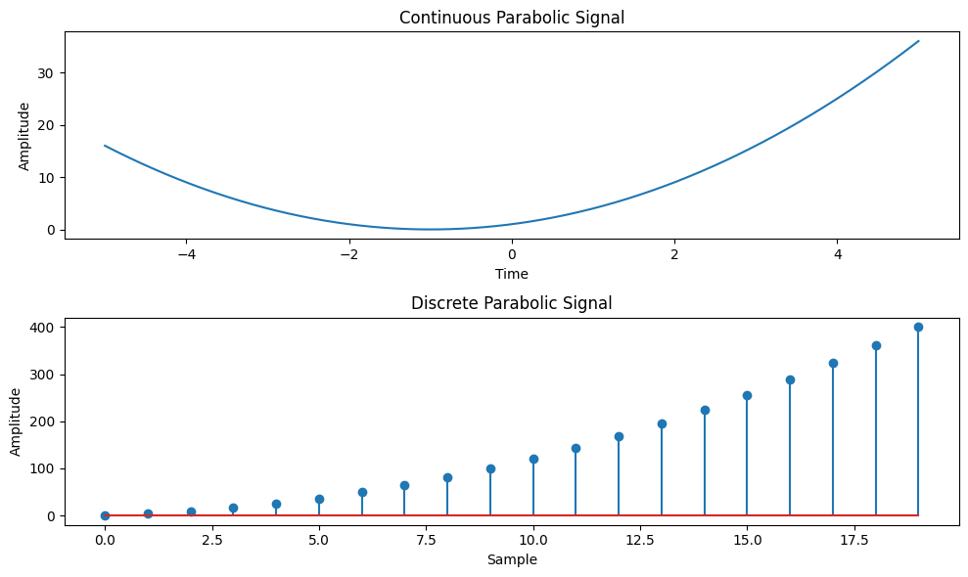

**AIM:** **Write a python program to Simulate continuous and discrete sine wave signal**

**Code:**

import numpy as np

import matplotlib.pyplot as plt

def simulate_continuous_sine_wave(time, amplitude, frequency, phase):

sine_wave = amplitude * np.sin(2 * np.pi * frequency * time + phase)

return sine_wave

def simulate_discrete_sine_wave(num_samples, sampling_frequency, amplitude, frequency, phase):

time = np.arange(num_samples) / sampling_frequency

sine_wave = amplitude * np.sin(2 * np.pi * frequency * time + phase)

return sine_wave

# Define the time range for the continuous sine wave signal

time = np.linspace(0, 1, 1000) # Time range from 0 to 1 second

# Define the number of samples, sampling frequency, and parameters for the discrete sine wave signal

num_samples = 100 # Number of samples

sampling_frequency = 10 # Sampling frequency in Hz

amplitude = 1 # Amplitude of the sine wave

frequency = 2 # Frequency of the sine wave in Hz

phase = 0 # Phase angle of the sine wave in radians

# Simulate the continuous sine wave signal

continuous_sine_wave = simulate_continuous_sine_wave(time, amplitude, frequency, phase)

# Simulate the discrete sine wave signal

discrete_sine_wave = simulate_discrete_sine_wave(num_samples, sampling_frequency, amplitude, frequency, phase)

# Plot and display the continuous and discrete sine wave signals

plt.figure(figsize=(10, 6))

plt.subplot(2, 1, 1)

plt.plot(time, continuous_sine_wave)

plt.title('Continuous Sine Wave Signal')

plt.xlabel('Time (s)')

plt.ylabel('Amplitude')

plt.subplot(2, 1, 2)

plt.stem(discrete_sine_wave)

plt.title('Discrete Sine Wave Signal')

plt.xlabel('Sample')

plt.ylabel('Amplitude')

plt.tight_layout()

plt.show()

# Save the sine wave signal arrays (optional)

# np.savetxt('continuous_sine_wave.txt', continuous_sine_wave, delimiter=',')

# np.savetxt('discrete_sine_wave.txt', discrete_sine_wave, delimiter=',')

**Output:**

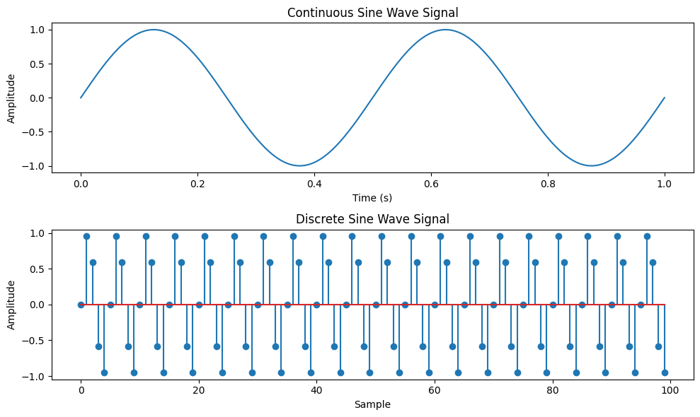

**AIM: Write a python program to simulate y(t)=u(t)+u(t-1)+3u(t+5).**

**Code:**

Now, let's see the Python program that simulates y(t) = u(t) + u(t-1) + 3*u(t+5):

import numpy as np

import matplotlib.pyplot as plt

def simulate_function(time):

y = np.zeros_like(time)

y[time >= 0] = 1

y[time >= 1] += 1

y[time >= -5] += 3

return y

# Define the time range

time = np.linspace(-10, 10, 1000)

# Simulate the function

function_values = simulate_function(time)

# Plot and display the function

plt.plot(time, function_values)

plt.title('Function y(t) = u(t) + u(t-1) + 3*u(t+5)')

plt.xlabel('Time')

plt.ylabel('Amplitude')

plt.ylim([-0.5, 5.5])

plt.grid(True)

plt.show()

**Output:**

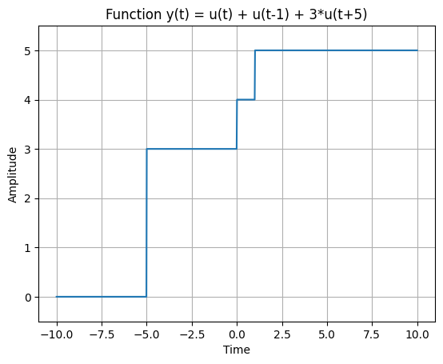

**AIM: Write a python program to simulate y(t)=Delta(t)+delta(t-1)+3*delta(t+5).**

**Code:**

Now, let's see the Python program that simulates y(t) = Delta(t) + delta(t-1) + 3*delta(t+5):

import numpy as np

import matplotlib.pyplot as plt

def simulate_function(time):

y = np.zeros_like(time)

y[time == 0] = 1

y[time == 1] += 1

y[time == -5] += 3

return y

# Define the time range

time = np.arange(-10, 11)

# Simulate the function

function_values = simulate_function(time)

# Plot and display the function

plt.stem(time, function_values)

plt.title('Function y(t) = Delta(t) + delta(t-1) + 3*delta(t+5)')

plt.xlabel('Time')

plt.ylabel('Amplitude')

plt.ylim([-0.5, 4.5])

plt.grid(True)

plt.show()

**Output:**

