**Code:**

import cv2

import numpy as np

# Load the grayscale image

image = cv2.imread(r"D:\DSIP\ex1_1.png", cv2.IMREAD_GRAYSCALE)

if image is None:

print("Error: Could not open or find the image.")

exit()

# Image operations

def image_negation(input_image):

return 255 - input_image

def image_thresholding(input_image, threshold_value):

_, thresholded_image = cv2.threshold(input_image, threshold_value, 255, cv2.THRESH_BINARY)

return thresholded_image

def image_gamma_correction(input_image, gamma):

gamma_corrected = np.power(input_image / 255.0, gamma) * 255.0

return np.uint8(gamma_corrected)

# Resize helper to match sizes

def resize_to_common_size(images, width=300, height=300):

resized = []

for img in images:

resized.append(cv2.resize(img, (width, height), interpolation=cv2.INTER_LINEAR))

return resized

# Perform operations

negated_image = image_negation(image)

thresholded_image = image_thresholding(image, 102)

gamma_corrected_image = image_gamma_correction(image, -0.5)

# Resize all images to same size

resized_images = resize_to_common_size([

image,

negated_image,

thresholded_image,

gamma_corrected_image

])

# Add labels (optional)

def add_label(image, text):

return cv2.putText(image.copy(), text, (10, 25), cv2.FONT_HERSHEY_SIMPLEX,

0.8, (255), 2, cv2.LINE_AA)

labeled_images = [

add_label(resized_images[0], "Original"),

add_label(resized_images[1], "Negated"),

add_label(resized_images[2], "Thresholded"),

add_label(resized_images[3], "Gamma")

]

# Stack images horizontally

combined_image = cv2.hconcat(labeled_images)

# Show the combined image

cv2.imshow("Image Processing Results", combined_image)

cv2.waitKey(0)

cv2.destroyAllWindows()

**OUTPUT:**

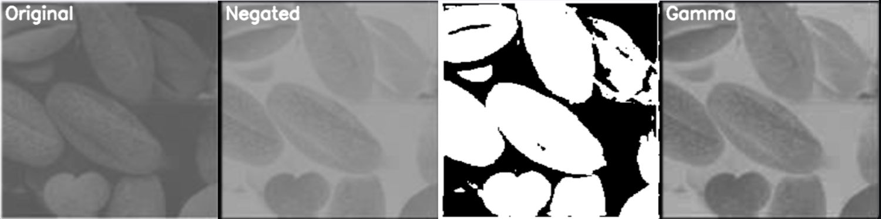

**CODE:**

import cv2

import numpy as np

*# Load the grayscale image*

image = cv2.imread(r"D:\DSIP\ex1_2.png", cv2.IMREAD_GRAYSCALE)

if image is None:

    print("Error: Could not open or find the image.")

    exit()

*# Image operations*

def image_negation(input_image):

    return 255 - input_image

def image_thresholding(input_image, threshold_value):

    _, thresholded_image = cv2.threshold(input_image, threshold_value, 255, cv2.THRESH_BINARY)

    return thresholded_image

def image_gamma_correction(input_image, gamma):

    gamma_corrected = np.power(input_image / 255.0, gamma) * 255.0

    return np.uint8(gamma_corrected)

*# Resize helper to match sizes*

def resize_to_common_size(images, width=300, height=300):

    resized = []

    for img in images:

        resized.append(cv2.resize(img, (width, height), interpolation=cv2.INTER_LINEAR))

    return resized

*# Perform operations*

negated_image = image_negation(image)

thresholded_image = image_thresholding(image, 118)

gamma_corrected_image = image_gamma_correction(image, 1)

*# Resize all images to same size*

resized_images = resize_to_common_size([

    image,

    negated_image,

    thresholded_image,

    gamma_corrected_image

])

*# Add labels (optional)*

def add_label(image, text):

    return cv2.putText(image.copy(), text, (10, 25), cv2.FONT_HERSHEY_SIMPLEX,

                       0.8, (255), 2, cv2.LINE_AA)

labeled_images = [

    add_label(resized_images[0], "Original"),

    add_label(resized_images[1], "Negated"),

    add_label(resized_images[2], "Thresholded"),

    add_label(resized_images[3], "Gamma")

]

*# Stack images horizontally*

combined_image = cv2.hconcat(labeled_images)

*# Show the combined image*

cv2.imshow("Image Processing Results", combined_image)

cv2.waitKey(0)

cv2.destroyAllWindows()\

**OUTPUT:**

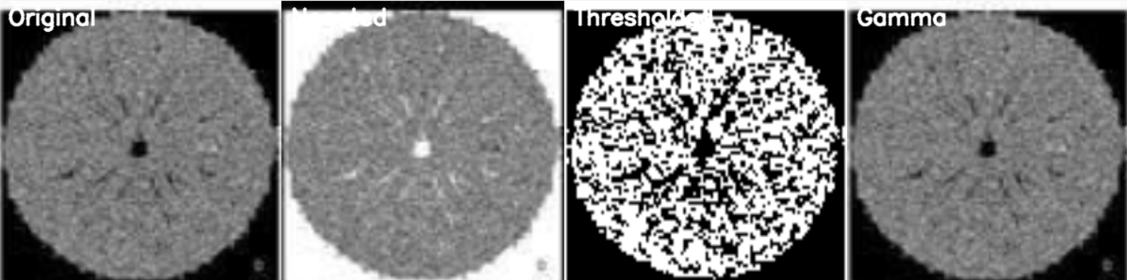

**CODE:**

import cv2

import numpy as np

*# Load the grayscale image*

image = cv2.imread(r"D:\DSIP\ex1_3.png",cv2.IMREAD_GRAYSCALE)

if image is None:

    print("Error: Could not open or find the image.")

    exit()

*# Image operations*

def image_negation(input_image):

    return 255 - input_image

def image_thresholding(input_image, threshold_value):

    _, thresholded_image = cv2.threshold(input_image, threshold_value, 255, cv2.THRESH_BINARY)

    return thresholded_image

def image_gamma_correction(input_image, gamma):

    gamma_corrected = np.power(input_image / 255.0, gamma) * 255.0

    return np.uint8(gamma_corrected)

*# Resize helper to match sizes*

def resize_to_common_size(images, width=300, height=300):

    resized = []

    for img in images:

        resized.append(cv2.resize(img, (width, height), interpolation=cv2.INTER_LINEAR))

    return resized

*# Perform operations*

negated_image = image_negation(image)

thresholded_image = image_thresholding(image, 25)

gamma_corrected_image = image_gamma_correction(image, 0.8)

*# Resize all images to same size*

resized_images = resize_to_common_size([

    image,

    negated_image,

    thresholded_image,

    gamma_corrected_image

])

*# Add labels (optional)*

def add_label(image, text):

    return cv2.putText(image.copy(), text, (10, 25), cv2.FONT_HERSHEY_SIMPLEX,

                       0.8, (255), 2, cv2.LINE_AA)

labeled_images = [

    add_label(resized_images[0], "Original"),

    add_label(resized_images[1], "Negated"),

    add_label(resized_images[2], "Thresholded"),

    add_label(resized_images[3], "Gamma")

]

*# Stack images horizontally*

combined_image = cv2.hconcat(labeled_images)

*# Show the combined image*

cv2.imshow("Image Processing Results", combined_image)

cv2.waitKey(0)

cv2.destroyAllWindows()

**OUTPUT:**

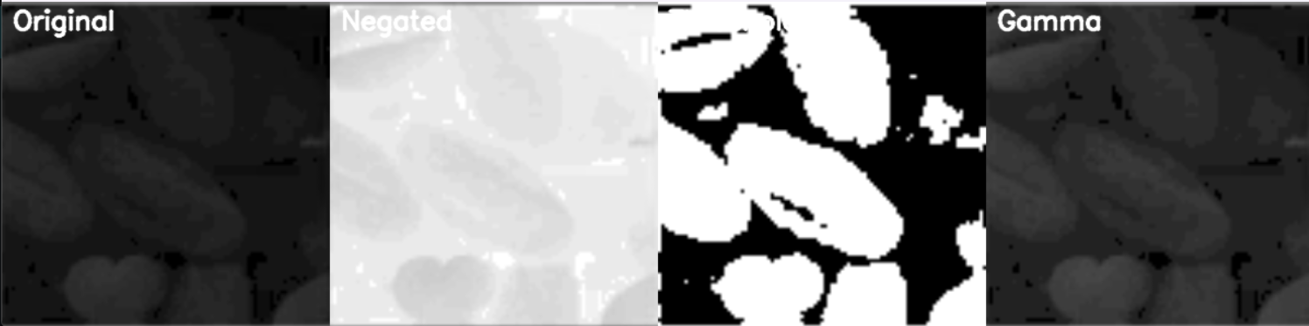

**CODE:**

import cv2

import numpy as np

*# Load the grayscale image*

image = cv2.imread(r"D:\DSIP\ex1_4.png", cv2.IMREAD_GRAYSCALE)

if image is None:

    print("Error: Could not open or find the image.")

    exit()

*# Image operations*

def image_negation(input_image):

    return 255 - input_image

def image_thresholding(input_image, threshold_value):

    _, thresholded_image = cv2.threshold(input_image, threshold_value, 255, cv2.THRESH_BINARY)

    return thresholded_image

def image_gamma_correction(input_image, gamma):

    gamma_corrected = np.power(input_image / 255.0, gamma) * 255.0

    return np.uint8(gamma_corrected)

*# Resize helper to match sizes*

def resize_to_common_size(images, width=300, height=300):

    resized = []

    for img in images:

        resized.append(cv2.resize(img, (width, height), interpolation=cv2.INTER_LINEAR))

    return resized

*# Perform operations*

negated_image = image_negation(image)

thresholded_image = image_thresholding(image, 1.2)

gamma_corrected_image = image_gamma_correction(image, -1.15)

*# Resize all images to same size*

resized_images = resize_to_common_size([

    image,

    negated_image,

    thresholded_image,

    gamma_corrected_image

])

*# Add labels (optional)*

def add_label(image, text):

    return cv2.putText(image.copy(), text, (10, 25), cv2.FONT_HERSHEY_SIMPLEX,

                       0.8, (255), 2, cv2.LINE_AA)

labeled_images = [

    add_label(resized_images[0], "Original"),

    add_label(resized_images[1], "Negated"),

    add_label(resized_images[2], "Thresholded"),

    add_label(resized_images[3], "Gamma")

]

*# Stack images horizontally*

combined_image = cv2.hconcat(labeled_images)

*# Show the combined image*

cv2.imshow("Image Processing Results", combined_image)

cv2.waitKey(0)

cv2.destroyAllWindows()

**OUTPUT:**

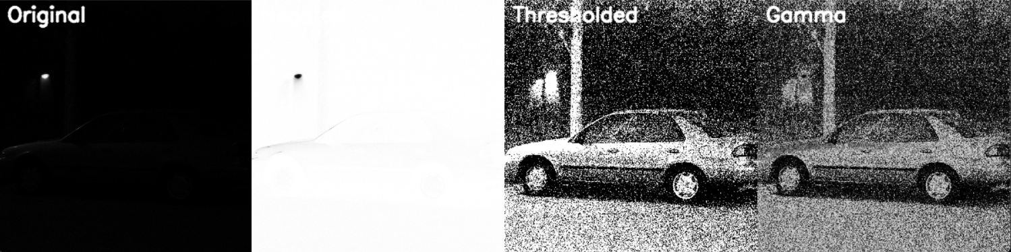

**CODE:**

import cv2

import numpy as np

*# Load the grayscale image*

image = cv2.imread(r"D:\DSIP\ex1_5.png", cv2.IMREAD_GRAYSCALE)

if image is None:

    print("Error: Could not open or find the image.")

    exit()

*# Image operations*

def image_negation(input_image):

    return 255 - input_image

def image_thresholding(input_image, threshold_value):

    _, thresholded_image = cv2.threshold(input_image, threshold_value, 255, cv2.THRESH_BINARY)

    return thresholded_image

def image_gamma_correction(input_image, gamma):

    gamma_corrected = np.power(input_image / 255.0, gamma) * 255.0

    return np.uint8(gamma_corrected)

*# Resize helper to match sizes*

def resize_to_common_size(images, width=300, height=300):

    resized = []

    for img in images:

        resized.append(cv2.resize(img, (width, height), interpolation=cv2.INTER_LINEAR))

    return resized

*# Perform operations*

negated_image = image_negation(image)

thresholded_image = image_thresholding(image, 2)

gamma_corrected_image = image_gamma_correction(image, -1)

*# Resize all images to same size*

resized_images = resize_to_common_size([

    image,

    negated_image,

    thresholded_image,

    gamma_corrected_image

])

*# Add labels (optional)*

def add_label(image, text):

    return cv2.putText(image.copy(), text, (10, 25), cv2.FONT_HERSHEY_SIMPLEX,

                       0.8, (255), 2, cv2.LINE_AA)

labeled_images = [

    add_label(resized_images[0], "Original"),

    add_label(resized_images[1], "Negated"),

    add_label(resized_images[2], "Thresholded"),

    add_label(resized_images[3], "Gamma")

]

*# Stack images horizontally*

combined_image = cv2.hconcat(labeled_images)

*# Show the combined image*

cv2.imshow("Image Processing Results", combined_image)

cv2.waitKey(0)

cv2.destroyAllWindows()

**OUTPUT:**

