Name: Shivam Bhatt

Enrollment No: 92301733046

Code:

import numpy as np

import pandas as pd

from sklearn.model_selection import train_test_split

from sklearn.metrics import accuracy_score, classification_report, confusion_matrix

# 1. Generate Dummy Student Data

np.random.seed(0)

N = 60

data = pd.DataFrame({

'hours_studied': np.random.randint(1, 10, N), # 1 to 9 hours/day

'attendance_pct': np.random.randint(50, 101, N), # 50% to 100% attendance

'assignments_done': np.random.randint(5, 21, N) # 5 to 20 assignments

})

# Generate exam score (continuous)

data['exam_score'] = (

data['hours_studied'] * 8 +

data['attendance_pct'] * 2 +

data['assignments_done'] * 3 +

np.random.normal(0, 15, N) # Noise

)

# Discretize target: Low=0, Medium=1, High=2

bins = [0, 500, 800, np.inf]

labels = [0, 1, 2]

data['score_class'] = pd.cut(data['exam_score'], bins=bins, labels=labels).astype(int)

X = data[['hours_studied', 'attendance_pct', 'assignments_done']]

y = data['score_class']

n_classes = len(y.unique())

# 2. Train-Test Split

X_train, X_test, y_train, y_test = train_test_split(

X, y, test_size=0.2, random_state=42, stratify=y

)

# Convert to NumPy

X_train_np = X_train.values

y_train_np = y_train.values

X_test_np = X_test.values

y_test_np = y_test.values

# 3. Logistic Regression (One-vs-Rest)

def sigmoid(z):

return 1 / (1 + np.exp(-z))

def train_one_vs_rest(X, y, n_classes, lr=1e-4, n_iter=5000):

n_samples, n_features = X.shape

weights = []

for k in range(n_classes):

yk = (y == k).astype(np.float64)

w = np.zeros(n_features)

b = 0.0

for _ in range(n_iter):

logits = np.dot(X, w) + b

y_pred = sigmoid(logits)

dw = np.dot(X.T, (y_pred - yk)) / n_samples

db = np.sum(y_pred - yk) / n_samples

w -= lr * dw

b -= lr * db

weights.append({'w': w, 'b': b})

return weights

def predict(X, weights):

n_samples = X.shape[0]

n_classes = len(weights)

probs = np.zeros((n_samples, n_classes))

for k in range(n_classes):

w = weights[k]['w']

b = weights[k]['b']

logits = np.dot(X, w) + b

probs[:, k] = sigmoid(logits)

return np.argmax(probs, axis=1)

# 4. Train & Evaluate

weights = train_one_vs_rest(X_train_np, y_train_np, n_classes)

y_pred = predict(X_test_np, weights)

print("Accuracy:", accuracy_score(y_test_np, y_pred))

print("\nClassification Report:\n", classification_report(y_test_np, y_pred))

print("\nConfusion Matrix:\n", confusion_matrix(y_test_np, y_pred))

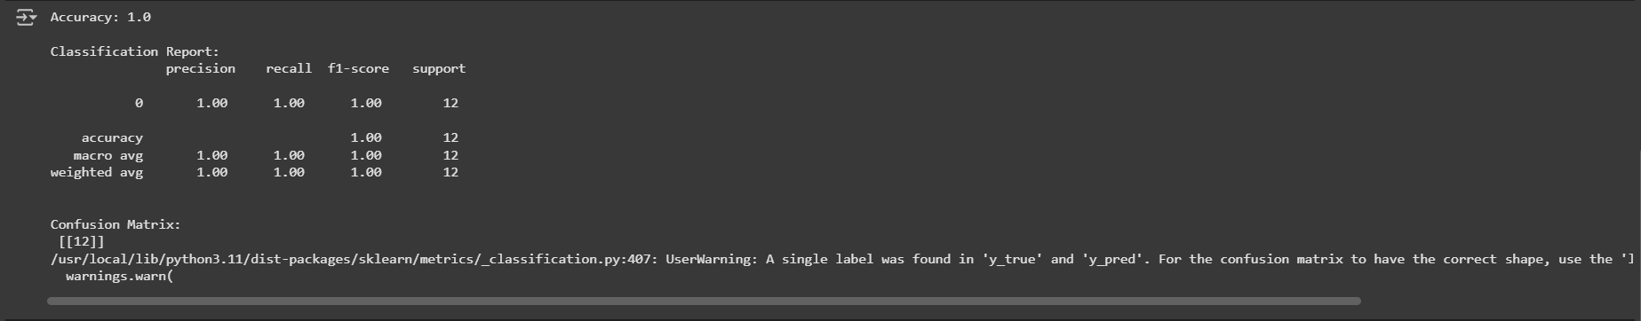

# 5. Sample Predictions

results = X_test.copy()

results['true_score'] = data.loc[X_test.index, 'exam_score']

results['true_class'] = y_test

results['pred_class'] = y_pred

print(results.head())

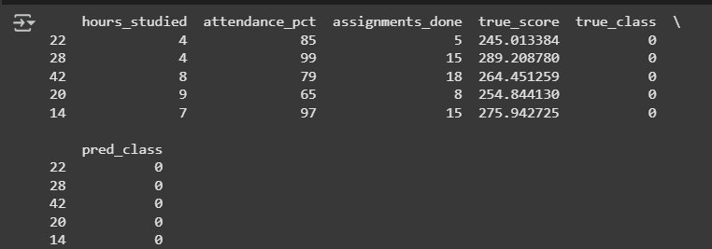

# 6. Class Distribution

print("\nClass distribution:")

print(data['score_class'].value_counts())

