**J523 SHIVAM KUMAR**   
 **Coding Challenge - Car Rental System – SQL**

* **CREATING DATABASE**
* Create database Carrental;

**Vehicle Table**

CREATE TABLE Vehicle (

vehicleID INT PRIMARY KEY,

make VARCHAR(50),

model VARCHAR(50),

year INT,

dailyRate DECIMAL(10, 2),

status ENUM('available', 'notAvailable'),

passengerCapacity INT,

engineCapacity DECIMAL(7, 2) );

**Customer Table**

CREATE TABLE Customer ( customerID INT PRIMARY KEY,

firstName VARCHAR(50),

lastName VARCHAR(50),

email VARCHAR(100),

phoneNumber VARCHAR(15) );

**Lease Table**

CREATE TABLE Lease ( leaseID INT PRIMARY KEY,

vehicleID INT, customerID INT,

startDate DATE,

endDate DATE,

type ENUM('DailyLease', 'MonthlyLease'),

FOREIGN KEY (vehicleID) REFERENCES Vehicle(vehicleID),

FOREIGN KEY (customerID) REFERENCES Customer(customerID) );

**Payment Table**

CREATE TABLE Payment (

paymentID INT PRIMARY KEY,

leaseID INT,

paymentDate DATE,

amount DECIMAL(10, 2),

FOREIGN KEY (leaseID) REFERENCES Lease(leaseID) );

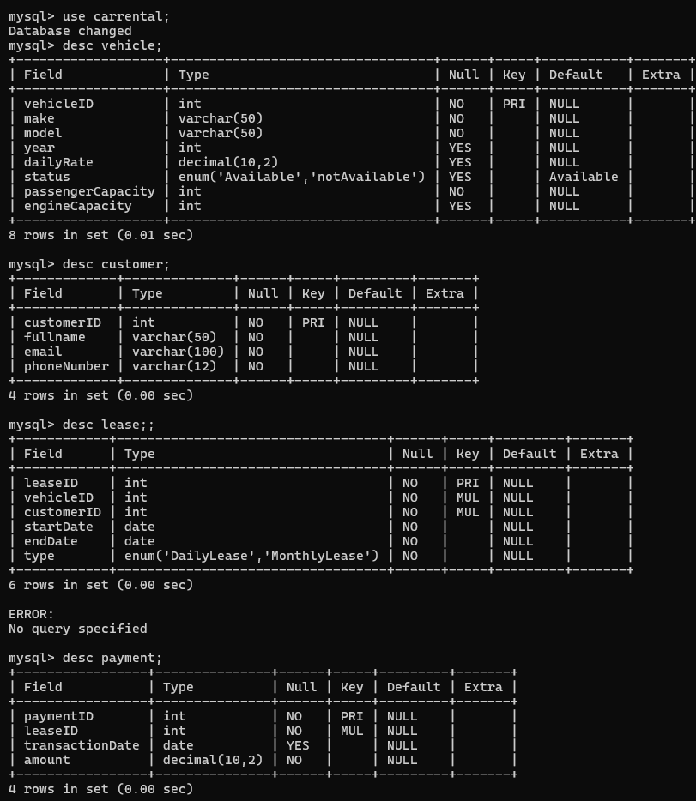

**INSERTING DATA**

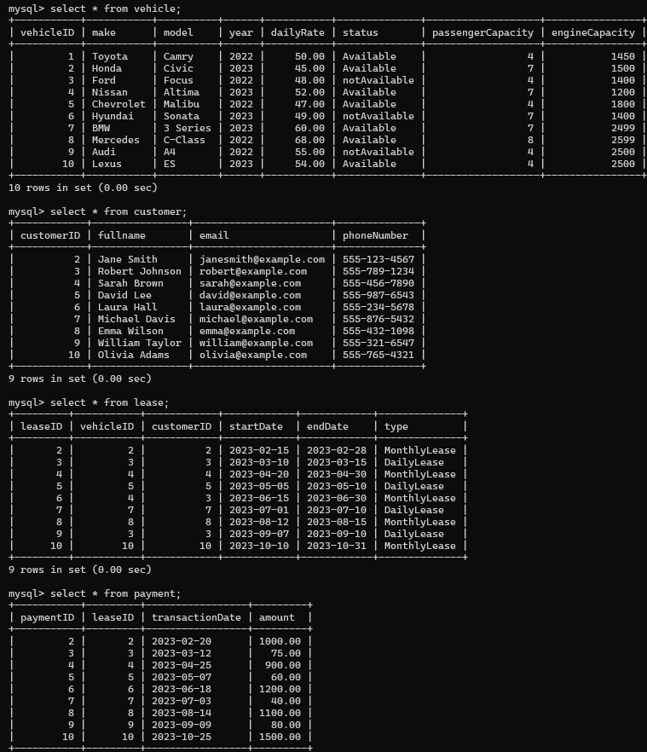

**20 SQL QUERIES**

1. Update the daily rate for a Mercedes car to 68.

* Update vehicle set dailyRate=68 where make='Mercedes';

1. Delete a specific customer and all associated leases and payments.

**// Delete associated payments**

START TRANSACTION;

* DELETE FROM Payment WHERE leaseID IN (SELECT leaseID FROM Lease WHERE customerID = 1);

**// Delete associated leases**

* DELETE FROM Lease WHERE customerID = 1;

**// Delete the customer**

* DELETE FROM Customer WHERE customerID = 1;

COMMIT;

1. Rename the "paymentDate" column in the Payment table to "transactionDate".

* ALTER TABLE Payment CHANGE paymentDate transactionDate DATE;

1. Find a specific customer by email.

-> SELECT * from customer WHERE email = 'robert@example.com';

1. Get active leases for a specific customer.

* SELECT * FROM Lease WHERE customerID = 3 AND CURDATE() BETWEEN

'2023-08-12' AND '2023 08-15' ;

1. Find all payments made by a customer with a specific phone number.

SELECT P.* FROM Payment P

JOIN Lease L ON P.leaseID = L.leaseID

JOIN Customer C ON L.customerID = C.customerID

WHERE C.phoneNumber = '555-555-5555';

7. Calculate the average daily rate of all available cars.

-> SELECT AVG(dailyRate) AS averageDailyRate FROM Vehicle

WHERE status = 'available';

8. Find the car with the highest daily rate.

-> SELECT *FROM Vehicle ORDER BY dailyRate DESC LIMIT 1;

9. Retrieve all cars leased by a specific customer.

-> SELECT V.* FROM Vehicle V JOIN Lease L ON V.vehicleID = L.vehicleID

WHERE L.customerID = 1; -- Replace with the specific customerID

10. Find the details of the most recent lease.

-> SELECT * FROM Lease

ORDER BY startDate DESC LIMIT 1;

11. List all payments made in the year 2023.

-> select * from payment where year(transactionDate)=2023;

12. Retrieve customers who have not made any payments.

-> SELECT C.* FROM Customer C LEFT JOIN Lease L ON C.customerID = L.customerID

LEFT JOIN Payment P ON L.leaseID = P.leaseID

WHERE P.paymentID IS NULL;

13. Retrieve Car Details and Their Total Payments.

-> SELECT V.*, SUM(P.amount) AS totalPayments

FROM Vehicle V

LEFT JOIN Lease L ON V.vehicleID = L.vehicleID

LEFT JOIN Payment P ON L.leaseID = P.leaseID

GROUP BY V.vehicleID;

14. Calculate Total Payments for Each Customer.

-> SELECT C.customerID, C.fullName, SUM(P.amount) AS totalPayments

FROM Customer C

LEFT JOIN Lease L ON C.customerID = L.customerID

LEFT JOIN Payment P ON L.leaseID = P.leaseID

GROUP BY C.customerID;

15. List Car Details for Each Lease.

-> SELECT V .*, L .* FROM Vehicle V

JOIN Lease L ON V.vehicleID = L.vehicleID;

16. Retrieve Details of Active Leases with Customer and Car Information.

-> SELECT L.*, C.fullName, V.*

FROM Lease L

JOIN Customer C ON L.customerID = C.customerID

JOIN Vehicle V ON L.vehicleID = V.vehicleID

WHERE CURDATE() BETWEEN L.startDate AND L.endDate;

17. Find the Customer Who Has Spent the Most on Leases.

-> SELECT C.customerID, C.fullName, SUM(P.amount) AS totalSpent

FROM Customer C

JOIN Lease L ON C.customerID = L.customerID

JOIN Payment P ON L.leaseID = P.leaseID

GROUP BY C.customerID

ORDER BY totalSpent DESC

LIMIT 1;

18. List All Cars with Their Current Lease Information

SELECT V.*, L.leaseID, L.startDate, L.endDate, L.customerID

FROM Vehicle V

LEFT JOIN Lease L ON V.vehicleID = L.vehicleID

AND CURDATE() BETWEEN L.startDate AND L.endDate;