**Requirement**

**1.****Introduction [IMG_256](http://www.ecs.csun.edu/~rlingard/COMP684/Example2SoftArch.htm#Toc)**

#### Purpose : **It is brief introduction about the required steps that are to be taken for “CollegeStudent” Project.**

**2.****Architectural Representation [IMG_261](http://www.ecs.csun.edu/~rlingard/COMP684/Example2SoftArch.htm#Toc)**

**This document presents the architecture as a series of views; use case view, logical view, process view and deployment view. There is no separate implementation view described in this document. These are views on an underlying Unified Modeling Language (UML) model .**

**3. Goals  [IMG_262](http://www.ecs.csun.edu/~rlingard/COMP684/Example2SoftArch.htm#Toc)**

1. **Implement a web application to register for students.**
2. **After registration, User will be able to login into the system.**

**3. Student Role:**

**a. Upload Image and update profile.**

**b. Choose course**

**c. Show the list of subjects (alogn with teacher) for selected course.**

**4. Teacher Roles:**

**a. Show the list of students alogn with course who have selected the respective subject**

**b. Should have access on visit students profiles (Only for his subject).**

**5. Admin Role:**

**a. Can Create course and list of subject for each course.**

**b. Can assign subjects to the Teachers.**

**c. Can add/remove student and teachers.**

**4.  Main website  [IMG_263](http://www.ecs.csun.edu/~rlingard/COMP684/Example2SoftArch.htm#Toc)(Users)**

* **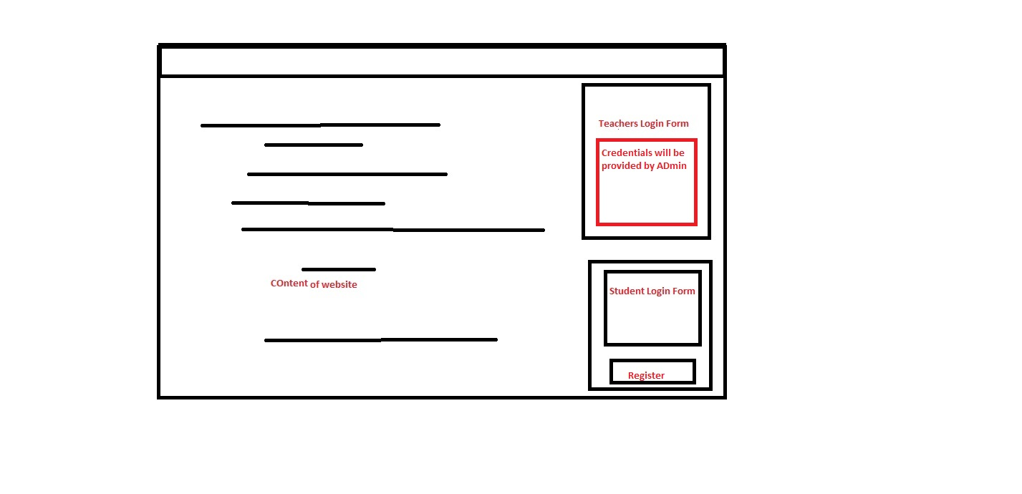Main website will contain two thing one, main body/content of website second ,Separate log in form for teacher as well as Student**
* **Credentials of teacher will be provided by Admin**
* **Student have to register themselves in the college website with their student ID ,in our case it can be their Enroll number**
* **Users(other than student ) can view the body or content of website**

**5. Student Registration Form  [IMG_263](http://www.ecs.csun.edu/~rlingard/COMP684/Example2SoftArch.htm#Toc)(Student Role)**

**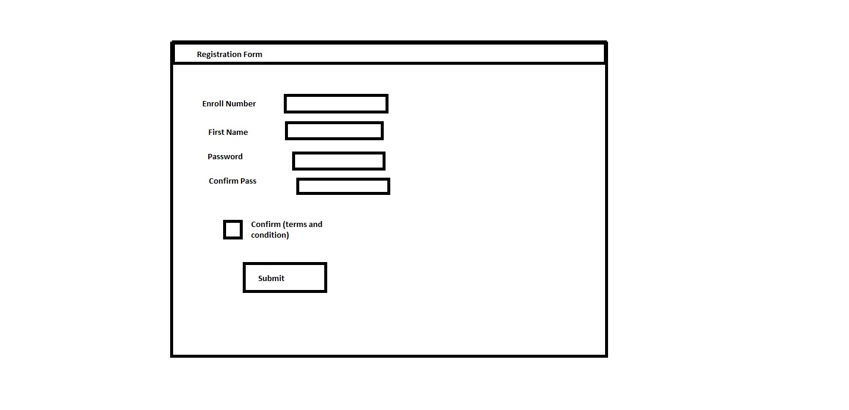**

* **Student will have to register through their Enroll number**
* **Their Enroll number will determine there subject and Respective course**

**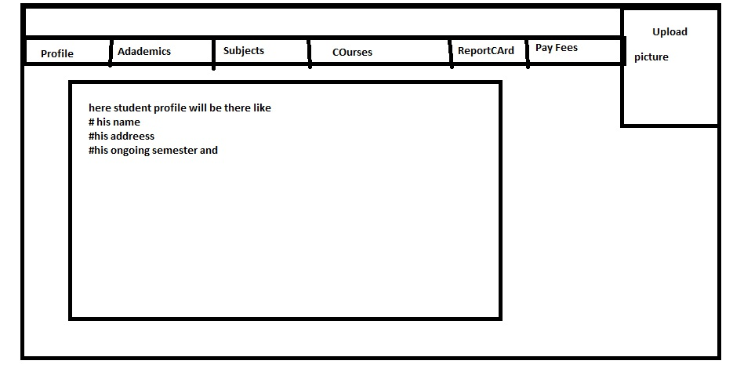5.1 Student Page when he/she will loggedin the website**

* **In right top corner Student can upload their Profile Picture**
* **Separate section will be there and there separate views will be there for profile , academic , subjects , courses**
* **In profile section Student can view and edit their Profile**
* **Academics will contains its 10th 12th and other certifications**
* **Subjects will contains the subjects which will be there according to their “Enrollment number “**
* **According to particular Subject , Teacher and their respected courses will be there to be selected by student**
* **Report card will be there for previous semester Mark sheet and marks (will be null if in 1st sem )**
* **Pay fees will be online portal for fees submission**

1. **Teacher LogIn**

* **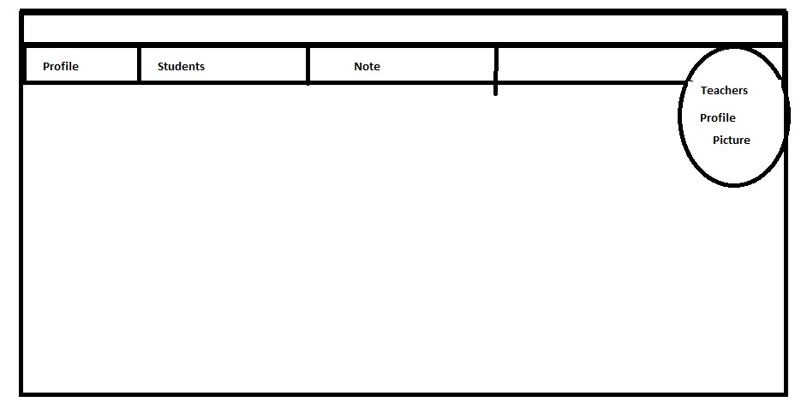Teacher can upload their picture in right top corner**
* **Teacher can view and edit their profile in Profile section**
* **Student Index will be there where teacher can view the list of student along with the courses who have selected the respective subject**
* **On clicking on particular Student , their profile should be open**

**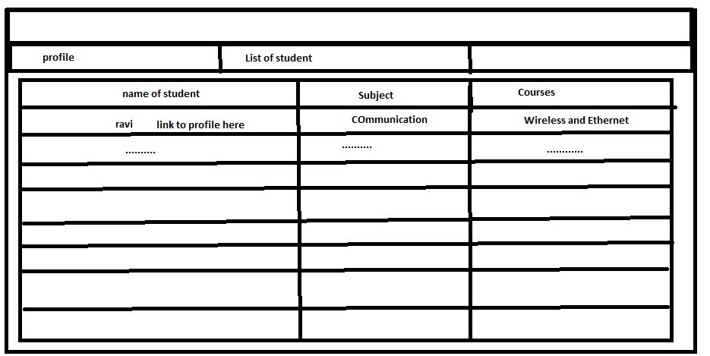**

1. **Admin LogIn**

* **Separate page or view will be created for admin and url will be provided to Directer and HODS (in our case for college website )**

**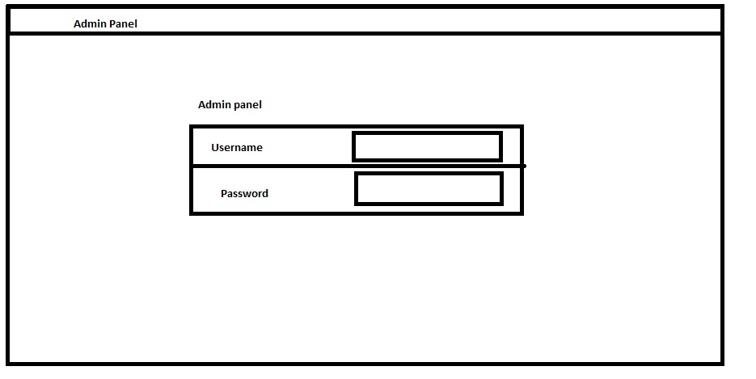**

* **Admin credential will be saved to database and will be provided to them by developer**
* **After log in Admin can manage role or Add role in main website like Student, Teacher or other workers role**

**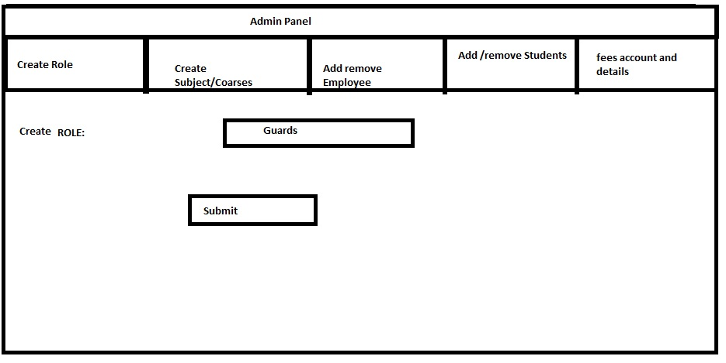**

* **Can create rolls**
* **Can Add Subject or remove them**
* **Can Add or remove Employee, Student**
* **Can view the fee details (All credit and debit details)**

1. **Roles**

**Users panel**

* **Can view the website and can see the basic content of website like news , feeds , pictures and events which is performed on college**

**Students panel**

* **Can registered to the website**
* **Can upload their picture**
* **Can select subjects and respective courses**
* **Can view and edit their website**
* **Can apply for Forget password**
* **can upload their profile picture**
* **Can view their report cards**
* **Can view their fees details**

**Teachers panel**

* **Can not be registered(credentials will be provided by Admin )**
* **Can upload their profile picture**
* **Can view and edit their profile details**
* **Can see the respective student connected to their subject& courses**
* **Can view their profile by clicking on particular student**
* **Note section is provided for Note or important Details**

**Admin Panel**

* **Can create Role (Teachers, Student, Employee , guard etc.)**
* **Can create subject and courses**
* **Can ADD/ remove teachers**
* **Can ADD/ remove Student**
* **Can see the fee structure of individuals**
* **Can assign particular subject to particular teacher(in create “Subject/courses“section**

**-------------------------------------------------------------------------------------------------------------------**