# 17. **Explain the working of P-N junction diode in forward and reverse biased mode.**

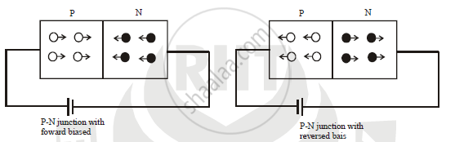

A P-N junction diode is said to be forward biased when the positive terminal of a cell or battery is connected to the p-side of the junction and the negative terminal to the n side.  
When diode is forward-biased the depletion region narrows and consequently, the potential barrier is lowered. This causes the majority charge carriers of each region to cross into the other region. The electrons travel from the n-side to the p-side and go to the positive terminal of the battery. The holes that travel from the p-side to the n-side combine with the electrons injected into the n-region from the negative terminal of the battery. This way the diode conducts when forward-biased.

Reverse-biased pn junction diode  
A pn-junction diode is said to be reverse biased when the positive terminal of a cell or battery is connected to the n-side of the junction and the negative terminal to the p-side.  
When reverse biased, the depletion region widens and the potential barrier is increased. The polarity of the battery extracts the majority charge carriers of each region. The holes in the p-region from the electrons injected into the p-region from the negative terminal of the battery. The electrons in the n-region go to the positive terminal of the battery. This way, the majority charge carrier concentration in each region decreases against the equilibrium values and the reverse biased junction diode has a high resistance. Thus, the diffusion current across the junction becomes zero. Thus, the diode does not conduct when reverse biased and is said to be in a quiescent or non-conducting state i.e., it acts as an open switch.

**26. Define Rectifier. Explain the working principle of Bridge full wave rectifier with neat diagram. Also write its ripple factor and efficiency formula with their ideal values.**

A **rectifier** is **a device that converts an oscillating two-directional alternating current (AC) into a single-directional direct current (DC)**. Rectifiers can take a wide variety of physical forms, from vacuum tube diodes and crystal radio receivers to modern silicon-based designs.

A Full wave rectifier is a circuit arrangement which **makes use of both half cycles of input alternating current (AC) and converts them to direct current (DC)**.

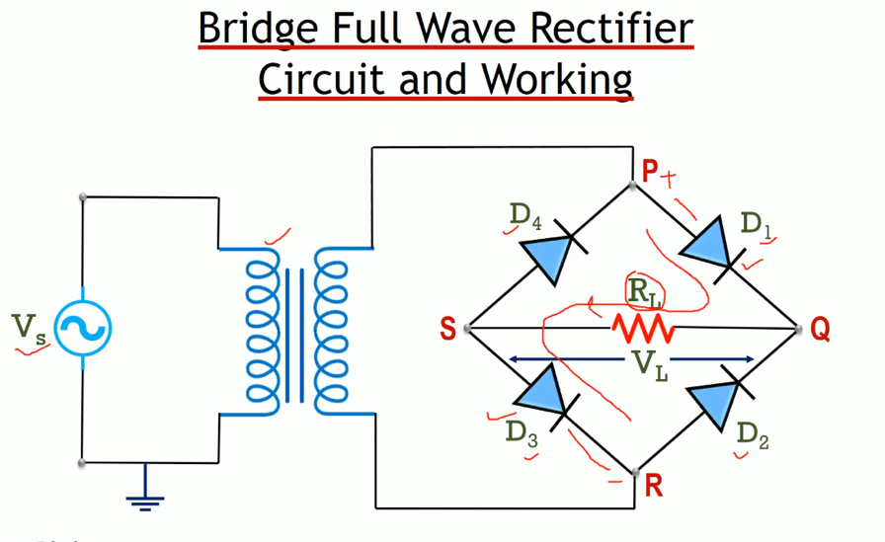

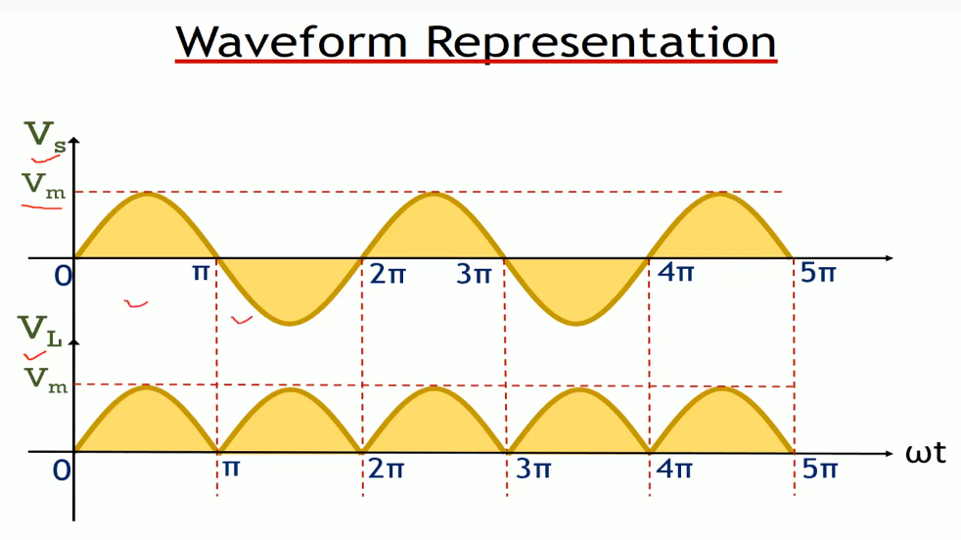

* Vs = represents the signal applied at the input
* VL=represents the signal applied at the output
* Vm = represents the maximum value of Voltage signal

30.Draw and explain the forward and reverse biased p-n junction V-I characteristics curve

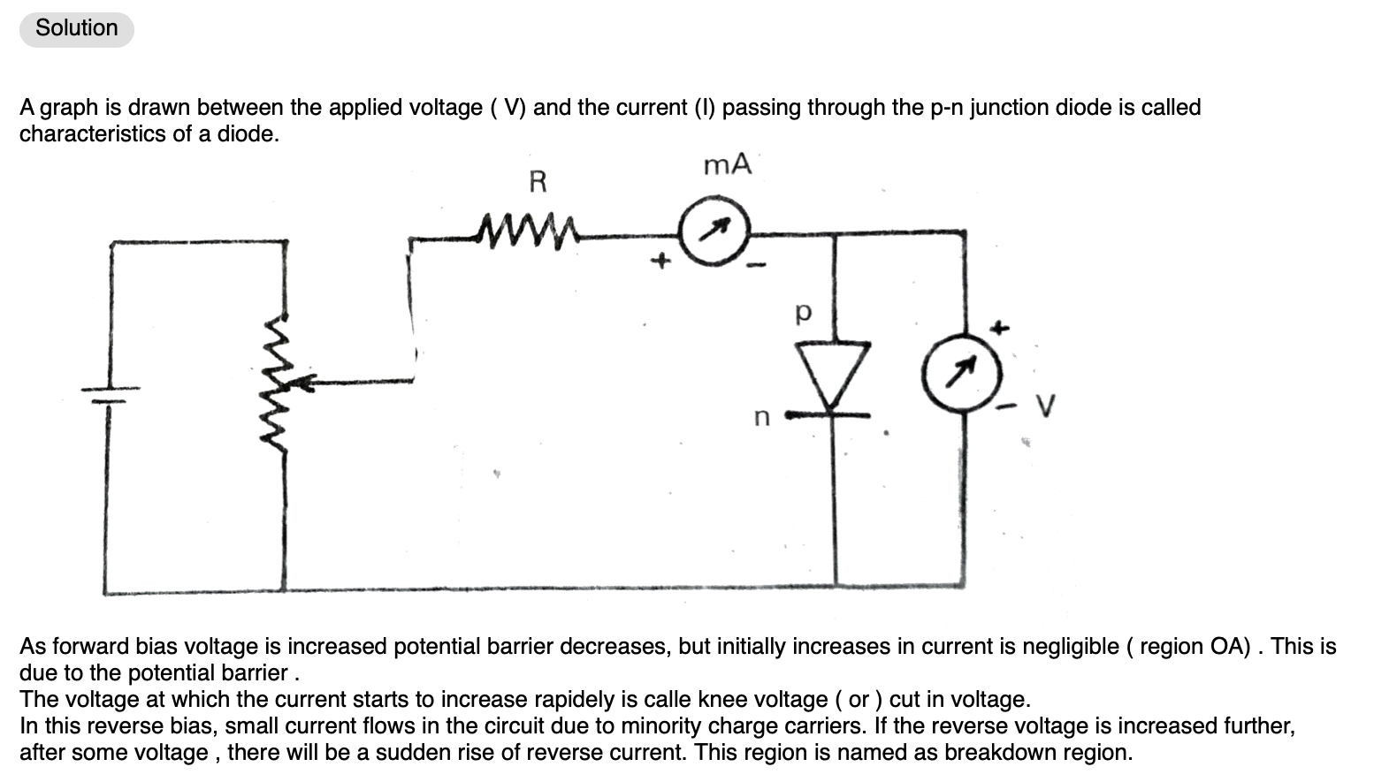

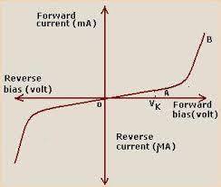

[[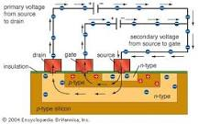](https://www.google.com/search?client=safari&sa=X&bih=634&biw=1039&hl=en&sxsrf=APq-WBtg1YrLoJRqM1wNxt_hyov9AfJ1Rg:1645342202417&q=Why+transistor+is+called+bipolar+junction+transistor?&tbm=isch&source=iu&ictx=1&vet=1&fir=1uLzVq6M4CpqEM%252CIGgUbMTwV2amkM%252C_&usg=AI4_-kTLOjJnCPzdei0iWVsVWlF-sXbgmA&ved=2ahUKEwjl7ois4Y32AhXh63MBHXqcA3kQ9QF6BAgLEAE#imgrc=1uLzVq6M4CpqEM)](https://www.google.com/search?client=safari&sa=X&bih=634&biw=1039&hl=en&sxsrf=APq-WBtg1YrLoJRqM1wNxt_hyov9AfJ1Rg:1645342202417&q=Why+transistor+is+called+bipolar+junction+transistor?&tbm=isch&source=iu&ictx=1&vet=1&fir=1uLzVq6M4CpqEM%252CIGgUbMTwV2amkM%252C_&usg=AI4_-kTLOjJnCPzdei0iWVsVWlF-sXbgmA&ved=2ahUKEwjl7ois4Y32AhXh63MBHXqcA3kQ9QF6BAgLEAE" \l "imgrc=1uLzVq6M4CpqEM)

device is often called the bipolar junction **counterparts** (the holes corresponding to an absence of electrons in the crystal lattice) coexist briefly in the presence of one another.

transistor **because its operation requires that the negatively charged electrons and their positively charged**