# Overview

Drag and drop email builder with the ability to modify element-specific properties.

**Design Specification**

Email builder consists of a single screen. This page is created using material-UI & [react-smooth-dnd](https://www.npmjs.com/package/react-smooth-dnd).

**How it works**

 1. From the Contents menu a user and drag a component Text, Button, Image, Separator/ Divider, Bullet and drop it in the middle of the dividers.

 2. After dropping the component it would be added in items and users can delete and edit.

 3. On save the current template is saved in local storage & on refresh saved template can be prefetched.

4. On download, a responsive Html file is downloaded and the user can view the Html.

5. On reset, all the current progress is removed.

**Next steps**

1. Support multiple columns.

2. Allowing redo and undo action.

3. Preview feature.

**Screenshots**

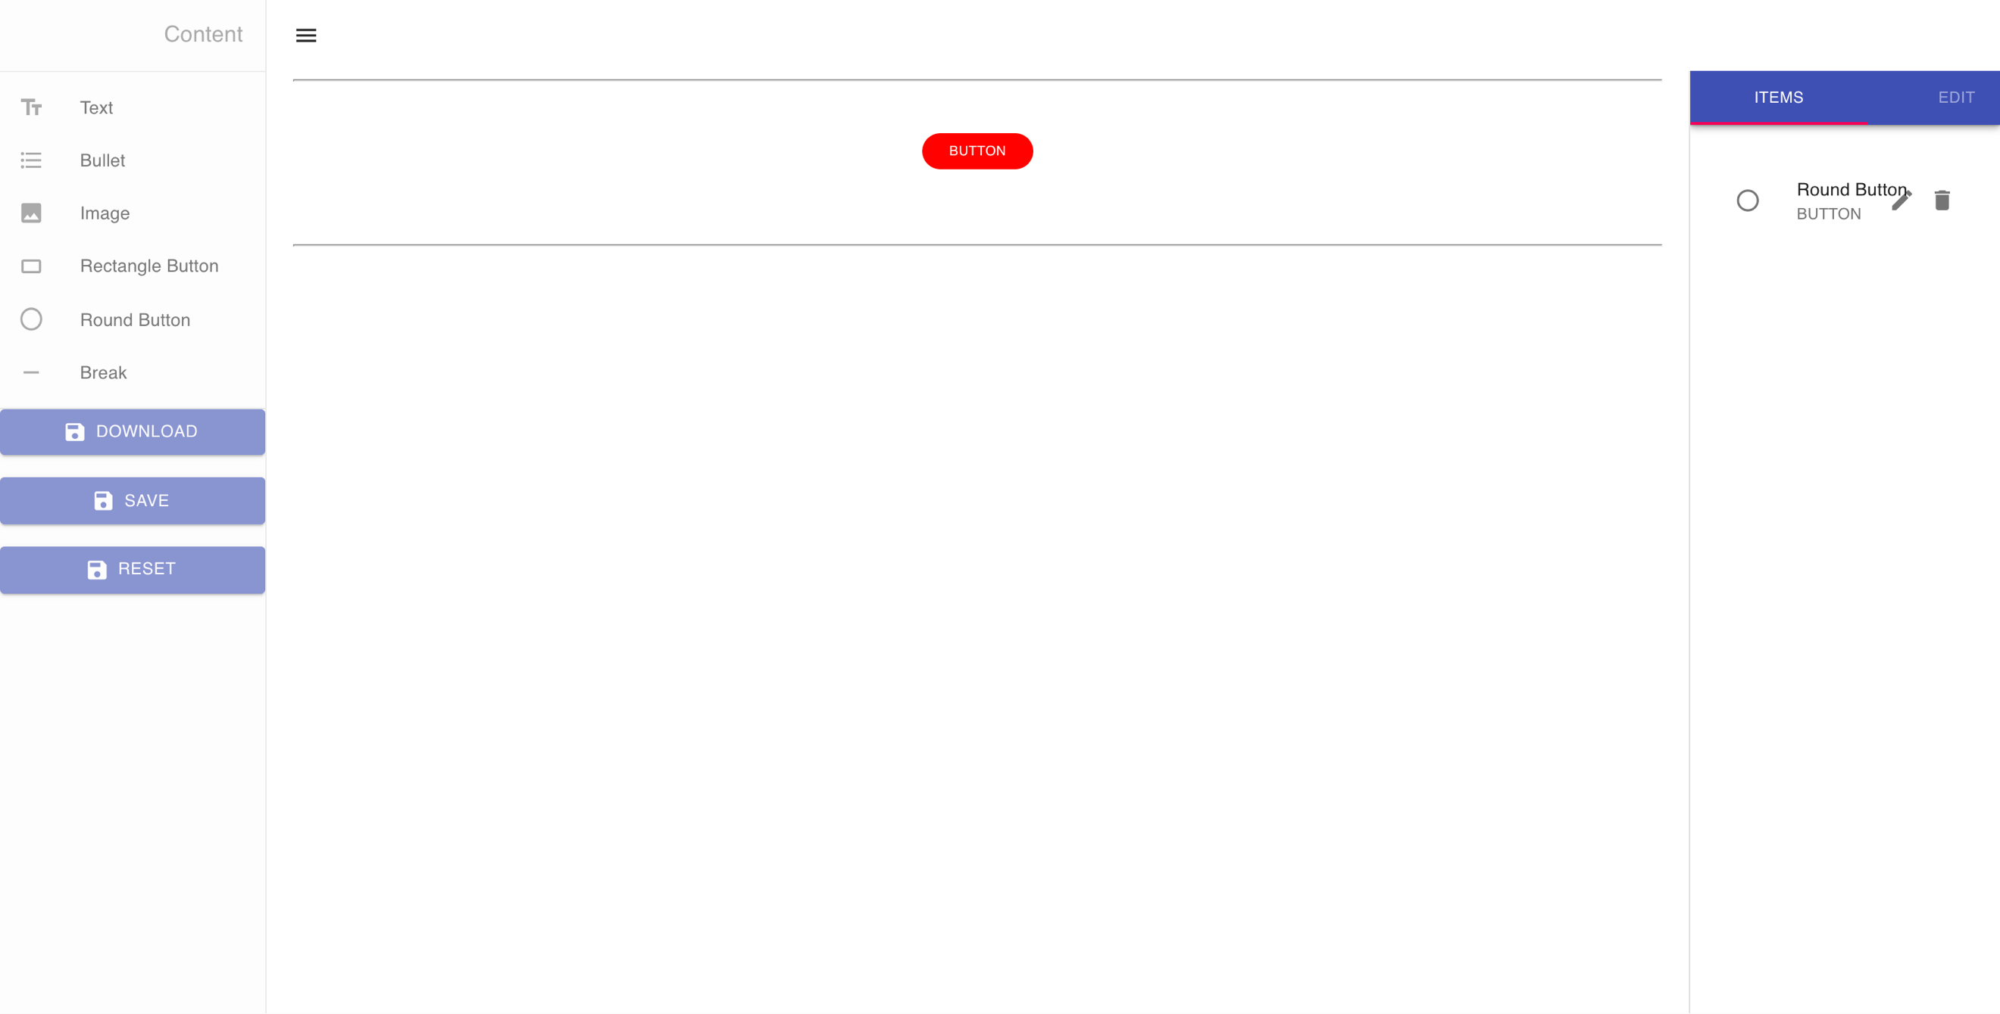

Figure 1 Button dragged & dropped.



Figure 2 Button editable properties.