Active Directory Setup Guide

Step 1: Open Active Directory Users and Computers
Launch the Active Directory Users and Computers console to begin managing users, groups, and organizational units.
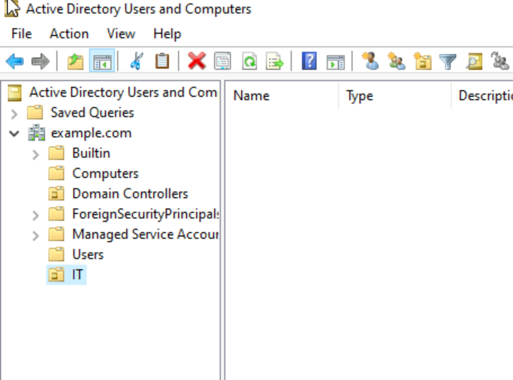

Step 2: Create a New User (user4)
To create a new user, right-click on the desired Organizational Unit (OU) and select 'New' > 'User'. Fill in the user details such as full name and logon name.
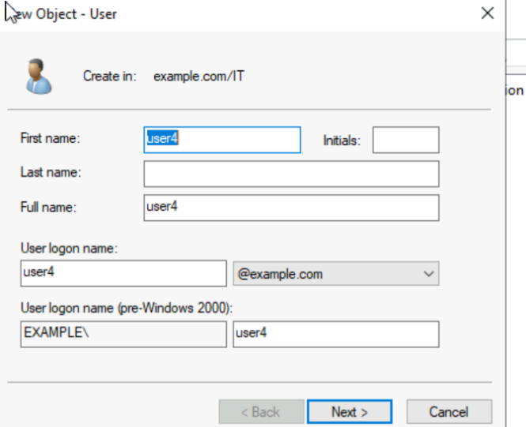
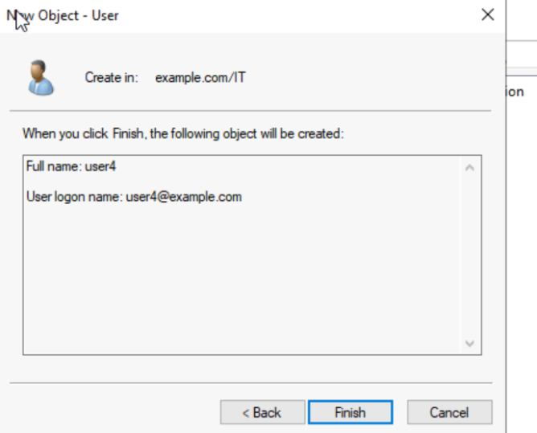

Step 3: Create Another User (user5)
Repeat the process to create another user named 'user5'. Ensure to set the password and configure options like 'Password never expires'.
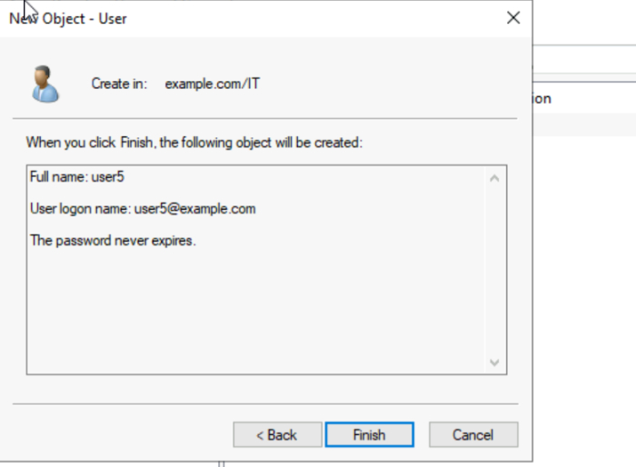

Step 4: Create a New Group (IT)
To create a group, right-click on the OU and select 'New' > 'Group'. Enter the group name and choose the appropriate group scope and type.
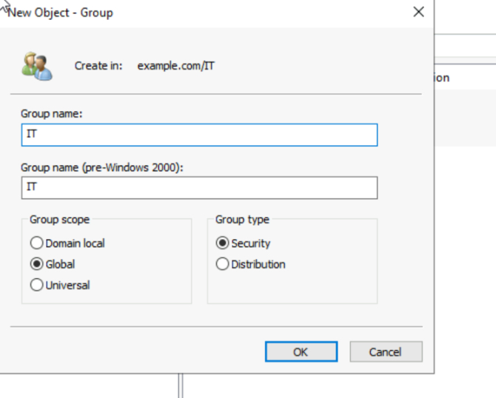

Step 5: Add Users to the Group
Add users to the newly created group by selecting the group properties and using the 'Members' tab to include users like user4 and user5.
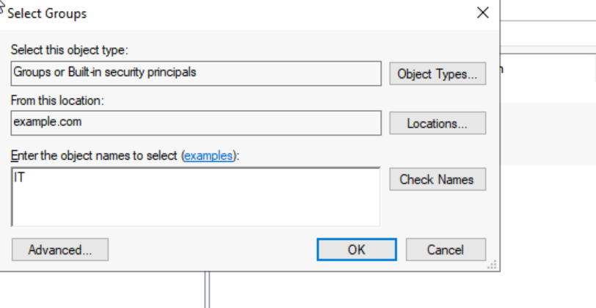
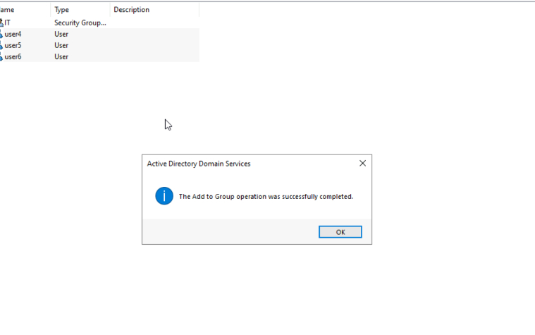
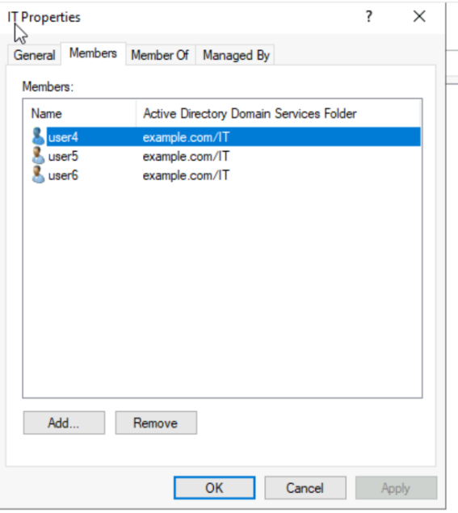

Step 6: Create an Organizational Unit (Production)
To organize users and groups, create an Organizational Unit (OU). Right-click on the domain and select 'New' > 'Organizational Unit'. Name it appropriately and enable protection from accidental deletion.
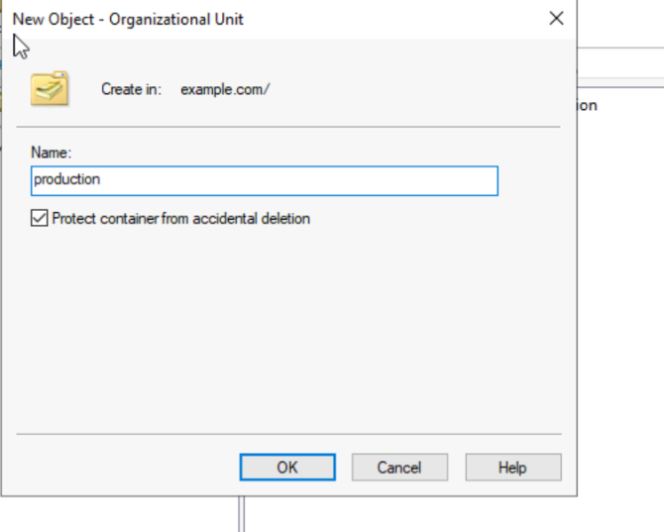

Step 7: Additional User and Group Management
Continue managing users and groups by creating more users, assigning them to groups, and verifying group memberships.
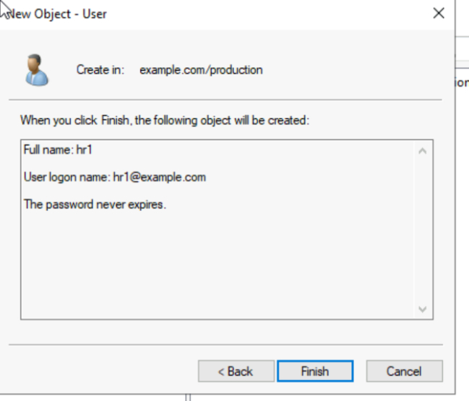
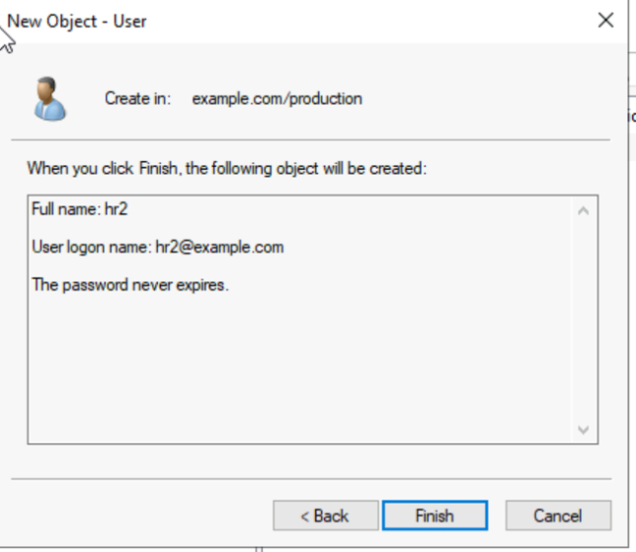
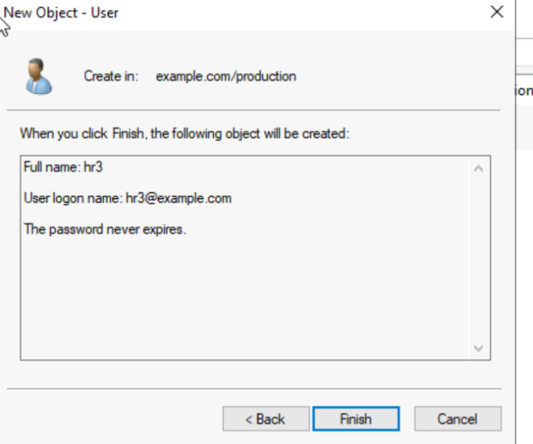
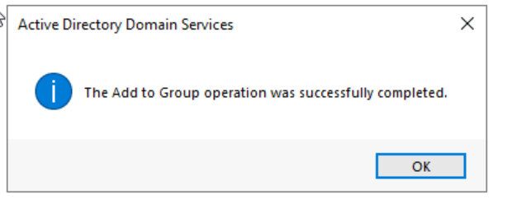
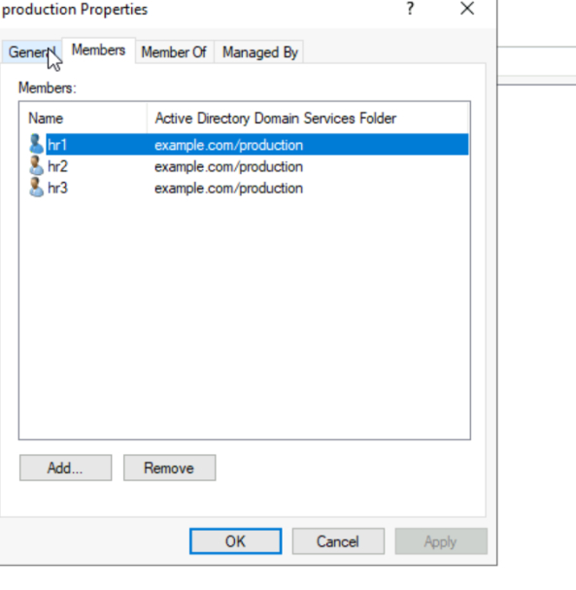

Step 8: Final Group and OU Configuration
Finalize the configuration by reviewing group properties and ensuring all users are correctly assigned.
