Windows Server 2022 Hands-On Setup Report
Date: 7 October 2025

Overview
This document summarizes the hands-on setup of Active Directory Domain Services (AD DS) and DNS on Windows Server 2022. The server was configured with a static IP, renamed to 'domcon', and roles and features were installed to establish a domain environment.

Step-by-Step Configuration

1. Rename Server to DOMCON
The server was renamed to 'domcon' using the System Properties dialog. This is essential for domain controller identification.
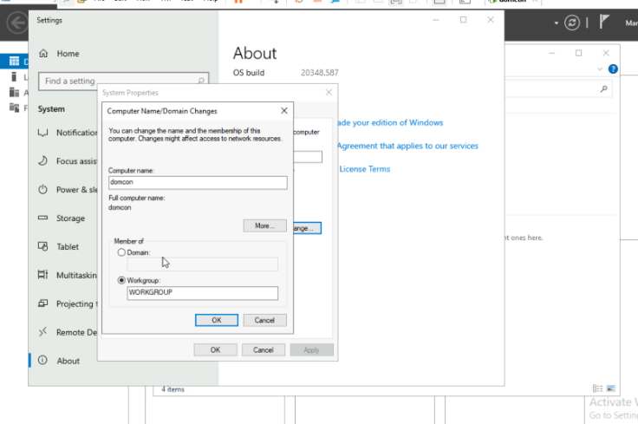

2. Configure Static IP Address
A static IP address was configured to ensure consistent network communication. The IP settings used were:
- IP Address: 192.168.10.1
- Subnet Mask: 255.255.255.0
- Preferred DNS: 127.0.0.1
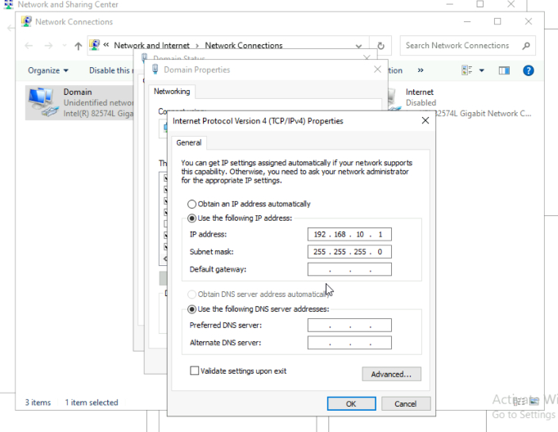

3. Install AD DS and DNS Roles
Using Server Manager, the Active Directory Domain Services and DNS Server roles were installed. Additional features like Group Policy Management were also included.
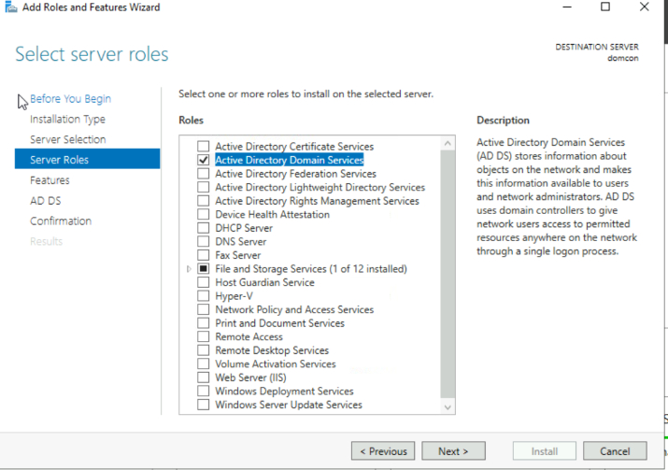

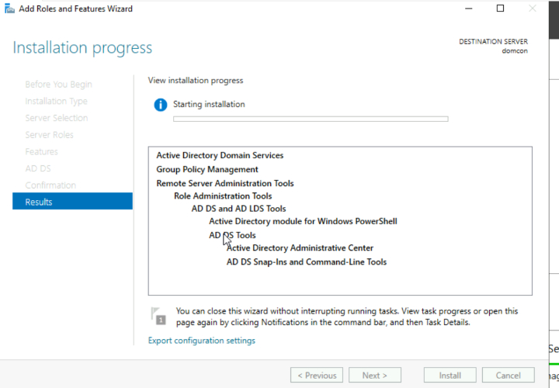

4. Configure Active Directory Domain Services
The server was promoted to a domain controller by creating a new forest. The root domain name was specified during the configuration.
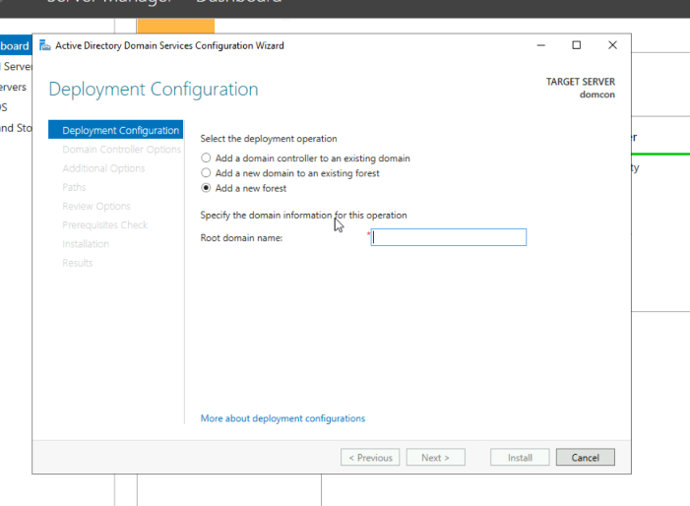
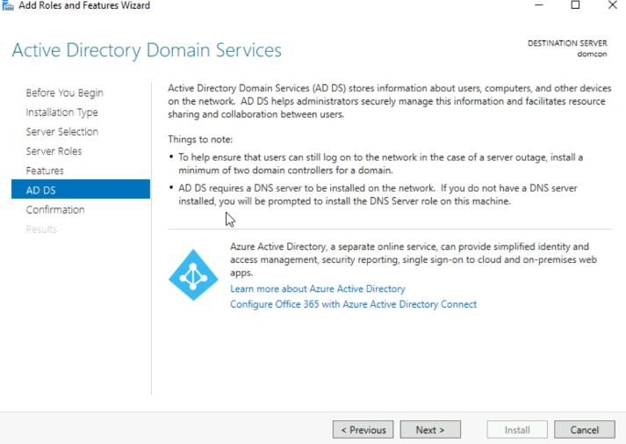

5. Specify AD DS Database and SYSVOL Paths
The default paths for the database, log files, and SYSVOL folder were set as follows:
- Database Folder: C:\Windows\NTDS
- Log Files Folder: C:\Windows\NTDS
- SYSVOL Folder: C:\Windows\SYSVOL
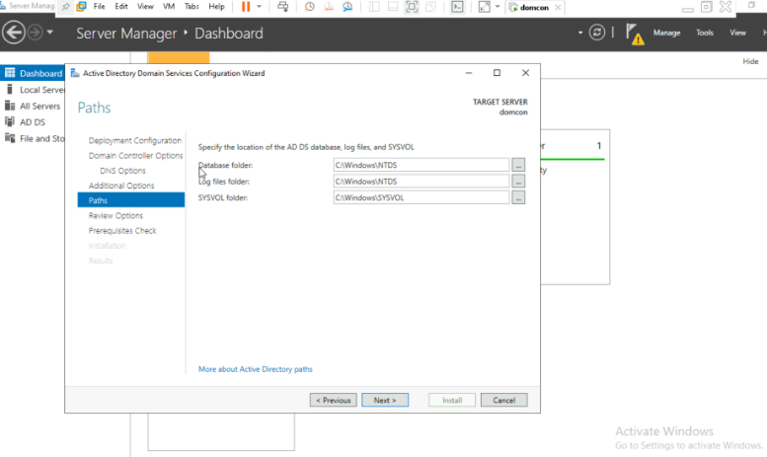

6. Validate Prerequisites
The system successfully validated all prerequisites before proceeding with the domain controller installation.
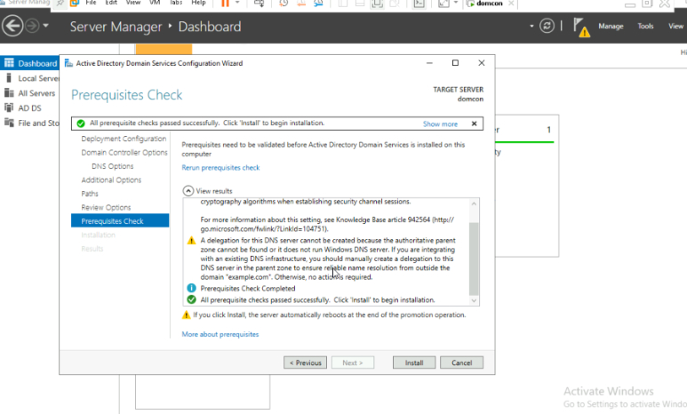

7. Review Network Interfaces
The server was equipped with multiple Ethernet interfaces using Intel(R) 82574L Gigabit Network adapters.
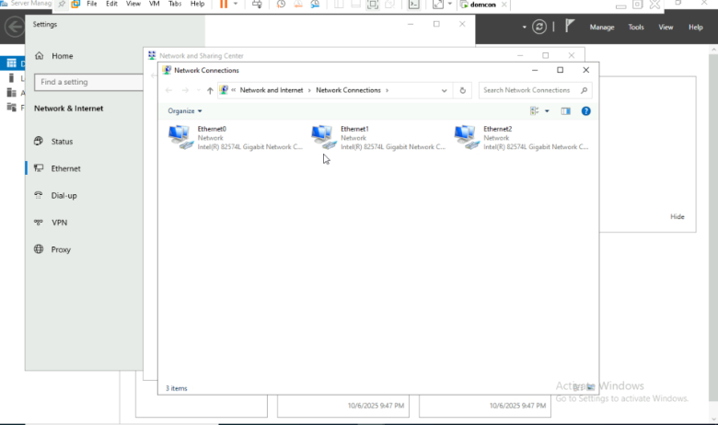

8. Verify Network Connectivity
Ping tests were conducted to verify network connectivity. Successful replies confirmed proper network setup.
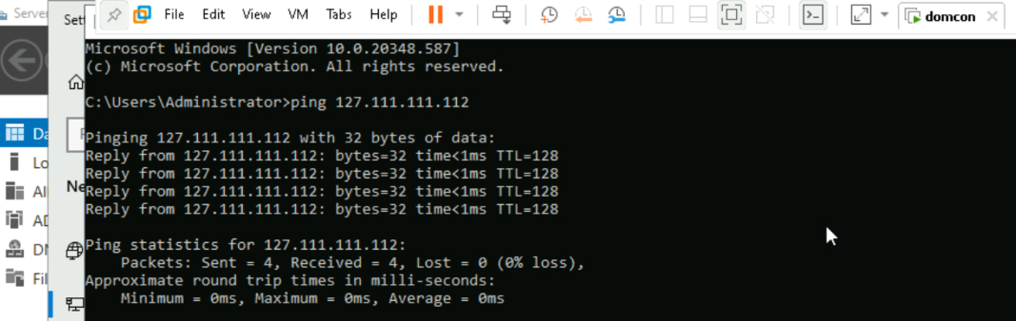

Active Directory Domain Services (AD DS) Setup and Domain Join Lab

Step 1: Install and configure AD DS on the server. Create a new forest with domain name 'example.com'.
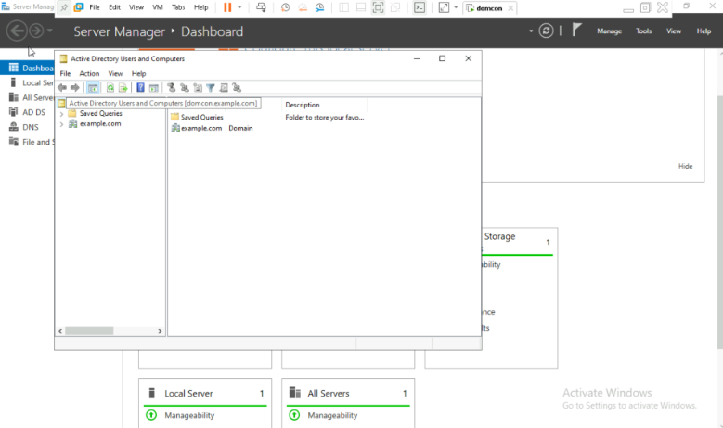

Step 2: Create user accounts: user1, user2, user3, admin1, admin2.
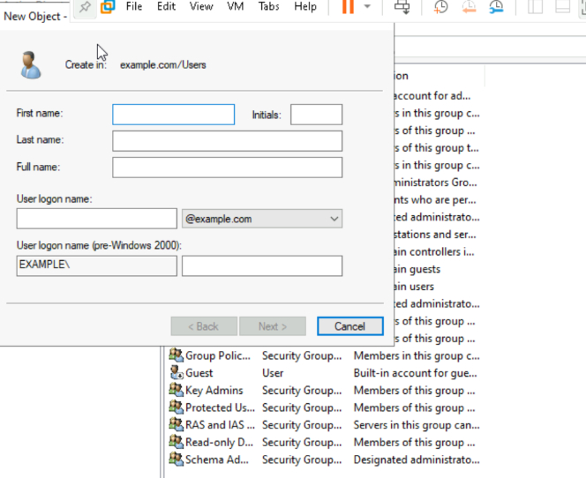

Step 3: Create a security group named 'Admin' and add admin1 and admin2 to this group.
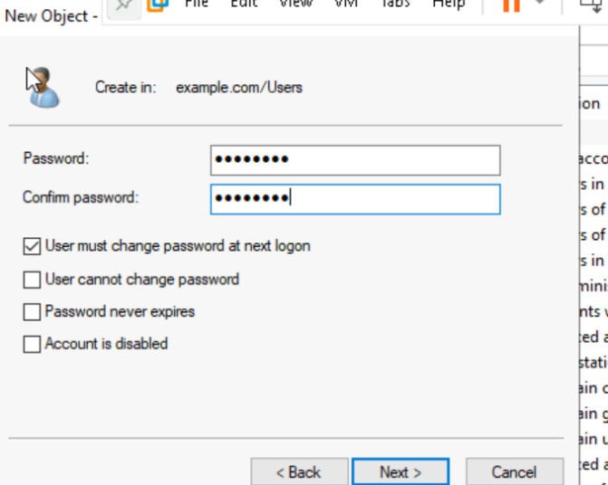

Step 4: Assign five major administrative privileges to the 'Admin' group.
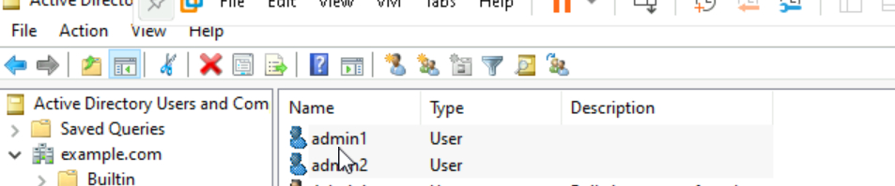

Step 5: On the client PC, configure DNS to point to the server's IP address.
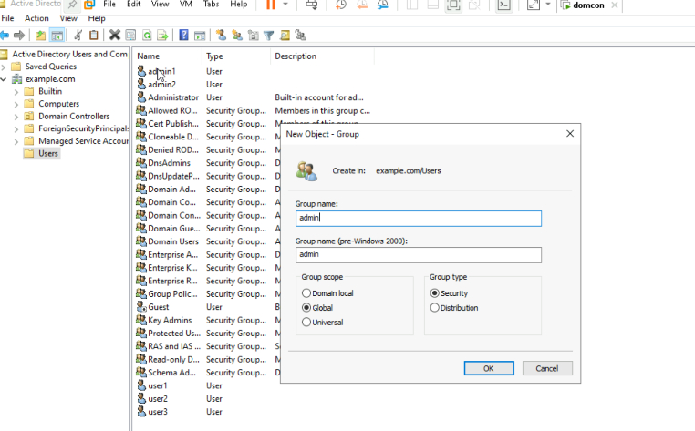

Step 6: Change the domain of the client PC to 'example.com' and restart the machine.
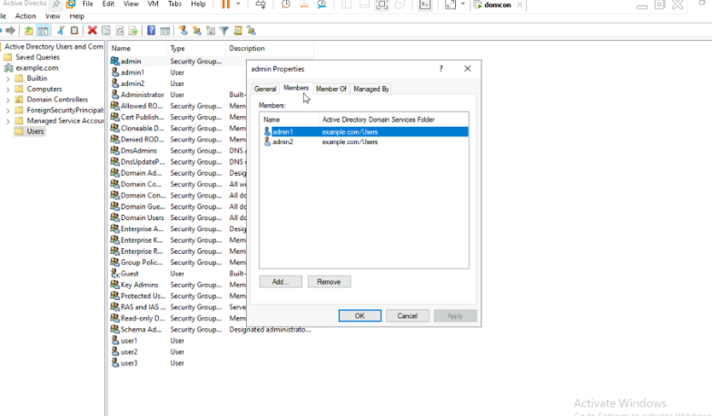

Step 7: Log in to Client PC 1 using domain credentials (e.g., user1).
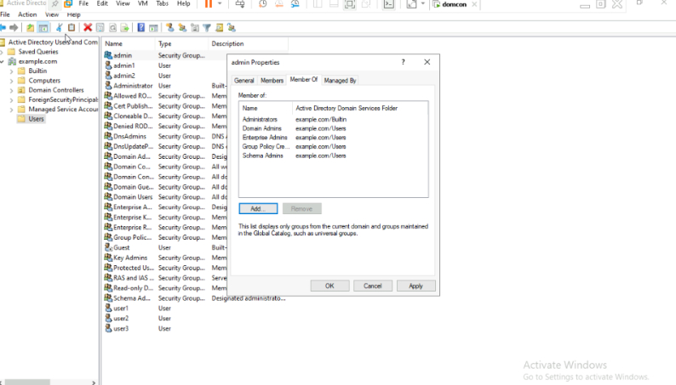

Step 8: Verify login for all users in VMware environment.
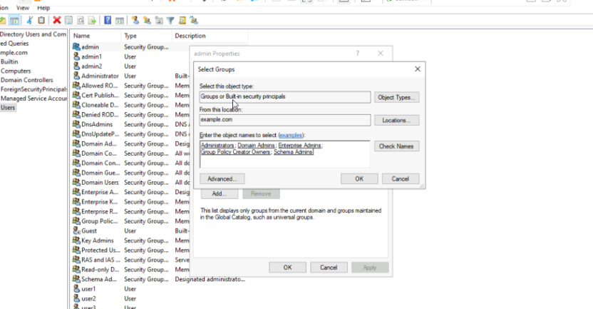

Step 9: Additional configuration and verification steps.
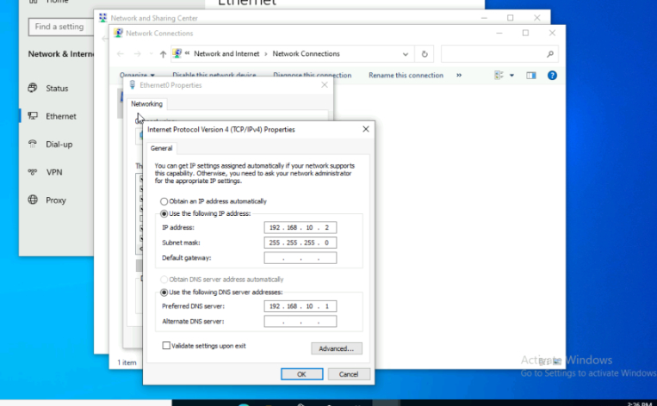

Step 10: Final confirmation and summary of the setup.
