Windows Server 2022 — DNS & Network Configuration Runbook
Prepared for: Shivam Kumar Sinha (Cognizant)
This runbook pairs your screenshots with detailed descriptions and exact execution steps to set up and verify DNS and IP configuration on Windows Server 2022. Follow each section in sequence.
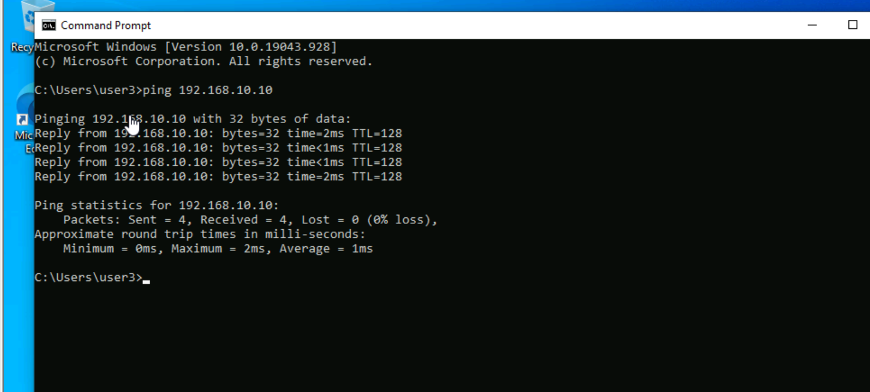
Screenshot 1 — Configure Static IPv4 on the Server
Description: Use the IPv4 properties of your network adapter to set a static IP and point DNS to the local server.
Execution Steps:
- Open **Control Panel → Network and Sharing Center → Change adapter settings**.
- Right‑click your active network adapter → **Properties**.
- Select **Internet Protocol Version 4 (TCP/IPv4)** → **Properties**.
- Choose **Use the following IP address** and enter your plan (example): IP `192.168.10.10`, Subnet Mask `255.255.255.0`, Default Gateway (as per your router).
- Set **Preferred DNS server** to the server’s IP (e.g., `192.168.10.10`). You may keep **Alternate DNS server** empty or add a secondary if available.
- Click **OK** → **Close**. Optionally run `ipconfig /all` to confirm settings.
Verification:
- Run `ping 192.168.10.10` locally to confirm the stack is up.
- Run `nslookup` (it should query your local DNS once the role is installed).
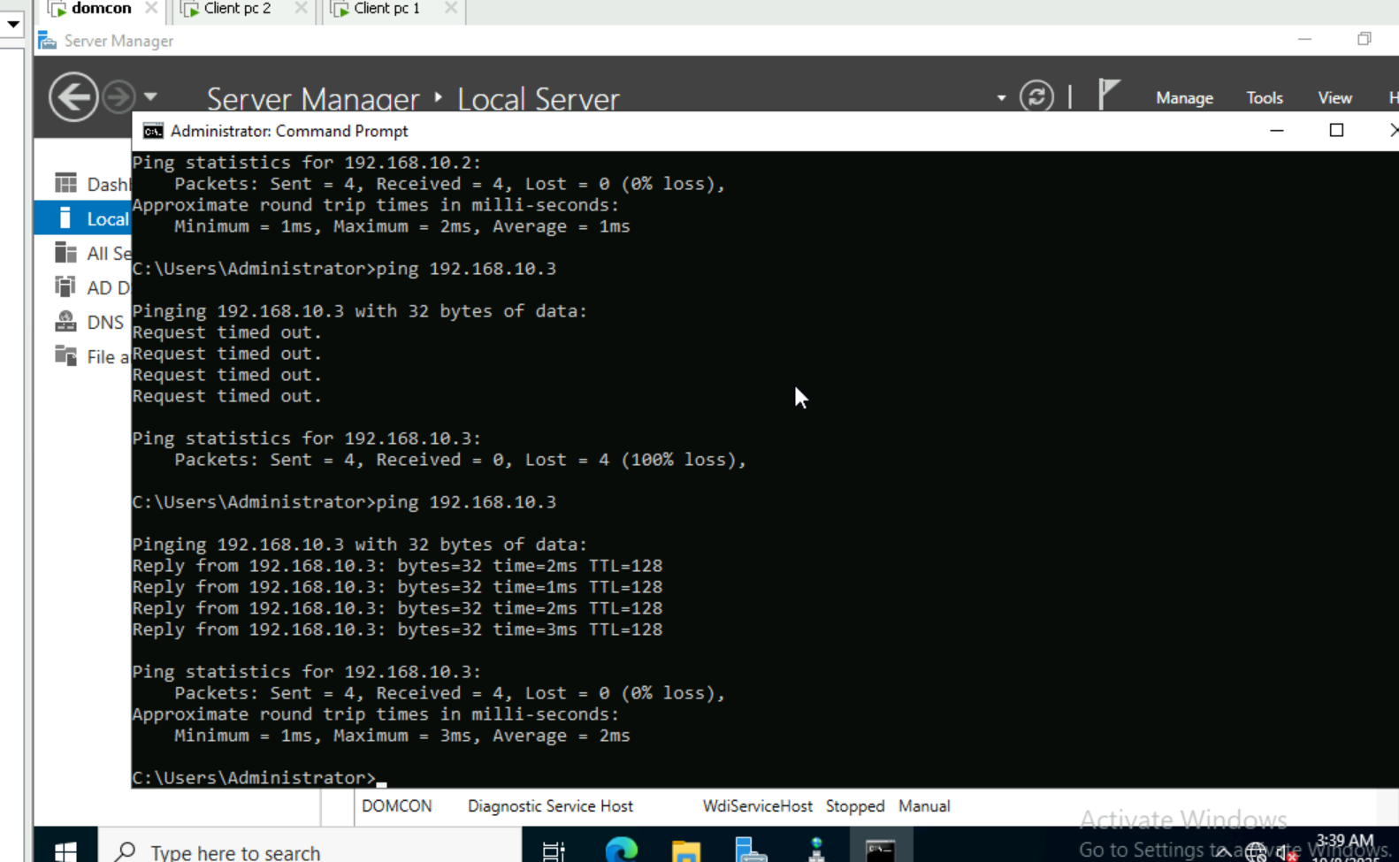
Screenshot 2 — Open DNS Manager & Review Forward Lookup Zones
Description: Forward Lookup Zones map hostnames (A records) to IP addresses.
Execution Steps:
- Open **Server Manager → Tools → DNS** to launch **DNS Manager**.
- Expand **<YourServer> → Forward Lookup Zones**.
- If the zone (e.g., `example.com`) already exists, select it and review existing records (A, CNAME, etc.).
Verification:
- Ensure the zone shows **SOA** and **NS** records by default.
- Confirm existing A records resolve using `nslookup hostname.example.com`.
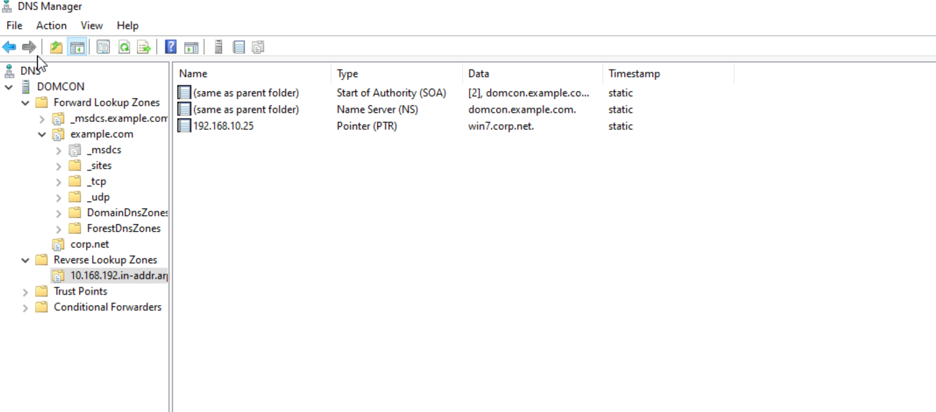
Screenshot 3 — Create a New Forward Lookup Zone (example.com)
Description: Add a primary zone for your internal namespace.
Execution Steps:
- In **DNS Manager**, right‑click **Forward Lookup Zones** → **New Zone**.
- Wizard: **Primary zone** → Store in Active Directory if the server is a domain controller, otherwise as a file.
- Zone Name: enter `example.com` (replace with your actual domain).
- Dynamic updates: choose **Allow only secure updates** for AD‑integrated zones; otherwise **Do not allow** for standalone.
- Finish the wizard.
Verification:
- The new zone appears under **Forward Lookup Zones** with default **SOA** and **NS** records.
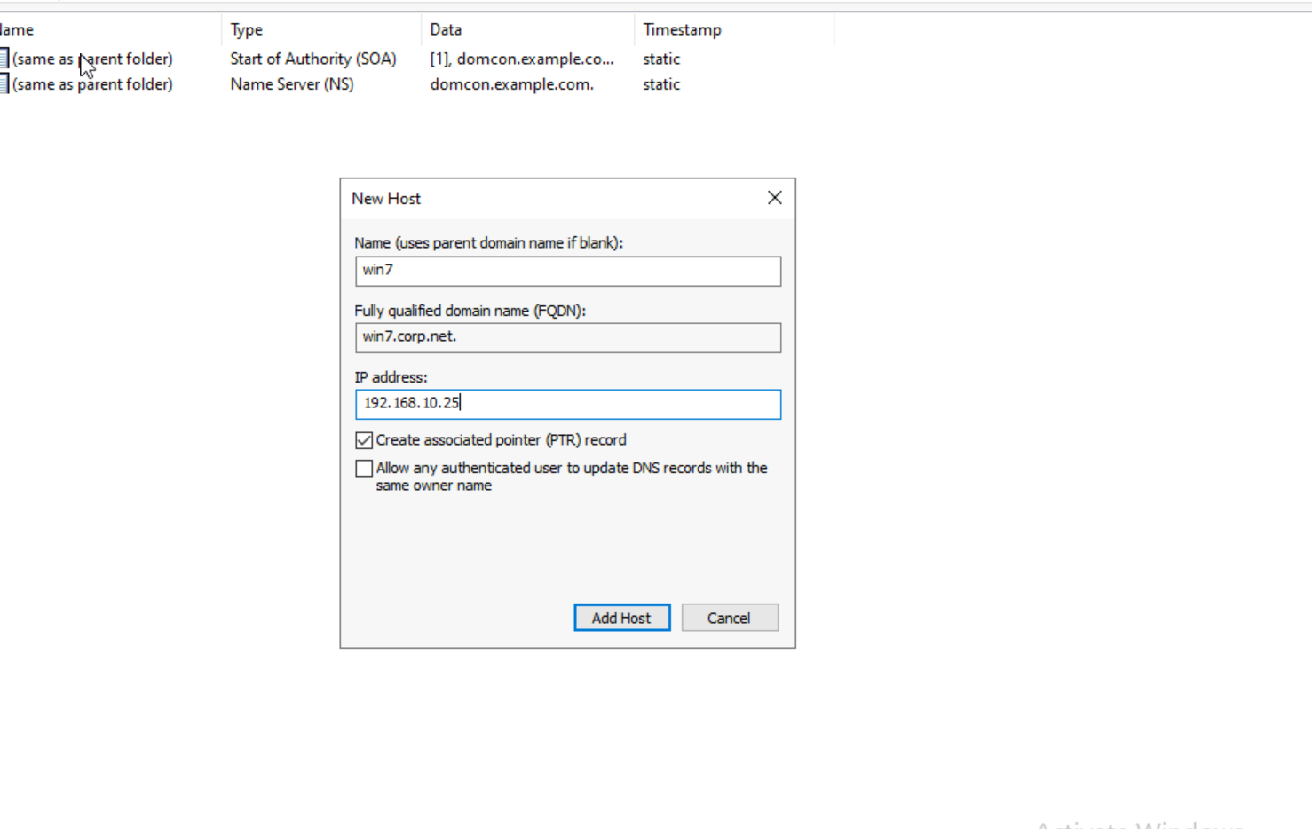
Screenshot 4 — Add Host (A) Records (domcon, clientpc1, clientpc2, win7, etc.)
Description: Create A records to map hostnames to IPs; also create PTR automatically.
Execution Steps:
- Select the zone (e.g., `example.com`).
- Right‑click in the right pane → **New Host (A or AAAA)**.
- Enter **Name** (e.g., `domcon`) and **IP address** (e.g., `192.168.10.10`).
- Check **Create associated pointer (PTR) record** to populate the reverse zone automatically.
- Click **Add Host** and **Done**.
- Repeat for `clientpc1` (e.g., `192.168.10.18`), `clientpc2`, `win7` (e.g., `192.168.10.25`) as per your addressing plan.
Verification:
- Run `nslookup domcon.example.com` and ensure the IP resolves.
- Reverse: `nslookup 192.168.10.10` should return `domcon.example.com` after PTR creation.
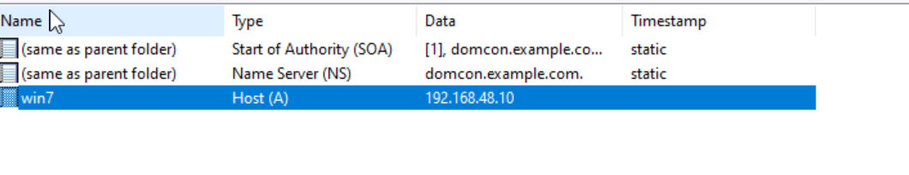
Screenshot 5 — Create a Reverse Lookup Zone (192.168.10.0/24)
Description: Reverse zones map IP addresses to hostnames via PTR records.
Execution Steps:
- In **DNS Manager**, right‑click **Reverse Lookup Zones** → **New Zone**.
- Zone type: **Primary zone**.
- Choose **IPv4 Reverse Lookup Zone** → **Network ID**: `192.168.10` for the /24 subnet.
- Finish the wizard.
Verification:
- Zone `10.in-addr.arpa` appears with **SOA**/**NS** records.
- Adding A records with "Create PTR" will auto‑populate PTRs here.
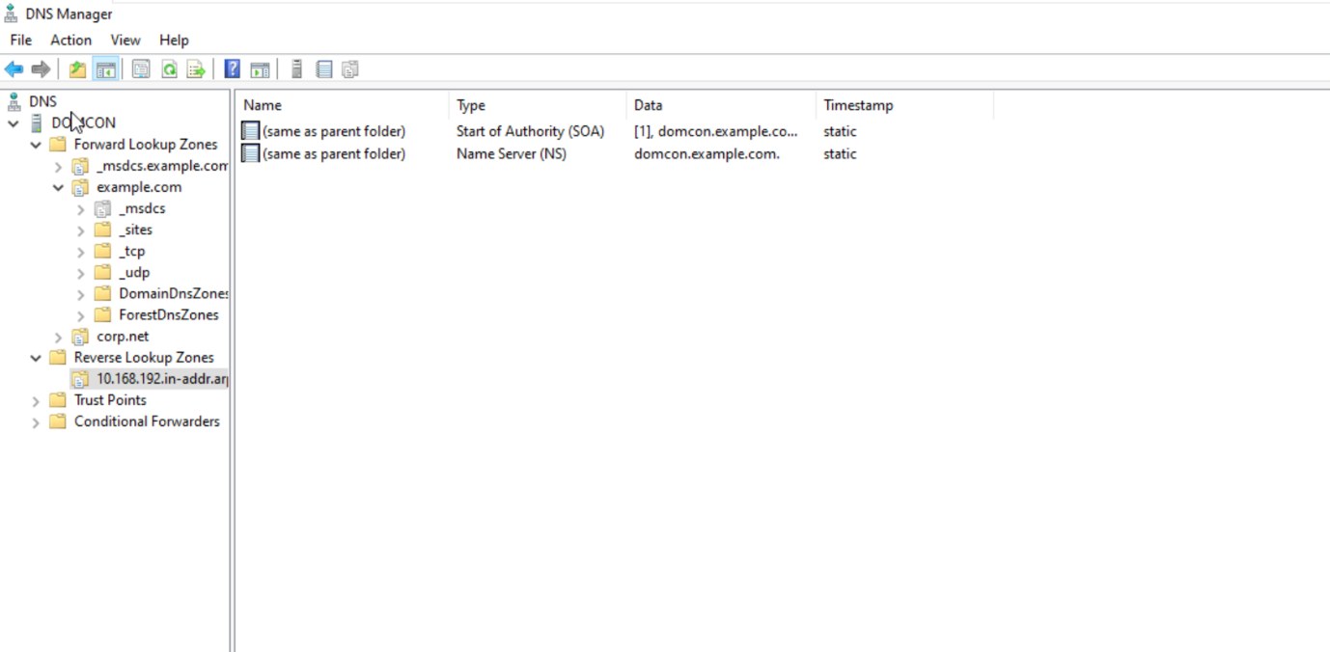
Screenshot 6 — Review Reverse Zone Contents (10.in-addr.arpa)
Description: Confirm SOA/NS and any PTR records created.
Execution Steps:
- Select **Reverse Lookup Zones → 10.in-addr.arpa**.
- Verify the presence of **SOA** and **NS** records.
- Ensure that hosts added earlier have corresponding **PTR** entries (e.g., `10.10.168.192.in-addr.arpa`).
Verification:
- `nslookup 192.168.10.10` returns the correct hostname.
- Use `ping -a 192.168.10.10` to see hostname resolution.
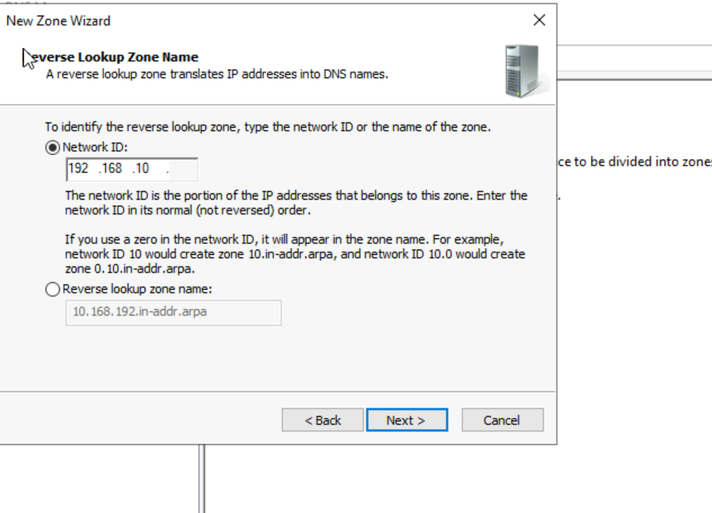
Screenshot 7 — Manually Add a Host (A) with PTR (e.g., win7 → 192.168.10.25)
Description: Demonstrates adding a single host and creating its PTR.
Execution Steps:
- Right‑click the forward zone (e.g., `example.com`) → **New Host (A or AAAA)**.
- Name: `win7`; IP address: `192.168.10.25` (or as per your setup).
- Check **Create associated pointer (PTR) record**.
- Click **Add Host** → **OK**.
Verification:
- `nslookup win7.example.com` returns `192.168.10.25`.
- `nslookup 192.168.10.25` returns `win7.example.com`.
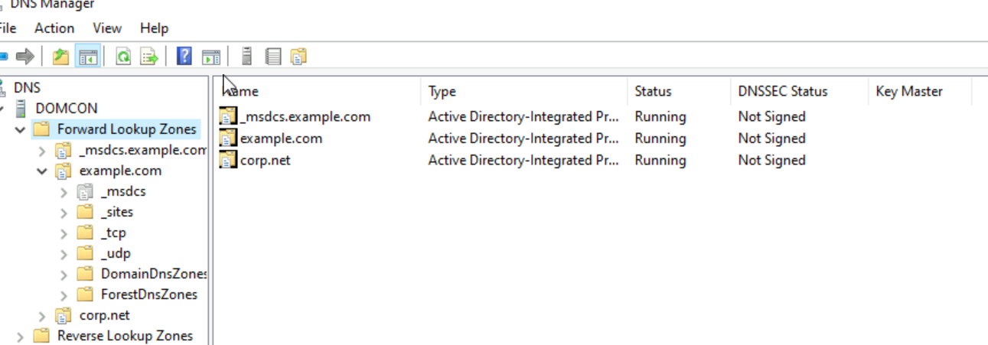
Screenshot 8 — Confirm NIC DNS Settings (Preferred/Alternate)
Description: Ensure the server points to itself (or loopback) for DNS, and clients point to the DNS server.
Execution Steps:
- Open **IPv4 Properties** of the network adapter.
- Preferred DNS server: set to the server IP (e.g., `192.168.10.10`) or `127.0.0.1` on the DNS server itself.
- Alternate DNS server: optional secondary DNS if available.
- Click **OK**.
Verification:
- On the server, `nslookup` shows the default server as your local DNS.
- On clients, ensure **Preferred DNS** points to the server and `nslookup` queries it.
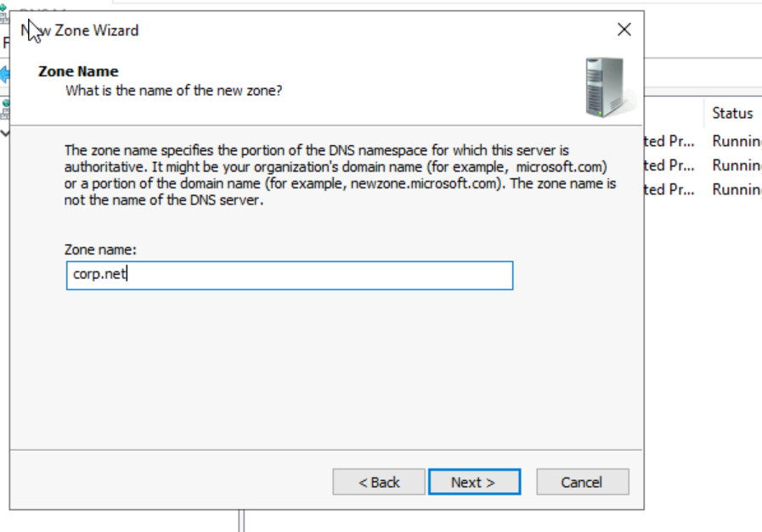
Screenshot 9 — Create an Additional Forward Zone (corp.net)
Description: Set up a second zone/namespace if required (e.g., lab split).
Execution Steps:
- In **DNS Manager**, right‑click **Forward Lookup Zones** → **New Zone**.
- Zone type: **Primary zone**.
- Zone Name: `corp.net` (replace as needed).
- Dynamic updates: choose per your environment.
- Finish the wizard.
Verification:
- Zone appears with default SOA/NS; add A records as needed.
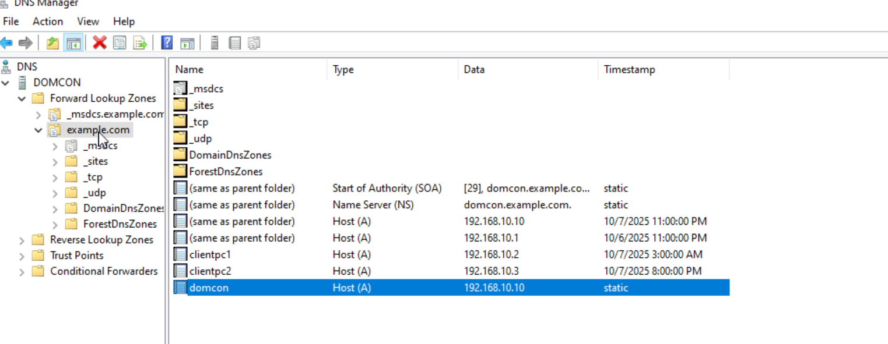
Screenshot 10 — Connectivity Test: Ping Server (192.168.10.10) from Clients
Description: Validates network reachability.
Execution Steps:
- On a client, open **Command Prompt**.
- Run: `ping 192.168.10.10`.
- If ping fails, check Windows Firewall on both ends and VLAN/subnet routing.
Verification:
- Successful replies (time<ms) indicate IP connectivity.
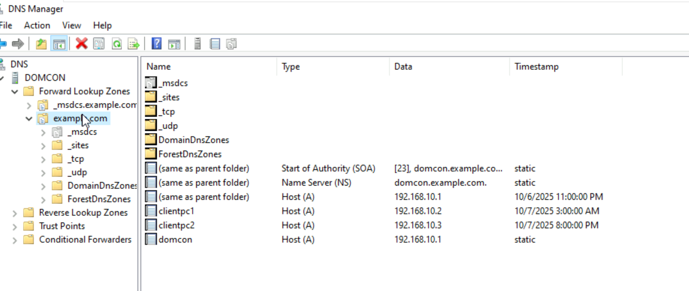
Screenshot 11 — Connectivity Test: Ping Another Client (e.g., 192.168.10.18)
Description: Ensures lateral connectivity within the subnet.
Execution Steps:
- From a second client, run: `ping 192.168.10.18`.
- If it fails, verify client firewall and that both are on the same subnet.
Verification:
- Successful responses confirm host is reachable.
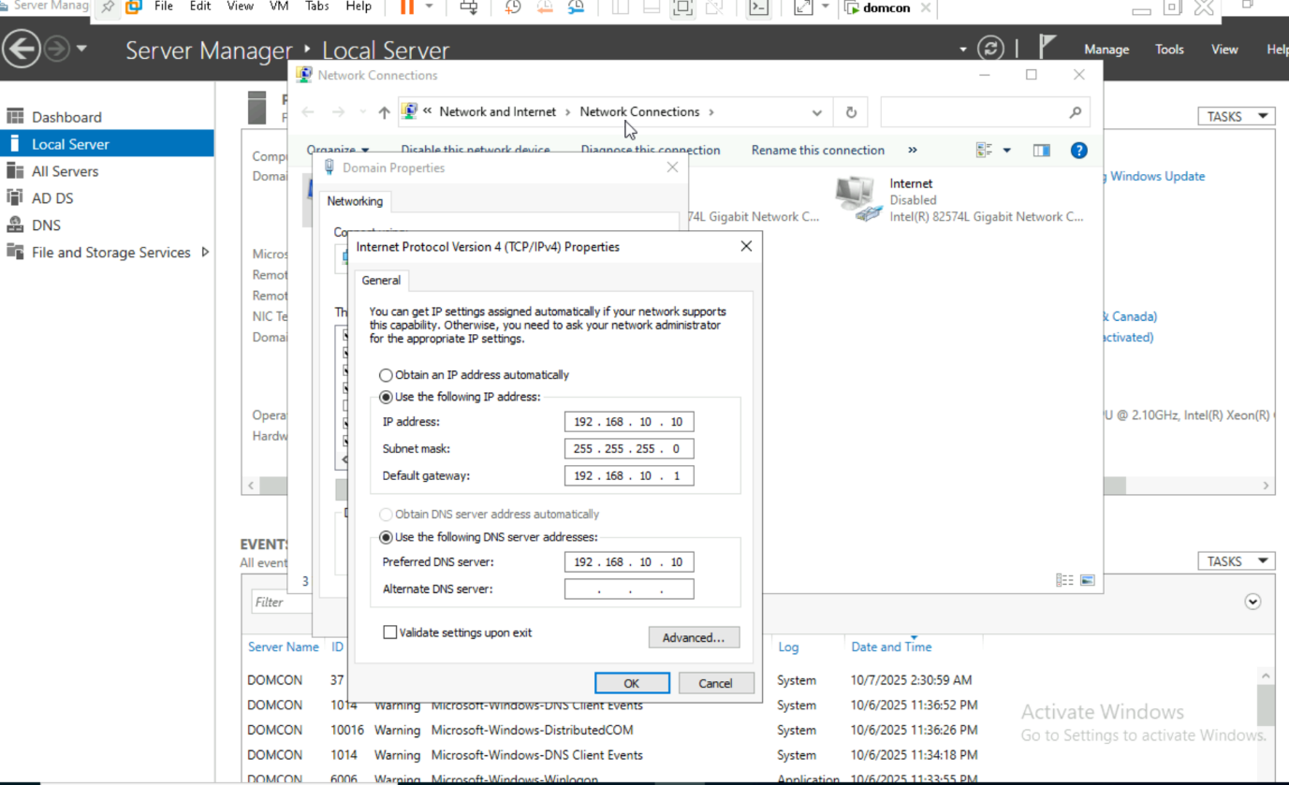
Screenshot 12 — Name Resolution Test: Ping by Hostname/FQDN
Description: Verifies DNS resolution for forward and reverse.
Execution Steps:
- Run: `ping domcon` or `ping domcon.example.com`.
- Run: `nslookup clientpc1.example.com`.
- Run: `nslookup 192.168.10.18` to test reverse PTR.
Verification:
- Hostnames resolve to correct IPs and pings succeed.
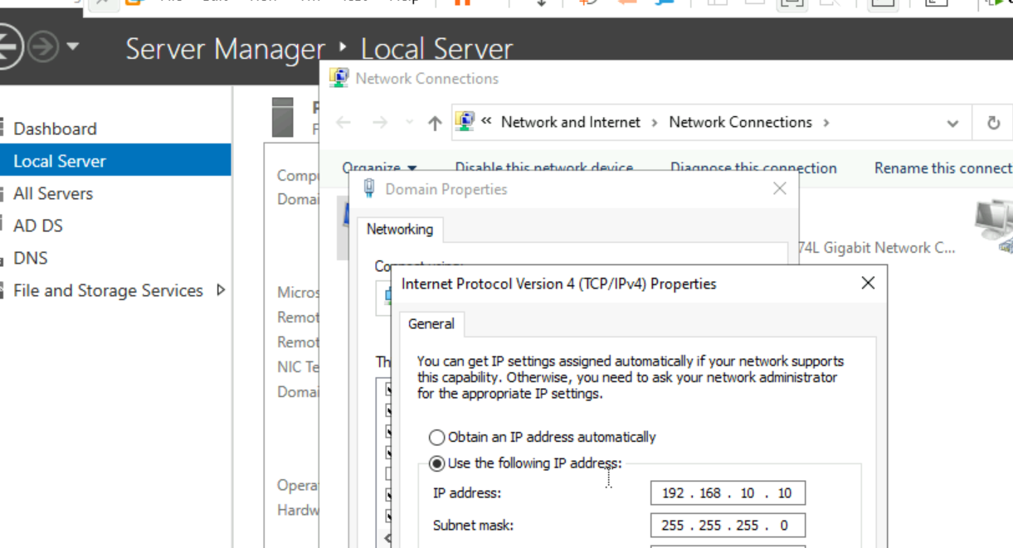
Screenshot 13 — Troubleshooting: Flush DNS, Check Zones, Firewall
Description: If resolution/connectivity fails, perform standard checks.
Execution Steps:
- On clients: `ipconfig /flushdns` then `ipconfig /registerdns`.
- On the DNS server: confirm **Forward** and **Reverse** zones contain correct records.
- Ensure **DNS Server** service is running: `services.msc` → **DNS Server**.
- Check Windows Firewall rules: allow **File and Printer Sharing (Echo Request - ICMPv4-In)** for ping.
- Use `nslookup` interactive mode to query specific records.
Verification:
- Re-run ping and nslookup tests; name/IP resolution should work.
