DHCP Server Setup and Configuration - Step-by-Step Documentation

Step 1: Post-Deployment Configuration
After installing the DHCP role, Server Manager prompts for post-deployment configuration. Click 'Complete DHCP Configuration' to launch the wizard.
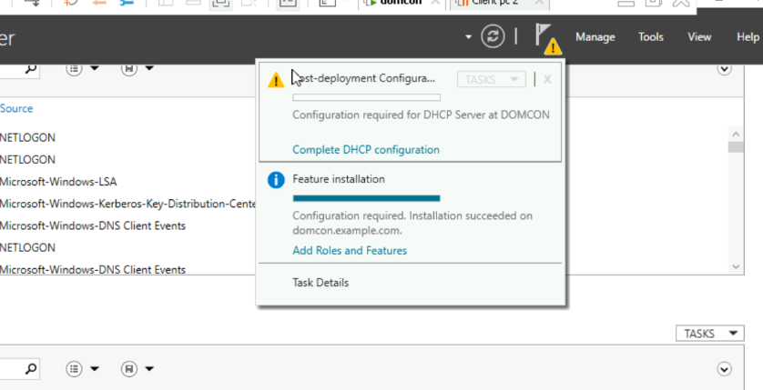

Step 2: Feature Installation Progress
Installation of DHCP Server tools is in progress. Wait for the installation to complete successfully.
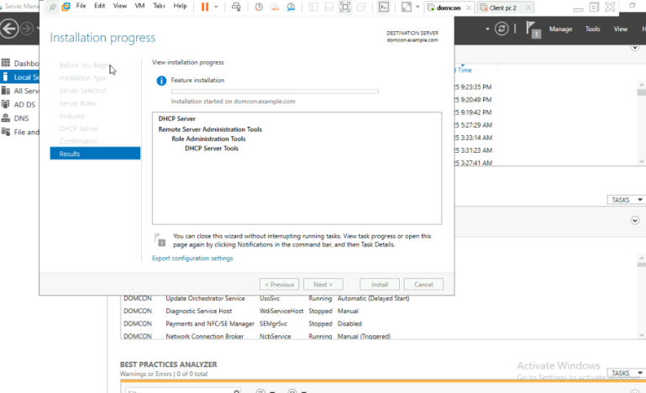

Step 3: DHCP Post-Install Configuration Wizard
The wizard explains the creation of security groups and server authorization. Click 'Next' to proceed.
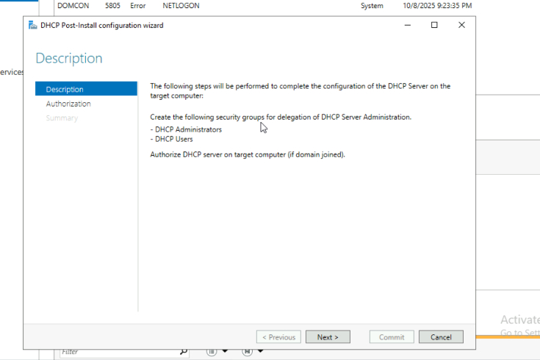

Step 4: Authorize DHCP Server
Enter domain admin credentials to authorize the DHCP server in Active Directory and click 'Commit'.
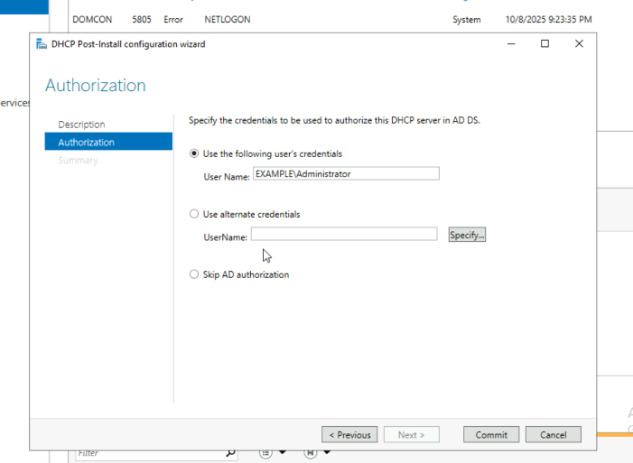

Step 5: Configuration Summary
Confirmation that security groups are created and server is authorized. Restart the DHCP service if prompted.
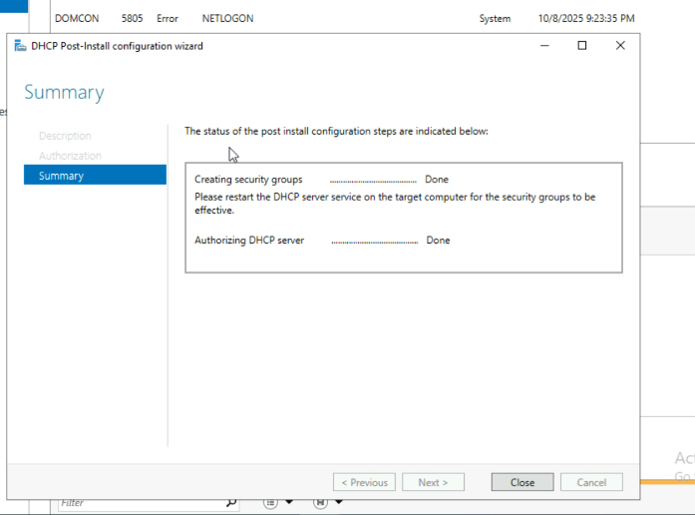

Step 6: DHCP Scope Overview
DHCP scopes (IPv4 and IPv6) are visible under the server. Right-click IPv4 > New Scope to begin scope creation.
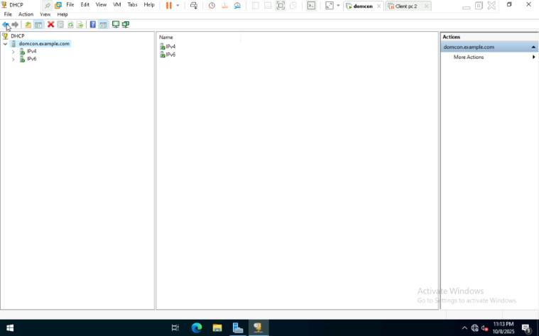

Step 7: New Scope Wizard - Welcome
Wizard for creating a new IP address distribution scope. Click 'Next' to begin scope setup.
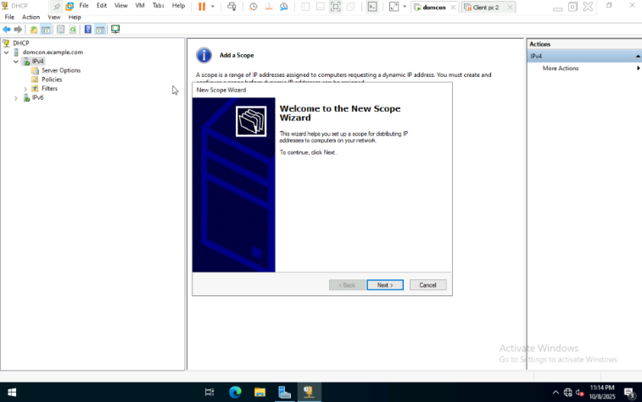

Step 8: Define Exclusion Range
IP range 192.168.10.60 to 192.168.10.70 is excluded to prevent these IPs from being assigned dynamically.
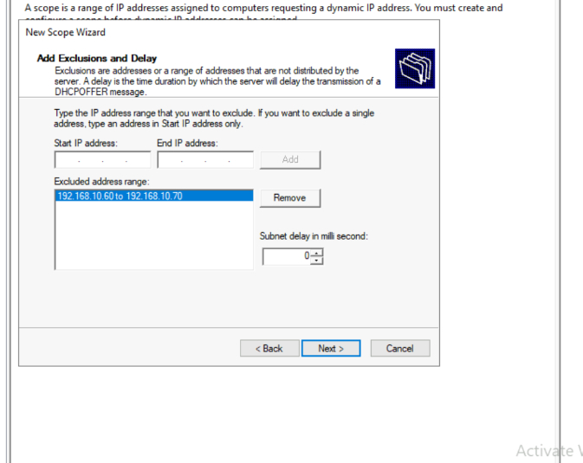

Step 9: Add Default Gateway
Router IP 192.168.10.1 is added as the default gateway used by clients.
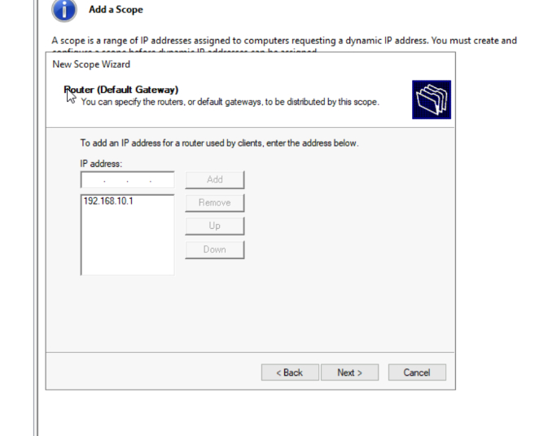

Step 10: Lease Duration
Lease duration is set to 30 days. Choose lease duration based on network needs.
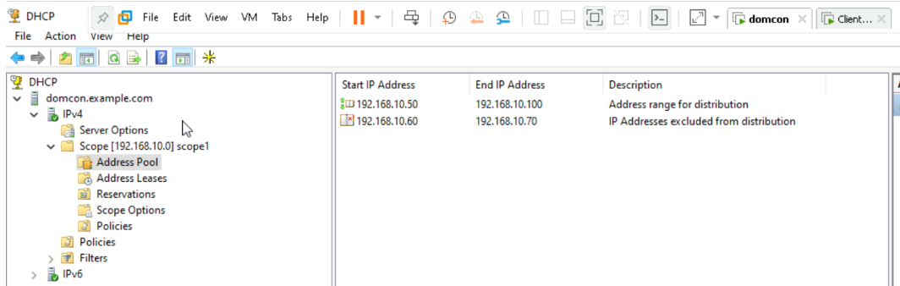

Step 11: Scope Activation
Scope is activated immediately after creation. Select 'Yes, I want to activate this scope now'.
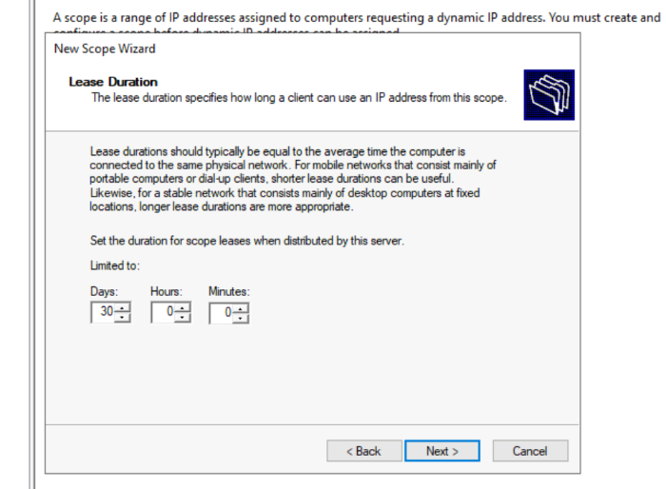

Step 12: DNS Configuration
Enter domain name (e.g., example.com) and DNS server IPs.
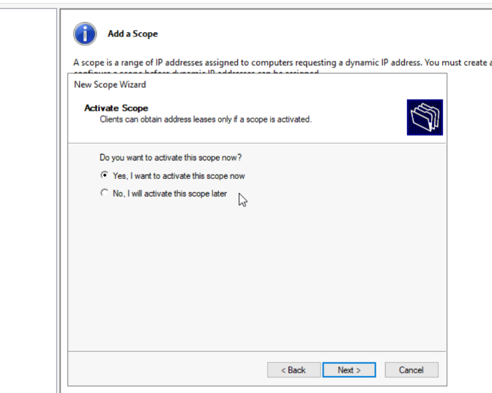

Step 13: IP Range Setup
IP range 192.168.10.50 to 192.168.10.100 is defined for the scope.
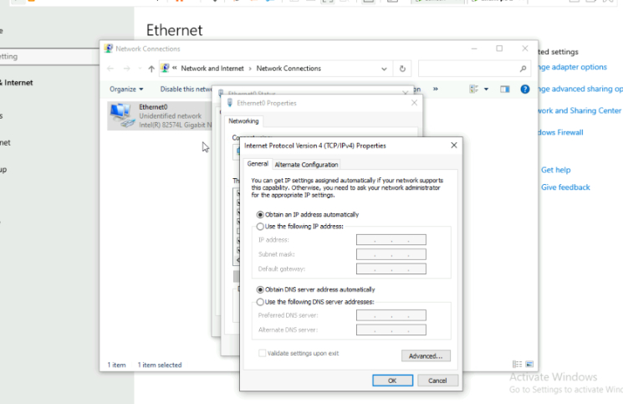

Step 14: Client IP Assignment
Ethernet settings show automatic IP assignment. Ensure client machines are set to obtain IP automatically.
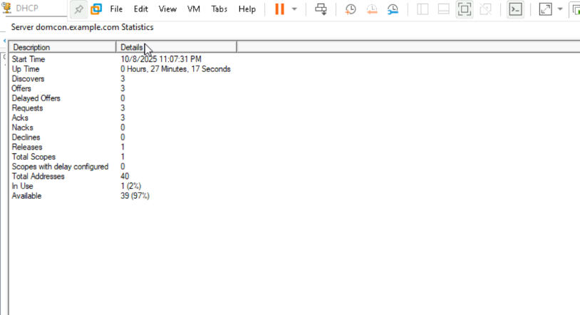

Step 15: DHCP Server Statistics
Server statistics show uptime, offers, and usage. Monitor DHCP performance and address usage.
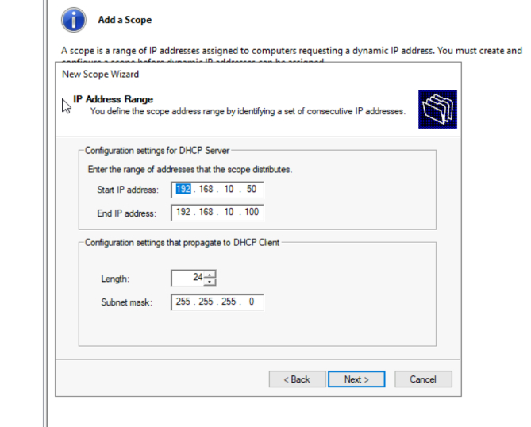

Step 16: Lease Details
Lease information includes client details and expiration. Review active leases and manage them as needed.
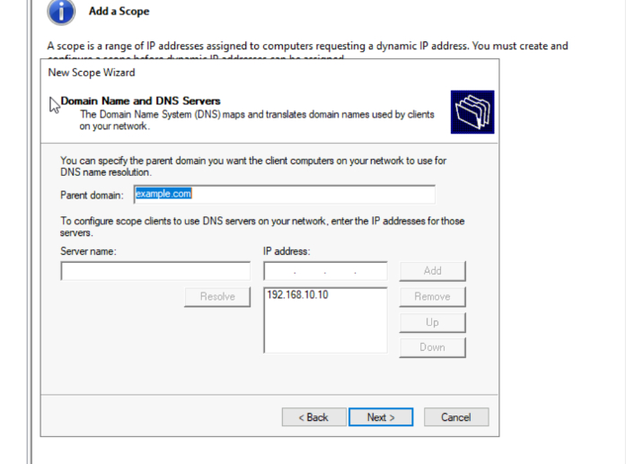

Step 17: IP Reservation
Reservation setup for static IPs based on MAC addresses. Add reservations to ensure specific devices always get the same IP.
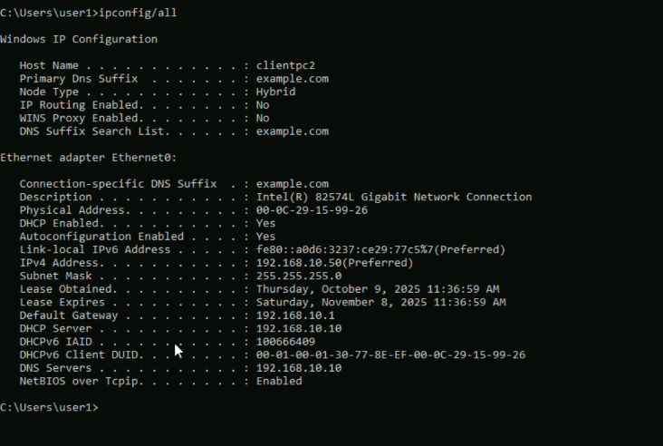

Step 18: IP Reservation Continued
Continue adding reservations for other devices as needed.
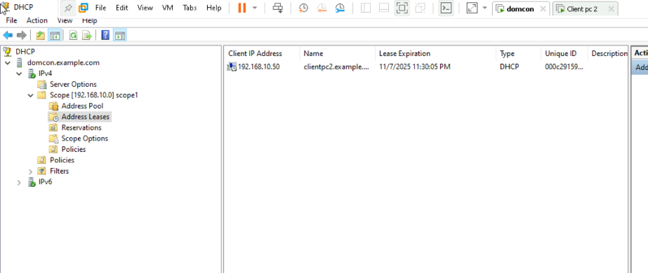

Step 19: Final Lease Overview
Final overview of leases and reservations. Confirm all settings and monitor DHCP activity.
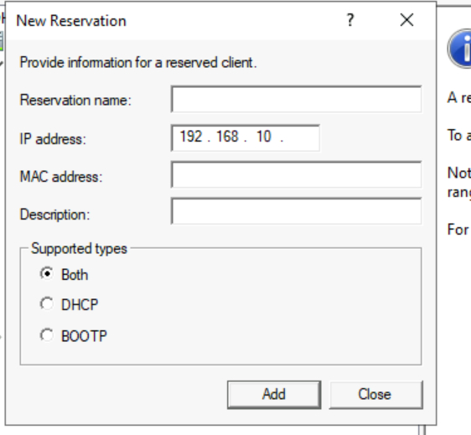

Step 20: DHCP Lease Summary
Detailed summary of DHCP leases including client PC details like lease expiration and unique ID.
