A Project Report On

# “Payroll Management System”



### Submitted By

### SHIVAM MANI TRIAPTHI

### Class : XII, A

**Under the Guidance of**

##### 

##### Mrs. Anju Yadav

##### PGT (ComputerScience)

##### Department of Computer Science

##### Kendriya Vidyalaya Paschim Vihar

##### New Delhi-110087

##### http://2.bp.blogspot.com/-JEvkDZGMzAI/UzFdKgPphbI/AAAAAAAABtA/1B3rPRpJQ9c/s1600/kvs+new+logo.jpg

# 

# D E C L A R A T I O N

#### I hereby declare that the project work entitled “***Payroll Management System***”, submitted to Department of Computer Science, Kendriya Vidyalaya Paschim Vihar NewDelhi is prepared by me. All the coding are result of my personal efforts.

###### SHIVAM MANI TRIPATHI

Class XII,A

A C K N O W L E D G E M E N T

I would like to express a deep sense of thanks & gratitude to my project guide Mrs. Anju Yadav mam for guiding me immensely during the course of the project. She always evinced keen interest in my work. Her constructive advice & constant motivation has been responsible for the successful completion of this project.

My sincere thanks goes to Mrs. Sabira Shori our principal mam, for her co-ordination in extending every possible support for the completion of this project.

I also thank to my parents for their motivation & support. I must thank to my classmates for their timely help & support inr compilation of this project.

**Last but not the least, I would like to thank all those who had helped directly or indirectly towards the completion of this project.**

SHIVAM MANI TRIPATHI

Class: XIIA

## CONTENTS

1. HEADER FILES USED. . . . . . . . . . . . . . . ..

2. WORKING DESCRIPTION. . . . . . . . . . . ..

3. CODING. . . . . . . . . .. . . . . . . . . . . . . . . . .

4. OUTPUT SCREENS. . . . . . . . . . . . . . . . . ..

5. BIBLIOGRAPHY. . . . . . . . . . . . . . . . . . . . . .

## HEADER FILES USED

1. FSTREAM.H- file handling.
2. PROCESS.H- exit() function.
3. CONIO.H- clrscr() and getch() functions.
4. STDIO.H- Standard I/O Operations.
5. STRING.H- String handling.
6. IOSTREAM.H- The basic C++ streams (I/O).
7. DOS.H- MS-DOS &8086 specific functions.
8. CTYPE.H- Character Conversion Macros and Functions.
9. STDLIB.H- Standard Library functions including

Conversion and search/sort routines.

**CODING**

**WORKING DESCRIPTION**

This program is very useful in reallife situation for providing

instant info.of Employees working under any company, department.

It also stores the info.about employee’s monthly salary,employee

Id and destination.

In this C++ program we can modify, add, delete, recall and list the records.

Being OOP concept available, we can add or remove function

anytime we need for further improvement of the program without recording.

**CODING**

//**********************************************************

// INCLUDED HEADER FILES

//**********************************************************

#include <fstream.h>

#include <process.h>

#include <string.h>

#include <stdlib.h>

#include <stdio.h>

#include <ctype.h>

#include <conio.h>

#include <dos.h>

//**********************************************************

// THIS CLASS CONTAINS ALL THE DRAWING FUNCTIONS

//**********************************************************

class LINES

{

public :

void LINE_HOR(int, int, int, char) ;

void LINE_VER(int, int, int, char) ;

void BOX(int,int,int,int,char) ;

void CLEARUP(void) ;

void CLEARDOWN(void) ;

} ;

//**********************************************************

// THIS CLASS CONTROL ALL THE FUNCTIONS IN THE MENU

//**********************************************************

class MENU

{

public :

void MAIN_MENU(void) ;

private :

void EDIT_MENU(void) ;

void INTRODUCTION(void) ;

} ;

//**********************************************************

// THIS CLASS CONTROL ALL THE FUNCTIONS RELATED TO EMPLOYEE

//**********************************************************

class EMPLOYEE

{

public :

void NEW_EMPLOYEE(void) ;

void MODIFICATION(void) ;

void DELETION(void) ;

void DISPLAY(void) ;

void LIST(void) ;

void SALARY_SLIP(void) ;

private :

void ADD_RECORD(int, char[], char[], char[], int, int, int, char[], char, char, char, float, float) ;

void MODIFY_RECORD(int, char [], char [], char [], char [], char, char, char, float, float) ;

void DELETE_RECORD(int) ;

int LASTCODE(void) ;

int CODEFOUND(int) ;

int RECORDNO(int) ;

int FOUND_CODE(int) ;

void DISPLAY_RECORD(int) ;

int VALID_DATE(int, int, int) ;

int code, dd, mm, yy ;

char name[50], address[100], phone[12], desig[16] ;

char grade, house, convense ;

float loan, basic ;

} ;

//**********************************************************

// THIS FUNCTION CONTROL ALL THE FUNCTIONS IN THE MAIN MENU

//**********************************************************

void MENU :: MAIN_MENU(void)

{char ch ;

LINES L ;

L.CLEARUP() ;

while (1)

{clrscr() ;

L.BOX(28,7,51,9,218) ;

L.BOX(10,5,71,21,218) ;

L.BOX(11,6,70,20,219) ;

gotoxy(31,8) ;

cout <<" ROHIT PVT. LTD." ;

gotoxy(30,11) ;

cout <<"1: NEW EMPLOYEE" ;

gotoxy(30,12) ;

cout <<"2: DISPLAY EMPLOYEE" ;

gotoxy(30,13) ;

cout <<"3: LIST OF EMPLOYEES" ;

gotoxy(30,14) ;

cout <<"4: SALARY SLIP" ;

gotoxy(30,15) ;

cout <<"5: EDIT" ;

gotoxy(30,16) ;

cout <<"0: QUIT" ;

gotoxy(30,18) ;

cout <<"ENTER YOUR CHOICE :" ;

ch = getch() ;

if (ch == 27 || ch == '0')

break ;

else

if (ch == '1')

{

EMPLOYEE E ;

E.NEW_EMPLOYEE() ;

}

else

if (ch == '2')

{

EMPLOYEE E ;

E.DISPLAY() ;

}

else

if (ch == '3')

{

EMPLOYEE E ;

E.LIST() ;

}

else

if (ch == '4')

{

EMPLOYEE E ;

E.SALARY_SLIP() ;

}

else

if (ch == '5')

EDIT_MENU() ;

}

L.CLEARUP() ;

}

//**********************************************************

// THIS FUNCTION CONTROL ALL THE FUNCTIONS IN THE EDIT MENU

//**********************************************************

void MENU :: EDIT_MENU(void)

{

char ch ;

LINES L ;

L.CLEARDOWN() ;

while (1)

{ clrscr() ;

L.BOX(28,8,49,10,218) ;

L.BOX(10,5,71,21,218) ;

L.BOX(11,6,70,20,219) ;

gotoxy(31,9) ;

cout <<"E D I T M E N U" ;

gotoxy(30,13) ;

cout <<"1: DELETE RECORD" ;

gotoxy(30,14) ;

cout <<"2: MODIFY RECORD" ;

gotoxy(30,15) ;

cout <<"0: EXIT" ;

gotoxy(30,17) ;

cout <<"ENTER YOUR CHOICE :" ;

ch = getch() ;

if (ch == 27 || ch == '0')

break ;

else

if (ch == '1')

{

EMPLOYEE E ;

E.DELETION() ;

}

else

if (ch == '2')

{

EMPLOYEE E ;

E.MODIFICATION() ;

}

}

L.CLEARDOWN() ;

}

//**********************************************************

// THIS FUNCTION DRAWS THE HORRIZONTAL LINE

//**********************************************************

void LINES :: LINE_HOR(int column1, int column2, int row, char c)

{

for ( column1; column1<=column2; column1++ )

{

gotoxy(column1,row) ;

cout <<c ;

}

}

//**********************************************************

// THIS FUNCTION DRAWS THE VERTICAL LINE

//**********************************************************

void LINES :: LINE_VER(int row1, int row2, int column, char c)

{

for ( row1; row1<=row2; row1++ )

{

gotoxy(column,row1) ;

cout <<c ;

}

}

//**********************************************************

// THIS FUNCTION DRAWS THE BOX

//**********************************************************

void LINES :: BOX(int column1, int row1, int column2, int row2, char c)

{

char ch=218 ;

char c1, c2, c3, c4 ;

char l1=196, l2=179 ;

if (c == ch)

{

c1=218 ;

c2=191 ;

c3=192 ;

c4=217 ;

l1 = 196 ;

l2 = 179 ;

}

else

{

c1=c ;

c2=c ;

c3=c ;

c4=c ;

l1 = c ;

l2 = c ;

}

gotoxy(column1,row1) ;

cout <<c1 ;

gotoxy(column2,row1) ;

cout <<c2 ;

gotoxy(column1,row2) ;

cout <<c3 ;

gotoxy(column2,row2) ;

cout <<c4 ;

column1++ ;

column2-- ;

LINE_HOR(column1,column2,row1,l1) ;

LINE_HOR(column1,column2,row2,l1) ;

column1-- ;

column2++ ;

row1++ ;

row2-- ;

LINE_VER(row1,row2,column1,l2) ;

LINE_VER(row1,row2,column2,l2) ;

}

//**********************************************************

// THIS FUNCTION CLEAR THE SCREEN LINE BY LINE UPWARD

//**********************************************************

void LINES :: CLEARUP(void)

{

for (int i=25; i>=1; i--)

{

//delay(20) ;

gotoxy(1,i) ; clreol() ;

}

}

//**********************************************************

// THIS FUNCTION CLEAR THE SCREEN LINE BY LINE DOWNWORD

//**********************************************************

void LINES :: CLEARDOWN(void)

{

F

or (int i=1; i<=25; i++)

{

//delay(20) ;

gotoxy(1,i) ; clreol() ;

}

}

//**********************************************************

// THIS FUNCTION ADDS THE GIVEN DATA IN THE EMPLOYEE'S FILE

//**********************************************************

void EMPLOYEE :: ADD_RECORD(int ecode, char ename[50], char eaddress[100], char ephone[12], int d, int m, int y, char edesig[16], char egrade, char ehouse, char econv, float eloan, float ebasic)

{

fstream file ;

file.open("EMPLOYEE.DAT", ios::app) ;

code = ecode ;

strcpy(name,ename) ;

strcpy(address,eaddress) ;

strcpy(phone,ephone) ;

dd = d ;

mm = m ;

yy = y ;

strcpy(desig,edesig) ;

grade = egrade ;

house = ehouse ;

convense = econv ;

loan = eloan ;

basic = ebasic ;

file.write((char *) this, sizeof(EMPLOYEE)) ;

file.close() ;

}

//**********************************************************

// THIS FUNCTION MODIFY THE GIVEN DATA IN THE

// EMPLOYEE'S FILE

//**********************************************************

void EMPLOYEE :: MODIFY_RECORD(int ecode, char ename[50], char eaddress[100], char ephone[12], char edesig[16], char egrade, char ehouse, char econv, float eloan, float ebasic)

{

int recno ;

recno = RECORDNO(ecode) ;

fstream file ;

file.open("EMPLOYEE.DAT", ios::out | ios::ate) ;

strcpy(name,ename) ;

strcpy(address,eaddress) ;

strcpy(phone,ephone) ;

strcpy(desig,edesig) ;

grade = egrade ;

house = ehouse ;

convense = econv ;

loan = eloan ;

basic = ebasic ;

int location ;

location = (recno-1) * sizeof(EMPLOYEE) ;

file.seekp(location) ;

file.write((char *) this, sizeof(EMPLOYEE)) ;

file.close() ;

}

//**********************************************************

// THIS FUNCTION DELETE THE RECORD IN THE EMPLOYEE FILE

// FOR THE GIVEN EMPLOYEE CODE

//**********************************************************

void EMPLOYEE :: DELETE_RECORD(int ecode)

{

fstream file ;

file.open("EMPLOYEE.DAT", ios::in) ;

fstream temp ;

temp.open("temp.dat", ios::out) ;

file.seekg(0,ios::beg) ;

while (!file.eof())

{

file.read((char *) this, sizeof(EMPLOYEE)) ;

if (file.eof())

break ;

if (code != ecode)

temp.write((char *) this, sizeof(EMPLOYEE)) ;

}

file.close() ;

temp.close() ;

file.open("EMPLOYEE.DAT", ios::out) ;

temp.open("temp.dat", ios::in) ;

temp.seekg(0,ios::beg) ;

while (!temp.eof())

{

temp.read((char *) this, sizeof(EMPLOYEE)) ;

if ( temp.eof() )

break ;

file.write((char *) this, sizeof(EMPLOYEE)) ;

}

file.close() ;

temp.close() ;

}

//**********************************************************

// THIS FUNCTION RETURNS THE LAST EMPLOYEE'S CODE

//**********************************************************

int EMPLOYEE :: LASTCODE(void)

{

fstream file ;

file.open("EMPLOYEE.DAT", ios::in) ;

file.seekg(0,ios::beg) ;

int count=0 ;

while (file.read((char *) this, sizeof(EMPLOYEE)))

count = code ;

file.close() ;

return count ;

}

//**********************************************************

// THIS FUNCTION RETURNS 0 IF THE GIVEN CODE NOT FOUND

//**********************************************************

int EMPLOYEE :: FOUND_CODE(int ecode)

{

fstream file ;

file.open("EMPLOYEE.DAT", ios::in) ;

file.seekg(0,ios::beg) ;

int found=0 ;

while (file.read((char *) this, sizeof(EMPLOYEE)))

{

if (code == ecode)

{

found = 1 ;

break ;

}

}

file.close() ;

return found ;

}

//**********************************************************

// THIS FUNCTION RETURNS RECORD NO. OF THE GIVEN CODE

//**********************************************************

int EMPLOYEE :: RECORDNO(int ecode)

{

fstream file ;

file.open("EMPLOYEE.DAT", ios::in) ;

file.seekg(0,ios::beg) ;

int recno=0 ;

while (file.read((char *) this, sizeof(EMPLOYEE)))

{

recno++ ;

if (code == ecode)

break ;

}

file.close() ;

return recno ;

}

//**********************************************************

// THIS FUNCTION DISPLAYS THE LIST OF THE EMPLOYEES

//**********************************************************

void EMPLOYEE :: LIST(void)

{

clrscr() ;

int row = 6 , found=0, flag=0 ;

char ch ;

gotoxy(31,2) ;

cout <<"LIST OF EMPLOYEES" ;

gotoxy(30,3) ;

cout <<"~~~~~~~~~~~~~~~~~~~" ;

gotoxy(1,4) ;

cout <<"CODE NAME PHONE DOJ DESIGNATION GRADE SALARY" ;

gotoxy(1,5) ;

cout <<"~~~~~~~~~~~~~~~~~~~~~~~~~~~~~~~~~~~~~~~~~~~~~~~~~~~~~~~~~~~~~~~~~~~~~~~~~~~~~~~" ;

fstream file ;

file.open("EMPLOYEE.DAT", ios::in) ;

file.seekg(0,ios::beg) ;

while (file.read((char *) this, sizeof(EMPLOYEE)))

{

flag = 0 ;

//delay(20) ;

found = 1 ;

gotoxy(2,row) ;

cout <<code ;

gotoxy(6,row) ;

cout <<name ;

gotoxy(31,row) ;

cout <<phone ;

gotoxy(40,row) ;

cout <<dd <<"/" <<mm <<"/" <<yy ;

gotoxy(52,row) ;

cout <<desig ;

gotoxy(69,row) ;

cout <<grade ;

if (grade != 'E')

{

gotoxy(74,row) ;

cout <<basic ;

}

else

{

gotoxy(76,row) ;

cout <<"-" ;

}

if ( row == 23 )

{

flag = 1 ;

row = 6 ;

gotoxy(1,25) ;

cout <<"Press any key to continue or Press <ESC> to exit" ;

ch = getch() ;

if (ch == 27)

break ;

clrscr() ;

gotoxy(31,2) ;

cout <<"LIST OF EMPLOYEES" ;

gotoxy(30,3) ;

cout <<"~~~~~~~~~~~~~~~~~~~" ;

gotoxy(1,4) ;

cout <<"CODE NAME PHONE DOJ DESIGNATION GRADE SALARY" ;

gotoxy(1,5) ;

cout <<"~~~~~~~~~~~~~~~~~~~~~~~~~~~~~~~~~~~~~~~~~~~~~~~~~~~~~~~~~~~~~~~~~~~~~~~~~~~~~~~" ;

}

else

row++ ;

}

if (!found)

{

gotoxy(5,10) ;

cout <<"\7Records not found" ;

}

if (!flag)

{

gotoxy(1,25) ;

cout <<"Press any key to continue..." ;

getche() ;

}

file.close () ;

}

//**********************************************************

// THIS FUNCTION DISPLAYS THE RECORD OF THE EMPLOYEES

//**********************************************************

void EMPLOYEE :: DISPLAY_RECORD(int ecode)

{

fstream file ;

file.open("EMPLOYEE.DAT", ios::in) ;

file.seekg(0,ios::beg) ;

while (file.read((char *) this, sizeof(EMPLOYEE)))

{

if (code == ecode)

{

gotoxy(5,5) ;

cout <<"Employee Code # " <<code ;

gotoxy(5,6) ;

cout <<"~~~~~~~~~~~~~" ;

gotoxy(5,7) ;

cout <<"Name : " <<name ;

gotoxy(5,8) ;

cout <<"Address : " <<address ;

gotoxy(5,9) ;

cout <<"Phone no. : " <<phone ;

gotoxy(5,11) ;

cout <<"JOINING DATE" ;

gotoxy(5,12) ;

cout <<"~~~~~~~~~~~~" ;

gotoxy(5,13) ;

cout <<"Day : " <<dd ;

gotoxy(5,14) ;

cout <<"Month : " <<mm ;

gotoxy(5,15) ;

cout <<"Year : " <<yy ;

gotoxy(5,17) ;

cout <<"Designation : " <<desig ;

gotoxy(5,18) ;

cout <<"Grade : " <<grade ;

if (grade != 'E')

{

gotoxy(5,19) ;

cout <<"House (y/n) : " <<house ;

gotoxy(5,20) ;

cout <<"Convense (y/n) : " <<convense ;

gotoxy(5,22) ;

cout <<"Basic Salary : " <<basic ;

}

gotoxy(5,21) ;

cout <<"Loan : " <<loan ;

}

}

file.close() ;

}

//**********************************************************

// THIS FUNCTION GIVE DATA TO ADD IN THE FILE

//**********************************************************

void EMPLOYEE :: NEW_EMPLOYEE(void)

{

clrscr() ;

char ch, egrade, ehouse='N', econv='N' ;

char ename[50], eaddress[100], ephone[12], edesig[16], t1[10] ;

float t2=0.0, eloan=0.0, ebasic=0.0 ;

int d, m, y, ecode, valid ;

gotoxy(72,2) ;

cout <<"<0>=EXIT" ;

gotoxy(28,3) ;

cout <<"ADDITION OF NEW EMPLOYEE" ;

gotoxy(5,5) ;

cout <<"Employee Code # " ;

gotoxy(5,6) ;

cout <<"~~~~~~~~~~~~~" ;

gotoxy(5,7) ;

cout <<"Name : " ;

gotoxy(5,8) ;

cout <<"Address : " ;

gotoxy(5,9) ;

cout <<"Phone no. : " ;

gotoxy(5,11) ;

cout <<"JOINING DATE" ;

gotoxy(5,12) ;

cout <<"~~~~~~~~~~~~" ;

gotoxy(5,13) ;

cout <<"Day : " ;

gotoxy(5,14) ;

cout <<"Month : " ;

gotoxy(5,15) ;

cout <<"Year : " ;

gotoxy(5,17) ;

cout <<"Designation : " ;

gotoxy(5,18) ;

cout <<"Grade : " ;

gotoxy(5,21) ;

cout <<"Loan : " ;

ecode = LASTCODE() + 1 ;

if (ecode == 1)

{

ADD_RECORD(ecode, "null", "null", "null", 0, 0, 0, "null", 'n', 'n', 'n', 0.0, 0.0) ;

DELETE_RECORD(ecode) ;

}

gotoxy(21,5) ;

cout <<ecode ;

do

{

valid = 1 ;

gotoxy(5,25) ; clreol() ;

cout <<"Enter the name of the Employee" ;

gotoxy(20,7) ; clreol() ;

gets(ename) ;

strupr(ename) ;

if (ename[0] == '0')

return ;

if (strlen(ename) < 1 || strlen(ename) > 50)

{

valid = 0 ;

gotoxy(5,25) ; clreol() ;

cout <<"\7Enter correctly (Range: 1..50)" ;

getch() ;

}

} while (!valid) ;

do

{

valid = 1 ;

gotoxy(5,25) ; clreol() ;

cout <<"Enter Address of the Employee" ;

gotoxy(20,8) ; clreol() ;

gets(eaddress) ;

strupr(eaddress) ;

if (eaddress[0] == '0')

return ;

if (strlen(eaddress) < 1 || strlen(eaddress) > 100)

{

valid = 0 ;

gotoxy(5,25) ; clreol() ;

cout <<"\7Enter correctly (Range: 1..100)" ;

getch() ;

}

} while (!valid) ;

do

{

valid = 1 ;

gotoxy(5,25) ; clreol() ;

cout <<"Enter Phone no. of the Employee or Press <ENTER> for none" ;

gotoxy(20,9) ; clreol() ;

gets(ephone) ;

if (ephone[0] == '0')

return ;

if ((strlen(ephone) < 10 && strlen(ephone) > 0) || (strlen(ephone) > 10))

{

valid = 0 ;

gotoxy(5,25) ; clreol() ;

cout <<"\7Enter correctly" ;

getch() ;

}

} while (!valid) ;

if (strlen(ephone) == 0)

strcpy(ephone,"-") ;

char tday[3], tmonth[3], tyear[5] ;

int td ;

do

{

valid = 1 ;

do

{

gotoxy(5,25) ; clreol() ;

cout <<"ENTER DAY OF JOINING" ;

gotoxy(13,13) ; clreol() ;

gets(tday) ;

td = atoi(tday) ;

d = td ;

if (tday[0] == '0')

return ;

} while (d == 0) ;

do

{

gotoxy(5,25) ; clreol() ;

cout <<"ENTER MONTH OF JOINING" ;

gotoxy(13,14) ; clreol() ;

gets(tmonth) ;

td = atoi(tmonth) ;

m = td ;

if (tmonth[0] == '0')

return ;

} while (m == 0) ;

do

{

gotoxy(5,25) ; clreol() ;

cout <<"ENTER YEAR OF JOINING" ;

gotoxy(13,15) ; clreol() ;

gets(tyear) ;

td = atoi(tyear) ;

y = td ;

if (tyear[0] == '0')

return ;

} while (y == 0) ;

if (d>31 || d<1)

valid = 0 ;

else

if (((y%4)!=0 && m==2 && d>28) || ((y%4)==0 && m==2 && d>29))

valid = 0 ;

else

if ((m==4 || m==6 || m==9 || m==11) && d>30)

valid = 0 ;

else

if (y<1990 || y>2020)

valid = 0 ;

if (!valid)

{

valid = 0 ;

gotoxy(5,25) ; clreol() ;

cout <<"\7Enter correctly" ;

getch() ;

gotoxy(13,14) ; clreol() ;

gotoxy(13,15) ; clreol() ;

}

} while (!valid) ;

do

{

valid = 1 ;

gotoxy(5,25) ; clreol() ;

cout <<"Enter Designation of the Employee" ;

gotoxy(20,17) ; clreol() ;

gets(edesig) ;

strupr(edesig) ;

if (edesig[0] == '0')

return ;

if (strlen(edesig) < 1 || strlen(edesig) > 15)

{

valid = 0 ;

gotoxy(5,25) ; clreol() ;

cout <<"\7Enter correctly (Range: 1..15)" ;

getch() ;

}

} while (!valid) ;

do

{

gotoxy(5,25) ; clreol() ;

cout <<"Enter Grade of the Employee (A,B,C,D,E)" ;

gotoxy(20,18) ; clreol() ;

egrade = getche() ;

egrade = toupper(egrade) ;

if (egrade == '0')

return ;

} while (egrade < 'A' || egrade > 'E') ;

if (egrade != 'E')

{

gotoxy(5,19) ;

cout <<"House (y/n) : " ;

gotoxy(5,20) ;

cout <<"Convense (y/n) : " ;

gotoxy(5,22) ;

cout <<"Basic Salary : " ;

do

{

gotoxy(5,25) ; clreol() ;

cout <<"ENTER IF HOUSE ALLOWANCE IS ALLOTED TO EMPLOYEE OR NOT" ;

gotoxy(22,19) ; clreol() ;

ehouse = getche() ;

ehouse = toupper(ehouse) ;

if (ehouse == '0')

return ;

} while (ehouse != 'Y' && ehouse != 'N') ;

do

{

gotoxy(5,25) ; clreol() ;

cout <<"ENTER IF CONVENCE ALLOWANCE IS ALLOTED TO EMPLOYEE OR NOT" ;

gotoxy(22,20) ; clreol() ;

econv = getche() ;

econv = toupper(econv) ;

if (econv == '0')

return ;

} while (econv != 'Y' && econv != 'N') ;

}

do

{

valid = 1 ;

gotoxy(5,25) ; clreol() ;

cout <<"ENTER LOAN AMOUNT IF ISSUED" ;

gotoxy(22,21) ; clreol() ;

gets(t1) ;

t2 = atof(t1) ;

eloan = t2 ;

if (eloan > 50000)

{

valid = 0 ;

gotoxy(5,25) ; clreol() ;

cout <<"\7SHOULD NOT GREATER THAN 50000" ;

getch() ;

}

} while (!valid) ;

if (egrade != 'E')

{

do

{

valid = 1 ;

gotoxy(5,25) ; clreol() ;

cout <<"ENTER BASIC SALARY OF THE EMPLOYEE" ;

gotoxy(22,22) ; clreol() ;

gets(t1) ;

t2 = atof(t1) ;

ebasic = t2 ;

if (t1[0] == '0')

return ;

if (ebasic > 50000)

{

valid = 0 ;

gotoxy(5,25) ; clreol() ;

cout <<"\7SHOULD NOT GREATER THAN 50000" ;

getch() ;

}

} while (!valid) ;

}

gotoxy(5,25) ; clreol() ;

do

{

gotoxy(5,24) ; clreol() ;

cout <<"Do you want to save (y/n) " ;

ch = getche() ;

ch = toupper(ch) ;

if (ch == '0')

return ;

} while (ch != 'Y' && ch != 'N') ;

if (ch == 'N')

return ;

ADD_RECORD(ecode, ename, eaddress, ephone, d, m, y, edesig, egrade, ehouse, econv, eloan, ebasic) ;

}

//**********************************************************

// THIS FUNCTION GIVE CODE FOR THE DISPLAY OF THE RECORD

//**********************************************************

void EMPLOYEE :: DISPLAY(void)

{

clrscr() ;

char t1[10] ;

int t2, ecode ;

gotoxy(72,2) ;

cout <<"<0>=EXIT" ;

gotoxy(5,5) ;

cout <<"Enter code of the Employee " ;

gets(t1) ;

t2 = atoi(t1) ;

ecode = t2 ;

if (ecode == 0)

return ;

clrscr() ;

if (!FOUND_CODE(ecode))

{

gotoxy(5,5) ;

cout <<"\7Record not found" ;

getch() ;

return ;

}

DISPLAY_RECORD(ecode) ;

gotoxy(5,25) ;

cout <<"Press any key to continue..." ;

getch() ;

}

//**********************************************************

// THIS FUNCTION GIVE DATA FOR THE MODIFICATION OF THE

// EMPLOYEE RECORD

//**********************************************************

void EMPLOYEE :: MODIFICATION(void)

{

clrscr() ;

char ch, egrade, ehouse='N', econv='N' ;

char ename[50], eaddress[100], ephone[12], edesig[16], t1[10] ;

float t2=0.0, eloan=0.0, ebasic=0.0 ;

int ecode, valid ;

gotoxy(72,2) ;

cout <<"<0>=EXIT" ;

gotoxy(5,5) ;

cout <<"Enter code of the Employee " ;

gets(t1) ;

t2 = atoi(t1) ;

ecode = t2 ;

if (ecode == 0)

return ;

clrscr() ;

if (!FOUND_CODE(ecode))

{

gotoxy(5,5) ;

cout <<"\7Record not found" ;

getch() ;

return ;

}

gotoxy(72,2) ;

cout <<"<0>=EXIT" ;

gotoxy(22,3) ;

cout <<"MODIFICATION OF THE EMPLOYEE RECORD" ;

DISPLAY_RECORD(ecode) ;

do

{

gotoxy(5,24) ; clreol() ;

cout <<"Do you want to modify this record (y/n) " ;

ch = getche() ;

ch = toupper(ch) ;

if (ch == '0')

return ;

} while (ch != 'Y' && ch != 'N') ;

if (ch == 'N')

return ;

clrscr() ;

fstream file ;

file.open("EMPLOYEE.DAT", ios::in) ;

file.seekg(0,ios::beg) ;

while (file.read((char *) this, sizeof(EMPLOYEE)))

{

if (code == ecode)

break ;

}

file.close() ;

gotoxy(5,5) ;

cout <<"Employee Code # " <<ecode ;

gotoxy(5,6) ;

cout <<"~~~~~~~~~~~~~" ;

gotoxy(40,5) ;

cout <<"JOINING DATE : " ;

gotoxy(40,6) ;

cout <<"~~~~~~~~~~~~~~" ;

gotoxy(55,5) ;

cout <<dd <<"/" <<mm <<"/" <<yy ;

gotoxy(5,7) ;

cout <<"Name : " ;

gotoxy(5,8) ;

cout <<"Address : " ;

gotoxy(5,9) ;

cout <<"Phone no. : " ;

gotoxy(5,10) ;

cout <<"Designation : " ;

gotoxy(5,11) ;

cout <<"Grade : " ;

gotoxy(5,14) ;

cout <<"Loan : " ;

do

{

valid = 1 ;

gotoxy(5,25) ; clreol() ;

cout <<"Enter the name of the Employee or <ENTER> FOR NO CHANGE" ;

gotoxy(20,7) ; clreol() ;

gets(ename) ;

strupr(ename) ;

if (ename[0] == '0')

return ;

if (strlen(ename) > 50)

{

valid = 0 ;

gotoxy(5,25) ; clreol() ;

cout <<"\7Enter correctly (Range: 1..25)" ;

getch() ;

}

} while (!valid) ;

if (strlen(ename) == 0)

{

strcpy(ename,name) ;

gotoxy(20,7) ;

cout <<ename ;

}

do

{

valid = 1 ;

gotoxy(5,25) ; clreol() ;

cout <<"Enter Address of the Employee or <ENTER> FOR NO CHANGE" ;

gotoxy(20,8) ; clreol() ;

gets(eaddress) ;

strupr(eaddress) ;

if (eaddress[0] == '0')

return ;

if (strlen(eaddress) > 100)

{

valid = 0 ;

gotoxy(5,25) ; clreol() ;

cout <<"\7Enter correctly (Range: 1..30)" ;

getch() ;

}

} while (!valid) ;

if (strlen(eaddress) == 0)

{

strcpy(eaddress,address) ;

gotoxy(20,8) ;

cout <<eaddress ;

}

do

{

valid = 1 ;

gotoxy(5,25) ; clreol() ;

cout <<"Enter Phone no. of the Employee or or <ENTER> FOR NO CHANGE" ;

gotoxy(20,9) ; clreol() ;

gets(ephone) ;

if (ephone[0] == '0')

return ;

if ((strlen(ephone) < 10 && strlen(ephone) > 0) || (strlen(ephone) > 10))

{

valid = 0 ;

gotoxy(5,25) ; clreol() ;

cout <<"\7Enter correctly" ;

getch() ;

}

} while (!valid) ;

if (strlen(ephone) == 0)

{

strcpy(ephone,phone) ;

gotoxy(20,9) ;

cout <<ephone ;

}

do

{

valid = 1 ;

gotoxy(5,25) ; clreol() ;

cout <<"Enter Designation of the Employee or <ENTER> FOR NO CHANGE" ;

gotoxy(20,10) ; clreol() ;

gets(edesig) ;

strupr(edesig) ;

if (edesig[0] == '0')

return ;

if (strlen(edesig) > 15)

{

valid = 0 ;

gotoxy(5,25) ; clreol() ;

cout <<"\7Enter correctly (Range: 1..15)" ;

getch() ;

}

} while (!valid) ;

if (strlen(edesig) == 0)

{

strcpy(edesig,desig) ;

gotoxy(20,10) ;

cout <<edesig ;

}

do

{

gotoxy(5,25) ; clreol() ;

cout <<"Enter Grade of the Employee (A,B,C,D,E) or <ENTER> FOR NO CHANGE" ;

gotoxy(20,11) ; clreol() ;

egrade = getche() ;

egrade = toupper(egrade) ;

if (egrade == '0')

return ;

if (egrade == 13)

{

egrade = grade ;

gotoxy(20,11) ;

cout <<grade ;

}

} while (egrade < 'A' || egrade > 'E') ;

if (egrade != 'E')

{

gotoxy(5,12) ;

cout <<"House (y/n) : " ;

gotoxy(5,13) ;

cout <<"Convense (y/n) : " ;

gotoxy(5,15) ;

cout <<"Basic Salary : " ;

do

{

gotoxy(5,25) ; clreol() ;

cout <<"ALLOTED HOUSE ALLOWANCE ? or <ENTER> FOR NO CHANGE" ;

gotoxy(22,12) ; clreol() ;

ehouse = getche() ;

ehouse = toupper(ehouse) ;

if (ehouse == '0')

return ;

if (ehouse == 13)

{

ehouse = house ;

gotoxy(22,12) ;

cout <<ehouse ;

}

} while (ehouse != 'Y' && ehouse != 'N') ;

do

{

gotoxy(5,25) ; clreol() ;

cout <<"ALLOTED CONVENCE ALLOWANCE or <ENTER> FOR NO CHANGE" ;

gotoxy(22,13) ; clreol() ;

econv = getche() ;

econv = toupper(econv) ;

if (econv == '0')

return ;

if (econv == 13)

{

econv = convense ;

gotoxy(22,13) ;

cout <<econv ;

}

} while (econv != 'Y' && econv != 'N') ;

}

do

{

valid = 1 ;

gotoxy(5,25) ; clreol() ;

cout <<"ENTER LOAN AMOUNT or <ENTER> FOR NO CHANGE" ;

gotoxy(22,14) ; clreol() ;

gets(t1) ;

t2 = atof(t1) ;

eloan = t2 ;

if (eloan > 50000)

{

valid = 0 ;

gotoxy(5,25) ; clreol() ;

cout <<"\7SHOULD NOT GREATER THAN 50000" ;

getch() ;

}

} while (!valid) ;

if (strlen(t1) == 0)

{

eloan = loan ;

gotoxy(22,14) ;

cout <<eloan ;

}

if (egrade != 'E')

{

do

{

valid = 1 ;

gotoxy(5,25) ; clreol() ;

cout <<"ENTER BASIC SALARY or <ENTER> FOR NO CHANGE" ;

gotoxy(22,15) ; clreol() ;

gets(t1) ;

t2 = atof(t1) ;

ebasic = t2 ;

if (t1[0] == '0')

return ;

if (ebasic > 50000)

{

valid = 0 ;

gotoxy(5,25) ; clreol() ;

cout <<"\7SHOULD NOT GREATER THAN 50000" ;

getch() ;

}

} while (!valid) ;

if (strlen(t1) == 0)

{

ebasic = basic ;

gotoxy(22,15) ;

cout <<ebasic ;

}

}

gotoxy(5,25) ; clreol() ;

do

{

gotoxy(5,18) ; clreol() ;

cout <<"Do you want to save (y/n) " ;

ch = getche() ;

ch = toupper(ch) ;

if (ch == '0')

return ;

} while (ch != 'Y' && ch != 'N') ;

if (ch == 'N')

return ;

MODIFY_RECORD(ecode,ename,eaddress,ephone,edesig,egrade,ehouse,econv,eloan,ebasic) ;

gotoxy(5,23) ;

cout <<"\7Record Modified" ;

gotoxy(5,25) ;

cout <<"Press any key to continue..." ;

getch() ;

}

//**********************************************************

// THIS FUNCTION GIVE CODE NO. FOR THE DELETION OF THE

// EMPLOYEE RECORD

//**********************************************************

void EMPLOYEE :: DELETION(void)

{

clrscr() ;

char t1[10], ch ;

int t2, ecode ;

gotoxy(72,2) ;

cout <<"<0>=EXIT" ;

gotoxy(5,5) ;

cout <<"Enter code of the Employee " ;

gets(t1) ;

t2 = atoi(t1) ;

ecode = t2 ;

if (ecode == 0)

return ;

clrscr() ;

if (!FOUND_CODE(ecode))

{

gotoxy(5,5) ;

cout <<"\7Record not found" ;

getch() ;

return ;

}

gotoxy(72,2) ;

cout <<"<0>=EXIT" ;

gotoxy(24,3) ;

cout <<"DELETION OF THE EMPLOYEE RECORD" ;

DISPLAY_RECORD(ecode) ;

do

{

gotoxy(5,24) ; clreol() ;

cout <<"Do you want to delete this record (y/n) " ;

ch = getche() ;

ch = toupper(ch) ;

if (ch == '0')

return ;

} while (ch != 'Y' && ch != 'N') ;

if (ch == 'N')

return ;

DELETE_RECORD(ecode) ;

LINES L ;

L.CLEARDOWN() ;

gotoxy(5,23) ;

cout <<"\7Record Deleted" ;

gotoxy(5,25) ;

cout <<"Press any key to continue..." ;

getch() ;

}

//**********************************************************

// THIS FUNCTION RETURN 0 IF THE GIVEN DATE IS INVALID

//**********************************************************

int EMPLOYEE :: VALID_DATE(int d1, int m1, int y1)

{

int valid=1 ;

if (d1>31 || d1<1)

valid = 0 ;

else

if (((y1%4)!=0 && m1==2 && d1>28) || ((y1%4)==0 && m1==2 && d1>29))

valid = 0 ;

else

if ((m1==4 || m1==6 || m1==9 || m1==11) && d1>30)

valid = 0 ;

return valid ;

}

//**********************************************************

// THIS FUNCTION PRINTS THE SALARY SLIP FOR THE EMPLOYEE

//**********************************************************

void EMPLOYEE :: SALARY_SLIP(void)

{

clrscr() ;

char t1[10] ;

int t2, ecode, valid ;

gotoxy(72,2) ;

cout <<"<0>=EXIT" ;

gotoxy(5,5) ;

cout <<"Enter code of the Employee " ;

gets(t1) ;

t2 = atoi(t1) ;

ecode = t2 ;

if (ecode == 0)

return ;

clrscr() ;

if (!FOUND_CODE(ecode))

{

gotoxy(5,5) ;

cout <<"\7Record not found" ;

getch() ;

return ;

}

fstream file ;

file.open("EMPLOYEE.DAT", ios::in) ;

file.seekg(0,ios::beg) ;

while (file.read((char *) this, sizeof(EMPLOYEE)))

{

if (code == ecode)

break ;

}

file.close() ;

int d1, m1, y1 ;

struct date d;

getdate(&d);

d1 = d.da_day ;

m1 = d.da_mon ;

y1 = d.da_year ;

char *mon[12]={"January","February","March","April","May","June","July","August","September","November","December"} ;

LINES L ;

L.BOX(2,1,79,25,219) ;

gotoxy(31,2) ;

cout <<"SAM'S PVT. LTD." ;

L.LINE_HOR(3,78,3,196) ;

gotoxy(34,4) ;

cout <<"SALARY SLIP" ;

gotoxy(60,4) ;

cout <<"Date: " <<d1 <<"/" <<m1 <<"/" <<y1 ;

gotoxy(34,5) ;

cout <<mon[m1-1] <<", " <<y1 ;

L.LINE_HOR(3,78,6,196) ;

gotoxy(6,7) ;

cout <<"Employee Name : " <<name ;

gotoxy(6,8) ;

cout <<"Designation : " <<desig ;

gotoxy(67,8) ;

cout <<"Grade : " <<grade ;

L.BOX(6,9,75,22,218) ;

L.LINE_HOR(10,71,20,196) ;

int days, hours ;

if (grade == 'E')

{

do

{

valid = 1 ;

gotoxy(10,21) ;

cout <<"ENTER NO. OF DAYS WORKED IN THE MONTH " ;

gotoxy(10,11) ;

cout <<"No. of Days : " ;

gets(t1) ;

t2 = atof(t1) ;

days = t2 ;

if (!VALID_DATE(days,m1,y1))

{

valid = 0 ;

gotoxy(10,21) ;

cout <<"\7ENTER CORRECTLY " ;

getch() ;

gotoxy(10,11) ;

cout <<" " ;

}

} while (!valid) ;

do

{valid = 1 ;

gotoxy(10,21) ;

cout <<"ENTER NO. OF HOURS WORKED OVER TIME " ;

gotoxy(10,13) ;

cout <<"No. of hours : " ;

gets(t1) ;

t2 = atof(t1) ;

hours = t2 ;

if (hours > 8 || hours < 0)

{

valid = 0 ;

gotoxy(10,21) ;

cout <<"\7ENTER CORRECTLY " ;

getch() ;

gotoxy(10,13) ;

cout <<" " ;

}

} while (!valid) ;

gotoxy(10,21) ;

cout <<" " ;

gotoxy(10,11) ;

cout <<" " ;

gotoxy(10,13) ;

cout <<" " ;

}

gotoxy(10,10) ;

cout <<"Basic Salary : Rs." ;

gotoxy(10,12) ;

cout <<"ALLOWANCE" ;

if (grade != 'E')

{

gotoxy(12,13) ;

cout <<"HRA : Rs." ;

gotoxy(12,14) ;

cout <<"CA : Rs." ;

gotoxy(12,15) ;

cout <<"DA : Rs." ;

}

else

{

gotoxy(12,13) ;

cout <<"OT : Rs." ;

}

gotoxy(10,17) ;

cout <<"DEDUCTIONS" ;

gotoxy(12,18) ;

cout <<"LD : Rs." ;

if (grade != 'E')

{

gotoxy(12,19) ;

cout <<"PF : Rs." ;

}

gotoxy(10,21) ;

cout <<"NET SALARY : Rs." ;

gotoxy(6,24) ;

cout <<"CASHIER" ;

gotoxy(68,24) ;

cout <<"EMPLOYEE" ;

float HRA=0.0, CA=0.0, DA=0.0, PF=0.0, LD=0.0, OT=0.0, allowance, deduction, netsalary ;

if (grade != 'E')

{

if (house == 'Y')

HRA = (5*basic)/100 ;

if (convense == 'Y')

CA = (2*basic)/100 ;

DA = (5*basic)/100 ;

PF = (2*basic)/100 ;

LD = (15*loan)/100 ;

allowance = HRA+CA+DA ;

deduction = PF+LD ;

}

else

{

basic = days * 30 ;

LD = (15*loan)/100 ;

OT = hours * 10 ;

allowance = OT ;

deduction = LD ;

}

netsalary = (basic+allowance)-deduction ;

gotoxy(36,10) ;

cout <<basic ;

if (grade != 'E')

{

gotoxy(22,13) ;

cout <<HRA ;

gotoxy(22,14) ;

cout <<CA ;

gotoxy(22,15) ;

cout <<DA ;

gotoxy(22,19) ;

cout <<PF ;

}

else

{

gotoxy(22,13) ;

cout <<OT ;

}

gotoxy(22,18) ;

cout <<LD ;

gotoxy(33,15) ;

cout <<"Rs." <<allowance ;

gotoxy(33,19) ;

cout <<"Rs." <<deduction ;

gotoxy(36,21) ;

cout <<netsalary ;

gotoxy(2,1) ;

getch() ;

}

//**********************************************************

// MAIN FUNCTION CALLING MAIN MENU

//**********************************************************

void main()

{

clrscr();

gotoxy(27,10);

cout<<"Shivam Mani Tripathi";

gotoxy(27,11);

cout<<"COMPUTER SCIENCE ";

gotoxy(27,12);

cout<<"PROJECT:- SALARY MANAGMENT";

int i,j,k;

char ch[100];

gotoxy(24,18);

i=18;

cout<<" CLASS:- 12-A";

gotoxy(24,19);

cout<<"ROLL NO. 42";

gotoxy(24,20);

cout<<"press enter to continue";

getch();

clrscr();

gotoxy(30,12);

cout<<"loading ";

j=3;

for(i=0;i<8;i++)

{

cout<<".";

}

struct intro

{

char pro[20];

char pronam[20];

char dir[20];

char dirnam[20];

char gra[20];

char graname[20];

};

MENU menu ;

menu.MAIN_MENU() ;

}

**OUTPUT**

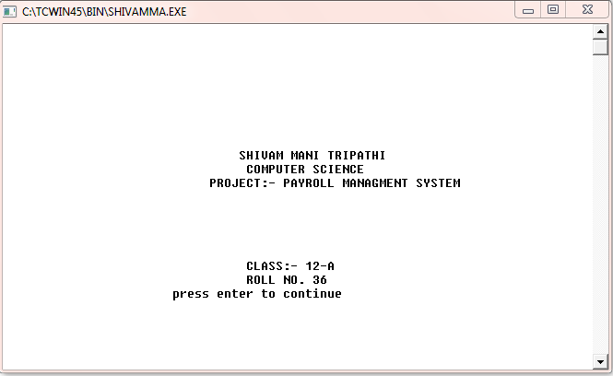

* WELCOME SCREEN

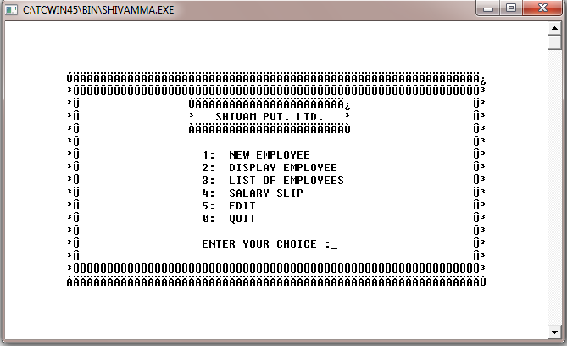

* ADDITION OF NEW EMPLOYEE

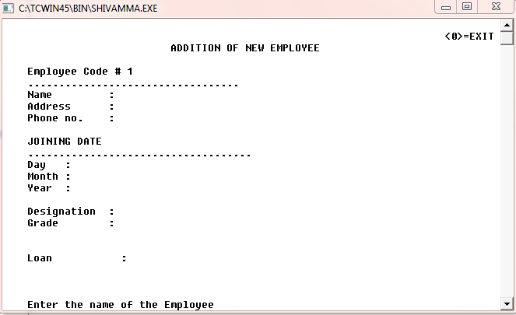

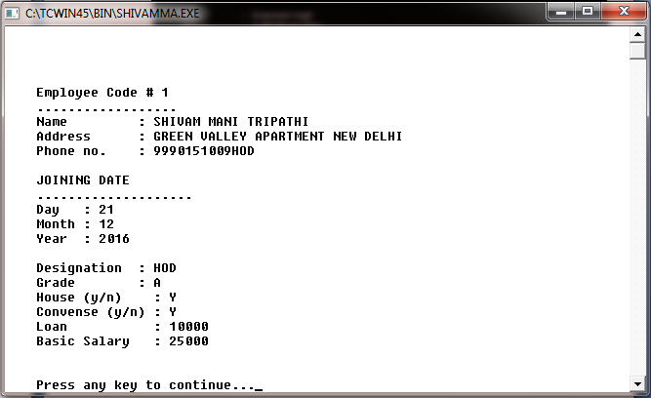

* LIST OF EMPLOYEE

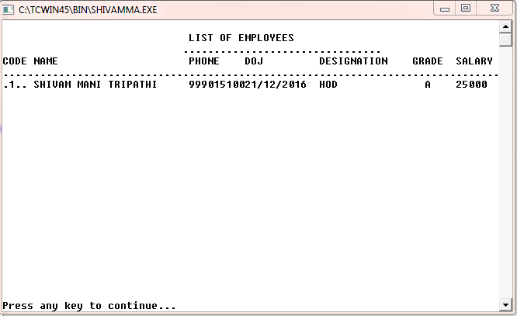

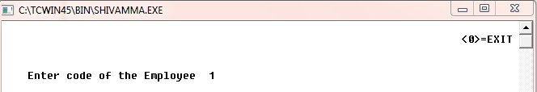

# C:\Users\admin\Desktop\ouput s\4.PNG

* SALARY SLIP

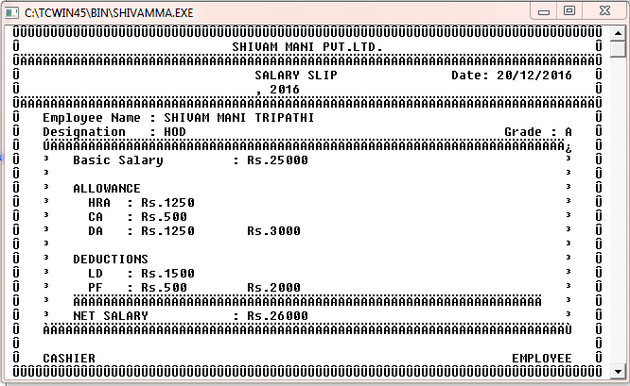

* EDIT MENU

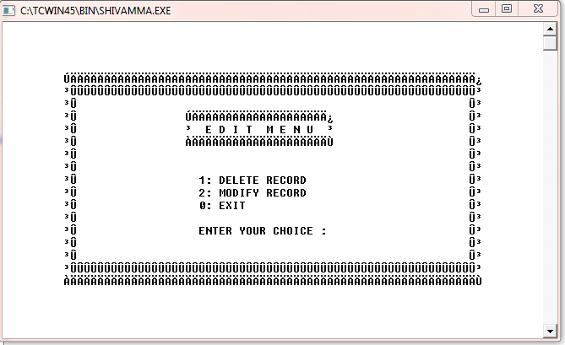

* MODIFY RECORD

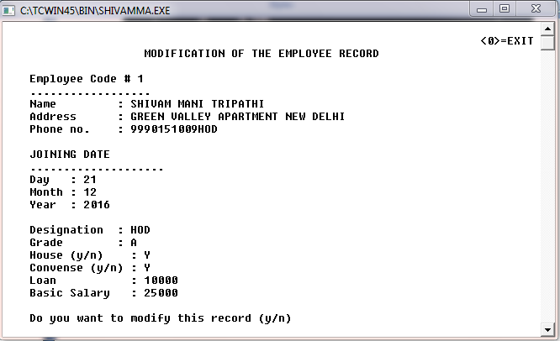

* DELETE RECORD

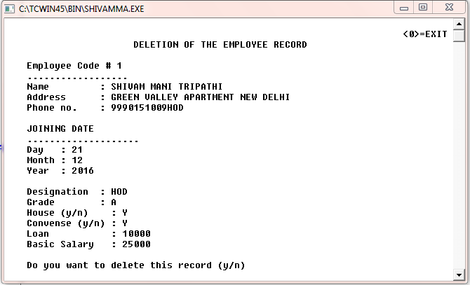

**BIBLIOGRAPHY**

* 1. <http://www.google.com/>
  2. [http://en.wikipedia.org](http://en.wikipedia.org/)
  3. Computer Science with C++ by Sumita Arora
  4. Object Oriented Programming by Robert Lafore
  5. [www.bOtskOOL.com](http://www.botskool.com/)



C E R T I F I C A T E

This is to certify that ***SHIVAM MANI TRIPATHI***

Of Class XII A has prepared the report on the Project entitled “Payroll Management System”. The report is the result of his efforts & endeavors. The report is found worthy of acceptance as final project report for the subject Computer Science of Class

XII,A. He has prepared the report under my guidance.

(Mrs. Anju Yadav)

PGT (Computer Science)

Department of Computer Science

Kendriya VidyalayaPaschim Vihar

New Delhi-87