A Project Report On

# “BANK MANAGEMENT SYSTEM”



### Submitted By

###### ROHIT KUMAR

Class : XII A

**Under the Guidance of**

Mrs. Anju Yadav PGT (ComputerScience)

Department of Computer Science

Kendriya Vidyalaya Paschim Vihar

New Delhi-110087

A C K N O W L E D G E M E N T

I would like to express a deep sense of thanks & gratitude to my project guide Mr. Anju Yadav Mam for guiding me immensely through the course of the project. He always evinced keen interest in my work. His constructive advice & constant motivation have been responsible for the successful completion of this project.

My sincere thanks goes to Mrs. Sabira Shori Our principal Mam, for his co-ordination in extending every possible support for the completion of this project.

I also thanks to my parents for their motivation & support. I must thanks to my classmates for their timely help & support for compilation of this project.

**Last but not the least, I would like to thank all those who had helped directly or indirectly towards the completion of this project.**

ROHIT KUMAR

Class: XIIA



C E R T I F I C A T E

This is to certify that ***ROHIT KUMAR***

Of Class XII A has prepared the report on the Project entitled “BANK MANAGEMENT SYSTEM”. The report is the result of his efforts & endeavors. The report is found worthy of acceptance as final project report for the subject Computer Science of Class

XII,A. He has prepared the report under my guidance.

(Mrs. Anju Yadav)

PGT (Computer Science)

Department of Computer Science

Kendriya VidyalayaPaschim Vihar

New Delhi-87

INDEX

1. HEADER FILES USED ……………………….
2. CODING. . . . . . . . . .. . . . . . . . . . . . . . . . .
3. OUTPUT SCREEN SHOTS. . . . . . . . . . . . . . . . . ..
4. BIBLIOGRAPHY. . . . . . . . . . . . . . . . . . . . .

**INTRODUCTION**

THIS PROGRAMME IS USE TO MANTANE THE BANK ACCOUNT OF USER THROW THIS WE CAN CREATE NEW ACCOUNT ,WE CAN DELELT OR MODIFY THE ACCOUNT AND WE CAN DEPOIST OR WITHDRAWE MONEY TO .THIS PROGRAMME HAS 10 OUTPUT SCREEN.

**HEADER FILES USED**

1. FSTREAM.H- file handling.
2. CONIO.H- clrscr() and getch() functions.
3. STDIO.H- standard I/O Operations.
4. STRING.H- string handling.
5. CTYPE.H- Character Conversion Macros and Functions.
6. IOMAINP.H-

Conversion and search/sort routines.

**CODING**

//***************************************************************

// HEADER FILE USED IN PROJECT

//****************************************************************

#include<iostrem.h>

#include<fstream.h>

#include<conio.h>

#include<stdio.h>

#include<ctype.h>

#include<iomanip.h>

#include<string.h>

//***************************************************************

// CLASS USED IN PROJECT

//****************************************************************

class account

{

int acno;

char name[50];

int deposit;

char type;

public:

void create_account(); //function to get data from user

void show_account(); //function to show data on screen

void modify(); //function to get new data from user

void dep(int); //function to accept amount and add to balance amount

void draw(int); //function to accept amount and subtract from balance amount

void report(); //function to show data in tabular format

int retacno(); //function to return account number

int namesize(); // function to return length of string subtracted from 20

int retdeposit(); //function to return balance amount

char rettype(); //function to return type of account

}; //class ends here

void account::create_account()

{

cout<<"\nEnter The account No. :";

cin>>acno;

cout<<"\n\nEnter The Name of The account Holder : ";

gets(name);

cout<<"\nEnter Type of The account (C/S) : ";

cin>>type;

type=toupper(type);

cout<<"\nEnter The Initial amount(>=500 for Saving and >=1000 for current ) : ";

cin>>deposit;

cout<<"\n\n\nAccount Created..";

}

void account::show_account()

{

cout<<"\nAccount No. : "<<acno;

cout<<"\nAccount Holder Name : ";

cout<<name;

cout<<"\nType of Account : "<<type;

cout<<"\nBalance amount : "<<deposit;

}

void account::modify()

{

cout<<"\nThe account No. "<<acno;

cout<<"\n\nEnter The Name of The account Holder : ";

gets(name);

cout<<"\nEnter Type of The account (C/S) : ";

cin>>type;

type=toupper(type);

cout<<"\nEnter The amount : ";

cin>>deposit;

}

void account::dep(int x)

{

deposit+=x;

}

void account::draw(int x)

{

deposit-=x;

}

int account::namesize()

{int n;

n=20-strlen(name);

return n;

}

void account::report()

{ int n=namesize();

cout<<acno<<setw(10)<<" "<<name<<setw(n)<<" "<<type<<setw(12)<<deposit<<endl;

}

int account::retacno()

{

return acno;

}

int account::retdeposit()

{

return deposit;

}

char account::rettype()

{

return type;

}

//***************************************************************

// function declaration

//****************************************************************

void write_account(); //function to write record in binary file

void display_sp(int); //function to display account details given by user

void modify_account(int); //function to modify record of file

void delete_account(int); //function to delete record of file

void display_all(); //function to display all account details

void deposit_withdraw(int, int); // function to desposit/withdraw amount for given account

void intro(); //introductory screen function

//***************************************************************

// THE MAIN FUNCTION OF PROGRAM

//****************************************************************

int main()

{

char ch;

int num;

clrscr();

intro();

do

{

clrscr();

cout<<"\n\n\n\tMAIN MENU";

cout<<"\n\n\t01. NEW ACCOUNT";

cout<<"\n\n\t02. DEPOSIT AMOUNT";

cout<<"\n\n\t03. WITHDRAW AMOUNT";

cout<<"\n\n\t04. BALANCE ENQUIRY";

cout<<"\n\n\t05. ALL ACCOUNT HOLDER LIST";

cout<<"\n\n\t06. CLOSE AN ACCOUNT";

cout<<"\n\n\t07. MODIFY AN ACCOUNT";

cout<<"\n\n\t08. EXIT";

cout<<"\n\n\tSelect Your Option (1-8) ";

cin>>ch;

clrscr();

switch(ch)

{

case '1':

write_account();

break;

case '2':

cout<<"\n\n\tEnter The account No. : "; cin>>num;

deposit_withdraw(num, 1);

break;

case '3':

cout<<"\n\n\tEnter The account No. : "; cin>>num;

deposit_withdraw(num, 2);

break;

case '4':

cout<<"\n\n\tEnter The account No. : "; cin>>num;

display_sp(num);

break;

case '5':

display_all();

break;

case '6':

cout<<"\n\n\tEnter The account No. : "; cin>>num;

delete_account(num);

break;

case '7':

cout<<"\n\n\tEnter The account No. : "; cin>>num;

modify_account(num);

break;

case '8':

cout<<"\n\n\tThanks for using bank managemnt system ";

break;

default :cout<<"\a";

}

getch();

}while(ch!='8');

return 0;

}

//***************************************************************

// function to write in file

//****************************************************************

void write_account()

{

account ac;

ofstream outFile;

outFile.open("account.dat",ios::binary|ios::app);

ac.create_account();

outFile.write((char *) &ac, sizeof(account));

outFile.close();

}

//***************************************************************

// function to read specific record from file

//****************************************************************

void display_sp(int n)

{

account ac;

int flag=0;

ifstream inFile;

inFile.open("account.dat",ios::binary);

if(!inFile)

{

cout<<"File could not be open !! Press any Key...";

return;

}

cout<<"\nBALANCE DETAILS\n";

while(inFile.read((char *) &ac, sizeof(account)))

{

if(ac.retacno()==n)

{

ac.show_account();

flag=1;

}

}

inFile.close();

if(flag==0)

cout<<"\n\nAccount number does not exist";

}

//***************************************************************

// function to modify record of file

//****************************************************************

void modify_account(int n)

{

int found=0;

account ac;

fstream File;

File.open("account.dat",ios::binary|ios::in|ios::out);

if(!File)

{

cout<<"File could not be open !! Press any Key...";

return;

}

while(File.read((char *) &ac, sizeof(account)) && found==0)

{

if(ac.retacno()==n)

{

ac.show_account();

cout<<"\n\nEnter The New Details of account"<<endl;

ac.modify();

int pos=(-1)*sizeof(account);

File.seekp(pos,ios::cur);

File.write((char *) &ac, sizeof(account));

cout<<"\n\n\t Record Updated";

found=1;

}

}

File.close();

if(found==0)

cout<<"\n\n Record Not Found ";

}

//***************************************************************

// function to delete record of file

//****************************************************************

void delete_account(int n)

{

account ac;

ifstream inFile;

ofstream outFile;

inFile.open("account.dat",ios::binary);

if(!inFile)

{

cout<<"File could not be open !! Press any Key...";

return;

}

outFile.open("Temp.dat",ios::binary);

inFile.seekg(0,ios::beg);

while(inFile.read((char *) &ac, sizeof(account)))

{

if(ac.retacno()!=n)

{

outFile.write((char *) &ac, sizeof(account));

}

}

inFile.close();

outFile.close();

remove("account.dat");

rename("Temp.dat","account.dat");

cout<<"\n\n\tRecord Deleted ..";

}

//***************************************************************

// function to display all accounts deposit list

//****************************************************************

void display_all()

{

account ac;

ifstream inFile;

inFile.open("account.dat",ios::binary);

if(!inFile)

{

cout<<"File could not be open !! Press any Key...";

return;

}

cout<<"\n\n\t\tACCOUNT HOLDER LIST\n\n";

cout<<"====================================================\n";

cout<<"A/c no. NAME Type Balance\n";

cout<<"====================================================\n";

while(inFile.read((char *) &ac, sizeof(account)))

{

ac.report();

}

inFile.close();

}

//***************************************************************

// function to deposit and withdraw amounts

//****************************************************************

void deposit_withdraw(int n, int option)

{

int amt;

int found=0;

account ac;

fstream File;

File.open("account.dat", ios::binary|ios::in|ios::out);

if(!File)

{

cout<<"File could not be open !! Press any Key...";

return;

}

while(File.read((char *) &ac, sizeof(account)) && found==0)

{

if(ac.retacno()==n)

{

ac.show_account();

if(option==1)

{

cout<<"\n\n\tTO DEPOSITE AMOUNT ";

cout<<"\n\nEnter The amount to be deposited ";

cin>>amt;

ac.dep(amt);

}

if(option==2)

{

cout<<"\n\n\tTO WITHDRAW AMOUNT ";

cout<<"\n\nEnter The amount to be withdraw ";

cin>>amt;

int bal=ac.retdeposit()-amt;

if((bal<500 && ac.rettype()=='S') || (bal<1000 && ac.rettype()=='C'))

cout<<"Insufficience balance";

else

ac.draw(amt);

}

int pos=(-1)* sizeof(ac);

File.seekp(pos,ios::cur);

File.write((char *) &ac, sizeof(account));

cout<<"\n\n\t Record Updated";

found=1;

}

}

File.close();

if(found==0)

cout<<"\n\n Record Not Found ";

}

//***************************************************************

// INTRODUCTION FUNCTION

//****************************************************************

void intro()

{

cout<<"\n\n\n\t\t\t\t BANK";

cout<<"\n\n\t\t\t\tMANAGEMENT";

cout<<"\n\n\t\t\t\t SYSTEM";

cout<<"\n\n\n\n\t\t\tMADE BY : Rohit Kumar";

cout<<"\n\n\t\t\tSCHOOL : Kendriya vidyalaya paschim vihar";

getch();

}

//***************************************************************

// END OF PROJECT

//***************************************************************

**SCREEN SHOT**

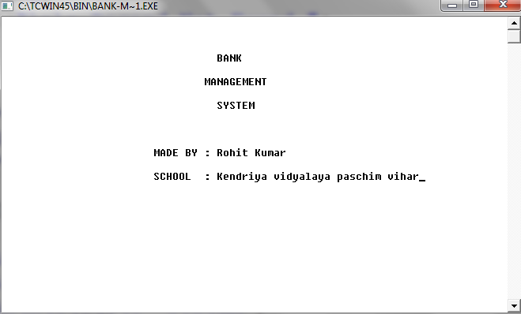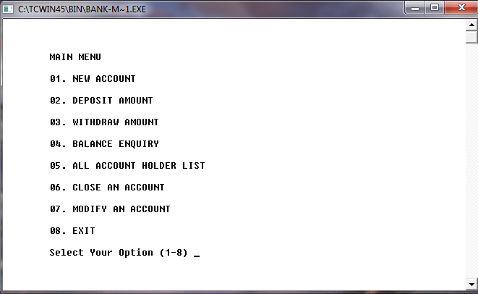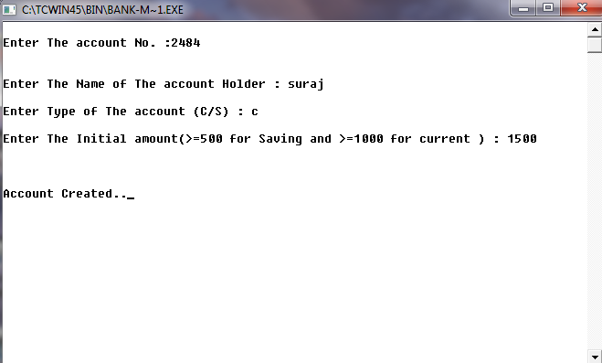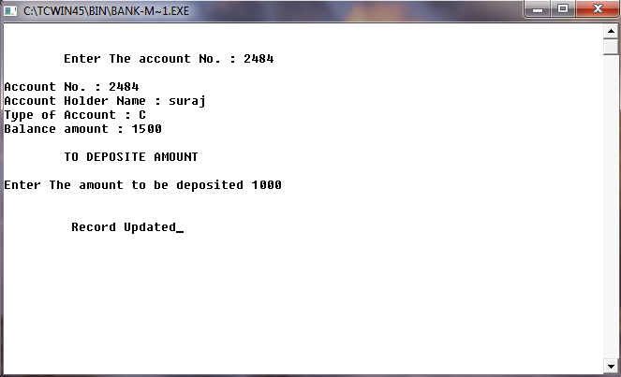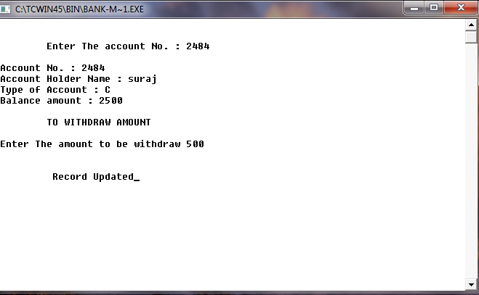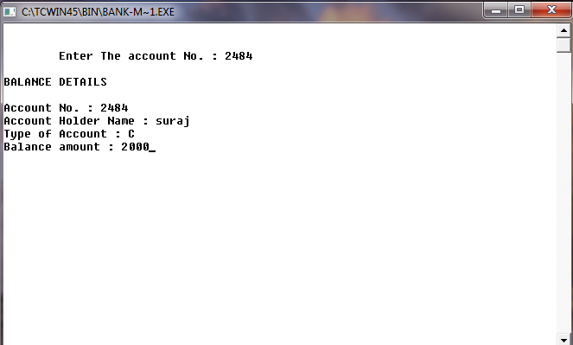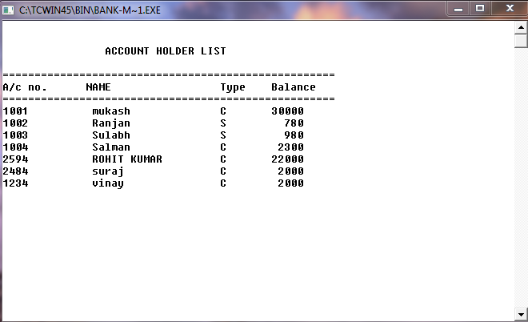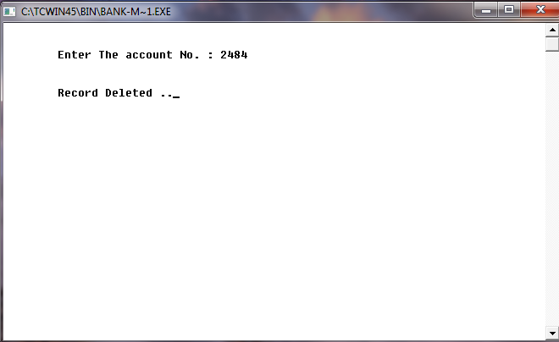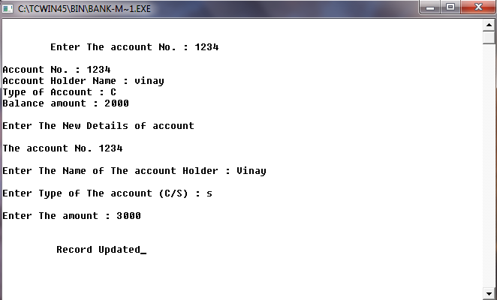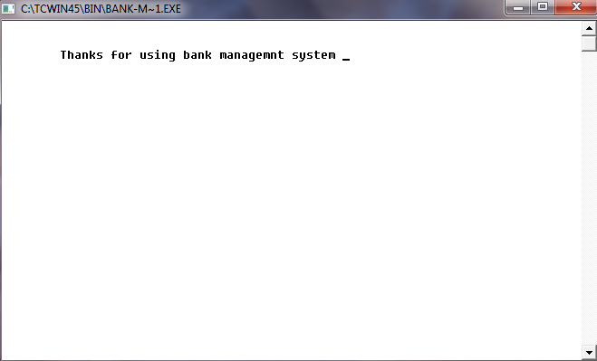

**BIBLIOGRAPHY**

* 1. <http://www.google.com/>
  2. [http://en.wikipedia.org](http://en.wikipedia.org/)
  3. Computer Science with C++ by Sumita Arora
  4. Object Oriented Programming by Robert Lafore
  5. [www.bOtskOOL.com](http://www.botskool.com/)