Results of Support vector machine

Paramters found:

TFIDf paramter:

TfidfVectorizer(analyzer='word', binary=False, decode_error='strict',
dtype=<class 'numpy.float64'>, encoding='utf-8',
input='content', lowercase=True, max_df=0.5, max_features=40000,
min_df=1, ngram_range=(1, 2), norm='l2', preprocessor=None,
smooth_idf=True, stop_words=None, strip_accents=None,
sublinear_tf=False, token_pattern='(?u)\\b\\w\\w+\\b',
tokenizer=None, use_idf=True, vocabulary=None)

random forest Hyperparamters:
RandomForestClassifier(bootstrap=True, class_weight=None, criterion='gini',
max_depth=8, max_features='log2', max_leaf_nodes=None,
min_impurity_decrease=0.0, min_impurity_split=None,
min_samples_leaf=1, min_samples_split=2,
min_weight_fraction_leaf=0.0, n_estimators=500,
n_jobs=None, oob_score=False, random_state=42, verbose=0,
warm_start=False)

1

METRICS
Accuracy: 0.768361581920904

Confusion matrix:
Along the row we have actual labels
Along the columns: Predicted

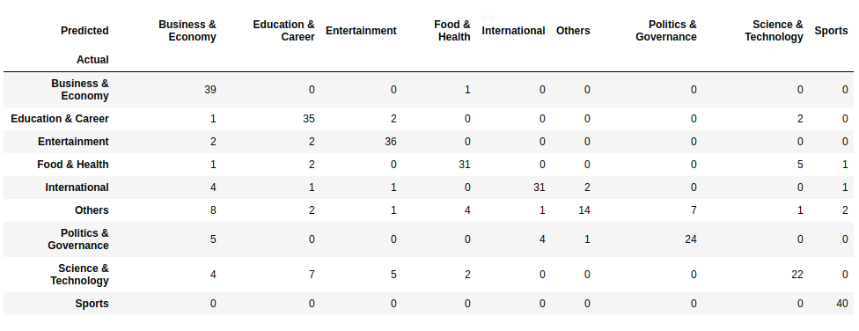

In case of muliclass classification, we have class wise precision, recall., f1 score:

Shown below

