Results of naive bayes

Paramters found:

TFIDf paramter:
TfidfVectorizer(analyzer='word', binary=False, decode_error='strict',
dtype=<class 'numpy.float64'>, encoding='utf-8',
input='content', lowercase=True, max_df=0.75,
max_features=40000, min_df=1, ngram_range=(1, 2), norm='l2',
preprocessor=None, smooth_idf=True, stop_words=None,
strip_accents=None, sublinear_tf=False,
token_pattern='(?u)\\b\\w\\w+\\b', tokenizer=None, use_idf=True,
vocabulary=None)

NaiveBayes Hyperparamters:
MultinomialNB(alpha=0.1, class_prior=None, fit_prior=True)

METRICS
Accuracy: 0.807909604519774

Confusion matrix:
Along the row we have actual labels
Along the columns: Predicted

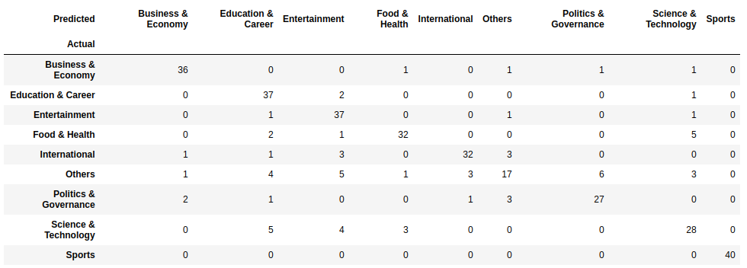

I

n case of muliclass classification, we have class wise precision, recall., f1 score:

Shown below

