Results of Support vector machine

Paramters found:

TFIDf paramter:

TfidfVectorizer(analyzer='word', binary=False, decode_error='strict',
dtype=<class 'numpy.float64'>, encoding='utf-8',
input='content', lowercase=True, max_df=0.5, max_features=40000,
min_df=1, ngram_range=(1, 2), norm='l2', preprocessor=None,
smooth_idf=True, stop_words=None, strip_accents=None,
sublinear_tf=False, token_pattern='(?u)\\b\\w\\w+\\b',
tokenizer=None, use_idf=True, vocabulary=None)

SVM Hyperparamters:
svm.SVC(C=3, cache_size=200, class_weight=None, coef0=0.0,
decision_function_shape='ovr', degree=3, gamma='auto_deprecated',
kernel='linear', max_iter=-1, probability=False, random_state=None,
shrinking=True, tol=0.001, verbose=False)

METRICS
Accuracy:0.8135593220338984

Confusion matrix:
Along the row we have actual labels
Along the columns: Predicted

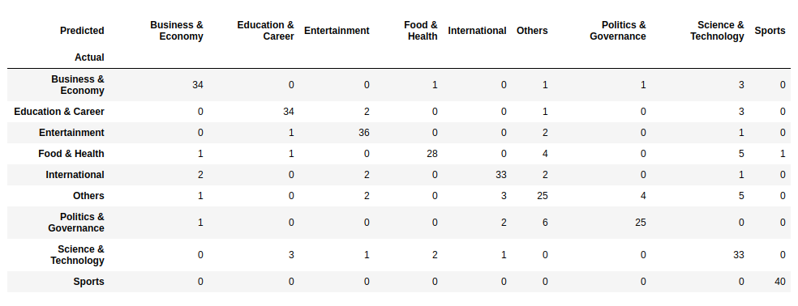

In case of muliclass classification, we have class wise precision, recall., f1 score:

Shown below

