Results of XLNet

Paramters found:

XLNEt:

Paramters:
model: xlnet_base_cased
batch_size:8
sequence_length:512
learning_rate:2e-5
optimizer:Adam

METRICS
Accuracy:82.43626062322946
Confusion matrix:
Along the row we have actual labels
Along the columns: Predicted

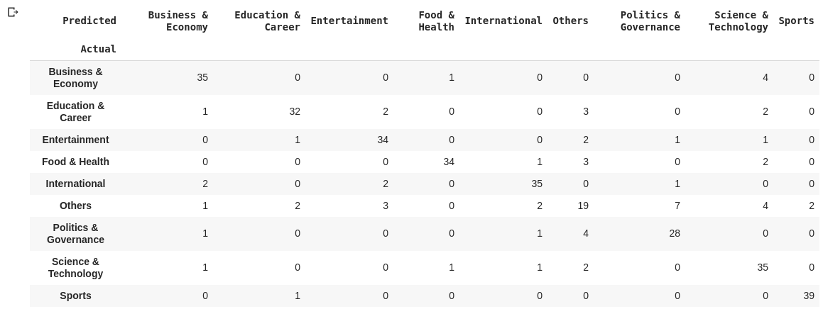

In case of muliclass classification, we have class wise precision, recall., f1 score:

Shown below

