If you want to pull and run any image inside your machine run the following command
- docker run -d -p 5173:5173 shivamsdeng/first-image

if you want to build your own image (fist write all the logic inside the docker file) and then the this command.
- docker build -t “Image_Name” .
(dot defines that take the source from the current location)

Tu run the any images inside your machine
- docker run -d -p 5173:5173 first-image

Check all the images
- docker images

check the currently running images
- docker ps
(this will list all the container that are actively running)
to kill any container
- docker kill process_id/image_name

to delete the image
- docker rmi image_name

Note: the folder name that you assign in WORKDIR that will be create the folder inside your docker container. In my case react-app will create after build
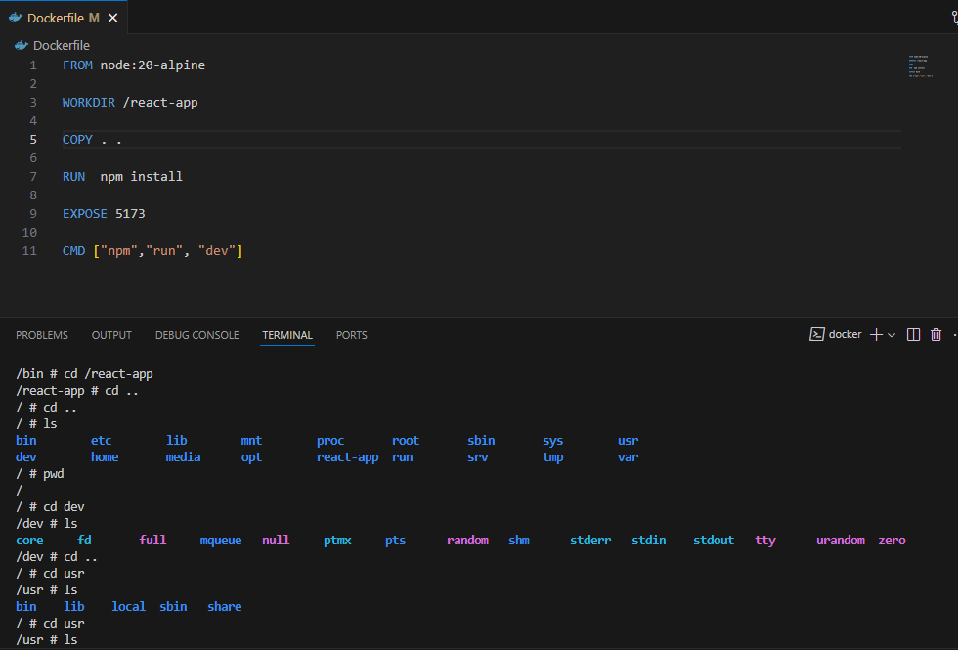
Go inside the Container => WORKDIR name will be the show as the root folder inside the Folder.
-it stands for interactive -> sh means sh inside
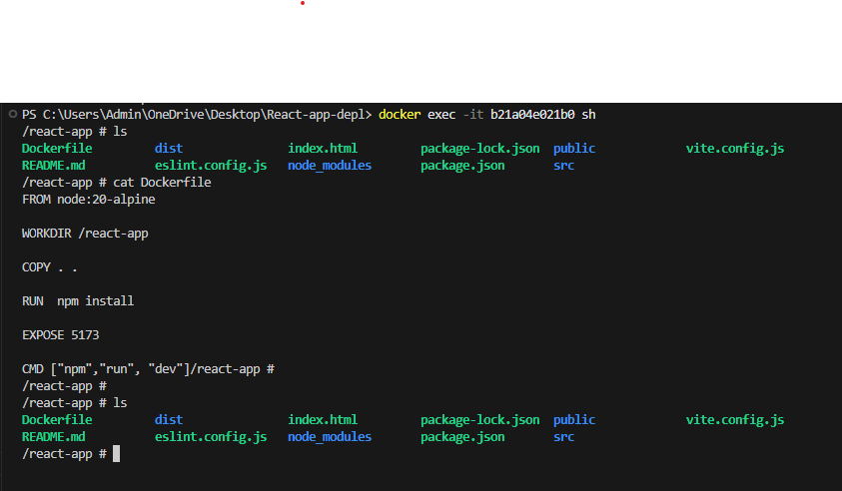

To push any images on docker hub you have to run this command
- docker tag first-image shivamsdeng/first-image
(first give the tag name to your docker image)
- docker push shivamsdeng/first-image
(before all this you should be login)
for login and logout
- docker login
- docker logout

