Lab6 Assignment
2017KUCP1004

1.

#include<stdio.h>

void table(int a)
{
int i;
printf("\nTable of %d:-\n",a);

for(int i=1;i<=10;i++)
printf("%dx%02d=%d\n",a,i,a*i);

}

main()
{
int n;
printf("Enter Number:");
scanf("%d",&n);

table(n );
}

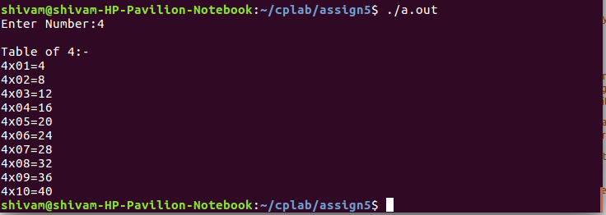

2.

#include<stdio.h>

int fact(int a)
{
if(a==1)
return 1;
else
return a*fact(a-1);
}

main()
{
int n,f;
printf("Enter Number:");
scanf("%d",&n);

f=fact(n);
printf("\nFactorial of entered number:%d\n",f);
}

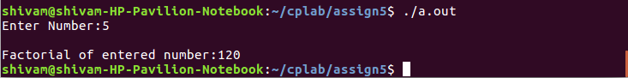

3.

#include<stdio.h>

int dgsum(int a)
{
if(a==0)
return 0;
else
return a%10+dgsum(a/10);
}

main()
{
int n,s;
printf("Enter Number:");
scanf("%d",&n);

s=dgsum(n);
printf("\nSum of digits of entered number:%d\n",s);
}

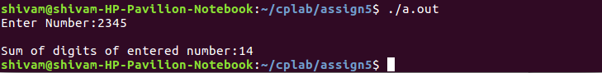

4.

#include<stdio.h>

main()
{
int arr[6],i,n;

for(i=0;i<6;i++)
{
printf("Enter Number %d: ",i+1);
scanf("%d",&arr[i]);
}

printf("\nEnter a number:");
scanf("%d",&n);

for(i=0;i<6;i++)
{
if(n==arr[i])
{ printf("\nEntered number exists in the array\n");
break;
}
else if(i==5)
printf("\nEntered number does not exist in the array\n");
}

}

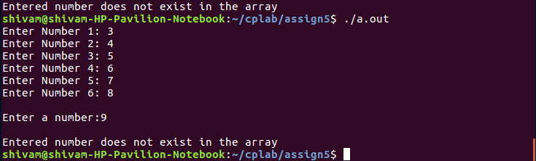

5.

#include<stdio.h>

main()
{
int arr[100],i,n,sum=0,prod=1;
float avg;

printf("Enter Number of array elements:");
scanf("%d",&n);

for(i=0;i<n;i++)
{
printf("Enter Number %d: ",i+1);
scanf("%d",&arr[i]);
}

for(i=0;i<n;i++)
{
sum=sum+arr[i];
prod=prod*arr[i];
}

avg=(float)sum/n;

printf("\nSum of array elements: %d\n",sum);
printf("\nAverage of array elements: %.2f\n",avg);
printf("\nProduct of array elements: %d\n",prod);
}

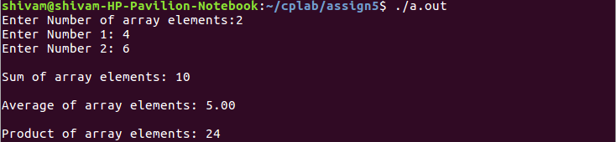

6.
#include<stdio.h>
main()
{
int arr[100],i,n,x;
printf("Enter Number of array elements:");
scanf("%d",&n);

for(i=0;i<n;i++)
{
printf("Enter Number %d: ",i+1);
scanf("%d",&arr[i]);
}
printf("Enter 1 for largest number in the array, 2 for smallest and 3 for both:");
scanf("%d",&x);
switch(x)
{
case 1: for(i=0;i<n;i++)
{
if(arr[0]<arr[i])
arr[0]=arr[i];
}
printf("\nLargest of array elements: %d\n",arr[0]);
break;
case 2: for(i=0;i<n;i++)
{
if(arr[0]>arr[i])
arr[0]=arr[i];
}
printf("\nSmallest of array elements: %d\n",arr[0]);
break;
case 3: arr[n]=arr[0];
for(i=0;i<n;i++)
{
if(arr[0]<arr[i])
arr[0]=arr[i];
if(arr[n]>arr[i])
arr[n]=arr[i];
}
printf("\nLargest of array elements: %d\n",arr[0]);
printf("\nSmallest of array elements: %d\n",arr[n]);
break;
}
}

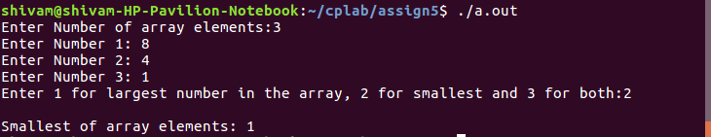
7.

#include<stdio.h>

main()
{
int i,n,arr[10];

for(i=0;i<10;i++)
{
printf("Enter Number %d: ",i+1);
scanf("%d",&arr[i]);
}

printf("\nEnter a number you want to replace:");
scanf("%d",&n);

for(i=0;i<10;i++)
{
if(n==arr[i])
arr[i]=n%2;
}

printf("\nArray:\n");
for(i=0;i<10;i++)
{
printf("%d\t",arr[i]);
}
printf("\n");
}

