Assignment 8
2017KUCP1004
2017KUCP1020

1.

#include<stdio.h>

struct person
{
char name [50];
int emp_no;
float salary;
};

int main()
{
struct person person1 = { "XYZ" , 13245 , 23000.00 };

printf("\nPerson1 details:\nName:%s \nEmp_no:%d \nSalary:%f \n",person1.name,person1.emp_no,person1.salary);

return 0;
}

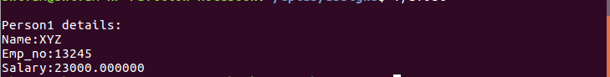

2.

#include<stdio.h>

struct person
{
char name [50];
int emp_no;
float salary;
};

void main()
{
struct person person1;

printf("Enter Person1 details(Name,Emp_no,Salary):\n");

scanf("%s%d%f",person1.name,&person1.emp_no,&person1.salary);

printf("\nPerson1 details:\nName:%s \nEmp_no:%d \nSalary:%f \n",person1.name,person1.emp_no,person1.salary);

}

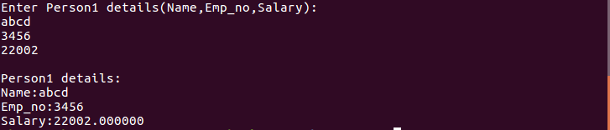

3.

#include<stdio.h>

struct person
{
char name [50];
int emp_no;
float salary;
};

int main()
{
struct person person1 = { "XYZ" , 13245 , 23000.00 },*p;
p=&person1;

struct person person2 = { "abcd" , 34567 , 50000.00 };

printf("\nPerson1 details:\nName:%s \nEmp_no:%d \nSalary:%f \n",person1.name,(*p).emp_no,p->salary);

return 0;
}

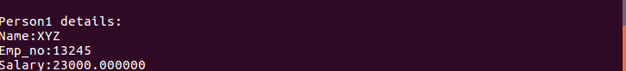

4.

#include<stdio.h>

struct person
{
char name [50];
int emp_no;
float salary;
};

int main()
{
struct person a[2] = {{ "XYZ" , 13245 , 23000.00 } , { "abcd" , 34567 , 50000.00 }},*p;
p=&a[0];

printf("Person1 details:\nName:%s \nEmp_no:%d \nSalary:%f \n",a[0].name,(*p).emp_no,p->salary);

printf("Person2 details:\nName:%s \nEmp_no:%d \nSalary:%f \n",a[1].name,(*(++p)).emp_no,(p+1)->salary);

return 0;
}



5.

#include<stdio.h>

struct dist
{
int feet;
float inch;
}
main()
{
struct dist d1,d2,sum;

printf("\nEnter First Distance:\n");
printf("Feet:");
scanf("%d",&d1.feet);
printf("Inches:");
scanf("%f",&d1.inch);

printf("\nEnter Second Distance:\n");
printf("Feet:");
scanf("%d",&d2.feet);
printf("Inches:");
scanf("%f",&d2.inch);

sum.feet=d1.feet + d2.feet;
sum.inch=d1.inch + d2.inch;

if(sum.inch>=12)
{
sum.inch-=12;
sum.feet++;
}

printf("\nSum of Distances:%d'%.2f\n",sum.feet,sum.inch);

}

