Assignment 9
2017KUCP1004

1.

#include<stdio.h>

struct employee
{
int emp_id;
char name[20];
float salary;
char designation[20];
float experience;
};

int main()
{
struct employee emp;
printf("\n%d \n",sizeof(emp));
return 0;
}

2.

#include<stdio.h>

struct dob
{
int day;
int month;
int year;
};

struct student
{
int roll_no;
char name[100];
float fees;
struct dob date;
};

int main()
{
struct student std;

printf("Enter roll no: ");
scanf("%d",&std.roll_no);
printf("Enter name: ");
scanf("%s",std.name);
printf("Enter fees: ");
scanf("%f",&std.fees);
printf("Enter date of birth: ");
scanf("%d %d %d",&std.date.day,&std.date.month,&std.date.year);

printf("\nStudent Details:- \n");
printf("Roll no: %d \n",std.roll_no);
printf("Name: %s \n",std.name);
printf("Fees: %f \n",std.fees);
printf("Date of birth: %d-%d-%d \n",std.date.day,std.date.month,std.date.year);

return 0;
}

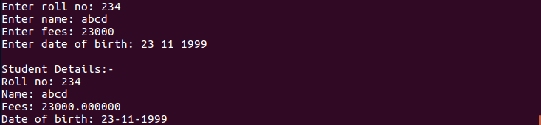

3.

#include<stdio.h>

struct student
{
int roll_no;
char name[50];
float fees;
char dob[50];
};

int main()
{
struct student std[30];
int n,i,rollno,n_rollno;
float n_fees;
char n_dob[50], n_name[50];

printf("Enter the number of students: ");
scanf("%d",&n);

for(i=0;i<n;i++)
{
printf("\nEnter Student %d Details:- \n",i+1);
printf("Enter roll no: ");
scanf("%d",&std[i].roll_no);
printf("Enter name: ");
scanf(" %s",std[i].name);
printf("Enter fees: ");
scanf("%f",&std[i].fees);
printf("Enter date of birth: ");
scanf(" %s",std[i].dob);
}

for(i=0;i<n;i++)
{
printf("\nStudent %d Details:- \n",i+1);
printf("Roll no: %d \n",std[i].roll_no);
printf("Name: %s \n",std[i].name);
printf("Fees: %f \n",std[i].fees);
printf("Date of birth: %s \n",std[i].dob);
}

printf("\nEnter the roll no of student to be edited: ");
scanf("%d",&rollno);
printf("Enter new roll no: ");
scanf("%d",&std[rollno-1].roll_no);
printf("Enter new name: ");
scanf(" %s",std[rollno-1].name);
printf("Enter new fees: ");
scanf("%f",&std[rollno-1].fees);
printf("Enter new date of birth: ");
scanf(" %s",std[rollno-1].dob);

for(i=0;i<n;i++)
{
printf("\nStudent %d Details:- \n",i+1);
printf("Roll no: %d \n",std[i].roll_no);
printf("Name: %s \n",std[i].name);
printf("Fees: %f \n",std[i].fees);
printf("Date of birth: %s \n",std[i].dob);
}

return 0;
}

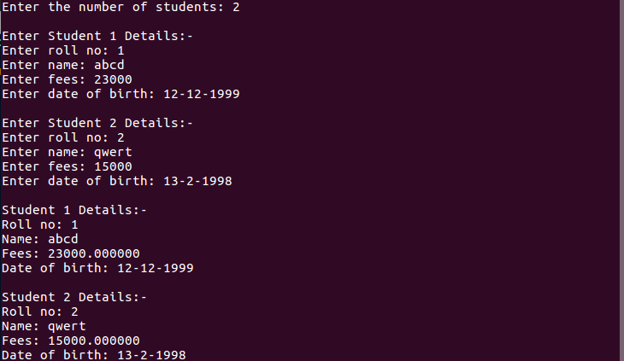
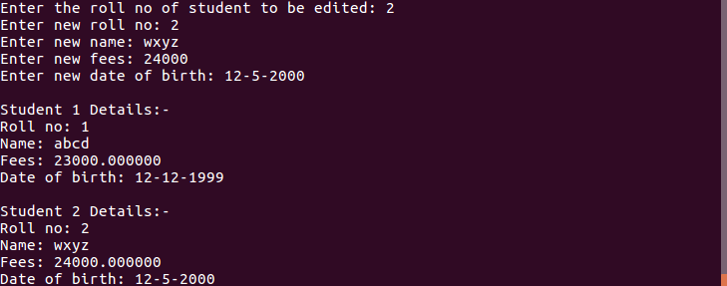

4.

#include<stdio.h>

struct dist
{
int km;
float m;
};

void sum(struct dist d1,struct dist d2)
{
int km;
float m;

km=d1.km + d2.km;
m=d1.m + d2.m;

if(m>=100)
{
m-=100;
km++;
}
printf("\nSum of Distances:%dkm %.2fm\n",km,m);
}

void diff(struct dist d1,struct dist d2)
{
int km;
float m;

if(d1.km>d2.km)
{
km=d1.km - d2.km;
m=d1.m - d2.m;
}
else
{
km=d2.km - d1.km;
m=d2.m - d1.m;
}

if(m<0)
{
m+=100;
km--;
}
printf("\nDifference of Distances:%dkm %.2fm\n",km,m);
}

int main()
{
struct dist d1,d2;
int out;

do
{
printf("\n1. Read the distances");
printf("\n2. Display the distances");
printf("\n3. Add the distances");
printf("\n4. Subtract the distances");
printf("\n5. Exit\n");

printf("\nSelect an option:");
scanf("%d",&out);

switch(out)
{
case 1:
printf("\nEnter First Distance:\n");
printf("Kilometers:");
scanf("%d",&d1.km);
printf("meters:");
scanf("%f",&d1.m);

printf("\nEnter Second Distance:\n");
printf("Kilometers:");
scanf("%d",&d2.km);
printf("meters:");
scanf("%f",&d2.m);
break;

case 2:
printf("\nDistance 1:%dkm %.2fm\n",d1.km,d1.m);
printf("\nDistance 2:%dkm %.2fm\n",d2.km,d2.m);
break;

case 3:
sum(d1,d2);
break;

case 4:
diff(d1,d2);
break;
}
}while(out!=5);

return 0;
}

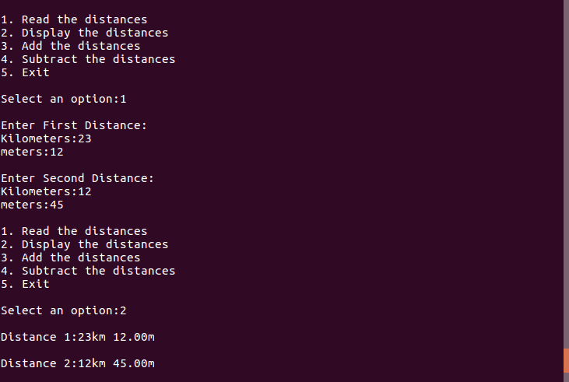

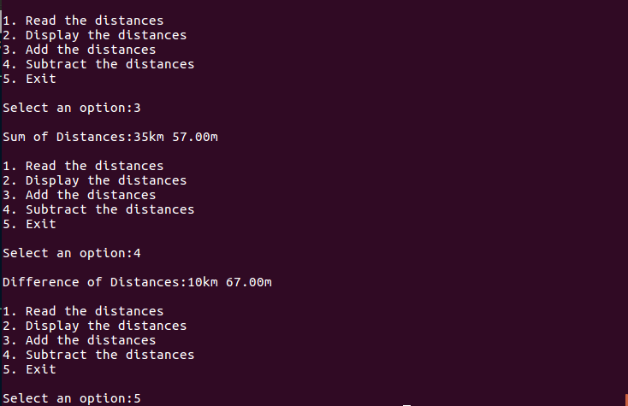

5.

#include<stdio.h>
#include<string.h>

struct student
{
int roll_no;
char name[50];
float fees;
char dob[50];
};

int main()
{
struct student std1,std2,*p1,*p2;
p1=&std1;
p2=&std2;

p1->roll_no=1;
strcpy(p1->name,"abcd");
p1->fees=23000;
strcpy(p1->dob,"12-11-1999");

printf("\nEnter Student 2 Details:- \n");
printf("Enter roll no: ");
scanf("%d",&p2->roll_no);
printf("Enter name: ");
scanf(" %s",p2->name);
printf("Enter fees: ");
scanf("%f",&p2->fees);
printf("Enter date of birth: ");
scanf(" %s",p2->dob);

printf("\nStudent 1 Details:- \n");
printf("Roll no: %d \n",p1->roll_no);
printf("Name: %s \n",p1->name);
printf("Fees: %f \n",p1->fees);
printf("Date of birth: %s \n",p1->dob);

printf("\nStudent 2 Details:- \n");
printf("Roll no: %d \n",p2->roll_no);
printf("Name: %s \n",p2->name);
printf("Fees: %f \n",p2->fees);
printf("Date of birth: %s \n",p2->dob);

return 0;
}

