Base.html

<link href="https://cdn.jsdelivr.net/npm/bootstrap-icons@1.11.3/font/bootstrap-icons.css" rel="stylesheet">

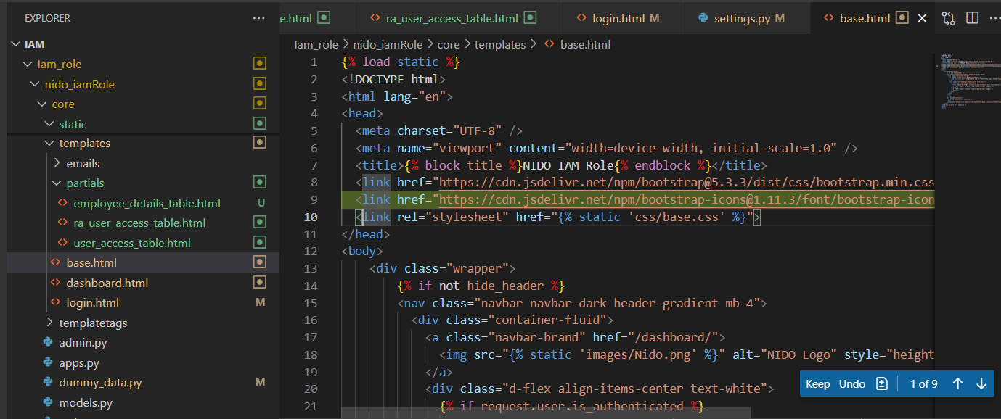

Dashboard.html

<!-- Modal for viewing roles -->

<div class="modal fade" id="rolesModal" tabindex="-1" aria-labelledby="rolesModalLabel" aria-hidden="true">

  <div class="modal-dialog">

    <div class="modal-content">

      <div class="modal-header">

        <h5 class="modal-title" id="rolesModalLabel">Application Roles</h5>

        <button type="button" class="btn-close" data-bs-dismiss="modal" aria-label="Close"></button>

      </div>

      <div class="modal-body">

        <div id="roles-list-container"></div>

      </div>

      <div class="modal-footer">

  <button type="button" class="btn btn-primary" style="background:#ff512f;border-color:#ff512f" data-bs-dismiss="modal">Close</button>

      </div>

    </div>

  </div>

</div>

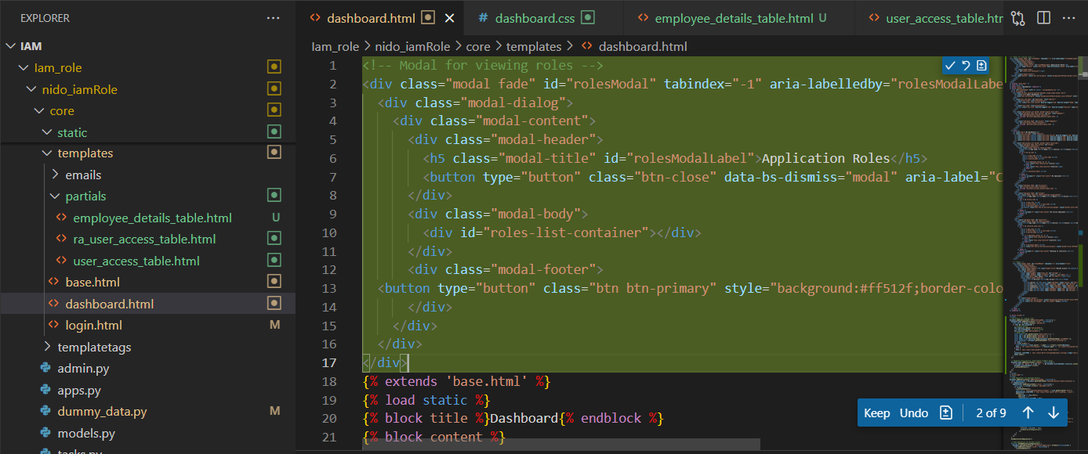

<button class="btn btn-primary" style="background:#ff512f;border-color:#ff512f" data-bs-dismiss="modal">Cancel</button>

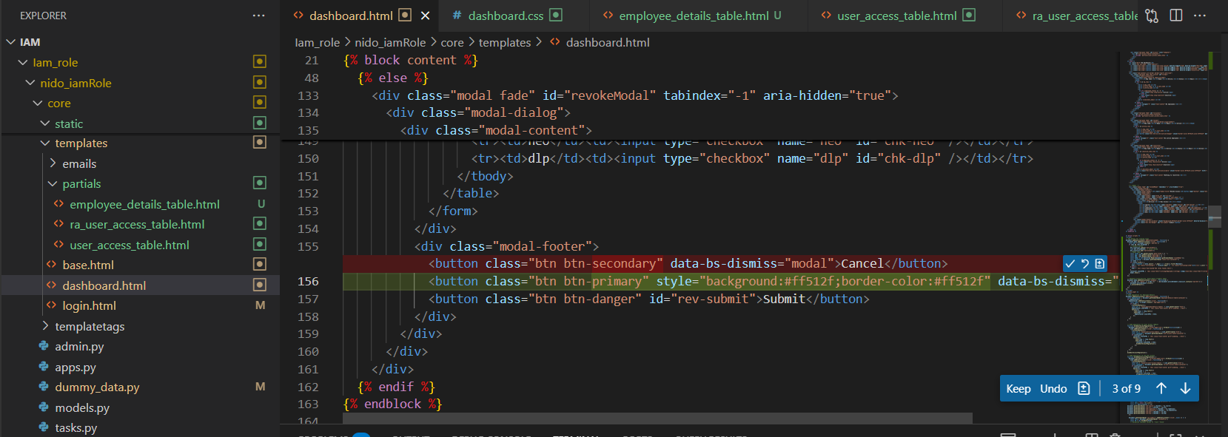

<script>

// Eye button for viewing roles

document.addEventListener('DOMContentLoaded', function() {

  document.body.addEventListener('click', function(e) {

    const btn = e.target.closest('.eye-btn');

    if (btn && !btn.disabled) {

      // Animate button

      btn.classList.remove('eye-animate');

      void btn.offsetWidth; // force reflow

      btn.classList.add('eye-animate');

      // Modal logic

      const roles = btn.getAttribute('data-roles') || '';

      const app = btn.getAttribute('data-app') || '';

      const emp = btn.getAttribute('data-emp') || '';

      const modal = new bootstrap.Modal(document.getElementById('rolesModal'));

      const container = document.getElementById('roles-list-container');

      let html = '';

      if (roles.trim()) {

        const roleList = roles.split(',').map(r => r.trim()).filter(Boolean);

        html = `<ul class="list-group">` + roleList.map(r => `<li class="list-group-item">${r}</li>`).join('') + `</ul>`;

      } else {

        html = '<div class="text-muted">No roles found.</div>';

      }

      container.innerHTML = `<div class="mb-2"><strong>Employee:</strong> ${emp}</div><div class="mb-2"><strong>Application:</strong> ${app.toUpperCase()}</div>` + html;

      modal.show();

    }

  });

  // Keyboard accessibility: Enter/Space triggers modal

  document.body.addEventListener('keydown', function(e) {

    if ((e.key === 'Enter' || e.key === ' ') && document.activeElement.classList.contains('eye-btn')) {

      document.activeElement.click();

      e.preventDefault();

    }

  });

});

</script>

(till here refer below……………………)

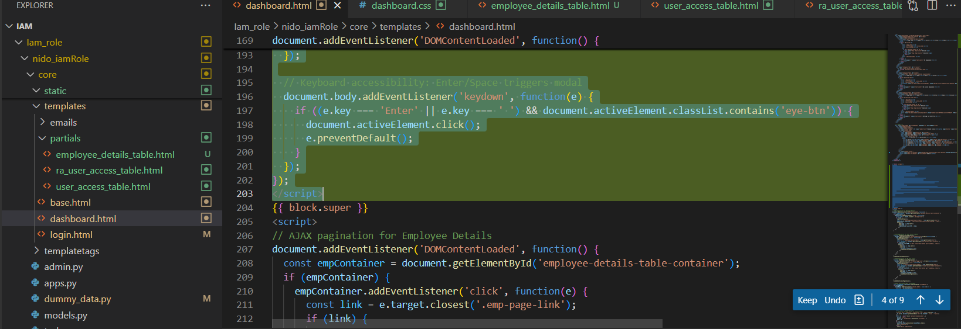

Views.py

'module': emp.get('module', ''),

            'user_role': emp.get('user_role', ''),

            'menu_name': emp.get('menu_name', ''),

            'user_role_name': emp.get('user_role_name', ''),

            'roles': emp.get('roles', ''),

            'status_tc': emp.get('status_tc', ''),

        })

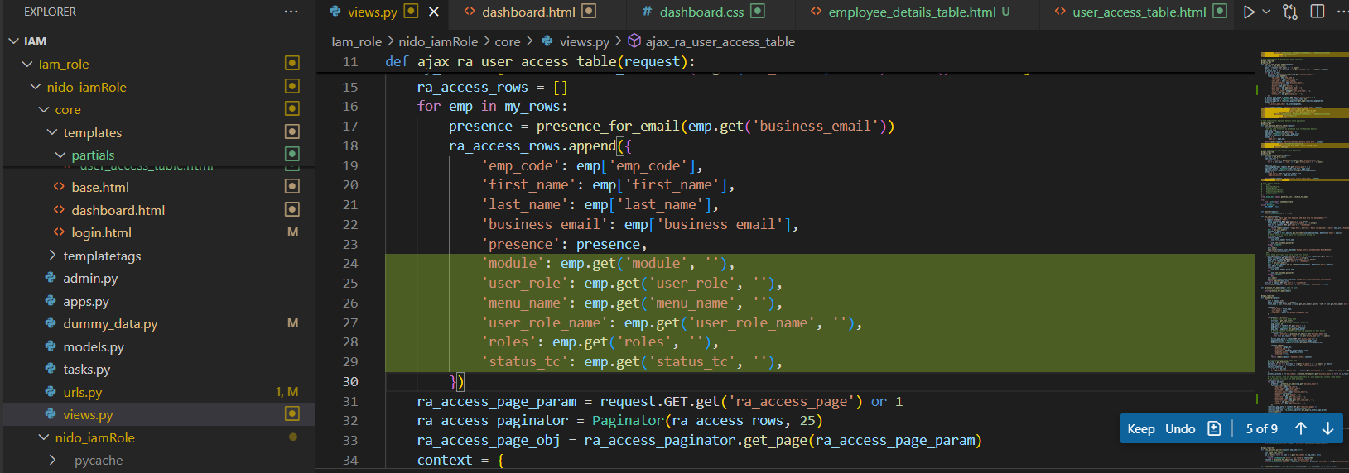

'module': emp.get('module', ''),

                'user_role': emp.get('user_role', ''),

                'menu_name': emp.get('menu_name', ''),

                'user_role_name': emp.get('user_role_name', ''),

                'roles': emp.get('roles', ''),

                'status_tc': emp.get('status_tc', ''),

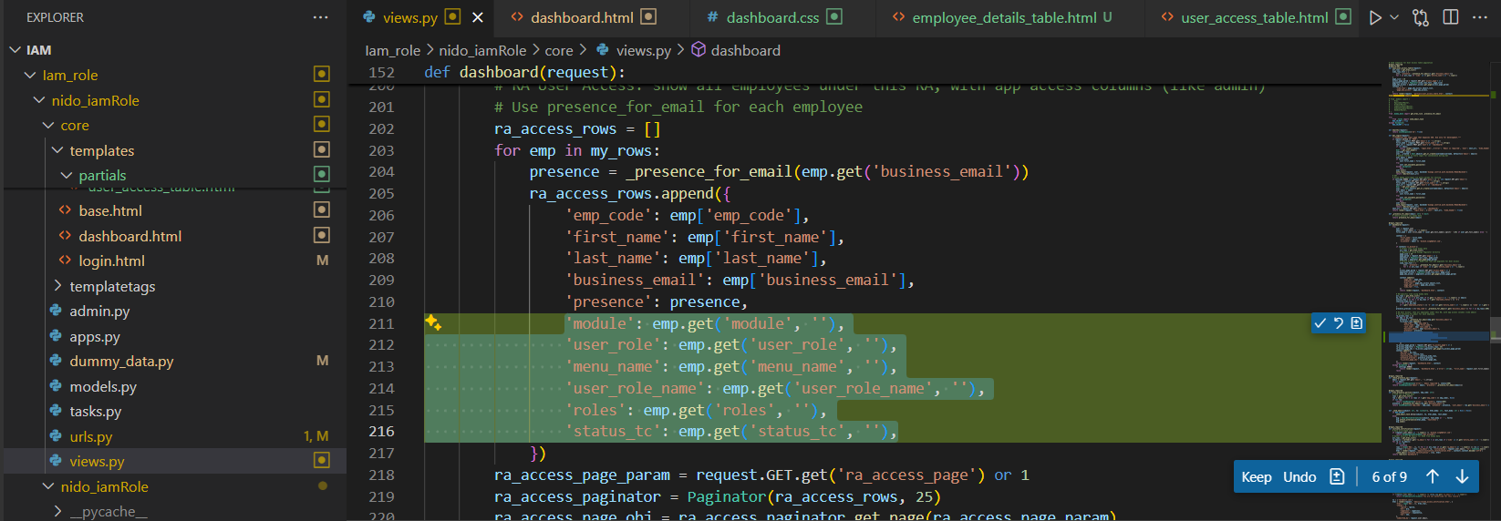

User_access_table.html

      <td class="text-center">

        {% if h.presence.rpulse %}

          <span class="badge bg-success">Yes</span>

          <button class="btn btn-link p-0 ms-1 eye-btn" data-app="rpulse" data-roles="{{ h.module }}" data-emp="{{ h.emp_code }}" aria-label="View Roles" title="View Roles">

            <i class="bi bi-eye"></i>

          </button>

        {% else %}

          <span class="badge bg-secondary">No</span>

          <button class="btn btn-link p-0 ms-1 eye-btn" disabled title="No Access">

            <i class="bi bi-eye-slash"></i>

          </button>

        {% endif %}

      </td>

      <td class="text-center">

        {% if h.presence.dre %}

          <span class="badge bg-success">Yes</span>

          <button class="btn btn-link p-0 ms-1 eye-btn" data-app="dre" data-roles="{{ h.user_role }}" data-emp="{{ h.emp_code }}" aria-label="View Roles" title="View Roles">

            <i class="bi bi-eye"></i>

          </button>

        {% else %}

          <span class="badge bg-secondary">No</span>

          <button class="btn btn-link p-0 ms-1 eye-btn" disabled title="No Access">

            <i class="bi bi-eye-slash"></i>

          </button>

        {% endif %}

      </td>

      <td class="text-center">

        {% if h.presence.ingenious %}

          <span class="badge bg-success">Yes</span>

          <button class="btn btn-link p-0 ms-1 eye-btn" data-app="ingenious" data-roles="{{ h.menu_name }}" data-emp="{{ h.emp_code }}" aria-label="View Roles" title="View Roles">

            <i class="bi bi-eye"></i>

          </button>

        {% else %}

          <span class="badge bg-secondary">No</span>

          <button class="btn btn-link p-0 ms-1 eye-btn" disabled title="No Access">

            <i class="bi bi-eye-slash"></i>

          </button>

        {% endif %}

      </td>

      <td class="text-center">

        {% if h.presence.exponentia %}

          <span class="badge bg-success">Yes</span>

          <button class="btn btn-link p-0 ms-1 eye-btn" data-app="exponentia" data-roles="{{ h.user_role_name }}" data-emp="{{ h.emp_code }}" aria-label="View Roles" title="View Roles">

            <i class="bi bi-eye"></i>

          </button>

        {% else %}

          <span class="badge bg-secondary">No</span>

          <button class="btn btn-link p-0 ms-1 eye-btn" disabled title="No Access">

            <i class="bi bi-eye-slash"></i>

          </button>

        {% endif %}

      </td>

      <td class="text-center">

        {% if h.presence.neo %}

          <span class="badge bg-success">Yes</span>

          <button class="btn btn-link p-0 ms-1 eye-btn" data-app="neo" data-roles="{{ h.roles }}" data-emp="{{ h.emp_code }}" aria-label="View Roles" title="View Roles">

            <i class="bi bi-eye"></i>

          </button>

        {% else %}

          <span class="badge bg-secondary">No</span>

          <button class="btn btn-link p-0 ms-1 eye-btn" disabled title="No Access">

            <i class="bi bi-eye-slash"></i>

          </button>

        {% endif %}

      </td>

      <td class="text-center">

        {% if h.presence.dlp %}

          <span class="badge bg-success">Yes</span>

          <button class="btn btn-link p-0 ms-1 eye-btn" data-app="dlp" data-roles="{{ h.status_tc }}" data-emp="{{ h.emp_code }}" aria-label="View Roles" title="View Roles">

            <i class="bi bi-eye"></i>

          </button>

        {% else %}

          <span class="badge bg-secondary">No</span>

          <button class="btn btn-link p-0 ms-1 eye-btn" disabled title="No Access">

            <i class="bi bi-eye-slash"></i>

          </button>

        {% endif %}

      </td>

Till below……………….

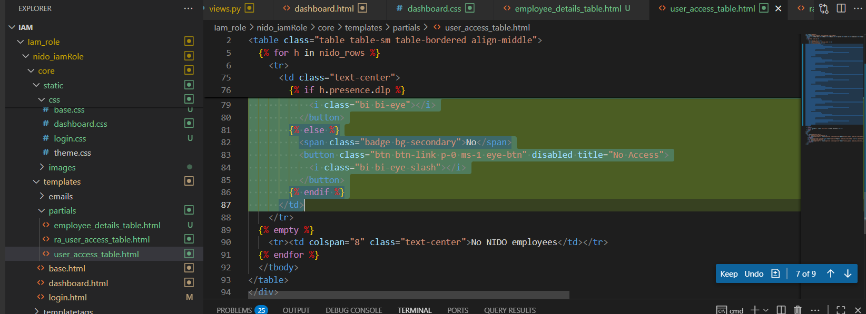

Dashboard.css

/* Eye button interactivity */

.eye-btn {

  transition: transform 0.12s cubic-bezier(.4,2,.6,1), box-shadow 0.12s;

  outline: none;

  position: relative;

}

.eye-btn:focus-visible {

  box-shadow: 0 0 0 2px #ff512f55;

  z-index: 2;

}

.eye-btn:hover:not(:disabled) i.bi-eye {

  color: #ff512f;

  transform: scale(1.2);

}

.eye-btn:active:not(:disabled) {

  animation: eye-pulse 0.18s cubic-bezier(.4,2,.6,1);

}

@keyframes eye-pulse {

  0% { transform: scale(1); }

  50% { transform: scale(1.25); }

  100% { transform: scale(1); }

}

.eye-btn[aria-label]:hover:after, .eye-btn[aria-label]:focus:after {

  content: attr(aria-label);

  position: absolute;

  left: 100%;

  top: 50%;

  transform: translateY(-50%);

  background: #222;

  color: #fff;

  padding: 2px 8px;

  border-radius: 4px;

  font-size: 0.8em;

  white-space: nowrap;

  margin-left: 8px;

  z-index: 10;

  pointer-events: none;

}

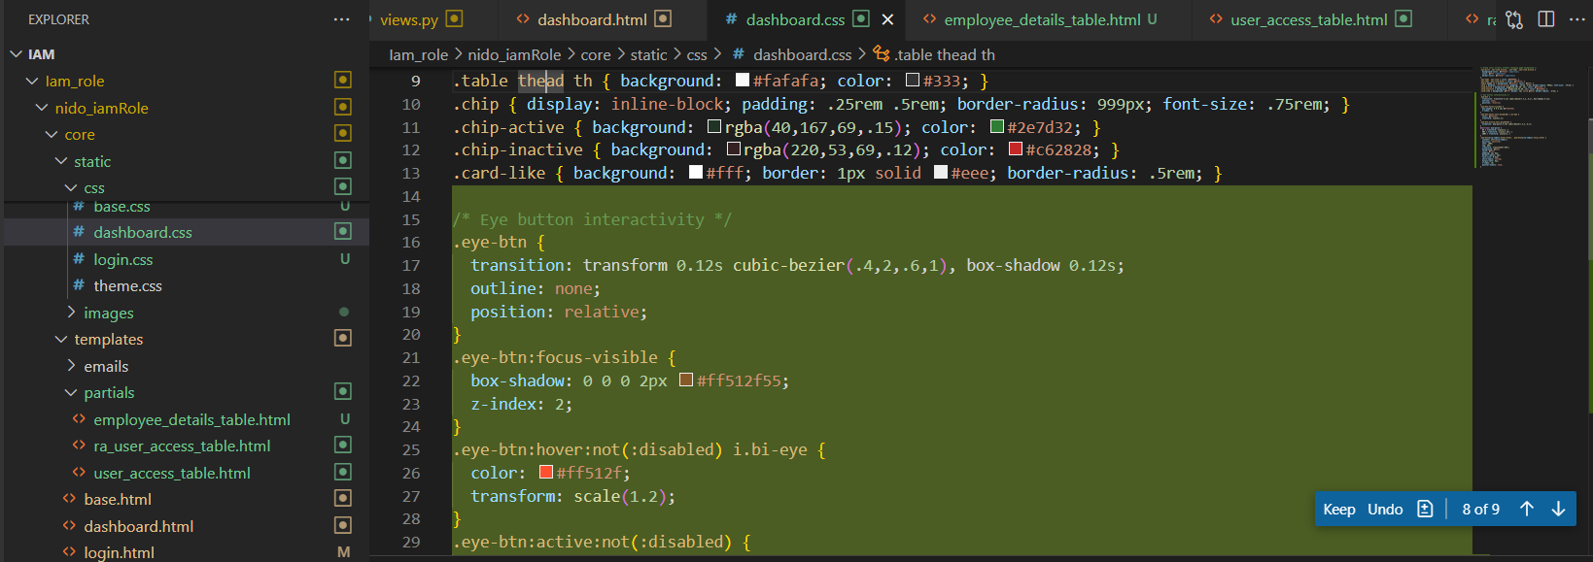

Ra_user_access_table.html

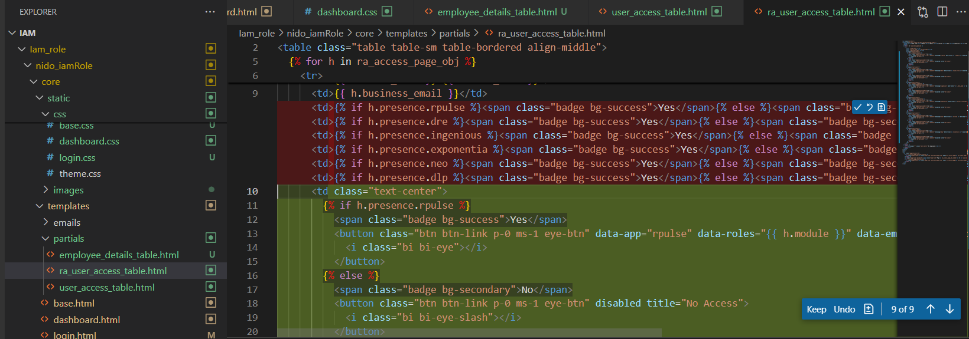

      <td class="text-center">

        {% if h.presence.rpulse %}

          <span class="badge bg-success">Yes</span>

          <button class="btn btn-link p-0 ms-1 eye-btn" data-app="rpulse" data-roles="{{ h.module }}" data-emp="{{ h.emp_code }}" aria-label="View Roles" title="View Roles">

            <i class="bi bi-eye"></i>

          </button>

        {% else %}

          <span class="badge bg-secondary">No</span>

          <button class="btn btn-link p-0 ms-1 eye-btn" disabled title="No Access">

            <i class="bi bi-eye-slash"></i>

          </button>

        {% endif %}

      </td>

      <td class="text-center">

        {% if h.presence.dre %}

          <span class="badge bg-success">Yes</span>

          <button class="btn btn-link p-0 ms-1 eye-btn" data-app="dre" data-roles="{{ h.user_role }}" data-emp="{{ h.emp_code }}" aria-label="View Roles" title="View Roles">

            <i class="bi bi-eye"></i>

          </button>

        {% else %}

          <span class="badge bg-secondary">No</span>

          <button class="btn btn-link p-0 ms-1 eye-btn" disabled title="No Access">

            <i class="bi bi-eye-slash"></i>

          </button>

        {% endif %}

      </td>

      <td class="text-center">

        {% if h.presence.ingenious %}

          <span class="badge bg-success">Yes</span>

          <button class="btn btn-link p-0 ms-1 eye-btn" data-app="ingenious" data-roles="{{ h.menu_name }}" data-emp="{{ h.emp_code }}" aria-label="View Roles" title="View Roles">

            <i class="bi bi-eye"></i>

          </button>

        {% else %}

          <span class="badge bg-secondary">No</span>

          <button class="btn btn-link p-0 ms-1 eye-btn" disabled title="No Access">

            <i class="bi bi-eye-slash"></i>

          </button>

        {% endif %}

      </td>

      <td class="text-center">

        {% if h.presence.exponentia %}

          <span class="badge bg-success">Yes</span>

          <button class="btn btn-link p-0 ms-1 eye-btn" data-app="exponentia" data-roles="{{ h.user_role_name }}" data-emp="{{ h.emp_code }}" aria-label="View Roles" title="View Roles">

            <i class="bi bi-eye"></i>

          </button>

        {% else %}

          <span class="badge bg-secondary">No</span>

          <button class="btn btn-link p-0 ms-1 eye-btn" disabled title="No Access">

            <i class="bi bi-eye-slash"></i>

          </button>

        {% endif %}

      </td>

      <td class="text-center">

        {% if h.presence.neo %}

          <span class="badge bg-success">Yes</span>

          <button class="btn btn-link p-0 ms-1 eye-btn" data-app="neo" data-roles="{{ h.roles }}" data-emp="{{ h.emp_code }}" aria-label="View Roles" title="View Roles">

            <i class="bi bi-eye"></i>

          </button>

        {% else %}

          <span class="badge bg-secondary">No</span>

          <button class="btn btn-link p-0 ms-1 eye-btn" disabled title="No Access">

            <i class="bi bi-eye-slash"></i>

          </button>

        {% endif %}

      </td>

      <td class="text-center">

        {% if h.presence.dlp %}

          <span class="badge bg-success">Yes</span>

          <button class="btn btn-link p-0 ms-1 eye-btn" data-app="dlp" data-roles="{{ h.status_tc }}" data-emp="{{ h.emp_code }}" aria-label="View Roles" title="View Roles">

            <i class="bi bi-eye"></i>

          </button>

        {% else %}

          <span class="badge bg-secondary">No</span>

          <button class="btn btn-link p-0 ms-1 eye-btn" disabled title="No Access">

            <i class="bi bi-eye-slash"></i>

          </button>

        {% endif %}

      </td>

Till below(……………………..)

