Practice

Open Excel to a blank worksheet.

Part A

Create a spreadsheet like the one below. Enter all the numbers.
  - Change the formatting of the numbers to dollars.
  - Make the grid around the cells visible.
  - Insert the title “Monthly Budget” and center and merge it.
    - Change the font to Baker Signet, size 18.
    - Make the text white and the fill black.
  - Insert the subtitle “January 2005 – June 2005.”
    - Change the font to Baker Signet, size 10
    - Make text white and fill black.
    - Center and merge it.
  - Total the expenses at the bottom of each month.
    - Widen columns if necessary so numbers can be seen.
  - Put a dark border around the edges of the document.
  - Change the amount for gasoline in June from $60 to $70.
  - Figure out the average for each row. You must know the formula on your own!
  - Center and bold the headings (months and average)
    - Change the font to BakerSignet on the headings
    - Bold the headings in column A.
    - Change the font to BakerSignet.
  - Add a header with your name, period, and FINAL PART A.
  - Print

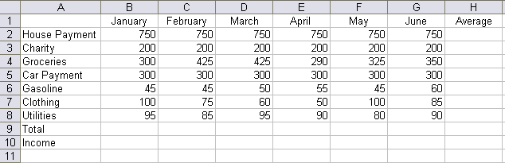

Part B

Keep the work from Part A open. You will be making two graphs from this information.

Graph 1 – Pie Chart

This graph will show the total amount of money spent on each category over a six month period.

To do this, you must total the amount spent on each item in column I. Do not include the average in your equation.

Next, highlight the expenses (house payment, gasoline, etc). Hold down the ctrl key and highlight your new totals.

Create a pie chart. Go to data labels and show the percentages.
Cut and paste all the information you need and the graph to a new sheet.

Graph 2. – Bar Chart

This will be a bar chart for income and expenses.

Below your total column, type Income in A12. Enter the income for each month. They are as follows:
January: 2,000
February: 2,100
March: 2,000
April: 1,900
May: 2,500
June: 2,200

Create a bar chart that looks like the one below. Include the chart you make and the date for the chart on the page you print. This page should include the two data sets and the two charts. Print preview to make sure it all prints on one page.
