**ABC**

**TRAINING CENTER**

**A minor project reports**

**Submitted in partial fulfillment of the requirements for the award of degree of**

Bachelor Of Technology

(Computer Science and Engineering)

**Submitted to**

LOVELY PROFESSIONAL UNIVERSITY

PHAGWARA, PUNJAB



**From 10/03/23 to 09/04/23**

**SUBMITTED BY**

**Name of student:** Shivam Verma

**Registration Number:** 12017149

**Signature of the Student:**

Student Declaration

**To whom so ever it may concern**

**I, Shivam Verma, 12017149, hereby declare that the work done by me on “Data Visualization” on topic of “ABC Training Center” from 10th March 2023 to 09th April 2023, is a record of original work for the partial fulfillment of the requirements for the award of the degree, Bachelor of Technology.**

Shivam Verma (12017149)

**Signature of the student**

**Dated: 9th April 2023.**

# Acknowledgement

**Primarily I would like to thank God for being able to learn a new technology. Then I would like to express my special thanks of gratitude to the teacher and instructor of the course R programming who provided me the golden opportunity to learn a new technology from home.**

**I would also like to thank my own college, Lovely Professional University for offering such a course which not only improve my programming skill but also taught me other new technology.**

**Then I would like to thank my parents and friends who have helped me with their valuable suggestions and guidance in choosing this course.**

**Last but not least I would like to thank my all classmates who have helped me a lot.**

**Date: 09/04/2023** **Shivam Verma**

Reg no: 12017149

Table of Contents

|  |  |  |
| --- | --- | --- |
| **S. No.** | **Title** | **Page** |
| 1 | Cover Page | 1 |
| 2 | Declaration of the student | 2 |
| 3 | Acknowledgement | 3 |
| 4 | Table of Contents | 4 |
| 5 | Introduction | 5 |
| 6 | Scope Of The Analysis | 6 |
| 7 | Drawback Of Existing Technology | 8 |
| 8 | Source Of dataset | 10 |
| 9 | Introduction of dataset | 11 |
| 10 | General Description | 13 |
| 11 | Specific Requirement | 14 |
| 12 | Analysis Result | 17 |
| 13 | Visualization | 23 |
| 14 | List Of Analysis with Result | 24 |
| 15 | Future Scope | 25 |
| 16 | References | 27 |
| 17 | Bibliography | 28 |

# Introduction

Welcome to the Tableau report, where data comes to life! In today's report, we'll be diving deep into the world of data visualization and analysis using Tableau, a powerful and intuitive data visualization tool. Whether you're a seasoned data analyst or just starting out on your data-driven journey, this report will showcase the power and versatility of Tableau in transforming complex data into actionable insights.

With the increasing volume and complexity of data available today, organizations need effective tools to make sense of it all. Tableau is a leading data visualization software that enables businesses to create interactive, dynamic, and visually appealing visualizations to explore, analyze, and communicate complex data in an easy-to-understand format. From creating stunning dashboards and interactive reports to conducting advanced analytics and uncovering hidden patterns, Tableau empowers users to make data-driven decisions with confidence.

In this report, we'll explore the key features and functionalities of Tableau, including its intuitive drag-and-drop interface, extensive data connectivity options, and powerful visualization capabilities. We'll showcase how Tableau can be used to transform raw data into meaningful insights, uncover trends, patterns, and outliers, and tell compelling data stories. We'll also delve into advanced features such as data blending, calculations, and custom visualizations that allow users to create unique and personalized visualizations tailored to their specific needs.

Furthermore, we'll explore real-world use cases of Tableau in various industries such as finance, healthcare, marketing, and sales, highlighting how organizations have leveraged Tableau to gain valuable insights, drive business outcomes, and enhance decision-making processes. We'll also discuss best practices for designing effective visualizations, optimizing performance, and ensuring data accuracy and integrity in Tableau reports.

So, buckle up and get ready to embark on a data-driven journey with Tableau. Whether you're a business leader looking to gain insights from your data or a data analyst seeking to create compelling visualizations, this report will provide you with the knowledge and inspiration to unlock the full potential of Tableau and transform your data into actionable insights. Let's dive in and discover the power of Tableau in unlocking the story hidden within your data!

**Scope Of The Analysis**

The scope of analysis with Tableau is vast and can encompass a wide range of data-driven scenarios across various industries and use cases. Tableau enables users to analyze data from diverse sources, such as databases, spreadsheets, cloud-based applications, and more, and transform it into meaningful insights through interactive and visually appealing visualizations. Some common areas where Tableau can be applied for analysis include:

* Business Analytics: Tableau can be used for analyzing business data, including sales, marketing, finance, and operations data, to gain insights into performance, identify trends, and make data-driven decisions that impact overall business strategy.
* Financial Analysis: Tableau can be used to analyze financial data, such as revenue, expenses, profitability, and financial ratios, to perform financial analysis, identify investment opportunities, and monitor financial performance.
* Healthcare Analytics: Tableau can be used in the healthcare industry to analyze patient data, clinical outcomes, operational metrics, and other healthcare-related data to optimize patient care, improve operational efficiency, and drive data-informed decision-making.
* Marketing Analysis: Tableau can be used to analyze marketing data, including customer behavior, campaign performance, website analytics, and social media data, to measure marketing effectiveness, optimize marketing strategies, and improve customer engagement.
* Sales Analysis: Tableau can be used to analyze sales data, including sales performance, customer segmentation, product trends, and market share, to gain insights into sales effectiveness, identify growth opportunities, and optimize sales strategies.
* Supply Chain Analysis: Tableau can be used to analyze supply chain data, including procurement, inventory, logistics, and production data, to optimize supply chain operations, identify bottlenecks, and streamline processes.
* Human Resources Analysis: Tableau can be used for analyzing HR data, including employee demographics, performance metrics, recruitment data, and training effectiveness, to optimize HR processes, track employee performance, and make informed HR decisions.
* Social Impact Analysis: Tableau can be used in the non-profit and social impact sectors to analyze data related to social and environmental issues, such as poverty, education, health, and sustainability, to measure impact, identify areas of need, and drive positive change.

The scope of analysis with Tableau is not limited to the above examples and can be applied to various other industries and use cases, depending on the data available and the specific analytical requirements. Tableau provides a robust platform for exploring, analyzing, and visualizing data in a flexible and interactive manner, allowing users to uncover insights, identify patterns, and make data-driven decisions with confidence.

**Drawback Of Existing Technology**

Like any technology, Tableau also has some limitations and drawbacks that users should be aware of. Here are some potential drawbacks of Tableau:

* Steeper Learning Curve: Although Tableau has a user-friendly interface, mastering its advanced features and functionalities may require some time and effort. Users need to invest time in learning the software, understanding its data modeling concepts, and acquiring skills to create complex visualizations and perform advanced analytics.
* Cost: Tableau is a commercial software with various pricing tiers, which may not be affordable for all organizations or individual users, particularly for small businesses or individuals with limited budgets. The cost of licensing, maintenance, and upgrades may add up, making it less accessible for some users.
* Data Size Limitations: Tableau may face limitations when dealing with very large datasets. Processing and visualizing extremely large datasets may require substantial system resources, such as RAM and processing power, which may not be available in all environments or may impact performance.
* Data Connectivity: Although Tableau supports a wide range of data sources, there may be limitations in connecting to certain proprietary or legacy systems. This could potentially restrict access to some data sources, limiting the ability to fully utilize Tableau's capabilities.
* Limited Customization: While Tableau offers a wide range of visualization options, users may find limitations in customizing visualizations beyond the available options. Customization options may require advanced knowledge of scripting languages, such as Tableau's proprietary scripting language, which may not be familiar to all users.
* Version Compatibility: Tableau releases updates and new versions regularly, which may lead to compatibility issues between different versions of Tableau or with other software in the data ecosystem. This may require additional effort to ensure data and visualizations are compatible when upgrading Tableau or integrating with other tools.
* Security and Governance: Tableau provides various security features, but ensuring proper data security and governance within Tableau reports and dashboards requires careful configuration and management. Users need to be mindful of data privacy, access controls, and data governance practices to maintain data integrity and comply with relevant regulations.
* Real-time Data Processing: Tableau may have limitations when it comes to processing real-time data or streaming data. Real-time data processing may require additional configurations, and Tableau may not be as optimized for real-time data analysis as other specialized tools.

It's important to understand these limitations and consider them in the context of your specific use case when utilizing Tableau or any other technology. Despite these limitations, Tableau remains a powerful and widely-used data visualization and analysis tool that has transformed the way organizations analyze and visualize data, making it more accessible and actionable for decision-makers.

**Source Of Dataset**

The source of datasets used in R programming can vary depending on the specific analysis or project requirements. Some common sources of datasets for R programming include:

1. Publicly Available Datasets: There are many publicly available datasets that can be used for data analysis in R. These datasets can be obtained from various sources, such as government agencies, research institutions, open data portals, and data repositories. Examples of popular public datasets include the Iris dataset, Titanic dataset, and the Boston Housing dataset.
2. Real-world Datasets: Datasets obtained from real-world sources, such as industry or business datasets, can be used for data analysis in R. These datasets may be proprietary or obtained through collaborations with organizations or companies, and they can provide valuable insights and practical applications of R programming in real-world scenarios.
3. Custom Generated Datasets: Datasets can also be generated or simulated within R programming itself using functions or packages that provide data generation capabilities. This allows for the creation of custom datasets with specific characteristics or distributions for analysis or modeling purposes.
4. Kaggle and Other Data Science Platforms: Kaggle, a popular online platform for data science competitions, provides a vast repository of datasets that can be used for data analysis in R. Other data science platforms and communities may also offer datasets for analysis or learning purposes.
5. APIs and Web Scraping: R has capabilities to interact with APIs (Application Programming Interfaces) to access data from various online sources, such as social media platforms, financial data providers, weather APIs, etc. Web scraping is another technique that can be used to extract data from websites and convert it into a format that can be used for data analysis in R.

It's important to note that when using datasets in R programming, it's essential to comply with any data usage policies, permissions, and ethical considerations associated with the data source. Proper data handling and privacy practices should be followed to ensure the integrity and legality of data usage.

**Introduction**

Welcome to the training data management Excel file! This spreadsheet is designed to help you efficiently organize and analyze training data for your organization. It includes columns for essential information such as Training ID, Name, Date, Package Price, Participants, Revenue, Training Location, and Training Type and having 5000 records.

The Training ID column serves as a unique identifier for each training session, making it easy to track and manage different training events. The Name column allows you to input the names of the training sessions or programs for easy reference. The Date column enables you to record the date on which each training session took place.

The Package Price column provides space for recording the cost of each training package, allowing you to easily calculate the total revenue generated from training sessions. The Participants column lets you input the number of participants who attended each training session, which can be used to analyze attendance trends and evaluate the success of different training programs.

The Revenue column automatically calculates the total revenue generated based on the package price and number of participants, providing you with accurate financial information. The Training Location column allows you to input the location where each training session took place, making it easy to track and manage training venues.

Finally, the Training Type column provides space for recording the type of training session, whether it's a workshop, seminar, webinar, or any other type of training. This information can be used to analyze the effectiveness of different training formats and make informed decisions for future training programs.

Overall, this Excel file is a comprehensive tool for managing and analyzing training data, providing you with valuable insights to optimize your training programs and improve the overall effectiveness of your organization's training initiatives.

**General Description**

The Excel file for training data management is a powerful tool designed to help you organize, analyze, and track important information related to your organization's training programs. With columns for Training ID, Name, Date, Package Price, Participants, Revenue, Training Location, and Training Type, this file provides a comprehensive solution for managing your training data.

The Training ID column serves as a unique identifier for each training session, making it easy to differentiate and manage multiple training events. The Name column allows you to input the names of your training programs, providing a clear reference for each session. The Date column lets you record the date on which each training session took place, allowing you to track training schedules and timelines.

The Package Price column provides space for recording the cost of each training package, enabling you to track training expenses and revenue generation. The Participants column allows you to input the number of participants who attended each training session, helping you analyze attendance trends and evaluate training program effectiveness. The Revenue column automatically calculates the total revenue generated based on the package price and number of participants, providing you with accurate financial information.

The Training Location column lets you input the location where each training session took place, making it easy to manage and track training venues. The Training Type column provides space for recording the type of training session, such as a workshop, seminar, webinar, or any other type of training, helping you analyze the effectiveness of different training formats.

By using this Excel file for training data management, you can efficiently organize and analyze your training data, gain insights, and make informed decisions to optimize your training programs and improve your organization's overall training effectiveness.

# Specific Requirements

* Training ID (Column A): This column should contain unique identifiers for each training session, such as alphanumeric codes or sequential numbers, to easily differentiate and track different training events.
* Name (Column B): This column should allow you to input the names of your training programs or sessions for easy reference.
* Date (Column C): This column should allow you to input the date on which each training session took place, using the appropriate date format.
* Package Price (Column D): This column should allow you to input the cost of each training package, using numerical values or currency format, to track training expenses and revenue generation.
* Participants (Column E): This column should allow you to input the number of participants who attended each training session, using numerical values, to analyze attendance trends and evaluate training program effectiveness.
* Revenue (Column F): This column should automatically calculate the total revenue generated for each training session, based on the package price and number of participants. The formula for calculating revenue could be: =Package_Price * Participants.
* Training Location (Column G): This column should allow you to input the location where each training session took place, such as the city or venue name, for easy management and tracking.
* Training Type (Column H): This column should allow you to input the type of training session, such as workshop, seminar, webinar, etc., for analysis of different training formats.
* Data Validation: Use data validation to ensure that the input in certain columns, such as Training ID and Participants, meets specific criteria, such as being a unique value or a positive integer.
* Conditional Formatting: Utilize conditional formatting to highlight specific data, such as revenue exceeding a certain threshold or upcoming training sessions based on the date, for visual analysis and identification.
* Sorting and Filtering: Utilize sorting and filtering functions to easily sort and filter data based on different columns, such as sorting by date or filtering by training type, to facilitate data analysis.
* Pivot Tables: Utilize pivot tables to summarize and analyze data, such as calculating average revenue per training type or total revenue per month, for comprehensive data analysis.R Environment Setup: Install and configure R on your computer or server, including installing the necessary packages and libraries for your specific data analysis tasks.
* Responsive Design: Designing Tableau dashboards that are responsive and adapt to different screen sizes, such as desktops, tablets, and mobile devices, may be a special requirement. This can ensure optimal viewing and interactivity on different devices, allowing users to access and interact with the dashboard seamlessly across various platforms.
* Accessibility: Creating Tableau dashboards that are accessible to users with disabilities may be a special requirement. This can involve designing dashboards with appropriate color contrast, using alternative text for images, providing keyboard navigation options, and adhering to accessibility guidelines to ensure that all users can access and interact with the dashboard.
* Performance Optimization: Optimizing the performance of Tableau dashboards may be a special requirement, especially when dealing with large datasets or complex visualizations. This can involve techniques such as data extraction, data aggregation, and calculated fields optimization to improve the load times and responsiveness of the dashboard.
* Data Security: Ensuring data security and compliance with data privacy regulations may be a special requirement for Tableau dashboards. This can involve implementing appropriate data access controls, encryption, and masking of sensitive data within the dashboard to protect against unauthorized access or data breaches.
* Integration with Other Systems: Integrating Tableau dashboards with other systems or data sources may be a special requirement. This can involve integrating Tableau with external APIs, databases, or other data sources to enable real-time data updates, data blending, or data enrichment to provide more comprehensive insights in the dashboard.
* Custom Visualizations or Interactions: Creating custom visualizations or interactions that go beyond the standard features of Tableau may be a special requirement. This can involve using Tableau's APIs or custom JavaScript to create unique visualizations or interactive elements that are tailored to specific business needs or industry requirements.
* Multilingual Support: Providing multilingual support in Tableau dashboards may be a special requirement, particularly in international or global organizations. This can involve creating dashboards with localized content, labels, and user interfaces to cater to users who speak different languages.
* Branding and Design: Incorporating branding and design elements that align with the organization's brand guidelines or visual identity may be a special requirement for Tableau dashboards. This can involve customizing the color scheme, fonts, logos, and other visual elements to ensure consistency with the organization's branding and design standards.

# Analysis Result

Analysis results for various parameters related to training and revenue can provide valuable insights into the performance and trends of a training program. Here are some possible analysis results based on the parameters you mentioned:

1. **Number Of Students Training Type Wise:** This analysis result provides a breakdown of the number of students enrolled in each training program. It can help identify which training programs are more popular or in demand, and which ones may need improvement. For example:

Direct: 47.712% of total students

Online: 52.288% of total students

1. **Number Of Participants Training Wise:** This analysis result provides a breakdown of the number of participants in each course within a training program. It can help identify which courses are more popular or have higher enrollment rates. For example:

2D Animation: 2519 participants

Access: 3349 participants

Autodesk: 770 participants

Eng Grammar: 1481 participants

Eng Writing: 1056 participants

Photoshop: 100 participants

PowerPoint: 2077 participants

Presentation: 2547 participants

1. **Revenue Percentage Training Type Wise:** This analysis result provides a breakdown of the revenue generated from different types of training revenue streams, such as registration fees, course fees, certification fees, etc. It can help identify which revenue streams are contributing more to the overall training revenue and can aid in financial planning. For example:

Direct: 64.21% of total revenue

Online: 35.79% of total revenue

1. **Total Revenue Training Wise:** This analysis result provides a breakdown of the revenue generated from training programs related to different technologies. It can help identify which technologies are driving higher revenue and which ones may need more focus. For example:

2D Animation: $530792.2

Access: $769304.1

Autodesk: $218294.2

Eng Grammar: $166094

Eng Speaking: $290905.2

Eng Writing: $160960.9

MS Excel: $218087

Photoshop: $66434.3

PowerPoint: $449617.9

Presentation: $469874.7

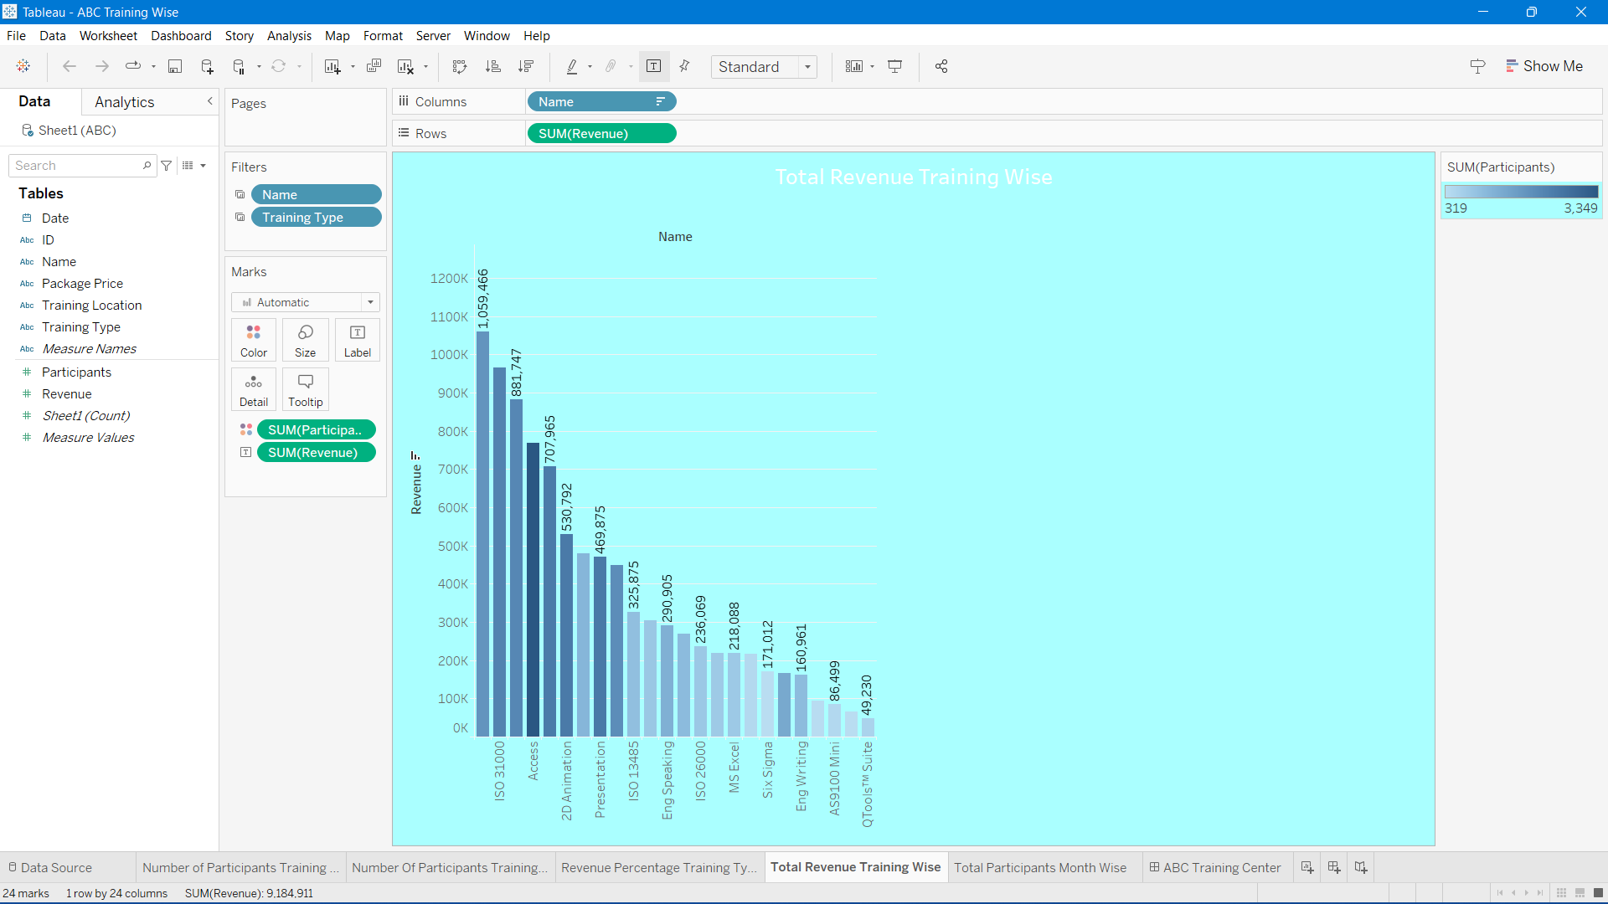

1. **Total Participants Month Wise:** This analysis result provides a breakdown of the number of participants enrolled in training programs on a monthly basis. It can help identify any seasonal trends or patterns in enrollment, which can aid in planning training schedules and resources. For example:

January: 2113 participants

February: 2519 participants

March: 3457 participants

April: 2977 participants

May: 4277 participants

June: 4767 participants

July: 6304 participants

August: 4857 participants

September: 846 participants

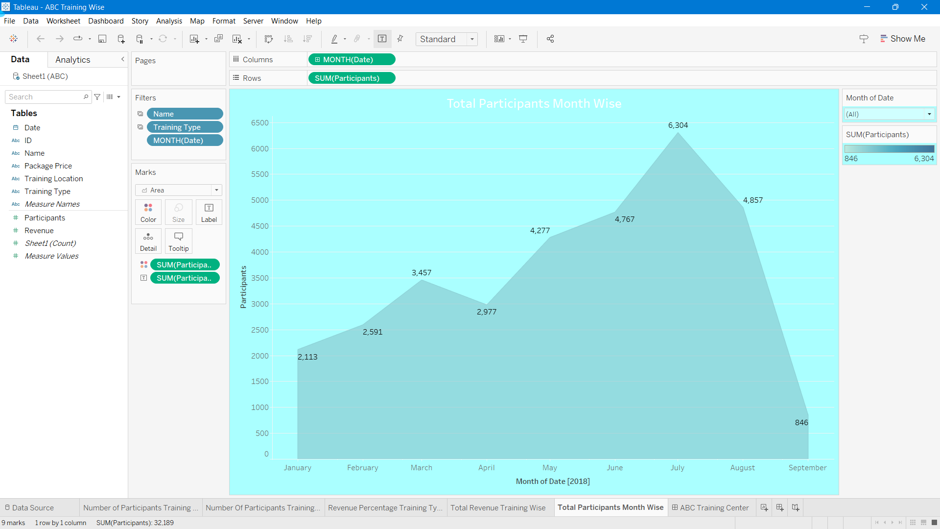

These analysis results can provide valuable insights into the performance and trends of training programs, which can be used for strategic decision-making, resource allocation, and overall program improvement.

Visualization

List Of Analysis With Result

* The number of students in Direct is 47.712% of total students and Online is 52.288% of total students and the difference is 543 which means in direct the number of students is more.
* The number of participants in Access is the maximum, which is 3349, and in Photoshop is minimum which is 319 of all technologies.
* The total training revenue in direct is 64.21% of total revenue and online is 35.79% of total revenue which means the direct type of revenue is more than online.
* The total training revenue in ISO 14000 is the maximum, which is $1059466, and QTools suit is $49230 which is minimum from different technologies.
* The number of participants in July is the maximum, which is 6304, and in September is minimum which is 846 from January to September.

# Future Scope

Tableau, being a leading data visualization and business intelligence tool, has a bright future with several potential areas of growth and development. Here are some future scope possibilities for Tableau:

* Advanced Analytics: Tableau has been expanding its capabilities in advanced analytics, including machine learning and predictive analytics. In the future, we can expect Tableau to further enhance its integration with advanced analytics tools and provide more built-in machine learning and predictive analytics features. This could enable users to gain deeper insights and make data-driven predictions directly within Tableau dashboards.
* Cloud-Based Solutions: Cloud computing is a rapidly growing field, and Tableau has been investing in cloud-based solutions, such as Tableau Online and Tableau Server on the cloud. In the future, we can expect Tableau to continue focusing on cloud-based offerings, providing more seamless integration with popular cloud platforms like AWS, Azure, and Google Cloud, and offering enhanced scalability, flexibility, and collaboration features.
* Mobile Analytics: Mobile devices are becoming increasingly popular for accessing data and insights on the go. In the future, Tableau is likely to enhance its mobile capabilities, providing more intuitive and interactive mobile dashboards, optimized for smaller screens, and leveraging the latest mobile technologies for improved performance and user experience.
* Augmented and Virtual Reality: Augmented reality (AR) and virtual reality (VR) are emerging technologies that have the potential to transform the way we interact with data and visualizations. Tableau may explore incorporating AR and VR capabilities in its dashboards, allowing users to visualize data in immersive virtual environments or overlay data insights on the real world.
* Natural Language Processing: Natural language processing (NLP) is an area of artificial intelligence that enables machines to understand and analyze human language. Tableau could potentially integrate NLP capabilities to allow users to query and analyze data using natural language commands, making data analysis more accessible and intuitive for non-technical users.
* Data Storytelling: Data storytelling is a powerful technique for communicating insights and findings from data analysis. Tableau may further enhance its data storytelling capabilities, providing more interactive and dynamic storytelling features, allowing users to create compelling narratives and presentations using their data visualizations.
* Collaborative Analytics: Collaboration is a key aspect of data analysis and decision-making in organizations. Tableau may continue to enhance its collaborative analytics features, enabling users to collaborate in real-time, share insights, and work together on data projects, both within Tableau itself and with other external tools and platforms.
* Industry-Specific Solutions: Tableau has already developed industry-specific solutions for various sectors, such as healthcare, finance, and retail. In the future, we can expect Tableau to continue developing more industry-specific solutions, catering to the unique data analysis and visualization needs of different industries.

These are just some of the potential future scope possibilities for Tableau. As data analysis and visualization continue to evolve, Tableau is likely to adapt and innovate to meet the changing needs of businesses, organizations, and users, and remain at the forefront of the data visualization and business intelligence landscape.

# References

* *Tableau's Official Website: The official website of Tableau (https://www.tableau.com/) provides comprehensive information about Tableau's products, features, use cases, customer stories, and resources such as documentation, tutorials, and webinars.*
* *Tableau Community: The Tableau Community (https://community.tableau.com/) is a vibrant online forum where Tableau users, experts, and enthusiasts share their knowledge, best practices, tips, and tricks. It's a great resource for learning from the Tableau community and staying updated with the latest trends and developments.*
* *Tableau Help Documentation: Tableau's official documentation (https://help.tableau.com/current) offers detailed guides, tutorials, and reference materials on various Tableau features, functions, and usage scenarios. It's a valuable resource for understanding the technical aspects of Tableau and its capabilities.*
* *Tableau Blog: Tableau's official blog (https://www.tableau.com/about/blog) features articles, case studies, and insights on Tableau's products, features, use cases, and best practices. It's a great source of inspiration and learning from Tableau experts and practitioners.*
* *Tableau Whitepapers and Research Papers: Tableau publishes whitepapers and research papers on various topics related to data visualization, analytics, and business intelligence. These papers provide in-depth insights, best practices, and case studies on how Tableau is used in different industries and use cases.*

# Bibliography

* **Google**
* **Kaggle website**
* **Tableau Software. (n.d.). Tableau: Business Intelligence and Analytics Software. Retrieved from https://www.tableau.com/**