🎓 AI Study Buddy
Cognitive Multimodal RAG Scholar Platform — System Architecture & Technical Specification
Version: 1.0.0 | Status: Production Ready | Architecture: 5-Tier Hybrid Cloud (Render + Vercel + Neon)

1. Executive Summary & Core Platform Mission
AI Study Buddy is an enterprise-grade, privacy-first Cognitive Scholar and Multi-Modal Retrieval-Augmented Generation (RAG) platform. Designed for university scholars, students, and research professionals, the platform transforms unstructured academic artifacts—including complex PDF research manuscripts, multi-page textbooks, Microsoft Word documents, audio lecture recordings, and diagram images—into isolated vector memories.
The system delivers real-time contextual knowledge retrieval, automated hierarchical chapter taxonomy, diagnostic Bloom's Taxonomy active-recall quizzes, Socratic multilingual voice tutoring (English, Hindi, Hinglish), Previous Year Question (PYQ) mock exam synthesis with Microsoft Word (.docx) export, and high-resolution academic concept schematics.

2. System Architecture Blueprint
The following high-resolution blueprint illustrates the complete five-tier architectural design and bidirectional data flows of the AI Study Buddy platform:
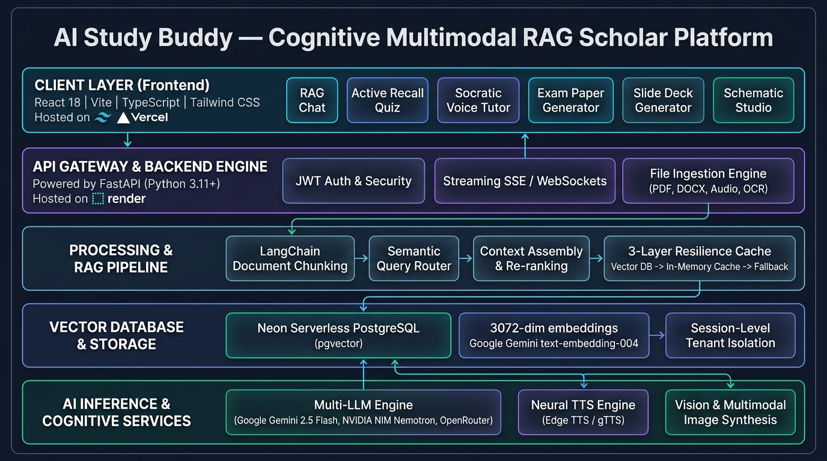
Figure 1: AI Study Buddy 5-Tier System Architecture Blueprint (Client, Gateway, RAG Pipeline, Neon PGVector, Multi-Provider AI)

3. Architectural Tiers & Component Specifications

Tier 1: Client Application Layer (Frontend SPA)
• Framework & Tooling: Built with React 18.3, TypeScript 5.9, and Vite 7.2, deployed on Vercel Edge Network for sub-100ms global delivery.
• Academic Design System: Styled using Tailwind CSS with custom academic palette (#FAF8F5 warm paper light mode, #050506 deep OLED dark mode), Lucide React iconography, and custom audio chime haptic feedback.
• Context Providers: AuthContext manages JWT access token lifecycle and user state. ThemeContext controls theme switching with seamless CSS variable reactivity.
• Interactive Workspaces: Includes dedicated tabs for Hierarchical Summaries, RAG Chat with Page Citations, Bloom's Active Recall Quiz, Socratic Voice Tutor with audio scrub bar, PYQ Exam Paper Generator, PowerPoint Deck Generator, and Concept Schematic Studio.

Tier 2: API Gateway & Core Engine (FastAPI)
• Engine Architecture: Asynchronous FastAPI running on Python 3.11+ managed by Uvicorn, containerized for automated zero-downtime deployment on Render.
• Security & Authentication: Stateless JWT Bearer token authentication (HS256) paired with PBKDF2-HMAC-SHA256 password hashing. Session isolation ensures users only access their authorized vector spaces.
• Robust Cross-Origin Architecture: Dynamic regex-based CORS middleware (allow_origin_regex) allows credentials and authenticated headers across all dynamic Vercel preview and production domains.

Tier 3: Ingestion Engine & Smart Deduplication Pipeline
• Multi-Format File Ingestion: Extracts text from PDF documents with page numbers ([Page X of Y]) via PyPDF, Microsoft Word (.docx) via python-docx, UTF-8 text/markdown/code/CSV, Image OCR via Google Gemini Vision, and Audio lectures via Gemini Audio transcription.
• Smart Vector Deduplication: Prior to chunking or embedding, the ingestion service cross-references existing document filenames indexed in PGVector for the active session. If a file is already present, embedding calculation is skipped to preserve API tokens and prevent duplicate retrieval chunks.
• Chunking Strategy: LangChain RecursiveCharacterTextSplitter with chunk_size=1000 characters and chunk_overlap=200 characters, tagging each vector with session_id and source filename.

Tier 4: Vector Database & 3-Layer Resilience Engine
• Neon Serverless PostgreSQL + pgvector: Vector embeddings are stored in Neon cloud PostgreSQL with the pgvector extension. Lifespan startup hooks automatically execute CREATE EXTENSION IF NOT EXISTS vector.
• High-Precision Embeddings: Generated using Google Gemini models/gemini-embedding-001, producing 3072-dimensional vector embeddings for superior semantic nuance.
• 3-Layer Retrieval Resilience Cascade: 1) Layer 1: Cosine similarity vector search via PGVector with session metadata filters. 2) Layer 2 (Hot Failover): In-memory session store (_MEMORY_STORE) if database connection pools encounter serverless cold starts. 3) Layer 3 (Deep Fallback): Direct database SQL chunk retrieval from langchain_pg_embedding to eliminate any possibility of query failure.

Tier 5: Multi-Provider AI Inference Hub & Speech Engine
• Tri-Engine Dynamic LLM Switching: Real-time switching between Google Gemini 2.5 Flash, NVIDIA NIM (Nemotron 3.5 Bolt), and OpenRouter (LLaMA 3.3 70B, DeepSeek Chat). If the primary provider encounters rate limits, an automated cascade switches to the next available provider.
• Dual-Layer Speech Engine: Voice explanations are generated using Microsoft Edge Neural TTS 7.3.1 (en-US-AvaNeural for English, hi-IN-SwaraNeural for Hindi, en-IN-NeerjaNeural for Hinglish) with instant fallback to Google Translate TTS (gTTS).
• Document & Presentation Generation: Automated generation of styled Microsoft Word (.docx) mock exam papers via python-docx and 16:9 widescreen Microsoft PowerPoint (.pptx) decks via python-pptx.

4. Database Schema & Data Models
Table 1: 'users' Entity Specification
Column | Data Type | Constraints | Description
id | VARCHAR | PK, UUIDv4 | Unique account identifier
email | VARCHAR | UNIQUE, INDEX, NOT NULL | User email address for login
hashed_password | VARCHAR | NOT NULL | PBKDF2-HMAC-SHA256 password hash
created_at | DATETIME | DEFAULT UTC NOW | Account creation timestamp
updated_at | DATETIME | ON UPDATE UTC NOW | Last profile update timestamp

Table 2: 'study_sessions' Entity Specification
Column | Data Type | Constraints | Description
id | VARCHAR | PK, UUIDv4 | Unique session identifier
user_id | VARCHAR | INDEX, NOT NULL | Owner user foreign identifier
title | VARCHAR | DEFAULT 'New Session' | Display title (auto-named from first upload)
created_at | DATETIME | DEFAULT UTC NOW | Session initialization timestamp
updated_at | DATETIME | ON UPDATE UTC NOW | Last modification timestamp

5. Core REST API Endpoint Reference
Table 3: Primary API Endpoints and Functional Specifications
Method | Endpoint Route | Parameters / Body | Functional Description
POST | /api/auth/register | email, password | Registers user and issues signed JWT Bearer token
POST | /api/auth/login | email, password | Authenticates user and returns JWT token
POST | /api/session/create | title, user_id | Initializes a new isolated study session in Neon DB
GET | /api/session/history | Authorization Header | Lists all study sessions for current user
DELETE | /api/session/{id} | session_id | Purges session and cascades vector deletion in PGVector
POST | /api/upload/ | files, session_id | Ingests files with duplicate detection into session vector memory
GET | /api/quiz/documents/{id} | session_id | Returns list of indexed document names in session
POST | /api/chat/ | query, session_id | Conversational RAG query returning answers with source page numbers
POST | /api/quiz/summary | session_id, summary_type | Generates brief or detailed structured study notes
POST | /api/quiz/generate | session_id, difficulty, num_q | Generates calibrated Bloom's Taxonomy MCQs
POST | /api/quiz/analyze | questions, user_answers | Evaluates student answers and returns remedial weak spots guide
POST | /api/quiz/pyq-generator | session_id, pyq_file | Analyzes exam paper pattern and generates customized mock paper
POST | /api/slides/generate | session_id, topic, num_slides | Generates and returns downloadable PowerPoint presentation (.pptx)

6. Local Setup & Execution Guide
Follow these instructions to run both services locally on developer workstations:
Step 1: Backend Setup (FastAPI)
cd backend
python -m venv venv
# On Windows:
venv\Scripts\activate
# On Linux/macOS: source venv/bin/activate
pip install -r requirements.txt
cp .env.example .env
python run.py

Step 2: Frontend Setup (React 18 + Vite)
cd frontend
npm install
npm run dev

7. Production Deployment Specifications
• Backend Web Service (Render): Configured with render.yaml for zero-downtime auto-deploy on push to main. Build command: pip install -r requirements.txt; Start command: uvicorn app.main:app --host 0.0.0.0 --port $PORT; Health check: /health.
• Frontend SPA (Vercel): Configured with vercel.json. Build command: cd frontend && npm install && npm run build; Output directory: frontend/dist. SPA rewrites route all paths to /index.html.
• Managed Database (Neon PostgreSQL): Serverless PostgreSQL with connection pooling (pool_recycle=240s, pool_size=10, max_overflow=20) to handle scale with zero server maintenance.

