**VISVESVARAYA TECHNOLOGICAL UNIVERSITY**

Belgaum, Karnataka

**DATABASE LABORATORY LABORATORY MANUAL 16MCA28**



**II SEMESTER - 2017**

Prepared By:

Nagesh B S Asst. Prof. Dept. of MCA RNSIT

Phone:9844032238

Department of MCA



ESTD: 2001

***An Institution with a difference***

# Program 1

**Create the following tables with properly specifying Primary keys, Foreign keys and solve the following queries.**

**BRANCH**(**Branchid**,Branchname,HOD) **STUDENT**(**USN**,Name,Address,Branchid,sem) **BOOK(Bookid,**Bookname,Authorid,Publisher,Branchid) **AUTHOR(Authorid**,Authorname,Country,age) **BORROW(**USN,Bookid,Borrowed_Date)

# Queries:

1. List the details of Students who are all Studying in 2nd sem MCA.
2. List the students who are not borrowed any books.
3. Display the USN, Student name, Branch_name, Book_name, Author_name , Books_Borrowed_Date of 2nd sem MCA Students who borrowed books.
4. Display the number of books written by each Author.
5. Display the student details who borrowed more than two books.
6. Display the student details who borrowed books of more than one Author.
7. Display the Book names in descending order of their names.
8. List the details of students who borrowed the books which are all published by the same Publisher.

**BRANCH**

|  |  |  |
| --- | --- | --- |
| **Branchid** | **Branchname** | **HOD** |

**STUDENT**



**Bookid**

**USN**

**BORROW**

|  |  |  |  |  |
| --- | --- | --- | --- | --- |
| **USN** | **Name** | **Address** | **Branchid** | **sem** |

**BOOK**

|  |  |  |  |  |
| --- | --- | --- | --- | --- |
| **Bookid** | **Bookname** | **Authorid** | **Publisher** | **Branchid** |

**AUTHOR**

|  |  |  |  |
| --- | --- | --- | --- |
| **Authorid** | **Authorname** | **Country** | **age** |

**Borrowed_Date**

create table branch (branchid int primary key,

bname varchar(10), hod varchar(10));

create table student

(usn varchar(10) primary key, name varchar(10),

addr varchar(15),

branchid int references branch(branchid), sem int);

create table book (bookid int primary key,

bname varchar(10), author

create table author (authorid int primary key,

aname varchar(10), country varchar(10), age int);

create table book (bookid int primary key, bname varchar(10),

authorid int references author(authorid), publisher varchar(10),

branchid int references branch(branchid));

create table borrow

(usn varchar(10) references student(usn), bookid int references book(bookid), borrowdate date);

SQL> select * from branch;

|  |  |  |  |  |
| --- | --- | --- | --- | --- |
| BRANCHID |  | BNAME |  | HOD |
| 1 |  | mca |  | npk |
| 2 |  | mba |  | bojanna |
| 3 |  | cse |  | gtr |
| 4 |  | ise |  | sudhamani |
| 5 |  | electrical |  | sumathi |

|  |  |  |  |  |  |  |
| --- | --- | --- | --- | --- | --- | --- |
| SQL> USN | select * from  NAME | student;  ADDR |  | BRANCHID |  | SEM |
| 1rn1 | harish | bangalore |  | 1 |  | 2 |
| 1rn2 | bharath | mysore |  | 2 |  | 3 |
| 1rn3 | kiran | delhi |  | 3 |  | 6 |
| 1rn4 | mahi | chennai |  | 4 |  | 7 |
| 1rn5 | krishna | hubli |  | 5 |  | 4 |

SQL> select * from book;

|  |  |  |  |  |  |  |  |  |
| --- | --- | --- | --- | --- | --- | --- | --- | --- |
| BOOKID |  | BNAME |  | AUTHORID |  | PUBLISHER |  | BRANCHID |
| 1111 |  | c prog |  | 123 |  | pearson |  | 1 |
| 2222 |  | dbms |  | 124 |  | mgrawhill |  | 2 |
| 3333 |  | oops |  | 125 |  | sapna |  | 3 |
| 4444 |  | unix |  | 126 |  | subhash |  | 4 |
| 5555 |  | cprog |  | 127 |  | pearson |  | 5 |

SQL> select * from author;

|  |  |  |  |  |  |  |
| --- | --- | --- | --- | --- | --- | --- |
| AUTHORID |  | ANAME |  | COUNTRY |  | AGE |
| 123 |  | navathe |  | india |  | 55 |
| 124 |  | ritche |  | uk |  | 44 |
| 125 |  | RAMKRISHNA |  | india |  | 55 |
| 126 |  | sumitabha |  | india |  | 38 |
| 127 |  | dennis |  | usa |  | 66 |

SQL> select * from borrow;

USN BOOKID BORROWDAT

1rn1 2222 10-JAN-00

1rn1 3333 05-MAR-16

1rn3 5555 01-JUN-10

1rn5 2222 19-MAY-00

1rn2 1111 22-FEB-15

### Query 1.

select * from student where sem=2 and branchid in (select branchid from branch where bname='mca')

USN NAME ADDR BRANCHID SEM

1rn1 harish bangalore 1 2

Query 2.

select * from student where usn not in (select usn from borrow); USN NAME ADDR BRANCHID SEM

1rn4 mahi chennai 4 7

### Query 3.

select student.usn ,student.name,branch.bname, book.bname, aname, borrowdate from student , branch, book, author, borrow where student.usn=borrow.usn and borrow.bookid=book.bookid and book.authorid =author.authorid and student.branchid=branch.branchid and student.sem=2 and branch.bname='mca';

|  |  |  |  |  |  |  |  |  |  |  |
| --- | --- | --- | --- | --- | --- | --- | --- | --- | --- | --- |
| USN |  | NAME |  | BNAME |  | BNAME |  | ANAME |  | BORROWDAT |
| 1rn1 |  | harish |  | mca |  | dbms |  | ritche |  | 10-JAN-00 |
| 1rn1 |  | harish |  | mca |  | oops |  | RAMKRISHNA |  | 05-MAR-16 |
| **Query 4.** |  |  |  |  |  |  |  |  |  |  |

select count(*) , authorid from book group by authorid;

|  |  |  |
| --- | --- | --- |
| COUNT(*) |  | AUTHORID |
| 1 |  | 123 |
| 1 |  | 125 |
| 1 |  | 124 |
| 1 |  | 126 |
| 1 |  | 127 |

### Query 5.

select * from student where usn in ( select usn from borrow group by usn having count(usn) >=2);

USN NAME ADDR BRANCHID SEM

1rn1 harish bangalore 1 2

### Query 6.

select * from student s where exists (select br.usn from borrow br join book bk on br.bookid=bk.bookid where br.usn=s.usn group by usn having count(distinct authorid)>1);

|  |  |  |  |  |  |  |  |  |  |
| --- | --- | --- | --- | --- | --- | --- | --- | --- | --- |
| USN |  |  | NAME |  | ADDR |  | BRANCHID |  | SEM |
| 1rn1  **Query** | **7.** |  | harish |  | bangalore |  | 1 |  | 2 |

select bname from book order by bname desc; BNAME

unix oops dbms cprog c prog

### Query 8.

select * from student s where exists (select usn , publisher from borrow join book on borrow.bookid=book.bookid where s.usn=borrow.usn group by usn having count(distinct publisher)=1);

USN NAME ADDR BRANCHID SEM

1rn2 bharath mysore 2 3

1rn3 kiran delhi 3 6

1rn5 krishna hubli 5 4

**Program 2**

## Design an ER-diagram for the following scenario, Convert the same into a relational model and

**then solve the following queries.**

Consider a Cricket Tournament “ABC CUP” organized by an organization. In the tournament there

are many teams are contesting each having a Teamid,Team_Name, City, a coach. Each team is uniquely identified by using Teamid. A team can have many Players and a captain. Each player is uniquely identified by Playerid, having a Name, and multiple phone numbers,age. A player represents only one team. There are many Stadiums to conduct matches. Each stadium is identified using Stadiumid, having a stadium_name,Address ( involves city,area_name,pincode).A team can play many matches. Each match played between the two teams in the scheduled date and time in the predefined Stadium. Each match is identified uniquely by using Matchid. Each match won by any of the one team that also wants to record in the database. For each match man_of_the match award given to a player.

## Queries:

1. Display the youngest player (in terms of age) Name, Team name , age in which he belongs of the tournament.
2. List the details of the stadium where the maximum number of matches were played.
3. List the details of the player who is not a captain but got the man_of _match award at least in two matches.
4. Display the Team details who won the maximum matches.
5. Display the team name where all its won matches played in the same stadium.

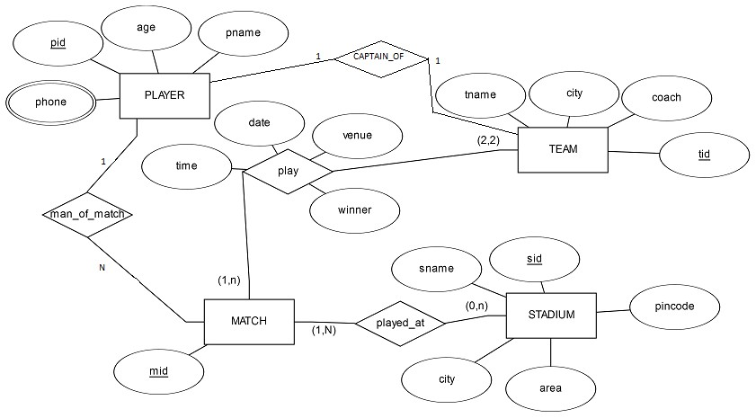

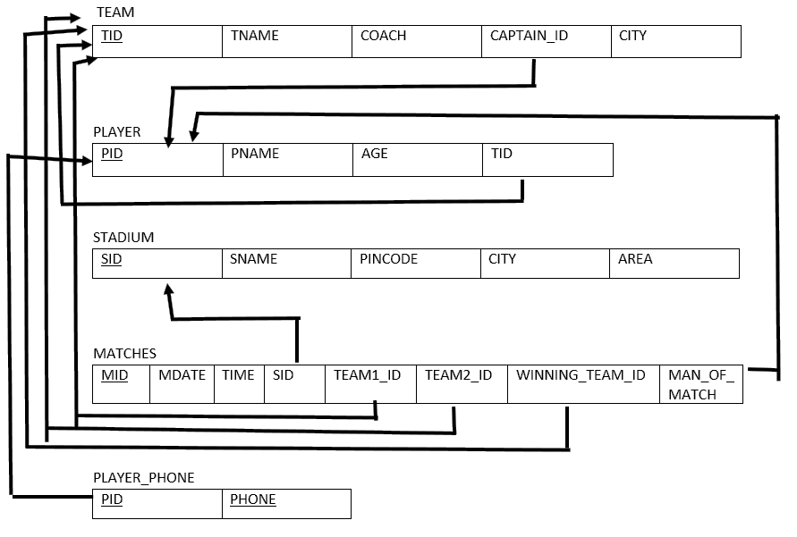

create table team

( tid int primary key, tname varchar(20), coach varchar(20), captain_pid int,

city varchar(20));

create table player

( pid int primary key, pname varchar(2),

age int,

tid int references team(tid))

create table stadium (sid int primary key, sname varchar(20),

picode number(8), city varchar(20), area varchar(20));

create table match (mid int primary key, mdate date,

time varchar(6),

sid int references stadium(sid), team1_id int references team(tid), team2_id int references team(tid),

winning_team_id int references team(tid),

man_of_match int references player(pid))

create table player_phone

( pid int references player(pid), phone int ,

primary key(pid,phone));

SQL> select * from team;

TID TNAME COACH CAPTAIN_PID CITY

* 1. rcb sunil 1 bangalore
  2. csk laxman 3 chennai
  3. royals singh 4 rajasthan
  4. daredevils sehwag 2 delhi

SQL> select * from player;

|  |  |  |  |  |  |  |  |
| --- | --- | --- | --- | --- | --- | --- | --- |
|  | PID PNAME | AGE |  | TID |  | | |
|  | 1 sachin | 33 |  | 123 |
|  | 2 dravid | 32 |  | 124 |
|  | 3 dhoni | 30 |  | 124 |
|  | 4 raina | 30 |  | 125 |
|  | 5 kohli | 23 |  | 126 |
| SQL> | select * from stadium; |  |  |  |
|  | SID SNAME | PICODE |  | CITY |  |  | AREA |
|  | 111 chinnaswamy | 56001 |  | bangalore |  |  | mg road |
|  | 222 kotla | 460009 |  | delhi |  |  | highway |
|  | 333 international | 38883 |  | chennai |  |  | tr nagar |
|  | 444 ksca | 560098 |  | bangalore |  |  | peenya |
|  | 555 csca | 567772 |  | cochin |  |  | beach road |
| SQL> | select * from match; |  |  |  |  |  |  |
| MID MDATE TIME SID TEAM1_ID TEAM2_ID WINNING_TEAM_ID MAN_OF_MATCH | | | | | | | |

|  |  |  |  |  |  |  |  |  |  |  |
| --- | --- | --- | --- | --- | --- | --- | --- | --- | --- | --- |
| 1 10-JAN-17 10am |  | 111 |  | 123 |  | 124 |  | 123 |  | 1 |
| 102 11-JAN-17 pm |  | 222 |  | 124 |  | 126 |  | 126 |  | 5 |
| 103 12-JAN-17 11am |  | 111 |  | 125 |  | 126 |  | 126 |  | 5 |
| 104 17-JAN-17 12pm |  | 111 |  | 125 |  | 123 |  | 123 |  | 1 |

SQL> select * from player_phone;

|  |  |  |
| --- | --- | --- |
| PID |  | PHONE |
| 1 |  | 998882928 |
| 2 |  | 877563733 |
| 2 |  | 988928822 |
| 3 |  | 877366383 |

# Query 1 :

Select pname, tname, age from player p, team t where p.tid=t.tid and age =(select min(age) from player);

PNAME TNAME AGE

kohli daredevils 23

# Query 2:

select * from stadium where sid in

(select sid from match group by sid having count(sid) = (select max(count(sid)) from match group by sid))

SID SNAME PICODE CITY AREA

111 chinnaswamy 56001 bangalore mg road

# Query 3:

select * from player where pid not in ( select captain_pid from team) and pid in (select man_of_match from match group by man_of_match having count(man_of_match)=2);

PID PNAME AGE TID

5 kohli 23 126

# Query 4:

select * from team where tid in (select winning_team_id from match group by winning_team_id having count(winning_team_id)= (select max(count(winning_team_id))from match group by winning_team_id))

TID TNAME COACH CAPTAIN_PID CITY

s

126 daredevils sehwag 2 delhi

# Query 5

select tname from team where tid in ( select winning_team_id from match group

by(winning_team_id,sid)

having count(*) in (select count(winning_team_id) from match group by winning_team_id))

TNAME

rcb

**Program 3**

**Consider the following Scenario and design an ER-Diagram, map the designed ER-diagram into a Relational model.** Consider an organization “ABC” having many employees. An employee works for one department. Each employee identified by using Empid, having Name, address ( described as House_no, city, district, state, pin code) and more than one phone numbers. Department identified by using Dno, having Dname, Dlocation. Each Department having a manager . Each department having many employees. There are many Projects , each project is controlled by the department. Each Project uniquely identified by Pno, having Project_name, Project_location. An employee works on many Projects. Number of hours per week worked on each project by an Employee also needs to be recorded in the database . A project is worked by many employees. Each employee supervised by the supervisor. Employee having many dependents. Dependents having the dependent_name, gender, age, address. Dependents are identified by Empid.

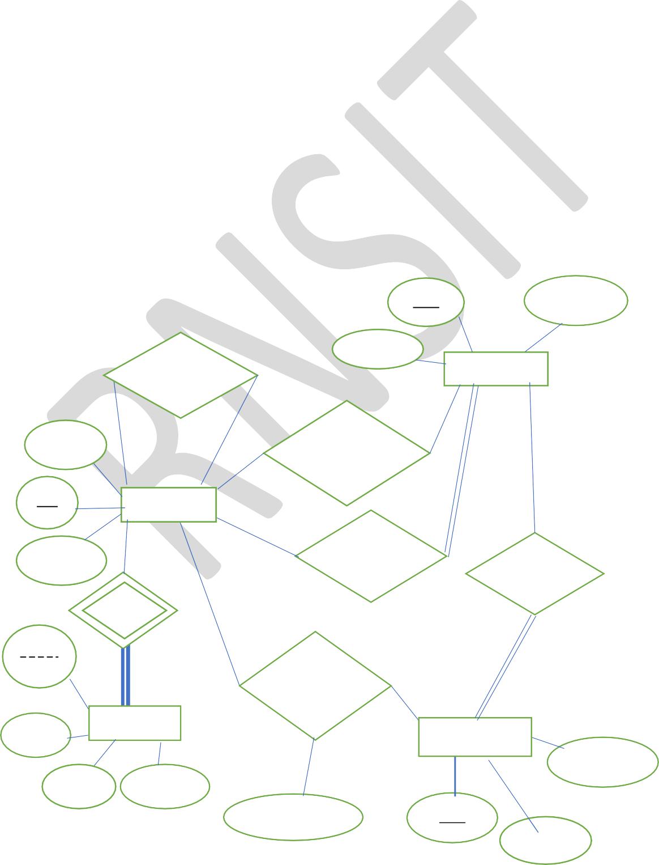**T1(Empid, Emp_Name,city, district, state, pin_code, phoneno, Dno,Dname,Dlocation, Dept_mgr_id, Pno, Project_name, Project_location, Number_of_Hours,Supervisor_Empid,**

**Dependent_name, gender, address) ,Deduce the above Relation T1 into the 3NF and then solve the following queries.**

**Queries:**

1. Display the details of the employees who are working on both the projects having project_no 5 and 10.
2. Display the details of employees having atleast two dependents.
3. Display the project name on which more number of employees are working.
4. Retrieve the employees who do not have any dependents.
5. Display the Employee details whose total number of hours per week working on various projects is maximum than all other employees.
6. create a view to display the number of employees working in each department.

dno dlocation

ename

SUPERVISES

1

1 M

dname

N

WORKSFOR

DEPARTMENT

1

eid address

EMPLOYEE

1

1

1

HAS

MANAGES

1

CONTROL

name

gender

N M

DEPENDENT

age address

WORKSON

1

N

PROJECT

plocation

No_of_hours pno

pname

Nagesh B S, Asst. Prof., Dept. of MCA, RNSIT, Bengaluru phone:9844032238

SQL> create table employee(eid int primary key, ename varchar(10),

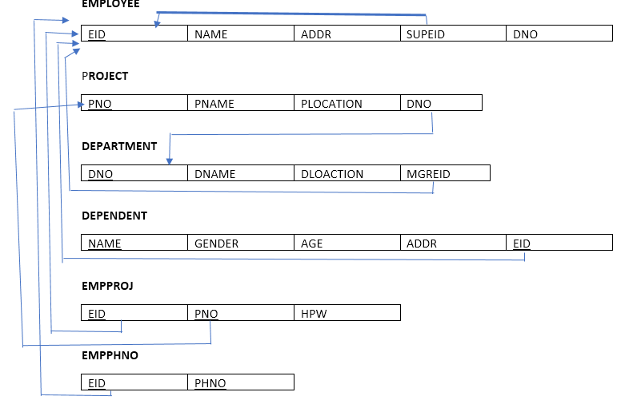

address varchar(10), supeid int,

dno int);

SQL> alter table employeee add constraint fk_supeid foreign key(supeid) references employeee(eid));

SQL> create table department(dno int primary key, dname varchar(20),

dlocation varchar(10),

mgrid int references employeee(eid));

SQL> alter table employeee add constraint fk_dno foreign key(dno) references department(dno));

SQL> create table project(pno int primary key, pname varchar(20),

plocation varchar(20),

dno int references department(dno));

SQL> create table dependent(name varchar(20), gender varchar(6),

age int,

addr varchar(20),

eid int references employeee(eid), primary key(name,eid));

SQL> create table empproj(eid int references employeee(eid), pno int references project(pno),

hpw int,

primary key(eid,pno));

SQL> create table empphno(eid int references employeee(eid), phno int,

primary key(eid,phno));

SQL> desc employee;

Name Null? Type

EID NOT NULL NUMBER(38)

NAME VARCHAR2(30)

ADDRESS VARCHAR2(30)

SUPEID NUMBER(38)

DNO NUMBER(38)

SQL> desc department;

Name Null? Type

DNO NOT NULL NUMBER(38)

DNAME VARCHAR2(20)

DLOCATION VARCHAR2(10)

MGRID NUMBER(38)

SQL> desc project;

Name Null? Type

PNO NOT NULL NUMBER(38)

PNAME VARCHAR2(20)

PLOCATION VARCHAR2(20)

DNO NUMBER(38)

SQL> desc dependent;

Name Null? Type

NAME NOT NULL VARCHAR2(20)

GENDER VARCHAR2(6)

AGE NUMBER(38)

ADDR VARCHAR2(20)

EID NOT NULL NUMBER(38)

SQL> desc empproj;

Name Null? Type

EID NOT NULL NUMBER(38)

PNO NOT NULL NUMBER(38)

HPW NUMBER(38)

SQL> desc empphno;

Name Null? Type

EID NOT NULL NUMBER(38)

PHNO NOT NULL NUMBER(38)

SQL> select * from employee;

EID NAME ADDRESS SUPEID DNO

|  |  |  |  |  |  |  |
| --- | --- | --- | --- | --- | --- | --- |
| 1 priya |  | bangalore |  | 5 |  | 200 |
| 2 sindu |  | davangere |  | 1 |  | 400 |
| 3 teertha |  | sirsi |  | 2 |  | 300 |

|  |  |  |
| --- | --- | --- |
| 4 spurthy | chikmangalore 3 | 200 |
| 5 raghavi | bangalore 4 | 500 |

SQL> select * from department;

|  |  |  |  |  |  |  |
| --- | --- | --- | --- | --- | --- | --- |
| DNO |  | DNAME |  | DLOCATION |  | MGRID |
| 100 |  | mca |  | blore |  | 4 |
| 200 |  | mba |  | mlore |  | 5 |
| 300 |  | cse |  | mumbai |  | 2 |
| 400 |  | mech |  | delhi |  | 3 |
| 500 |  | ece |  | chennai |  | 1 |

SQL> select * from project;

|  |  |  |  |  |  |  |
| --- | --- | --- | --- | --- | --- | --- |
| PNO |  | PNAME |  | PLOCATION |  | DNO |
| 111 |  | student |  | blore |  | 100 |
| 222 |  | library |  | madurai |  | 300 |
| 333 |  | hotel |  | chennai |  | 100 |
| 444 |  | railway |  | delhi |  | 500 |
| 555 |  | airline |  | ranchi |  | 400 |
| 5 |  | sp |  | mysore |  | 100 |
| 10 |  | raji |  | kolkata |  | 200 |

SQL> select * from dependent;

|  |  |  |  |  |  |  |
| --- | --- | --- | --- | --- | --- | --- |
| NAME | GENDER | AGE |  | ADDR |  | EID |
| priya | f | 20 |  | mumbai |  | 1 |
| divya | f | 19 |  | blore |  | 2 |
| priyanka | f | 18 |  | madurai |  | 3 |
| sarvan | m | 24 |  | delhi |  | 3 |
| jothi | f | 40 |  | madurai |  | 5 |
| lakshmi | f | 23 |  | udupi |  | 1 |
| SQL> select | * from empproj; |  |  | | | |
| EID | PNO | HPW |
| 1 | 111 | 5 |
| 3 | 222 | 4 |
| 2 | 333 | 7 |
| 4 | 111 | 10 |
| 5 | 444 | 20 |
| 1 | 5 | 4 |
| 1 | 10 | 8 |
| SQL> select | * from empphno; |  |
| EID | PHNO |  |
| 3 | 9025678934 |  |
| 4 | 9807654323 |  |
| 5 | 8907654323 |  |

2 7896897654

1 9087654321

**Query 1.** select * from employee where eid in(select w1.eid from empproj w1,empproj w2 where w1.pno=5 and w2.pno=10 and w1.eid=w2.eid);

EID NAME ADDRESS SUPEID DNO

1 priya bangalore 5 200

**Query 2.** select * from employee where eid in(select eid from dependent group by eid having count(eid)>=2);

EID NAME ADDRESS SUPEID DNO

1 priya bangalore 5 200

1. teertha sirsi 2 300

**Query 3.** select pname from project where pno in(select pno from empproj group by pno having count(pno)=(select max(count(pno)) from empproj group by pno))

PNAME

student

**Query 4.** select * from employee where eid not in (select eid from dependent);

EID NAME ADDRESS SUPEID DNO

1. spurthy chikmangalore 3 200

**Query 5.** select * from employee where eid in(select eid from empproj group by eid having sum(hpw)= 2 (select max(sum(hpw)) from empproj group by eid));

EID NAME ADDRESS SUPEID DNO

1. raghavi bangalore 4 500

### Query 6.

create view empcount(dno,no_of_emp) as select dno,count(dno) from employeee group by dno;

SQL> select * from empcount; DNO NO_OF_EMP

|  |  |  |
| --- | --- | --- |
| 200 |  | 2 |
| 300 |  | 1 |
| 400 |  | 1 |
| 500 |  | 1 |

# Program 4

Design an ER-diagram for the following scenario, Convert the same into a relational model, normalize Relations into a suitable Normal form and then solve the following queries. A country can have many Tourist places . Each Tourist place is identified by using tourist_place_id, having a name, belongs to a state, Number of kilometers away from the capital city of that state,history. There are many Tourists visits tourist places every year. Each tourist is identified uniquely by using Tourist_id, having a Name, age, Country and multiple emailids. A tourist visits many Tourist places, it is also required to record the visted_date in the database. A tourist can visit aTourist place many times at different dates. A Tourist place can be visited by many tourists either inthe same date or at different dates.

Queries:

1. List the state name which is having maximum number of tourist places.
2. List details of Tourist place where maximum number of tourists visited.
3. List the details of tourists visited all tourist places of the state “KARNATAKA”.
4. Display the details of the tourists visited at least one tourist place of the state, but visited all states tourist places.
5. Display the details of the tourist place visited by the tourists of all country.

COUNTRY AGE KILOMETERS VDATE

TOURIST_PLACE

HISTORY

STATE

TOURIST

M N

VISITS

TID TNAME

TPID

TP_NAME

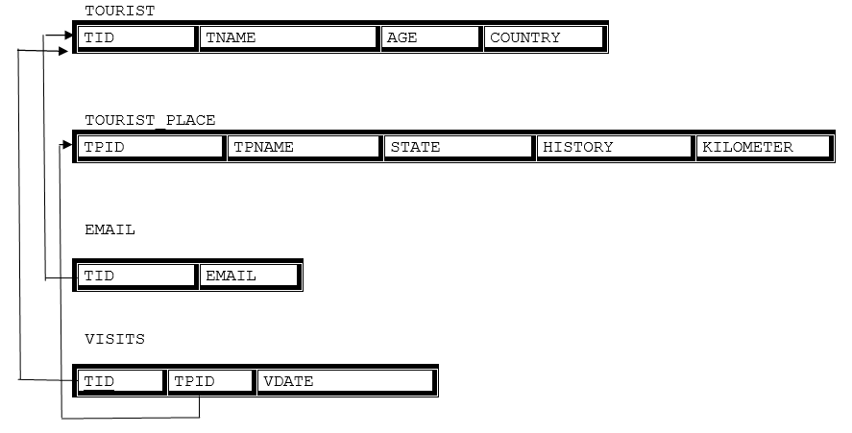

create table tourist_place (tpid number primary key, history varchar(20), kilometers number(3)

,state varchar(20), tpname varchar(20));

create table tourist(tid number primary key, country varchar(20),

age number,

tname varchar(20));

create table visits

(tpid number(3) references tourist_place(tpid), tid number references tourist(tid),

vdate date,

primary key(tpid,tid));

create table email

(tid number references tourist(tid), email varchar(20),primary key(tid,email));

desc tourist_place;

Name Null? Type

TPID NOT NULL NUMBER

HISTORY VARCHAR2(20)

KILOMETERS NUMBER

STATE VARCHAR2(20)

TPNAME VARCHAR2(20)

desc tourist;

Name Null? Type

TID NOT NULL NUMBER

COUNTRY VARCHAR2(20)

AGE NUMBER

TNAME VARCHAR2(20)

desc visits;

Name Null? Type

TPID NOT NULL NUMBER

TID NOT NULL NUMBER

VDATE DATE

desc email;

Name Null? Type

TID NUMBER

EMAIL VARCHAR2(20)

SQL> insert into tourist_place(tpid,history,kilometers,state,tpname)values('11','beauty',' 160','karnataka','ooty');

1 row created.

SQL> select * from tourist_place;

TPID HISTORY KILOMETERS STATE TPNAME

|  |  |  |  |  |  |  |
| --- | --- | --- | --- | --- | --- | --- |
| 11 beauty |  | 160 |  | karnataka |  | ooty |
| 12 monuments |  | 270 |  | kerala |  | beluru |
| 13 beach |  | 360 |  | tamilnadu |  | marina |

SQL> insert into tourist(tid,country,age,tname)values('22','india','34','prakash');

1 row created.

SQL> select * from tourist;

TID COUNTRY AGE TNAME

22 india 34 prakash

23 orissa 28 bhanu

24 india 30 nagesh

SQL> insert into visits values('&tpid','&tid','&vdate'); Enter value for tpid: 12

Enter value for tid: 23

Enter value for vdate: 13-nov-2014

old 1: insert into visits values('&tpid','&tid','&vdate') new 1: insert into visits values('12','23','13-nov-2014')

1 row created.

SQL> select * from visits;

|  |  |  |  |  |
| --- | --- | --- | --- | --- |
| TPID |  | TID |  | VDATE |
| 12 |  | 23 |  | 13-NOV-14 |
| 11 |  | 24 |  | 24-JUN-13 |
| 13 |  | 22 |  | 25-SEP-11 |
| 11 |  | 23 |  | 23-FEB-10 |
| 13 |  | 23 |  | 12-JAN-10 |
| 14 |  | 24 |  | 10-JAN-17 |

SQL> insert into email values('&tid','&email'); Enter value for tid: 23

Enter value for email: [bhanu12@gmail.com](mailto:bhanu12@gmail.com)

old 1: insert into email values('&tid','&email')

new 1: insert into email values('23','bhanu12@gmail.com')

1 row created.

SQL> select * from email; TID EMAIL

23 [bhanu12@gmail.com](mailto:bhanu12@gmail.com)

22 [prakash242@gmail.com](mailto:prakash242@gmail.com)

24 [nageshh@gmail.com](mailto:nageshh@gmail.com)

**Query 1:**

select state from tourist_place group by state having count(state)=(select max(count(state)) from tourist_place group by state);

STATE

karnataka

**query 2:**

select * from tourist_place where tpid in (select tpid from visits group by tpid having count(tpid)= (select max(count(tpid)) from visits group by tpid));

TPID HISTORY KILOMETERS STATE TPNAME

|  |  |  |  |  |  |  |
| --- | --- | --- | --- | --- | --- | --- |
| 11 |  | beauty |  | 160 karnataka |  | ooty |
| 13 |  | beach |  | 360 tamilnadu |  | marina |

**query 3:**

select * from tourist t where t.tid in (select tid from visits join tourist_place on

visits.tpid=tourist_place.tpid where state='karnataka'

group by tid having count(state) in (select count(state ) from tourist_place where state='karnataka') );

TID COUNTRY AGE TNAME

24 india 30 nagesh

**query 4:**

select * from tourist t where t.tid in (select tid from visits join tourist_place on visits.tpid=tourist_place.tpid

group by tid having count(distinct state)

in (select count(distinct state ) from tourist_place) ); TID COUNTRY AGE TNAME

23 orissa 28 bhanu

**query 5:**

select * from tourist_place where tpid in (

select tpid from visits join tourist on visits.tid=tourist.tid group by tpid having count(distinct country)=

(select count(distinct country) from tourist));

TPID HISTORY KILOMETERS STATE TPNAME

|  |  |  |  |  |
| --- | --- | --- | --- | --- |
| 11 beauty |  | 160 karnataka |  | ooty |
| 13 beach |  | 360 tamilnadu |  | marina |

Program 5

### Design an ER-diagram for the following scenario, Convert the same into a relational model, normalize Relations into a suitable Normal form and then solve the following queries.

A country wants to conduct an election for the parliament. A country having many constituencies.

Each constituency is identified uniquely by Constituency_id, having the Name, belongs to a state, Number_of_voters. A constituency can have many voters. Each voter is uniquely identified by using Voter_id, having the Name, age, address (involves Houseno, city, state, pincode). Each voter belongs to only one constituency. There are many candidates contesting in the election. Each candidates are uniquely identified by using candidate_id, having Name, phone_no, age, state. A candidate belongs to only one party. There are many parties. Each party is uniquely identified by using Party_id, having Party_Name, Party_symbol. A candidate can contest from many constituencies under a same party. A party can have many candidates contesting from different constituencies. No constituency having the candidates from the same party. A constituency can have many contesting candidates belongs to different parties. Each voter votes only one candidate of his/her constituency.

### Queries:

1. List the details of the candidates who are contesting from more than one constituencies which are belongs to different states.
2. Display the state name having maximum number of constituencies.
3. Create a stored procedure to insert the tuple into the voter table by checking the voter age.

If voter’s age is at least 18 years old, then insert the tuple into the voter else display the “Not an eligible voter msg” .

1. Create a stored procedure to display the number_of_voters in the specified constituency. Where the

constituency name is passed as an argument to the stored procedure.

1. Create a TRIGGER to UPDATE the count of “ Number_of_voters” of the respectiv

constituency in “CONSTITUENCY” table , AFTER inserting a tuple into the “VOTERS” table.

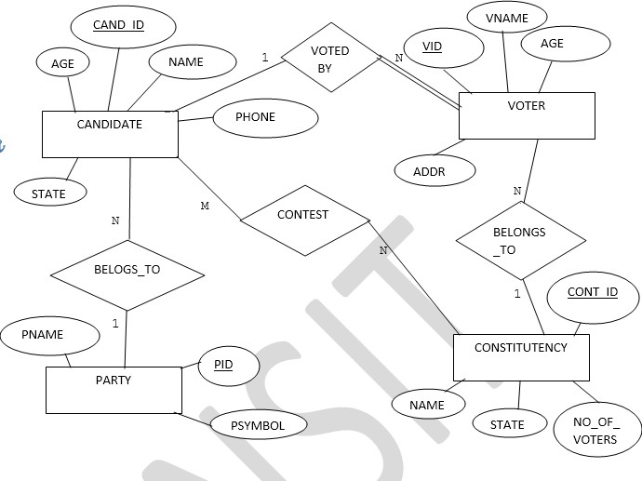

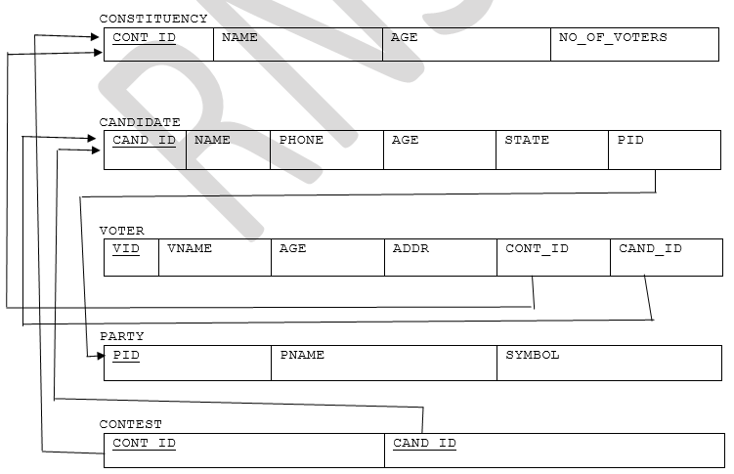

create table constituency (cons_id number(20) primary key, csname varchar(20),

csstate varchar(20), no_of_voters number(10));

create table party

(pid number(20) primary key, pname varchar(20),

psymbol varchar(10));

create table candidates (cand_id number(12) primary key, phone_no number(10),

age number(2), state varchar(20), name varchar(20),

pid int references party(pid));

create table contest

(cons_id number(20) references constituency(cons_id), cand_id number(12) references candidates(cand_id) primary key(cons_id,cand_id);

create table voter

(vid number(20) primary key, vname varchar(20),

vage number(5), vaddr varchar(20),

cons_id number(20) references constituency(cons_id), cand_id number(12) references candidates(cand_id));

select * from constituency;

CONS_ID CSNAME CSSTATE NO_OF_VOTERS

|  |  |  |  |  |  |
| --- | --- | --- | --- | --- | --- |
| 111 rajajinagar karnataka |  |  |  | 4 |  |
| 222 ramnagar kerala |  |  |  | 1 |
| select * from party; |  |  |  |  |
| PID PNAME PSYMBOL |  |  |  |  |
| 876 bjp lotus  877 congress hand |  |  |  |  |
| select * from candidates; |  |  |  |  |
| CAND_ID PHONE_NO AGE STATE |  | NAME |  |  | PID |
| 121 9538904626 23 kerala |  | raksha |  |  | 876 |
| 122 9740777502 24 karnataka |  | veena |  |  | 877 |
| select * from contest; CONS_ID CAND_ID |  |  |  |  |  |
| 111 122 |  |  |  |  |  |

|  |  |
| --- | --- |
| 222 | 121 |
| 222 | 122 |

select * from voter;

|  |  |  |  |  |  |  |  |  |
| --- | --- | --- | --- | --- | --- | --- | --- | --- |
| VID |  | VNAME |  | VAGE VADDR |  | CONS_ID |  | CAND_ID |
| 345 |  | prashanth |  | 21 kanakpura |  | 222 |  | 122 |
| 346 |  | prakash |  | 23 ramnagar |  | 111 |  | 121 |
| 348 |  | nagesh |  | 30 mandya |  | 111 |  | 121 |
| 349 |  | nagesh |  | 30 mandya |  | 111 |  | 121 |

**Query 1:**

select * from candidates where cand_id in (select cand_id from contest join constituency on contest.cons_id=constituency.cons_id

group by cand_id having count(distinct(csstate))>1);

CAND_ID PHONE_NO AGE STATE NAME PID

122 9740777502 24 karnataka veena 877

**Query 2:**

select csstate from constituency group by csstate having count(csstate) in (select max(count(csstate)) from constituency group by csstate);

CSSTATE

karnataka

**query 3:**

create or replace procedure agechecking ( id in number,age in number)

as BEGIN

if age>18 then

insert into voter(vid,vage) values (id,age); else

dbms_output.put_line('age should be high'); end if;

end agechecking;

/

Procedure created.

SQL> set serveroutput on; SQL> exec agechecking (25,21);

PL/SQL procedure successfully completed. **// row inserted**

SQL> exec agechecking (20,15);

age should be high **//Message displayed as age is less than or equal to 18**

PL/SQL procedure successfully completed.

**query 4:**

create or replace procedure display_count (

const_id number

)

as

vid constituency.cons_id % type; begin

select no_of_voters into vid from constituency where cons_id = const_id and rownum = 1;

dbms_output.put_line ( 'total voters are: ' || vid); end;

/

NO_OF_VOTERS

karnataka kerala

Procedure created.

SQL> select * from constituency; CONS_ID CSNAME

CSSTATE

2

1

111 rajajinagar

222 ramnagar

SQL> exec display_count(111); total voters are: 2

**Query 5:**

create or replace trigger count after insert on voter

for each row begin

update constituency

set no_of_voters = no_of_voters + 1 where cons_id=:new.cons_id;

end count;

/

Trigger created.

SQL> set serveroutput on;

SQL> select * from constituency;

CONS_ID CSNAME CSSTATE NO_OF_VOTERS

|  |  |  |  |  |
| --- | --- | --- | --- | --- |
| 111 rajajinagar |  | karnataka |  | 2 |
| 222 ramnagar |  | kerala |  | 1 |

SQL> insert into voter values(348,'nagesh',30,'mandya',111,121);

1 row created.

**After insertion into voter table , the constituency table is automatically updated.**

SQL> select * from constituency;

CONS_ID CSNAME CSSTATE NO_OF_VOTERS

111 rajajinagar karnataka 3

222 ramnagar kerala 1