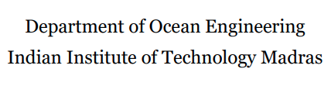



**Analysis of 2D flow field around submarine hull**

**Submitted by :**

**Shivanand Paramashivam Pillai**

**Roll.No:- OE21M027**

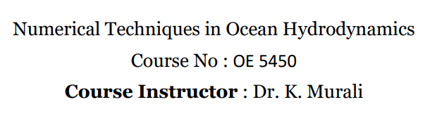

**Analysis of 2D flow field around submarine hull**

Department of Ocean Engineering, Indian Institute of Technology Madras

Shivanand Paramashivam Pillai

**Objective :-**

To analyse the velocity field and pressure field around the longitudinal cut section of Submarine by using Finite Element Method (FEM)

**Domain and Geometry :-**

A standard submarine hull model was used as a prototype for computations. The bow of our submarine model has been chosen as ellipsoidal and the stern has been chosen conical in shape with a portion of cylindrical mid body. The hull model has an overall length L of 80 m and maximum diameter D of 10 m. The sail is located in front of the hull with a length of 5m. The Tail is located at 5m from the rear of the hull.

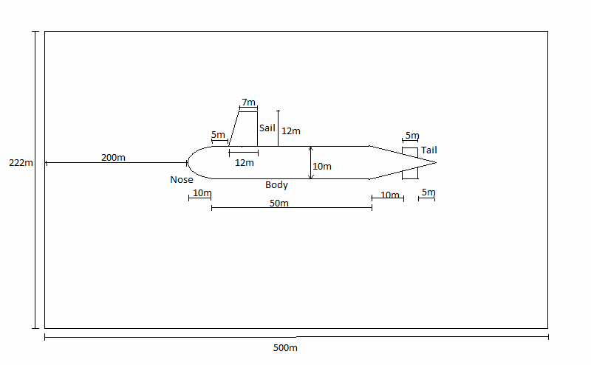

Figure.01. Sectional view of submarine hull

Domain of area 222m x 500m has been selected as ahown in figure.01

**Finite Element Formulation :-**

The use of computational tools to evaluate submarine flows have been tremendously increased over the last decade since the capacity and speed of computers were raised. In view of these developments, Finite Element Method (FEM) can offer a cost-effective solution to many problems in underwater vehicle hull forms. However, effective utilization of FEM for naval hydrodynamics depends on proper selection of models (i.e trial solution), grid generation and boundary resolution. The major steps in the finite element formulation and analysis of a typical problem are:

1. Discretization of the domain into a set of selected finite elements. A finite element is not just a geometric shape but it is endowed with certain geometric and physical features, as will be clear in the sequel.

2. Construction of a statement, often a weighted-integral or weak-form statement, that is equivalent to the differential equation to be analyzed over a typical element.

3. Development of the finite element model (set of algebraic relations among the unknowns) using the weighted-integral statement or weak form over an element. The same differential equation can have different finite element models depending on the choice of the method of approximation, that is Galerkin, weak-form Galerkin, least-squares, subdomain, collocation, and so on.

4. Assembly of finite elements to obtain the global system of algebraic equations.

5. Imposition of boundary conditions.

6. Solution of equations.

7. Postcomputation of the solution and quantities of interest.

**Meshing :-**

Regular triangular elements are considered for meshing as shown in figure.02. Mesh is generated by C++ code and is visualised by using Matlab.

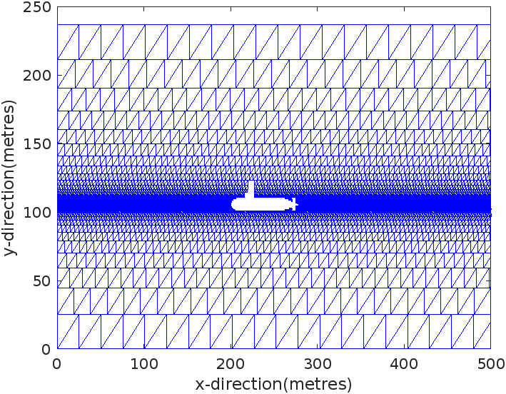

Figure.02.Mesh

C++ program is coded in such a way that mesh size gets finer near the surface of submarine hull.

**Governing equations :-**

Continuity Equation of mass :

$$\frac{∂u}{∂x}+\frac{∂v}{∂y}=0$$

……………………………..(1)

X-momentum Equation :

$$u\frac{∂u}{∂x}+v\frac{∂u}{∂y}+\frac{1}{ρ}\frac{∂P}{∂x}-\frac{μ}{ρ}\left(\frac{∂^{2}u}{∂x^{2}}+\frac{∂^{2}u}{∂y^{2}}\right)=0$$

……………….(2)

Y-momentum Equation :

$$u\frac{∂v}{∂x}+v\frac{∂v}{∂y}+\frac{1}{ρ}\frac{∂P}{∂y}-\frac{μ}{ρ}\left(\frac{∂^{2}v}{∂x^{2}}+\frac{∂^{2}v}{∂y^{2}}\right)=0$$

……………….(3)

In our analysis we have considered density $ρ=1025 kg/m^{3}$ and dynamic viscosity $μ=8.90×{10}^{-4} Pa.s$ to be constant throughout the fluid domain

u = Horizontal water particle velocity

v = Vertical water particle velocity

P = Pressure

**Boundary Conditions :-**

1. Flow direction of sea current is assumed to flow along the longitudinal axis of submarine

2. Inlet boundary condition is assumed at face AB as shown in below figure.02

3. Horizontal velocity at face AB is considered to be the relative speed between Submarine and current, which is taken as 3m/s , 10m/s and 20m/s , for comparing cases.

4. Vertical velocity at face AB is considered to be zero (v = 0 m/s).

5. No slip boundary condition is assumed for the surface of submarine hull, that means water particles velocity is zero at surface and stress is very high.

C

A

Fluid region

u = 10 m/s

v = 0 m/s

Ship region

B

D

**Development of Finite element Model :-**

Lets assume the trial solution for u, v and P as follows,

$u= a_{1}x+a_{2}xy$

……..(4)

$v= b_{1}y+b_{2}xy$

$$P=c_{1}x^{2}+{c_{2}y}^{2}$$

Weak formulation is carried by using weighted average method, The idea is to satisfy the differential equation in an average sense by converting it into an integral equation. The differential equation is multiplied by a weighting function and then averaged over the domain.Least square method is used in our analysis.

Lets, assume residuals of equations (1), (2) and (3) as shown below,

$R_{1}= \frac{∂u}{∂x}+\frac{∂v}{∂y}$

$R_{2}= u\frac{∂u}{∂x}+v\frac{∂u}{∂y}+\frac{1}{ρ}\frac{∂P}{∂x}-\frac{μ}{ρ}\left(\frac{∂^{2}u}{∂x^{2}}+\frac{∂^{2}u}{∂y^{2}}\right)$

…(5)

$$R_{3}= u\frac{∂v}{∂x}+v\frac{∂v}{∂y}+\frac{1}{ρ}\frac{∂P}{∂y}-\frac{μ}{ρ}\left(\frac{∂^{2}v}{∂x^{2}}+\frac{∂^{2}v}{∂y^{2}}\right)$$

Weighted integral form of equation (1), (2) and (3)

Note:- $∀^{f} and ∀^{e}$ are the start and finish of the domain over the single element

$$\iint_{∀^{e}}^{∀^{f}}{W_{1}R_{1}dxdy=0}$$

$$\iint_{∀^{e}}^{∀^{f}}{W_{2}R_{2}dxdy=0}$$

$$\iint_{∀^{e}}^{∀^{f}}{W_{3}R_{3}dxdy=0}$$

In the least square method, we try to minimize the residual in a least squares sense, that means $\int{\frac{∂R^{2}}{∂a_{i}}ds= \int{2R.\frac{∂R}{∂a_{i}}ds= \int{R.\frac{∂R}{∂a_{i}}ds=}0}}$, where $a_{i}$ is an coeffiecient of trial solutions.

The Weighting function for the least squares method is therefore, $W= \frac{∂R}{∂a_{i}}$

Therefore, it can assumed that $W_{1}=\frac{∂R_{1}}{∂b_{2}}$, $W_{2}=\frac{∂R_{2}}{∂c_{1}}$ and $W_{3}=\frac{∂R_{3}}{∂c_{2}}$…………..(6)

Hence, weighted integral form or weak form will be given as

$$\iint_{∀^{e}}^{∀^{f}}{\frac{∂R_{1}}{∂b_{2}}R_{1}dxdy=0}$$

$\iint_{∀^{e}}^{∀^{f}}{\frac{∂R_{2}}{∂c_{1}}R_{2}dxdy=0}$

…….(7)

$$\iint_{∀^{e}}^{∀^{f}}{\frac{∂R_{3}}{∂c_{2}}R_{3}dxdy=0}$$

From (4), (5) and (6),

$$\iint_{∀^{e}}^{∀^{f}}{x\left(a_{1}+a_{2}y+b_{1}+b_{2}x\right)dxdy=0}$$

$$\iint_{∀^{e}}^{∀^{f}}{\frac{2x}{ρ}\left[\left(a_{1}x+a_{2}xy\right)\left(a_{1}+a_{2}y\right)+\left(b_{1}y+b_{2}xy\right)\left(a_{2}x\right)\right]dxdy=0}$$

$$\iint_{∀^{e}}^{∀^{f}}{\frac{2y}{ρ}\left[\left(a_{1}x+a_{2}xy\right)\left(b_{2}y\right)+\left(b_{1}y+b_{2}xy\right)\left(b_{1}+b_{2}x\right)\right]dxdy=0}$$

In the mesh generation process, two types of triangles are used to generate regular triangular meshing as shown in below figure.03.

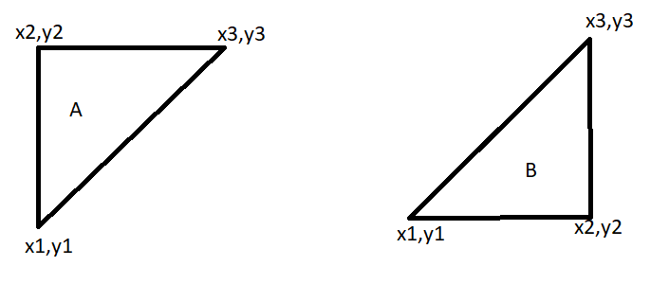

Figure.03

For A type of triangular elements, the following system of linear equations are formulated from FE model and boundary conditions.

$$\left[\begin{aligned}\begin{matrix}K_{11} \\ 0\end{matrix} \\ 0 \\ 0\end{aligned} \begin{aligned}\begin{matrix}K_{12} \\ K_{22}\end{matrix} \\ 0 \\ 0\end{aligned} \begin{aligned}\begin{matrix}K_{13} \\ K_{23}\end{matrix} \\ K_{33} \\ 0\end{aligned} \begin{aligned}\begin{matrix}K_{14} \\ K_{24}\end{matrix} \\ K_{34} \\ K_{44}\end{aligned}\right]\left[\begin{aligned}a_{1} \\ a_{2} \\ b_{1} \\ b_{2}\end{aligned}\right]=\left[\begin{aligned}X_{1} \\ X_{2} \\ X_{3} \\ X_{4}\end{aligned}\right]$$

Where,

$K_{11}=\frac{x_{1}^{2}}{2}\left(y_{1}-y_{3}\right)+\frac{x_{3}^{3}}{6m}$, $K_{12}= \frac{x_{1}^{2}}{4}\left(y_{1}^{2}-y_{3}^{2}\right)+\frac{{y_{3}x}_{3}^{3}}{6m}-\frac{x_{3}^{4}}{24m^{2}}$, $K_{13}=K_{11}$,

$K_{14}=\frac{x_{1}^{3}}{3}\left(y_{1}-y_{3}\right)+\frac{x_{3}^{4}}{12m}$, $K_{22}=x_{1}y_{1}-x_{1}\frac{K_{12}}{K_{11}}$, $K_{23}= -x_{1}\frac{K_{13}}{K_{11}}$, $K_{24}= -x_{1}\frac{K_{14}}{K_{11}}$,

$K_{33}=K_{13}\left[\frac{x_{2}\left(y_{2}-y_{1}\right)}{y_{1}K_{11}-K_{12}}\right]$, $K_{34}=K_{14}\left[\frac{x_{2}\left(y_{2}-y_{1}\right)}{y_{1}K_{11}-K_{12}}\right]$, $K_{44}=x_{1}y_{1}-y_{1}\frac{K_{14}}{K_{13}}$

$X_{1}=0$, $X_{2}= u_{1}$, $X_{3}=u_{2}-u_{1}\left[\frac{x_{2}y_{2}K_{11}-x_{2}K_{12}}{x_{1}y_{1}K_{11}-x_{1}K_{12}}\right]$, $X_{4}= v_{1}-\frac{y_{1}}{K_{13}}\left[\frac{u_{2}\left(x_{1}y_{1}K_{11}-x_{1}K_{12}\right)-u_{1}\left(x_{2}y_{2}K_{11}-x_{2}K_{12}\right)}{x_{1}x_{2}\left(y_{2}-y_{1}\right)}\right]$

$$\left[\begin{matrix}F_{1} & 0 \\ 0 & F_{2}\end{matrix}\right]\left[\begin{aligned}c_{1} \\ c_{2}\end{aligned}\right]=\left[\begin{aligned}G_{1} \\ G_{2}\end{aligned}\right]$$

Where,

$F_{1}=\frac{2}{3ρ}\left[x_{1}^{2}\left(y_{1}-y_{3}\right)+\frac{x_{3}^{4}}{4m}\right]$, $F_{2}= \frac{2m}{ρ}\left[ \frac{y_{1}}{3}\left(y_{1}^{3}-y_{3}^{3}\right)+\frac{y_{1}^{4}-y_{3}^{4}}{4}\right]$,

$G_{1}=-\left(M_{1}+M_{2}+M_{3}+M_{4}+M_{5}\right)$, $G_{2}=-(M_{6}+M_{7}+M_{8}+M_{9}+M_{10})$

$M_{1}=\frac{a_{1}^{2}}{3}\left[x_{1}^{2}\left(y_{1}-y_{3}\right)+\frac{x_{3}^{4}}{4m}\right]$, $M_{2}=\frac{a_{2}^{2}}{3}\left[\frac{x_{1}^{3}}{3}\left(y_{1}^{3}-y_{3}^{3}\right)+\frac{y_{3}^{2}x_{3}^{4}}{4m}-\frac{y_{3}x_{3}^{5}}{10m^{2}}+\frac{x_{3}^{6}}{60m^{3}}\right]$,

$M_{3}=\frac{2a_{1}a_{2}}{3}\left[\frac{x_{1}^{3}}{2}\left(y_{1}^{2}-y_{3}^{2}\right)+\frac{y_{3}x_{3}^{4}}{4m}-\frac{x_{3}^{5}}{20m^{2}}\right]$, $M_{4}=\frac{b_{1}}{2a_{1}}M_{3}$, $M_{5}=\frac{a_{2}b_{2}}{4}\left[\frac{x_{1}^{4}}{2}\left(y_{1}^{2}-y_{3}^{2}\right)+\frac{y_{3}x_{3}^{5}}{5m}-\frac{x_{3}^{6}}{30m^{2}}\right]$, $M_{6}=mb_{1}^{2}\left[\frac{y_{1}}{3}\left(y_{1}^{3}-y_{3}^{3}\right)+\frac{y_{1}^{4}-y_{3}^{4}}{4}\right]$,

$M_{7}=\frac{b_{2}^{2}}{a_{2}^{2}}M_{2}$, $M_{8}=b_{1}b_{2}\left[\frac{x_{1}^{3}}{3}\left(y_{1}^{3}-y_{3}^{3}\right)+\frac{y_{3}^{2}x_{3}^{3}}{3m}-\frac{y_{3}x_{3}^{4}}{6m^{2}}+\frac{x_{3}^{5}}{30m^{3}}\right]$,

$M_{9}= \frac{a_{1}b_{2}}{2}\left[\frac{x_{1}^{3}}{2}\left(y_{1}^{3}-y_{3}^{3}\right)+\frac{y_{3}^{2}x_{3}^{3}}{3m}-\frac{y_{3}x_{3}^{4}}{6m^{2}}+\frac{x_{3}^{5}}{30m^{3}}\right]$,

$M_{10}=\frac{a_{2}b_{2}}{2}\left[\frac{x_{1}^{2}}{4}\left(y_{1}^{4}-y_{3}^{4}\right)+\frac{y_{3}^{4}x_{3}^{2}}{3}-\frac{{my}_{3}^{5}x_{3}}{10}+\frac{m^{2}\left(y_{3}^{6}-y_{1}^{6}\right)}{60}\right]$

Note:- $m=\frac{x_{3}-x_{1}}{y_{3}-y_{1}}$

For B type of triangular elements, the following system of linear equations are formulated from FE model and boundary conditions.

$$\left[\begin{aligned}\begin{matrix}L_{11} \\ 0\end{matrix} \\ 0 \\ 0\end{aligned} \begin{aligned}\begin{matrix}L_{12} \\ L_{22}\end{matrix} \\ 0 \\ 0\end{aligned} \begin{aligned}\begin{matrix}L_{13} \\ L_{23}\end{matrix} \\ L_{33} \\ 0\end{aligned} \begin{aligned}\begin{matrix}L_{14} \\ L_{24}\end{matrix} \\ L_{34} \\ L_{44}\end{aligned}\right]\left[\begin{aligned}a_{1} \\ a_{2} \\ b_{1} \\ b_{2}\end{aligned}\right]=\left[\begin{aligned}Y_{1} \\ Y_{2} \\ Y_{3} \\ Y_{4}\end{aligned}\right]$$

Where,

$L_{11}=\frac{x_{3}^{2}}{2}\left(y_{3}-y_{1}\right)+\frac{x_{1}^{3}}{6m}$, $L_{12}= \frac{x_{3}^{2}}{4}\left(y_{3}^{2}-y_{1}^{2}\right)+\frac{{y_{1}x}_{1}^{3}}{6m}-\frac{x_{1}^{4}}{24m^{2}}$, $L_{13}=L_{11}$,

$L_{14}=\frac{x_{3}^{3}}{3}\left(y_{3}-y_{1}\right)+\frac{x_{1}^{4}}{12m}$, $L_{22}=x_{1}y_{1}-x_{1}\frac{L_{12}}{L_{11}}$, $L_{23}= -x_{1}\frac{L_{13}}{L_{11}}$, $L_{24}= -x_{1}\frac{L_{14}}{L_{11}}$,

$L_{33}=L_{13}\left[\frac{x_{3}\left(y_{3}-y_{1}\right)}{y_{1}L_{11}-L_{12}}\right]$, $L_{34}=L_{14}\left[\frac{x_{3}\left(y_{3}-y_{1}\right)}{y_{1}L_{11}-L_{12}}\right]$, $L_{44}=x_{1}y_{1}-y_{1}\frac{L_{14}}{L_{13}}$

$Y_{1}=0$, $Y_{2}= u_{1}$, $Y_{3}=u_{3}-u_{1}\left[\frac{x_{3}y_{3}L_{11}-x_{3}L_{12}}{x_{1}y_{1}L_{11}-x_{1}L_{12}}\right]$, $Y_{4}= v_{1}-\frac{y_{1}}{L_{13}}\left[\frac{u_{3}\left(x_{1}y_{1}L_{11}-x_{1}L_{12}\right)-u_{1}\left(x_{3}y_{3}L_{11}-x_{3}L_{12}\right)}{x_{1}x_{3}\left(y_{3}-y_{1}\right)}\right]$

$$\left[\begin{matrix}F_{3} & 0 \\ 0 & F_{4}\end{matrix}\right]\left[\begin{aligned}c_{1} \\ c_{2}\end{aligned}\right]=\left[\begin{aligned}G_{3} \\ G_{4}\end{aligned}\right]$$

Where,

$F_{3}=\frac{2}{3ρ}\left[x_{3}^{2}\left(y_{3}-y_{1}\right)+\frac{x_{1}^{4}}{4m}\right]$, $F_{4}= \frac{2m}{ρ}\left[ \frac{y_{3}}{3}\left(y_{3}^{3}-y_{1}^{3}\right)+\frac{y_{3}^{4}-y_{1}^{4}}{4}\right]$,

$G_{3}=-\left(N_{1}+N_{2}+N_{3}+N_{4}+N_{5}\right)$, $G_{4}=-(N_{6}+N_{7}+N_{8}+N_{9}+N_{10})$

$N_{1}=\frac{a_{1}^{2}}{3}\left[x_{3}^{2}\left(y_{3}-y_{1}\right)+\frac{x_{1}^{4}}{4m}\right]$, $N_{2}=\frac{a_{2}^{2}}{3}\left[\frac{x_{3}^{3}}{3}\left(y_{3}^{3}-y_{1}^{3}\right)+\frac{y_{1}^{2}x_{1}^{4}}{4m}-\frac{y_{1}x_{1}^{5}}{10m^{2}}+\frac{x_{1}^{6}}{60m^{3}}\right]$,

$N_{3}=\frac{2a_{1}a_{2}}{3}\left[\frac{x_{3}^{3}}{2}\left(y_{3}^{2}-y_{1}^{2}\right)+\frac{y_{1}x_{1}^{4}}{4m}-\frac{x_{1}^{5}}{20m^{2}}\right]$, $N_{4}=\frac{b_{1}}{2a_{1}}N_{3}$, $N_{5}=\frac{a_{2}b_{2}}{4}\left[\frac{x_{3}^{4}}{2}\left(y_{3}^{2}-y_{1}^{2}\right)+\frac{y_{1}x_{1}^{5}}{5m}-\frac{x_{1}^{6}}{30m^{2}}\right]$, $N_{6}=mb_{1}^{2}\left[\frac{y_{3}}{3}\left(y_{3}^{3}-y_{1}^{3}\right)+\frac{y_{3}^{4}-y_{1}^{4}}{4}\right]$,

$N_{7}=\frac{b_{2}^{2}}{a_{2}^{2}}N_{2}$, $N_{8}=b_{1}b_{2}\left[\frac{x_{3}^{3}}{3}\left(y_{3}^{3}-y_{1}^{3}\right)+\frac{y_{1}^{2}x_{1}^{3}}{3m}-\frac{y_{1}x_{1}^{4}}{6m^{2}}+\frac{x_{1}^{5}}{30m^{3}}\right]$,

$N_{9}= \frac{a_{1}b_{2}}{2}\left[\frac{x_{3}^{3}}{2}\left(y_{3}^{3}-y_{1}^{3}\right)+\frac{y_{1}^{2}x_{1}^{3}}{3m}-\frac{y_{1}x_{1}^{4}}{6m^{2}}+\frac{x_{1}^{5}}{30m^{3}}\right]$,

$N_{10}=\frac{a_{2}b_{2}}{2}\left[\frac{x_{3}^{2}}{4}\left(y_{3}^{4}-y_{1}^{4}\right)+\frac{y_{1}^{4}x_{1}^{2}}{3}-\frac{{my}_{1}^{5}x_{1}}{10}+\frac{m^{2}\left(y_{1}^{6}-y_{3}^{6}\right)}{60}\right]$

Note:- $m=\frac{x_{3}-x_{1}}{y_{3}-y_{1}}$

**Results :-**

Code to compute Pressure, u - velocity and v – velocity is developed in C++, which can be found in below google drive link:-

<https://drive.google.com/file/d/1bUn5yxQ-r48wFo28BFTBy3UuedzGvPPS/view?usp=sharing>

For plotting and post processing , Matlab is used

Case. 01 : relative velocity = 3 m/s

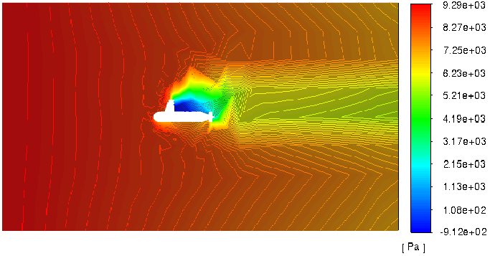

Figure.04: Pressure field around submarine for relative velocity of 3m/s (pressure ranges from -912Pa to 9290Pa)

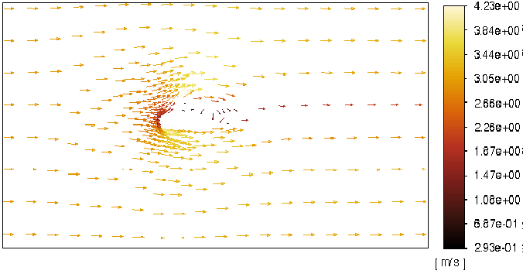

Figure.05: Velocity vector field around submarine for relative velocity of 3m/s (magnitude of velocity ranges from 0.293m/s to 4.23m/s)

Case.02 : Relative velocity = 10m/s

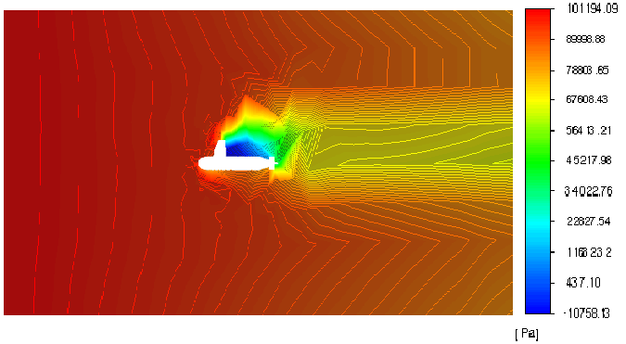

Figure.06: Pressure field around submarine for relative velocity of 10m/s (pressure ranges from -10758Pa to 101194Pa)

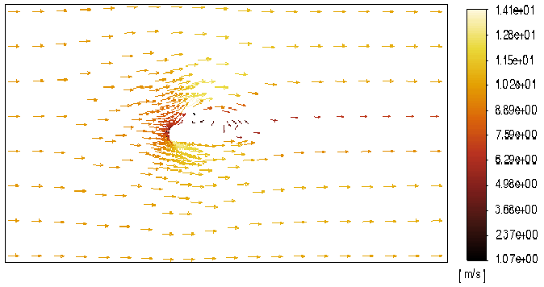

Figure.07: Velocity vector field around submarine for relative velocity of 10m/s (magnitude of velocity ranges from 1.07m/s to 14.1m/s)

Case.03 : Relative velocity = 20m/s

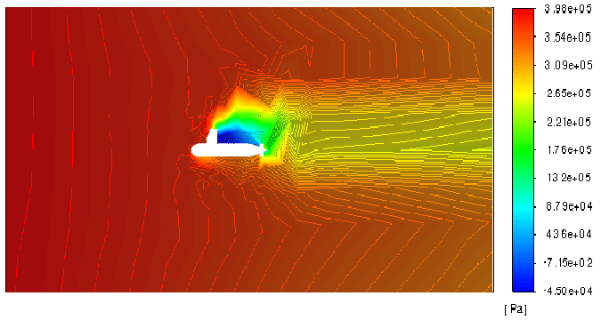

Figure.08: Pressure field around submarine for relative velocity of 10m/s (pressure ranges from -45000Pa to 398000Pa)

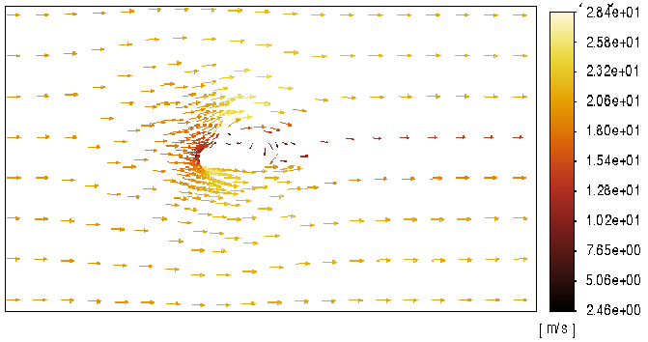

Figure.09: Velocity vector field around submarine for relative velocity of 10m/s (magnitude of velocity ranges from 2.46m/s to 28.4m/s)

**Conclusion:-**

Hence, pressure field and velocity vector fields are studied as per above results, the vorticity just behind the sail plane of submarine is very high.

**References:-**

1. Investigation of flow distribution around submarine, 2016, Istanbul Technical University, Abdi Kukner

2. Topology Model of the Flow around a Submarine Hull Form ,S.-K. Lee, Maritime Division Defence Science and Technology Group DST-Group–TR–3177

# 3. Experimental and Numerical Study of a Submarine and Propeller Behaviors in Submergence and Surface Conditions, [A. Vali](https://www.jafmonline.net/?_action=article&au=10308&_au=A.++Vali) , [B. Saranjam](https://www.jafmonline.net/?_action=article&au=10307&_au=B.++Saranjam) , [R. Kamali](https://www.jafmonline.net/?_action=article&au=10067&_au=R.++Kamali) [3](https://www.jafmonline.net/article_683.html#aff3)